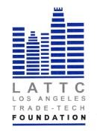

LOS ANGELES TRADE-TECHNICAL COLLEGE FOUNDATION
BOARD OF DIRECTORS
THURSDAY, OCTOBER 19, 2017 12:00PM
PRESIDENT’S CONFERENCE ROOM ST 541
REGULAR MEETING

- Call to Order

- Public Comment

- Approval of Minutes: Action

- Chairs Report

- Committee Reports
Finance
Scholarship
Annual Dinner Fundraiser
Website Construction

- President’s Report
- Adjournment

