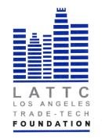

LOS ANGELES TRADE-TECHNICAL COLLEGE FOUNDATION
BOARD OF DIRECTORS
THURSDAY, NOVEMBER 16, 2017 12:00PM
PRESIDENT’S CONFERENCE ROOM ST 541
REGULAR MEETING

- Call to Order

- Public Comment

- Approval of Minutes Action

- Chairs Report

- Board Resolution for Wells Fargo, Morgan Stanley & Homestreet CD Action

- Annenberg Grant Approval Action

- Committee Reports
Finance – 2017-2018 Budget Action
Annual Dinner Fundraiser
Website Construction
Scholarship

- President’s Report
- Adjournment

