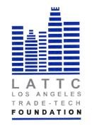

LOS ANGELES TRADE-TECHNICAL COLLEGE FOUNDATION
BOARD OF DIRECTORS
THURSDAY, APRIL 19, 2018
PRESIDENT’S CONFERENCE ROOM ST 541
REGULAR MEETING

- Call to Order

- Public Comment

- Closed Session

- Chair’s Report & Presentation

- March Minutes Action

- March Financials Action

- Final 2017-2018 Budget Action
Proposed Financial Reporting/Glossary/Cash Flow Analysis
- Committee Reports
2018 Student Benefit Dinner
Website

VII. President’s Report

VIII. Adjournment

