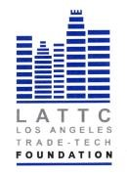

LOS ANGELES TRADE-TECHNICAL COLLEGE FOUNDATION
BOARD OF DIRECTORS
THURSDAY, NOVEMBER 15, 2018
PRESIDENT’S CONFERENCE ROOM ST 541
REGULAR MEETING

- Call to Order

- Public Comment

- Chair’s Report

- President’s Report

- September Minutes Action

- September Financials Action

- 2018 Audit Action

- New Board Member Herb Nadel Action

- Committee Reports
Investment Policy Update
2018 Student Benefit Dinner Update

X. Adjournment

