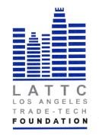

LOS ANGELES TRADE-TECHNICAL COLLEGE FOUNDATION
BOARD OF DIRECTORS
THURSDAY, APRIL 18, 2019
PRESIDENT’S CONFERENCE ROOM ST 541
REGULAR MEETING

- Call to Order

- Public Comment

- Chair’s Report

- February Minutes Action

- March Financials Action

- New Auditor Action

- New Bank Action

- Committee Reports
Investment Policy Update
2019 Student Benefit Dinner Update

VII. President’s Report

VIII. Adjournment

