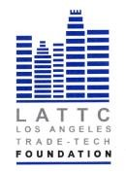

LOS ANGELES TRADE-TECHNICAL COLLEGE FOUNDATION
BOARD OF DIRECTORS
FINANCE COMMITTEE MEETING
TUESDAY, NOVEMBER 21,2017
3PM
DIAL IN

- Approve 2017-2018 Draft Budget Action

- Discussion of Investments

- Selection of new accounting firm Action

- ICAP Dinner 2018 Contract Action

