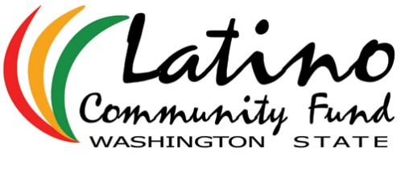
2017 Community Grants – Nomination Form

Complete and email to lilliane@latinocommunityfund.org, or fill it out online at http://www.latinocommunityfund.org/2017_community_grant_awards. Due: Friday, May 19th, 2017.

Organization information
Organization Name:
Mission:
Address: | Street address:
 | City |  |  |  |  |  |  | State |  |  |  | Zip
Contact person at organization: | Name: |  |  |  |  |  | Title:
Contact information: | Phone |  |  |  |  |  | Email:
Total revenues for most recent complete fiscal year:
Nonprofit Status: | ⃣ 501(c)3  EIN#: |  |  |  |  |  | ⃣ Fiscally Sponsored by another 501(c)3 Name:  EIN #:
Organization Size: | Total # staff: |  |  |  |  |  |  |  |  |  | Total # volunteers:
Eligibility | Yes or No
Is more than 50% of the programs’ or organizations’ governance board Latino/a?
Is the Executive Director (or equivalent) of the program or organization Latino/a?
Is the program or organization’s work directly aimed at improving the lives of Latinos?

Nominator Information
Name:
Relationship with requesting organization: |  | ⃣ Board member  ⃣ Volunteer |  |  |  |  | ⃣ Program participant/beneficiary  ⃣ Other:
Contact information: | Phone: |  |  |  |  |  | Email:
Request information
- What is the main work of the organization or program?
- How is this work important to the Latino/a community?
- How does the work of this organization advance leadership in the Latino/a community?
- How will additional funds advance the overall work and/or capacity of this organization or program?
- Amount $ Requested:

Contact Us! We welcome your questions about this call for nominations.
Lilliane Ballesteros: lilliane@latinocommunityfund.org / 661-717-2761
Peter Bloch-García: peter.blochgarcia@latinocommunityfund.org /206-354-1487
Vicky Breckwich Vásquez: vickysalud@gmail.com /206-482-3469
José Vásquez: jose.vasquez@latinocommunityfund.org /206-930-0668

