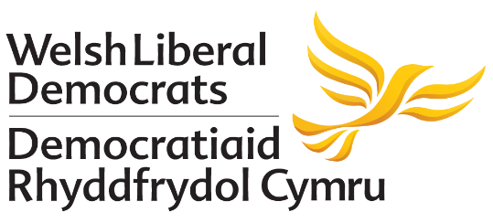

Jane Dodds and Kirsty Williams AM: written response to the BEIS call for evidence on the Consumer Contract Regulations Review

- We welcome the opportunity to respond to the Department for Business, Energy & Industrial Strategy’s call for evidence on the Consumer Contract Regulations Review.
- We respond as the Westminster Parliamentary Candidate for Brecon and Radnorshire and the Welsh Assembly Member for Brecon and Radnorshire.
- Our response focuses on proposals around tourism, particularly relating to potential implications of removing tourism and hospitality from the list of services exempt from the 14 day ‘cooling off period’.
Background
- Tourism and hospitality is a crucial part of Brecon and Radnorshire’s local economy, with many towns and communities across the constituency seeing visitors from across the UK and further afield.
- The Brecon Beacons, the Elan Valley, the Cambrian Mountains, the Royal Welsh Show, Dan Yr Ogof, Hay Festival, Offa’s Dyke Path, Green Man Festival, various walking routes and festivals, and a number of other attractions means tourism will continue to be crucial for Brecon and Radnorshire.
Cancellation provisions: exemptions
- As things stand, a range of tourism products are among those exempt from the 14 day right to return goods or cancel services for customers.
- An extract in page 13 of the consultation document states:
“Initial feedback from some stakeholders suggests that in some circumstances, certain exemptions could be causing consumer detriment, for example hotel bookings (an area of interest for the CMA) and urgent repairs. We are keen to gather further views and evidence.”
- Removing the tourism and hospitality from the list of exemptions would have implications for tourism and hospitality in Brecon and Radnorshire.
Cancellation provisions: tourism and hospitality
- We have heard concern from local representatives in the tourism sector as to the potential implications of removing the exemption, particularly relating to late bookings and how small businesses would be able to manage these.
- There are concerns that the proposals would lead to people ‘shopping around’ on late deals, with the ability to make multiple bookings and choosing which one to go through with at the latest possible opportunity.
- With no cancellation fee, a situation like this would leave small businesses out of pocket. In all likelihood they would be unable to find a replacement booking at such short notice.
- Last-minute cancellations can be damaging to small businesses, and plans that may have the consequence of increasing the number of these cancellations (with no cancellation fee) could cause significant difficulties for tourism and hospitality.
Conclusion
- If changes to the Consumer Contract Regulations Review have the consequence of increasing the number of late cancellations, small businesses in tourism and hospitality would face serious difficulties. This is particularly concerning for Brecon and Radnorshire.
- As the Department for Business, Energy & Industrial Strategy takes forward plans relating to the Consumer Contract Regulations Review, it should keep the concerns expressed by the tourism sector in mind and ensure they are addressed.

