Tom Brake’s St Helier Hospital Poster

As part of the campaign to Save Our St Helier, I am looking for a local child to draw a picture of St Helier Hospital. The winning picture will be used on postcards and posters as part of the campaign to save our local hospital.
If you would like to enter just draw a picture of St Helier Hospital below and include your details. I have put a small picture of the hospital below.
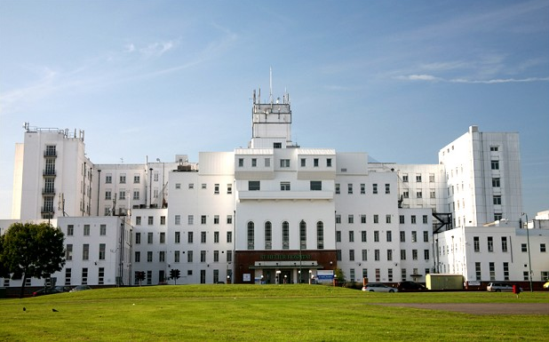

Child Name: Age:
Parent or Guardian: Phone or email:
Address:
Return entries to: Tom Brake MP, St Helier Poster, 5 Nightingale Road, Carshalton, SM5 2DN
or info@tombrake.co.uk by the 31st August
If you fill in this form, the Liberal Democrats and their elected representatives may use the information given to contact you. Some contacts may be automated. You can opt out of communications at any time by contacting us. Hosted by Mailchimp. Published and promoted on behalf of the Liberal Democrats by S.Drage at Unit 1, Streatham business centre, 1 Empire Mews, London SW16 2ED and by E. Drage on behalf of Sutton Liberal Democrats at Room 2, Kennedy House, 5 Nightingale road, Carshalton, SM5 2DN.

