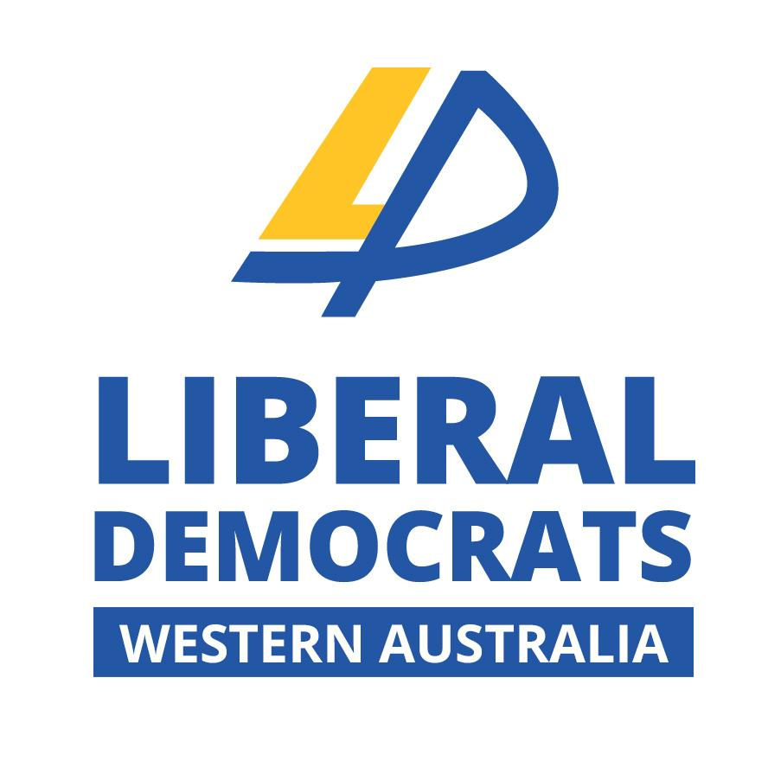
Liberal Democrats WA
State Council
General Meeting

6pm, Wednesday 5th September 2018
Snug Room (room to on left of bar)
Rosie O’Grady’s
205 James Street Northbridge

Agenda

- Open
- Apologies
- Minutes of previous meeting
- Motions with notice
  - Amend the Fair Work Act
The Liberal Democrats WA call for an amendment to the Fair Work Act (2009) to allow prospective employees to waive minimum wage rates to small businesses as defined under the Act (15 or fewer employees)
  - Offshore detention of asylum seekers
The Liberal Democrats WA call for the end of Australia’s offshore detention regime.
- Executive reports
- General business
- Guest speaker: Hon. Alison Xamon MLC: Challenges in Public Health in Western Australia
- Close

Entry Fee: $5 for students $10 for non-students
Apologies to Secretary: Rawden Hill (E) rawdenhill@gmail.com
Policy Motions (next meeting) to VP Policy: Jared Neaves (E) jared.f.neaves@gmail.com

