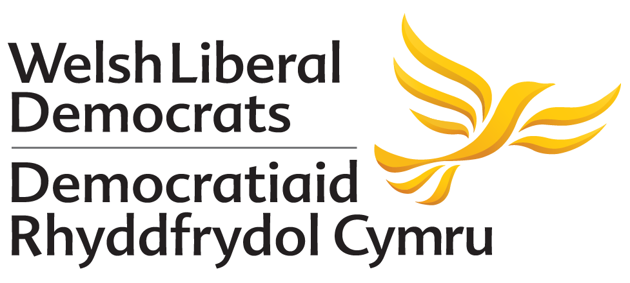

MOTION PROPOSED TO AUTUMN CONFERENCE 2018
THERE ARE EIGHT AMENDMENTS PROPOSED TO THIS MOTION

A More Equal Politics
Proposed by: National Policy Committee

Conference notes:
- The report by the Expert Panel on Assembly Electoral Reform A Parliament that Works for Wales.
- The Women’s Equality Network Wales manifesto Equality for Women and Girls in Wales.
- The obligations set out in Wales’ landmark Future Generations Act to create a more equal Wales.
- That the National Assembly for Wales became the first national legislature to achieve a 50:50 gender balance in 2003, before slipping back to 42% in 2016.
- That only 26% of Councillors in Wales are women and only 18% of council Leaders are women.
- That two councils in Wales have all-white male cabinets.
- The lack of BME women Assembly Members.
- The Welsh Liberal Democrat policy to offer ten hours a week of free childcare to all working parents from the end of paid parental leave (9 months) and for all children aged 2-3.
- The preamble to the Liberal Democrat constitution stating our commitment to “balance the fundamental values of liberty, equality and community” and to dispersing power and fostering diversity.

Conference believes that:
- Equality of opportunity is fundamental to creating a liberal society and that promoting opportunity is central to the values of the Welsh Liberal Democrats.
- Governments and Parliaments are more effective when they include and reflect the voices of every community they seek to represent.
- Creating a more equal Wales must involve promoting all forms of diversity, including race, gender, sexual orientation and disability and efforts to improve diversity must recognise the intersectionality of underprivileged groups.
- Welsh politics should aspire to reflect the diversity of Welsh communities and so inspire the next generation to believe that they can hold public office.

Conference calls for:
- The UK and Welsh Government to determine which Government has power to change electoral law to allow job-sharing candidates to stand for election and to pass the necessary legislation to make this a reality.
- The National Assembly for Wales to lobby the Secretary of State to commence Section 106 of the Equality Act 2010 in relation to Assembly elections so diversity information on all candidates is freely available.
- Welsh Governments to select gender-balanced Cabinets.
- Welsh Government to offer ten hours a week of free childcare to all parents from the end of paid parental leave (9 months).
- Welsh Government to examine the feasibility of creating a more flexible childcare system that gives all parents of children 9 months-4 years a set sum of free childcare they can use when they choose.
- The UK Government and Electoral Commission to ensure childcare is considered a legitimate campaign expense.

Amendment 1
Proposed by: National Policy Committee

After conference notes G insert new point add and renumber subsequent points:
“That only 30% of Welsh Lib Dem constituency candidates and 41% of list seat candidates were women in 2016.”

Amendment 2
Proposed by: National Policy Committee

After conference believes that i insert a new point and renumber subsequent points:
“That unconscious bias and ways in which the definition of merit is gendered hamper our ability to make decisions wholly on the basis of ability. We should therefore take steps to address this.”

Amendment 3
Proposed by: National Policy Committee

After original conference believes that iv insert a new point add and renumber subsequent points:
“That in order to achieve diverse elected chambers which give a voice and agency to all people in Wales, we must take positive action.”

Amendment 4
Proposed by: National Policy Committee

Reword conference calls for 2:
“The National Assembly for Wales to lobby the Secretary of State to commence Section 106 of the Equality Act 2010 in relation to Assembly elections so diversity information on all candidates is collected and freely available.”

Amendment 5
Proposed by: National Policy Committee

Reword conference calls for 3:
“Welsh Governments to select gender-balanced Cabinets and legislate to ensure that Local Authority Cabinets have at least 50% of members from diverse backgrounds. The definition of diverse backgrounds shall include ethnicity, race, socioeconomic status, gender, religion, sexual orientation, disability and trans identities.”

Amendment 6
Proposed by: National Policy Committee

After conference calls for 5 insert new point and renumber subsequent points:
“The Welsh Government to establish a cross-society and cross-industry Social Media Summit tasked with addressing the abuse, trolling, and threats elected members – and others - face on social media platforms.”

Amendment 7
Proposed by: National Policy Committee

At end of conference calls insert a new point:
“The NEC of the Welsh Liberal Democrats to establish a Task and Finish group to bring forward new candidate selection rules to Autumn Conference 2019 which would improve the diversity of Welsh Liberal Democrat candidates and elected members at all levels of government.”

Amendment 8
Proposed by: National Policy Committee

At end of conference calls insert a new point:
“The Welsh Liberal Democrats’ Campaigns and Candidates Committee in preparation for the 2021 Welsh Parliament elections;
- Seeks to ensure that 50% of those shortlisted to be from a group of protected characteristics as defined under the Equality Act; and,
- Immediately introduces the provision to extend the nomination deadlines and require local parties to demonstrate how they have identified and supported those from diverse backgrounds to apply for selection to regional list seat.”

