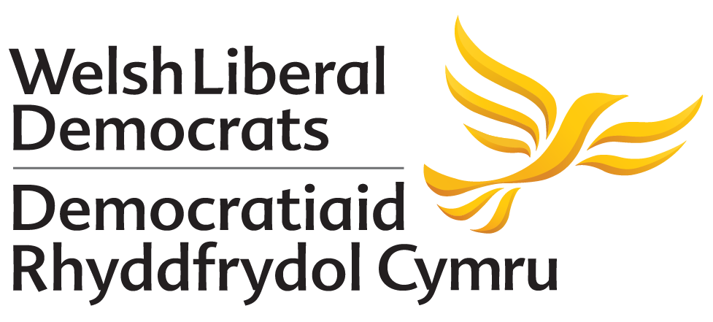

MOTION PROPOSED TO AUTUMN CONFERENCE 2018
NO AMENDMENT HAS BEEN PROPOSED TO THIS MOTION

Citizenship as Part of the National Curriculum for Wales
Proposed by: 20 Party Members

Conference Notes:
- The advent of votes being made statutorily available to all 16-17 year olds brings with it a duty that our society must embrace, that this new cohort of voters are fully equipped with the necessary information and tools to help them make an informed decision on how they will use their vote.
- That at present there are no instruments within the National Curriculum that provide that necessary educational stimulus to engage these young people in the processes of politics so they can make those informed choices.
Conference believes:
- It is becoming increasingly likely that a move towards extending the franchise to 16-17 year olds for the 2022 Local Elections here in Wales is gathering momentum.
- This is now the time to introduce a compulsory citizenship element into the national curriculum that will equip these young people to make informed choices if they wish to exercise their new-found franchise.

Conference calls for:
- The new curriculum for life to include a compulsory element in the curriculum that will help and equip all young people particularly from year 9 upwards to understand how citizenship and elections operate and influence in a democratic society.

