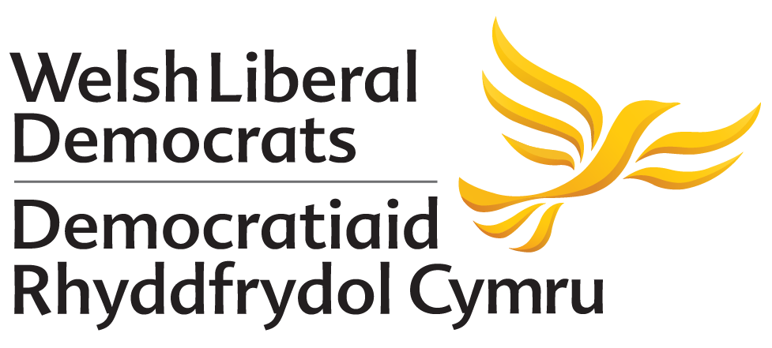

MOTION PROPOSED TO AUTUMN CONFERENCE 2018
NO AMENDMENT HAS BEEN PROPOSED TO THIS MOTION

Dumping Nuclear Waste
Proposed by: 20 Party Members

Conference notes with concern:
- The lack of Welsh Liberal Democrat policy on Nuclear Waste in Wales and previous support for nuclear power.
- The UK and Wales have been given false hope that nuclear energy is clean energy.
- The expense of nuclear energy and unsustainable disposal of waste.
- The UK’s 60-year legacy of nuclear waste.
- The large sums of money the nuclear energy industry is prepared to pay communities without stating the impacts on future generations.
- The threat of de-commissioning reactors and continued growth of the nuclear industry.
- Communities may be subjected to unwanted levels of nuclear and radioactive waste.
- Much of the waste is from England and potentially Northern Ireland.

Conference reaffirms:
- The Welsh Liberal Democrat commitment to: tackling climate change.
- The Welsh Liberal Democrat’s commitment to retaining membership of Euratom.
- Support for the Welsh Government’s targets for 70% of Welsh electricity to be generated by renewable energy by 2030 and for carbon emissions to be reduced by 80% by 2050.
- The need to achieve these targets through renewable energy sources.

Conference calls on Welsh Liberal Democrats to:
- Oppose the dumping of radioactive and nuclear waste on shores or land in Wales.
- Provide leadership in delivering clean energy for generations to come that supports communities and delivers locally.
- Campaign to retain membership of Euratom.
- Reinforce their commitment to protecting nature now and for future generations.

