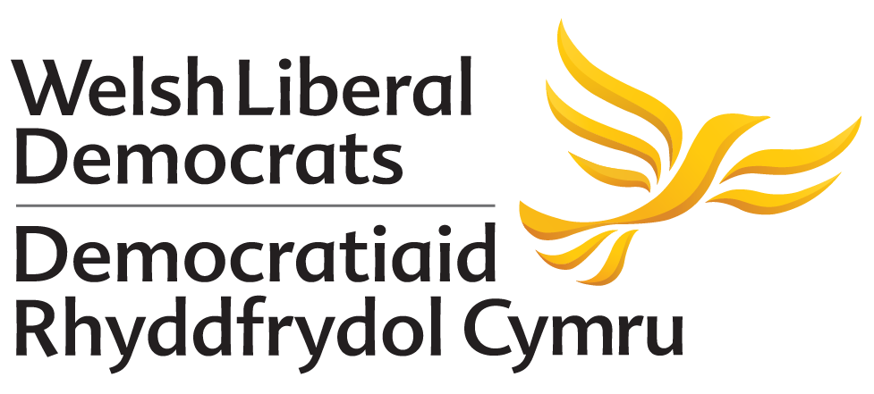

MOTION PROPOSED TO AUTUMN CONFERENCE 2018
NO AMENDMENT HAS BEEN PROPOSED TO THIS MOTION

People’s Vote and an Exit from Brexit
Proposed by: National Policy Committee

Conference recognises that:
- In the June 2016 referendum, voters were not given a choice between two known alternatives but had to decide whether to accept assurances from leading Brexit campaigners or rely on warnings and economic forecasts from the Remain campaign.
- Many of those – often contradictory – assurances given to the people of Wales and the UK as a whole before the referendum in June 2016 have since been shown to be unachievable and some even false at the time of their utterance or display.
- The Welsh economy, consisting of businesses of many types and sizes, including agriculture, manufacturing and financial services, will suffer from leaving the EU on any foreseeable terms.
- The current negotiations between the UK and the EU27 can only produce a ‘framework’ and not a detailed agreement on the future relationship until after 29 March 2019.
- Nevertheless, that ‘deal’, consisting of a withdrawal agreement and the framework, would offer a much clearer choice and enable the people of Wales and the UK as a whole to make a more informed judgement.
- It is normal for a surveyor’s report to enable house buyers to make a final decision, even after embarking on the purchase, so it is logical that such an opportunity be given to voters when so much more affecting their lives is at stake.

Conference calls upon:
- The UK Government and Parliament to offer the British people the final say in a referendum, including an option to stay in the EU, before it is too late to halt the UK’s exit from the EU and to do so irrespective of whether there is an agreement with the EU or a ‘no deal’ situation.
- The Welsh Government to maintain pressure for matters falling within its fields of competence to be devolved to Wales as soon as practicable if Brexit takes place.
- The Welsh Liberal Democrats to intensify our campaign for a ‘People’s Vote’ and ‘an exit from Brexit’, with Britain remaining a full and influential member of the European Union.

