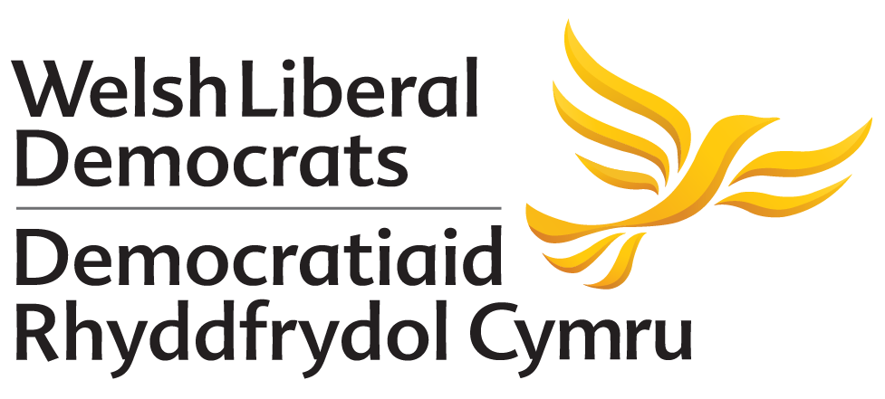

POLICY MOTION SPRING CONFERENCE 2019

Citizenship as Part of the National Curriculum for Wales

Conference Notes:
- The advent of votes being made statutorily available to all 16-17 year olds in local elections brings with it a duty that our society must embrace, that this new cohort of voters are fully equipped with the necessary information and tools to help them make an informed decision on how they will use their vote.
- At present the National Curriculum does not provide the sufficient educational stimulus to engage young people in the processes of politics so they can make those informed choices.
- Welsh Liberal Democrat Education Minister Kirsty Williams is in the process of establishing a new curriculum that will be taught in all maintained settings and schools from 2022.
Conference believes:
- It is becoming increasingly likely that a move towards extending the franchise to 16-17 year olds for elections here in Wales is gathering momentum.
- It is essential that all young people are educated to understand and exercise their human and democratic responsibilities and rights.
- Developing a new transformational curriculum will be crucial in realising our vision for young people to become ethical, informed citizens who are ready to play an active role in our democracy.

Conference calls for:
- One of the central purposes of the new curriculum must be to ensure young people leave education as ethical and well-informed citizens.
- Citizenship forming a key part of the new curriculum that all children must learn.
- A duty to be placed on schools to deliver a curriculum that equips all young people to understand how citizenship and elections operate in a democratic society.

