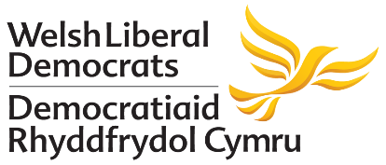
Conference Timetable: Ballroom (Main Hall)
Saturday:
10:35am – Opening of Conference: Kishan Devani, PPC for Montgomeryshire
10:45am – Party Accountability Session: Q&A with Committee Chairs & Representatives
11:15pm – Motion: Ending LGBTQ+ Youth Homelessness in Wales
11:55pm – Motion: Creating a less lonely Wales
12:25pm – Lunch
1:20pm – Speech: Bablin Molik, PPC for Cardiff Central
1:30pm – Motion: Saving the Welsh High Street
2:10pm – Motion: Dyfodol i’r Gymraeg - Welsh Language Education for all
2:50pm – Speech: Mark Williams, PPC for Ceredigion
3:00pm – Break
3:15pm – Kirsty Q&A
4:00pm – Speech: Angela Smith, MP for Penistone and Stocksbridge
4:10pm – General Election Campaigning Q&A (Members Only)
5:10pm – Conference Awards & Appeal
5:20pm – Speech: Jane Dodds, Leader of the Welsh Liberal Democrats and MP for Brecon & Radnorshire
8:00pm – Conference Dinner with Layla Moran, MP for Oxford West and Abingdon

Sunday:
10:45am – Federal Presidential Hustings
12pm - Update on the new Disciplinary Process
12:45pm – Lunch
1:25pm - Emergency Motion
1:45pm – Motion: Unite to Remain
3:55pm – Close of Conference
Conference Timetable: Usk Suite
Saturday:
11:15am – Training Session: Start Your Fundraising Training
1:25pm – Training Session: Producing Effective Literature
2:20pm – Training Session: Your Election (Candidates Only)
5:35pm – CCC Meeting

Sunday:
9am – NEC Meeting
4pm – F&MC Meeting

Conference Timetable: Additional Sessions/Events
Sunday:
7:30am - Liberal Democrat Christian Forum Prayer Meeting
(Held at Chapel of St Keynes inside Brecon Cathedral, LD3 9DP)

