Becoming a Liberal Democrat Candidate

Please note: if you require this document in an alternative format, such as large print or on coloured paper, please contact the LDHQ Candidates team on candidates@libdems.org.uk.

Introduction

Welcome to the Liberal Democrat approvals process. As a party, we are always delighted to welcome new candidates.

Becoming a parliamentary candidate and fighting an election as a representative of the Party can be a fantastic and often life-changing experience. As a candidate, you will have the chance to make a real difference to your local area and to stand up for local people. The role is one of variety - one day you may be dealing with a local resident’s problem, the next giving your opinion on national Party policy.

We hope that this document will provide you with a helpful overview of how the approvals process works. If you have any questions or if we can be of any assistance at all, please do not hesitate to contact us.

Contents

Introduction 1

Contents 1

Pathway to becoming a parliamentary candidate 3

The Approval Process 4

1. Self-Assessment, training and gaining experience 5

2. Application 5

3. Assessment 6

The Selection Process 7

Candidates for the Scottish Parliament 8

Candidates for the Welsh Assembly 8

Candidates for the European Elections 8

1. State Parties and Candidate Committees 9

2. State and Regional Candidates’ Chairs 9

3. The Candidates’ Office 10

Contacts 13

Self-assessment questionnaire 15

Pathway to becoming a parliamentary candidate

Request an application pack from the Candidates’ Office: candidates@libdems.org.uk
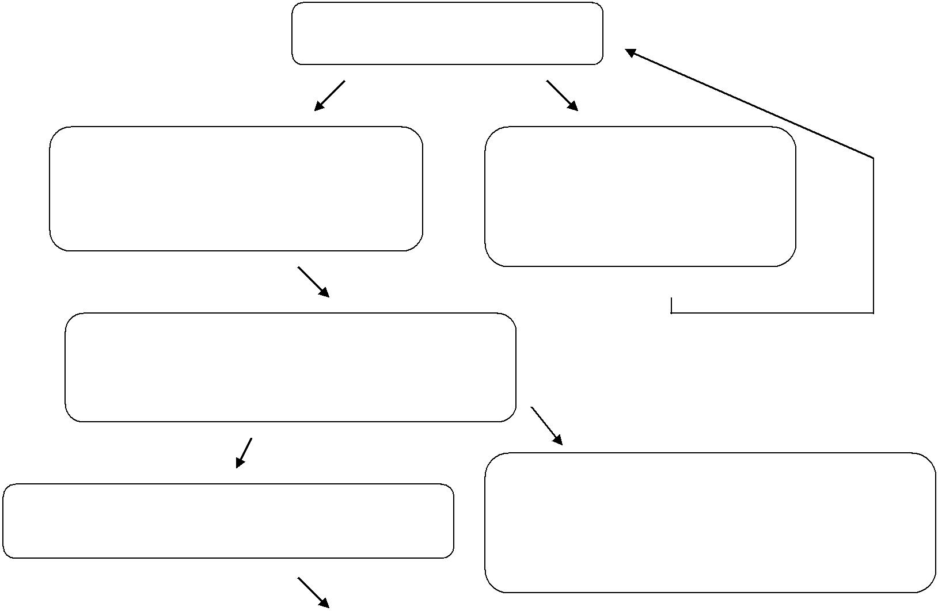

Read Competency Framework and undertake self-assessment

If you feel ready to apply complete and return the application pack and also undertake any training you feel will help you

Your form and references will be checked and if everything is in order you will be invited to attend an Assessment Centre once a place becomes available

If you pass the Assessment Centre your name will be added to the list of approved candidates

If you do not feel ready to apply undertake all relevant available training. Contact candidates@libdems.org.uk for more information

If you do not pass the Assessment Centre you will be given constructive feedback and advice about training and areas of improvement. In most cases you will be invited to attend another Assessment Centre after 12 months

Check the Members’ section of the

Federal Website for selection adverts

For constituency selections, apply and go through the Local Party Selection Process

If the Local Party selects you then you will then be the candidate there for the next election

For elections that use regional or top-up lists, apply and go through the list Selection Process

If you are selected onto the list you will be part of the Party’s campaign team for the next election

The Approval Process

The Party’s approvals process is designed to ensure clarity and transparency. The process is based upon a Competency Framework. This clearly expresses the Party’s view as to the abilities and qualities that a parliamentary candidate should possess. The six competencies that have been identified are:

- Communication Skills
- Leadership
- Strategic Thinking and Judgement Representing People
- Resilience
- Values in Action

The competency framework is available to members of the Party to study prior to assessment and is included in the candidate application pack. It also provides details of the behaviour through which a person can show whether or not they have the necessary skills.

The rest of this document outlines, in more detail, the steps involved in the process, as well as providing a glossary of key terms and useful contact information. After reading this document, if you decide that you would like to start the approvals process, then contact us at candidates@libdems.org.uk to request an application pack.

Please note: We are absolutely committed to making the approvals process accessible to all applicants. Please let us know of any access requirements as soon as possible so we can make reasonable adjustments.

1. Self-Assessment, training and gaining experience

We would strongly recommend that, as a first step, you complete the self-assessment questionnaire included at the end of this document. This will allow you to judge how ready you are to go through the approvals process.

If there are any areas in which you feel you would benefit from further training, or gaining practical experience before proceeding, contact the Candidates’ Office for recommendations on how to gain this. Some useful resources can also be found on the party’s online training portal here.

2. Application

Once you feel satisfied with your answers to the self-assessment questionnaire, you should request an application pack from the Candidates Office and complete the application form.

The application forms are very straightforward. They are used to ensure that you are who you say you are and that you are eligible to stand for Parliament. The application form does not form part of the assessment nor is seen by the assessors.

Each candidate is charged £50 towards the cost of their assessment day. If the cost would present you with any difficulties in attending the day, please contact the Candidates’ Office and we will be very happy to help.

We just ask you for the following information:

- Your contact details
- Some basic background information
- Social Media presence/history
- The contact details of three referees, one of which must be a Party member
- A signed declaration and code of conduct form

The completed forms should be sent to the Candidates’ Office who will pass them onto your Regional (or State) Candidates’ Chair (RCC).

The RCC will undertake a ‘Google’ search on your name – please note this is in order that we can discuss with you any potential issues, it does not mean that, if you raise any issues, you will not be able to proceed with approval.

3. Assessment

Once you have returned the completed application form you will be added to the list of people waiting for an assessment day (sometimes called ‘assessment centre’). As long as you have been a party member for 12 consecutive months in England and Wales and 9 consecutive months in Scotland and as long as there are no problems with your application, we will invite you to attend an assessment centre as soon as there is a space available.

Assessment centres take place across the country on a regular basis. Our target is that all eligible applicants will be offered a place at an assessment centre within six months of handing in their forms.

The assessment centre is based on the competency framework. This sets out the things we would expect a parliamentary candidate to do, and those things that a good candidate would probably not do. The assessment team does not see the information on your application form; they will base their assessment purely upon your performance during the assessment centre.

At the assessment centre, you will take part in a variety of exercises designed to allow you to show the assessors how you would perform as a parliamentary candidate. Information about these exercises will be sent to you once you have returned your application forms to give you time to prepare.

Key points to note:

- The exercises are designed so that there is no “right” or “wrong” way to complete them

- Several different assessors will mark you throughout the assessment centre. Assessors will be required to show evidence of things that you have said and done on the day to support the grade that you are given at the end of the day.

- You will be tested on relevant Party Policy questions, the contents of which would vary depending on whether you are being assessed to run in England, Scotland or Wales, or for Europe.

- If you successfully pass the assessment you will be approved immediately as a candidate. If you are not successfully approved on the assessment day you will receive helpful feedback and be eligible to reapply in either 1 or 5 years, depending on your final mark.

The Selection Process

Once you are an approved candidate and your name has been added to the Approved List, you are then free to put yourself forward for selection in any seat that advertises for a parliamentary candidate.

These adverts are published on a Friday on the Members’ section of the Federal website and are accompanied with an email notifying all approved candidates that the selection process for the seat has now begun.

The selection process typically has a number of steps:

- Application

Contact the Returning Officer (RO) whose details will be in the advert, who will send you an application for. Complete the application form and return it by the given deadline.

- Short-listing

The Local Party Selection Committee will then shortlist the applicants for the next stage. Sometimes this will require you to attend a short-listing interview.

3. Campaign and Hustings

If you are successfully short-listed, there is typically a period of three weeks during which you can campaign among local party members to persuade them of your case to be the candidate. At the end of the campaign, there will be a hustings meeting at which point the Local Party members will vote for who they want to represent them at the next General Election.

If the Local Party selects you, then you will fight the next General Election for that seat. If you are not short-listed, or not selected, it is important not to be discouraged but to ensure you request feedback that you can learn from for the future.

Candidates for the Scottish Parliament

There are 129 seats in the Scottish Parliament which are split between two types:

- 73 constituency-based seats elected by ‘first past the post’

- 57 regional seats based on the boundaries of multiple constituency seats, elected using the d’Hondt, or closed party list, method.

To stand in Scotland, candidates must have completed an assessment centre and also have successfully completed the Scottish policy assessment. The selections for different seat types are conducted such that the constituency seats follow the process outlined for a General Election Westminster seat, and the regional seats follow the process for a European Election.

Candidates for the Welsh Assembly

The 60 seats in the National Assembly for Wales are split between two types:

- 40 constituency constituency-based seats elected by ‘first past the post’
- 20 regional seats (4 in each of 5 regions) that are elected using the d'Hondt, or closed party list, method.

In order to be a candidate in Wales at either Assembly or Westminster elections, candidates must have completed an assessment centre and also have successfully completed the Welsh policy assessment. The selection for constituency seats takes place on a per constituency basis. The selection for regional list seats is done by a one-member one-vote system across each region.

Candidates for the European Election

European elections operate on the d’Hondt system of voting, which requires each party to have Euro-Regional list of candidates, ranked in order of preference. You can apply for selection in as many regions as you want but may only be included on one final list. To qualify for inclusion on the Lib Dem list, candidates must complete the relevant sections of the exercises on the assessment day.

Who’s who in approval and selection?

1. State Parties and Candidate Committees

The approval and selection of Parliamentary Candidates is the constitutional responsibility of each of the three Federal State Parties of England, Scotland and Wales. Each State has an elected Candidates Committee, which takes the decisions and sets the policies that govern the processes of the approval, selection and review of their Parliamentary Candidates. In England, this is undertaken by the English Candidates Committee (ECC); in Scotland, the Scottish Campaigns and Candidates Committee (SC&C); and in Wales, the Welsh Candidates & Campaigns Committee (WCC).

2. State and Regional Candidates’ Chairs

Each of these State Candidate Committees has an elected Chair who represents the Committee on a variety of bodies including the Joint States Candidates Committee (JSCC).

In England, each English region also has a Regional Candidates’ Chair (RCC), who is responsible for organising assessment centres, appointing Returning Officers, and providing advice and support to members going through the approvals and selection processes.

The full list and contact information for States and Regional Candidates’ Chairs can be found in the Contacts section below.

3. The Candidates’ Office

The staff in the Candidates’ Office, based at the Lib Dem headquarters in Westminster, are responsible for the day-to-day administration of the approvals process for the English, Scottish and Welsh Parties. They act as the first port of call for any general enquiry about standing as a Parliamentary Candidate, and can provide advice on the best person to speak with at a regional or state level if you have a more specific query.

Their responsibilities include sending out application forms, processing returned applications (including sending information about new applicants to Candidates’

Chairs) and providing support and advice to members going through the approvals and selection processes. They are also responsible for providing support and advice to the elected committees and Chairs.

Mentoring & support for Prospective Candidates

Almost no one at the start of their journey to become a candidate is likely to have all the relevant skills at the outset, or a full understanding of the steps in involved in the process to become a Liberal Democrat candidate. That’s why there are many options to access advice, support, mentorship and training at various stages in the process to becoming a candidate.

For an overview of the advice and mentoring options available, please click here to access the ‘Advice & Mentoring for Prospective Candidates’ document.

For information about training that might be able to help you with key competencies, contact the candidates’ office at candidates@libdems.org.uk.

The Liberal Democrats are particularly committed to increasing diversity throughout the party, and encouraging those from a diverse range of backgrounds to represent the Liberal Democrats at all levels. The Diversity, Candidates and Talent Support team at HQ can facilitate access to additional mentoring and support to potential Parliamentary candidates from under-represented groups. If you are interested in

receiving additional support to prepare for your assessment day, please get in touch at diversity@libdems.org.uk.

Other organisations that may be able to offer help, advice or training are:

PCA – Parliamentary Candidates’ Association www.parliamentary.org.uk

LDW – Liberal Democrat Women www.libdemwomen.org.uk/

LDDA – Liberal Democrat Disability Association www.disabilitylibdems.org.uk

LDCRE – Liberal Democrat Campaign for Race Equality
https://ldcre.org.uk/en/

LGBT+ - Liberal Democrats for Lesbian, Gay, Bisexual and Transgender Equality http://lgbt.libdems.org.uk/en

Glossary of Terms

Here are some common ‘jargon, terms and acronyms that you may hear people using about approval and selection:

PPC - Prospective Parliamentary Candidate - the person who will fight the seat for the Party at the next General Election

PSPC – Prospective Scottish Parliamentary Candidate

PAC – Prospective Assembly Candidate (Welsh Assembly)

PEPC - Prospective European Parliamentary Candidate

RO – Returning Officer - the person appointed by the region or state to make sure a selection is run fairly and according to the rules

ECC - English Candidates’ Committee - oversees the approval and selection of Candidates in England

SCC or C&C – Scottish Campaigns and Candidates’ Committee - oversees the approval and selection of Candidates in Scotland

WCC or CCC – Welsh Candidates’ and Campaigns Committee - oversees the approval and selection of Candidates in Wales

JSCC – Joint States’ Candidates’ Committee - co-ordinates the maintenance of standards in the approval and selection across all 3 States

RCC - Regional Candidates’ Chair - a member of the Regional Executive who has responsibility for approval and selection in that region. They also provide support and help to candidates throughout the approval and selection processes

Contacts

Diversity, Candidates & Talent Support Richard Kember, Natalie Chindipha, Naomi Farhi

8-10 Great George Street, London, SW1P 3AE candidates@libdems.org.uk

020 7340 4993 / 020 7340 4959

Candidate Chair Contacts 2020
State Chairs
Name | State | Email | Number
Prue Bray | England | prue@brayjc.plus.com
Alan Reid | Scotland | reidalan95@gmail.com
Julian Tandy | Wales

English Regional Candidates Chairs
Name | Region | Email | Number
Brian Orrell | London | brian.orrell@libdems.org.uk | 07876 507759
Iain MacDonald | Devon and Cornwall | info@wildword.co.uk | 07770 773 289
Neil Halsall | Western Counties | neil.ppcselections@gmail.com
Bruce Hubbard | North West | brucelhubbard@hotmail.com | 07982 216 990
Ian Jones | North East | igljones@live.co.uk | 01642 821220
Penny Robinson | Yorkshire and Humber | penny.rcc@gmail.com | 07854 753 207
Dawn Davidson | South East | dawn.davidson7@ntlworld.com
Stephen Lambert | South Central | stevenmlambert@outlook.com | 07884 428 833
Paul Clark | East of England | paul.hitchin7@gmail.com | 07778 743666
Jock Gallagher | West Midlands | jyg@cix.co.uk
Tad Jones | East Midlands | tadeuszjones@hotmail.com | 07815 496 917
Val Jay | (Vice-RCC) North West | jayvalerie68@gmail.com

Self-assessment questionnaire

This short questionnaire is designed to help you decide whether you are ready to submit an application for assessment. As the assessment centre is pass/fail, it is important that you make sure you are fully prepared and are applying at the right time for you.

Read this questionnaire to help you decide whether you would benefit from further training or development before attending the assessment centre, particularly if you have been a member for less than 12 months in England and Wales or 9 months in Scotland and so are not yet eligible to be assessed.

Policy and Values

Y / N
Do you feel you are in broad agreement with current party policy? Can you communicate Lib Dem policy clearly and persuasively?
Y / N
Y / N

Can you show how your Lib Dem values and beliefs affect the way you live your life?

Building skills in this area

The Policy area of the Party website contains briefings covering key policy areas. You can learn more about how policy is formed and keep up to date with new developments as well as through attending regional and federal conference.

Communication skills

Y / N
Are you able to use different styles of communication for different audiences and occasions?
Y / N
Do you enjoy talking to people and addressing their concerns? Do you look for opportunities to tell people about what the Lib Dems are doing for them?

Building skills in this area

There is Party training available in this area please contact us for details of what is coming up in the near future. Many people are nervous about things like public speaking, and training can be of great benefit in building skills and confidence.

Media

Y / N
Do you feel able to communicate appropriately with journalists? Are you able to think on your feet and respond quickly and appropriately to questions on topical matters?
Y / N
Do you make the most of media opportunities in order to maximise

Party profile?

Building skills in this area

There is Party training available in this area – please contact us for details of what is coming up in the near future. In addition, watching or listening to politicians being interviewed can be very helpful – both to pick up tips and to see what to avoid!

>>>> Next page for Campaigning info>>>>>
Campaigning

Do you have recent experience of participating in an election |  | Y / N
 | campaign?
 | Do you have the ability to see how national issues can be linked with | Y / N
 | areas of local concern?
 | Can you show that you are organised and able to plan ahead? | Y / N

Building skills in this area

The Campaigns department run training at regional and federal conferences to help you keep up to date with new techniques and advice. Council by-elections are also a great way to get some campaigning experience all year round – you can find out what’s happening near you on the federal website at www.libdems.org.uk/events or on the Flock Together website.

Inter-personal skills

Do you take the time to understand other people’s views and needs? Y / N

 | Are you able to deal effectively with conflict and opposition? | Y / N
 | Do you make an effort to be friendly and approachable when meeting | Y / N
 | new people?

Building skills in this area

There is Party training available in this area – please contact us for details of what is coming up in the near future.

Leadership

Do you have experience of leading a group of people? Y / N
Y / N
Are you able to inspire and motivate people to keep going, even when things are getting difficult?
Y / N

Are you able to listen to and take account of a diverse range of views and opinions?

Building skills in this area

Look out for areas where you can gain experience of leading a group of people both in your professional and personal life.

This questionnaire is designed as an aid to deciding when to apply for approval, and there is no recommended number of questions to which you should answer, “Yes”. If, however, you find that you have answered “No” to more than one question in any category, we would strongly advise you to undertake further development in that area becoming to assessment.

You can contact your Candidates’ Chair (please see the sheet of contact details above) for details of help available in your region or state, and the Candidates’ Office, on candidates@libdems.org.uk, for details of training at conference and across the country.

