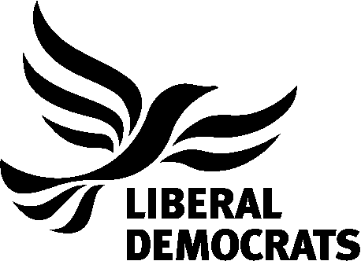
Godalming and District Liberal Democrats

-----------------------------------------

Quiz Night Booking Form

3rd March 2017 – 7.30pm

Name(s): ……………………………………….

Email: ………………………………………. Telephone: …………………………………………..

I would like to reserve …… ticket(s) at a cost of £10 per ticket.

Total Payment: £……

I will be paying: By Bank Transfer By Cheque In Cash*

Please make Cheques payable to GODALMING LIBERAL DEMOCRATS and send cheques to:

Paul Follows - Flat 30 Weirview Place, Cattershall Lane, Godalming, GU7 1DE.

For Bank Transfer Please Use: NATWEST - Sort Code - 60-09-04 and Account No. 00732109 and state the reference [YOUR NAME + QUIZ]

For all returned forms, any queries or if you wish to pay in cash please speak to the Treasurer or email LDGod_Treasury@outlook.com

