Please think about a woman you can nominate!

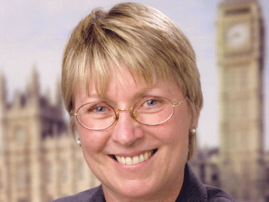
PATSY CALTON AWARD NOMINATION FORM 2019

My Nominee for local activist /Councillor/ MP/MSP/AM/MEP
(please delete as appropriate. You may nominate in any or all of the above categories)
.
Her Name: ___________________________________________________
Address: ___________________________________________________
Constituency: ___________________________________________________

My Name: ___________________________________________________
Address: ___________________________________________________

Email and/or phone no: _________________________________________________

In May 2005 when we won 62 parliamentary seats, 10 were held by women. Still a very poor proportion but progress had been made. Sadly on 29th May 2005 not long after re-election Patsy died. Patsy’s record of achievement is an inspiration to us all and we hope these annual awards for a female local activist, Councillor or MP/AM/MSP/MEP, will not only celebrate achievements by women but also encourage more women to participate in political processes at all levels.
The winner will be chosen by a panel from a shortlist and the award presented in Bournemouth at the Autumn Federal Conference in September 2019.

Please enclose ONE OTHER SIDE OF A4 ONLY explaining why you feel your nominee deserves the Patsy Calton Award. You are welcome to ask other people to sign the sheet to show their support if you wish. The judges will be looking for:

- Activity in the party at any level plus any positions held
- Inspirational qualities and motivation of others
- Any outstanding achievements, such as successful campaigning, fundraising, recruitment, contribution to policy formation etc
Please return this form to LDW by Monday 24th June by email: to: flo.clucas@btinternet.com

