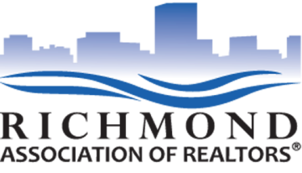
FOR IMMEDIATE RELEASE
June 16, 2015
FOR MORE INFORMATION, CONTACT:
Elizabeth Hancock Greenfield
Director of Government Affairs
(804) 422-5023
Richmond REALTORS® Political Action Committee Endorses
Chis Winslow and Leslie Haley for Chesterfield Board of Supervisors
Richmond, Va. – The Richmond Association of REALTORS® Political Action Committee has endorsed Christopher Winslow (Clover Hill District) and Leslie Haley (Midlothian District) in their campaigns for the two open seats on the Chesterfield Board of Supervisors.
Both candidates possess an in depth understanding of critical issues in their respective districts. Mr. Winslow’s position on school and community revitalization align closely with REALTORS®’ interest in maintaining a high quality of life in Chesterfield. Ms. Haley’s intersectional approach to economic development and the economic health of the county resonated strongly with RPAC trustees.
Mary K. McDonald, chairwoman of the trustees, stated “The trustees were impressed by both candidates’ attention to detail in their plans for the county and for their magisterial districts. Ms. Haley and Mr. Winslow have a firm grasp on REALTOR® issues and we look forward to working with both of them.”
The Richmond Association of REALTORS® represents over 4,000 members who live and work in the Richmond metropolitan area.
###

