Overview
NATIONAL LGBTI HEALTH ALLIANCE | 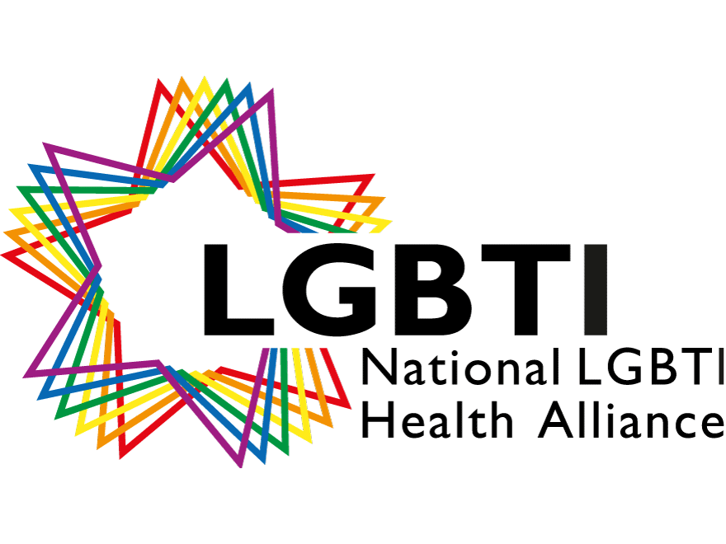
Date 13 October 2020
Prepared By: Zed Tintor
Expression of Interest: LGBTIQ+ Lived Experience Consultation
The National Suicide Prevention Taskforce has partnered with the Expert Advisory Group and the Suicide Prevention Research Fund to commission research that will help to build a better understanding about the lived experience of suicide in Australia to inform recommendations to government.

The LGBTIQ+ communities are identified as a population requiring a specific approach in the consultation process for this research. As such, the National LGBTI Health Alliance (the Alliance) has been commissioned by the NSP Taskforce to undertake this research area.

To support this important research the National LGBTI Health Alliance would like to interview six LGBTIQ+ people with lived experience of attempted suicide or experience of a suicidal crisis.

How will the consultation be conducted?
The Alliance has engaged Dragan Wright to interview participants. Dragan Wright is a qualified psychotherapist and counsellor specialising in complex trauma, trauma informed care and gender diversity. Please see website link below:
https://draganzanwright.com/
Dragan will conduct individual interviews with participants online via Zoom. It is expected the interview will be up to one hour.
A final report will be produced outlining the consultation process, areas of discussion and recommendations - the report will be used to inform future resource planning.

What questions will be asked?
The consultation aims to build a better understanding about the lived experience of suicide in Australia. This research will inform future funding priorities to the federal government.
The three topic areas will explore the following:
- What do people who have attempted suicide and/or people who have experienced a suicidal crisis believe were the most significant contributing factors to their suicide attempt or crisis?
- What were their experiences with a range of services in the lead up to, or during and following their suicide attempt?
- What services or which people were especially unhelpful or helpful with regard to the suicidal state that they experienced?

Remuneration
Participants will receive a payment of $90.00 for their participation.
In recognition of the sensitive nature of the content and the potential need for post interview support, participants will have access to a one-off follow up counselling session with their chosen practitioner. The Alliance will cover up-to $150.00 for the session.

Confidentiality
To protect the privacy and confidentiality of all participants, only pseudonyms will be used in the report.

When will the project commence?
The project will commence on 21 October 2020 and conclude 30 November 2020.

How do I express my interest to participate?
To express your interest please complete the attached form and return to Charlie Willbridge, MindOUT Coordinator Charlie.willbridge@lgbtihealth.org.au by 23 October 2020.

