REPORTS TO CONFERENCE
AUTUMN 2016

Table of Contents
Federal Conference Committee 2
Federal Policy Committee 9
Federal Executive 15
Leadership Election Regulations 22
Presidential Election Regulations 30
Committee Election Regulations 38
Federal Finance & Administration Committee 45
Federal Party Accounts 54
The Liberal Democrats Limited 79
Parliamentary Party Report (Commons) 82
Parliamentary Party Report (Lords) 87
Parliamentary Party Report (Europe) 92
Diversity Engagement Group 96
Campaign for Gender Balance 101
Federal Appeals Panel 103

Federal Conference Committee
York 2016
This spring we went back to York. In previous years it proved to be a popular venue and this time was no different, it received excellent feedback. A good percentage of attendees completed the online questionnaire which is sent to all members who register for conference. This document is incredibly useful to the conference office and FCC and I would urge all members to take the time to complete it.
80% of respondents rated the venue as good (33%) or excellent (47%). York continues to be one of our most popular venues. We will continue to monitor and put pressure on the venue in areas where negative feedback is received with a view to improving the experience for attendees.
FCC continues to keep a close eye on the number of debates on the agenda against non-debate items such as speeches and Q&A items. Feedback from York showed 89% of people believed the balance was about right. This is one of the highest ratings that has bene received in recent years. Getting the balance right is always difficult and we will continue to monitor the feedback received from attendees.
We are continuing to develop the conference App. 90% of those that returned the questionnaire used the App and of those that used it 80% rated it four or five (out of five) compared. This is a considerable increase on previous conferences. FCC want to continue to develop ways to make this even better and more useful.
Brighton 2016
This autumn we have returned to Brighton.
FCC is very mindful of the cost of attending conference. The cost of coming to conference as well as the overall length is often raised in feedback from members. As well as keeping registrations rates as low as possible to members, launching the conference access fund and negotiating discounts on travel costs we have been looking at the length of the autumn conference. The main costs of attending conference, for most people, is having to take time off work and the cost of accommodation. Many members are not able to take the time off work. There is also increasing pressure on all political parties to reduce the length of all political conferences to minimise the impact on parliamentary time.
With this in mind we have looked at ways of making full use of the Saturday to help those who can only come for a weekend as well as reducing the length of conference to try and keep down accommodation costs, while maintaining the amount of time available for 'member led policy motions'. Though conference does remain an income generator, we have also looked at ways of reducing the cost of conference to the Federal Party.
The autumn conference in Brighton this year will start at 9.00 am on Saturday morning. This will be the start of conference proper and the consultations sessions will be run as part of a longer fringe meeting slot. We will finish at approximately 3.30pm on Tuesday. This means we will have the same amount of time for member initiated motions. Many members will still use the opportunity to enjoy an extra day or two in Brighton but it is hoped the revised timing will save some members money and also enable more members to come to conference. It will also mean that those who just can come for a weekend get a full day on the Saturday.
We will be trialling this change for this conference and will consult with people as to how they felt it worked before deciding whether to do it again in 2017. Please do let us know what you think.
Motions
As always, every item on the agenda is still open to amendment. The deadline for submitting amendments – and also emergency motions and questions to reports – is 13.00 on Monday 5th September.
We continue to provide a drafting advisory service, and I would encourage all emergency motion and amendment submitters to make use of it – those who have used it in the past have had a much higher chance of having theirs accepted. The deadline for the advisory service for amendments and emergency motions is 13.00 on Monday 22nd August, please do use the service; drafts should be sent to motionsadvice@libdems.org.uk.
Agenda
This conference is the first conference since the EU referendum, sees us looking are reforming the governance of the party following extensive consultation by the Federal Executive and sees the Federal Policy Committee continue with its Agenda 2020 process. We have a number of interesting policy papers from the Policy Committee as well as a range of interesting motions on a wide range of issues. There will also be the opportunity to participate in a Q&A with the leader as well as question the various Party committees as to what they have been doing.
Given the fast moving position over ‘Brexit’ FCC has reserved a slot on the agenda for a motion on Europe. We have exercised our discretion to allow a later deadline for the submissions of motions on this topic in light of the referendum result. The deadline for submission is 13.00, Monday 5th September. The motion selected for debate will be printed in Conference Extra. The deadline for submission of amendments to this motion will be 17.00 on Thursday 15th September. Amendments selected for debate will be printed in Saturday's Conference Daily.
Once again it looks like we have a record number of first time attendees at conference this time. We have organised a full programme to help them understand how conference (and the wider party) works. We hope they find this useful and that they receive a warm welcome from those who have attended conference for many years, ensuring that come back again and again.
Spring 2017
Next spring we return to York for our spring conference from 17th to 19th March 2017.
Stewards
As always, conference can only take place due to the massive contribution and efforts of the volunteer stewarding team, who look after the exhibition, fringe, information desk, stage and auditorium, and ensure that we all get the most out of conference.
Federal Conference Committee
FCC members are here to help you make the most of conference – do feel free to ask us any questions you may have relating to the agenda and how to speak in debates. You can identify us by the badges we wear, with ‘FCC’ prominently displayed; there are also pictures of us (although looking at some of the photos it may be difficult to see the true likeness!) at the front of the Agenda.
FCC members are assigned to state and English regional parties, and SAOs. The idea is that they provide advice and assistance on submitting motions and when requested attend conferences to answer your questions. See the contact details at the end of this report, and don’t hesitate to get in touch with the relevant FCC member.
Thanks
The vast bulk of the hard work of organising conference throughout the year falls on the professional staff in the Conference Office at HQ: Sian Waddington and her team - Emma Price, Aisha Zeina and Chiara Gandini. I would also like to express my grateful thanks to all the others who make conference possible: to all my colleagues on the Conference Committee; to all the staff at HQ, in particular the Policy Team, led by Christian Moon, who process the motions and prepare much of the agenda material; and of course to the stewards’ team.
Two long standing members, Gareth Epps and Sandra Gidley, of FCC have stood down. They have been replaced by Joe Otten and Cara Jenkinson. My thanks go to both Gareth and Sandra for all their hard work over the years.
Conference is a fantastic event to be involved in and I’m proud to chair your FCC. I look forward to seeing you in Brighton.
Andrew Wiseman
Chair, Federal Conference Committee
August 2016
Regional and SAO reps 2016
Region | FCC Rep | Email
Devon & Cornwall | Justine McGuiness | mcguinness.jez@gmail.com
East of England | Zoe O'Connell | zoe@complicity.co.uk
East Midlands | Paul Tilsley | paul@ptilsley.freeserve.co.uk
London | Chris Maines | cmaines@cix.co.uk
Northern | Andrew Wiseman | andrewdwiseman@gmail.com
North West | Andrew Wiseman | andrewdwiseman@gmail.com
South Central | Andrew Wiseman | andrewdwiseman@gmail.com
South East | Andrew Wiseman | andrewdwiseman@gmail.com
West Midlands | Liz Lynne | liz_lynne@yahoo.co.uk
Western Counties | Justine McGuiness | mcguinness.jez@gmail.com
Yorkshire & the Humber | Andrew Wiseman | andrewdwiseman@gmail.com

The FCC has also appointed representatives to Party SAOs:
SAO | FCC Rep | Email
ALDES | Liz Lynne | liz_lynne@yahoo.co.uk
ALDC | Paul Tilsley | paul@ptilsley.freeserve.co.uk
LGBT+ | Zoe O'Connell | zoe@complicity.co.uk
WLD | Shas Sheehan | shas.sheehan@btinternet.com
Liberal Youth | Jon Ball | jonball@cix.co.uk
PCA | Liz Lynne | liz_lynne@yahoo.co.uk
Liberal Democrat Lawyers | Geoff Payne | geoff@geoffpayne.org
EMLD | Andrew Wiseman | andrewdwiseman@gmail.com

Federal Policy Committee
The Federal Policy Committee is responsible for researching and developing policy and overseeing the Federal Party’s policy-making process. This includes producing policy papers for debate at conference, and drawing up (in consultation with the parliamentary party) the Federal election manifestos for Westminster and European elections.
The FPC has 29 voting members: the Party Leader, four other MPs, the Party President, one peer, one MEP, three councillors, three state party reps and fifteen members directly elected by conference reps. It must be chaired by an MP, and is currently chaired by the Leader.

Committee Issues
As this will be the last FPC report from the 2014-16 Committee, I would like to take the opportunity to thank all the members of the Committee for the effort they have put in, in most cases on an entirely voluntary basis. FPC is always a hardworking committee, but especially so during the general election run-up.
Particular thanks are due to Duncan Brack, Julie Smith, and Norman Lamb for their support as Vice-Chairs of FPC – they have been a tremendous support to me as Chair. I would also like to record the FPC’s thanks to Gareth Epps for his work on the committee over many years, in particular as Chair of our Policy Equalities Impact Assessment Group. Gareth has stepped down for work reasons, and is replaced for the remainder of the current FPC by Antony Hook.
Agenda 2020
The Opportunity to Succeed, The Power to Change, which is presented for debate at Brighton, is the final outcome of the Agenda 2020 policy review that the FPC has been conducting over the last year since the 2015 election. A preliminary consultation paper and a collection of essays were published last summer, and discussed at consultative sessions at the Bournemouth Conference. A second, much fuller consultation paper was published before the York Conference. We also held a very popular essay competition linked to Agenda 2020 which was won by Edwin Burrows.
The Opportunity to Succeed, The Power to Change aims to describe the Liberal Democrats’ core beliefs, values and approach, to examine the challenges that the UK is likely to face and the government will need to respond to over the next five years, and to apply our approach to these challenges to produce priorities for policy development for the party throughout the remainder of this Parliament. The disastrous result of the referendum on the UK’s membership of the European Union on 23 June adds extra urgency to this process.
The paper includes proposals to publish a series of policy papers in priority areas for policy development. We have decided to set up new policy working groups to tackle four of the priority areas immediately, in order to be able to complete their reviews by Autumn 2017. Details are set out in the next section.
FPC Work Programme
In addition to the work on Agenda 2020, since the last conference working groups appointed by the FPC have produced policy papers on Liberty and Security and Social Security which will each be debated at Brighton, and consultation papers on Sex Work and Nuclear Weapons, which will be the subjects of consultative sessions.
FPC has also decided to establish four new policy working groups on priority topics identified by the Agenda 2020 process: Education (chaired by Cllr Lucy Nethsinga), 21st Century Economy (jointly chaired by Julia Goldsworthy and Mike Tuffrey), Rural Communities (chaired by Cllr Heather Kidd) and Britain in the World (chair to be announced).
The current schedule of consultation and policy papers is set out below:
Working Group | Consultation Session | Policy Paper
Liberty and Security |  | Brighton 2016
Social Security |  | Brighton 2016
Agenda 2020 |  | Brighton 2016
Sex Work | Brighton 2016 | Spring 2017
Nuclear Deterrent | Brighton 2016 | Spring 2017
Education | Spring 2017 | Autumn 2017
21st Century Economy | Spring 2017 | Autumn 2017
Rural Communities | Spring 2017 | Autumn 2017
Britain in the World | Spring 2017 | Autumn 2017
The FPC is very grateful to all those who give up a great deal of time to serve on our working groups. This is not the most glamourous role in the party but it is absolutely vital to our democratic policy-making process.
Manifesto Group
The FPC has appointed a group to be responsible for drafting a General Election Manifesto for use in the event of a snap election. In addition to myself, the membership of the group is:
Lord Dick Newby (Manifesto Working Group Chair)
Duncan Brack
Dr Julie Smith
Norman Lamb MP
Baroness Sal Brinton
Baroness Susan Kramer
Peter Price
Isobel Davidson
Prateek Buch
Baroness Kath Pinnock
Anuja Prashar
Lord Jonny Oates
Sarah Yong
Member Engagement
Since the last conference, we have made further progress in our efforts to strengthen members’ involvement in our policy development.
Alongside the full consultation papers produced for the Liberty and Security and Social Security papers, we ran online surveys. We received over a thousand responses to these.
We have also advertised the latest round of policy working groups more actively than ever before, generating over 800 applications in total. These included many new members, and a higher than usual level of diversity.
In response to requests, we have also made all previous policy papers available online in the members’ area of the website. We are continuing to work towards making the policy areas of our website more informative and accessible.
FPC Links
To encourage policy debate across the party FPC representatives take responsibility for promoting policy debate within the regions of England, including attending regional conferences where appropriate.
Region
Devon & Cornwall | Peter Price
East of England | Geoff Payne
East Midlands | Linda Jack
London | Mark Pack, Geoff Payne
Northern | (Gareth Epps – to be replaced)
North West | Julie Smith
South Central | Keith House
South East | Kelly-Marie Blundell
West Midlands | Phil Bennion
Western Counties | Peter Price
Yorkshire & the Humber | Duncan Brack
The FPC has also appointed representatives to liaise with Party SAOs:
SAO
ALDES | Jenny Woods
ALDC | Mark Pack
LGBT+ | Evan Harris
WLD | Rebecca Taylor, Belinda Brooks-Gordon
Liberal Youth | Kelly-Marie Blundell, Linda Jack
PCA | Julie Smith
Liberal Democrat Lawyers | Jonathan Marks
EMLD | Linda Jack
LDDA | Kelly-Marie Blundell
In addition, there is a Liberal Youth observer on FPC (Emily Tester) and an EMLD observer (Ruwan Uduwerage-Perera).
Policy Staffing and Volunteers
The Policy Unit consists of Christian Moon (Head of Policy), Rachael Clarke (Deputy Head of Policy), and Amy Hunt (on secondment from KPMG). The FPC is grateful for the hard work of all the staff.
Tim Farron MP
Chair, Federal Policy Committee

Federal Executive
The Federal Executive is responsible for directing, co-ordinating and implementing the work of the Federal Party, including overall strategy, campaigning, organisation, and staffing. The Federal Finance and Administration Committee (see below) and the Campaigns and Communications Committee both report to the FE.
The FE has 29 voting members: the Party President (Chair), three Vice-Presidents, the Leader, two additional MPs, one peer, one MEP, two councillors, three State Party reps and fifteen members elected directly by Federal Conference Reps.
The past six months have continued to be some of the most defining in our country’s, and our party’s history. We have seen the lows of difficult election results in Wales and London and the loss of the EU Referendum, contrasted by the highs of now being in Government in Wales, retaining 5 MSPs, being the party to gain the most seats in local elections, and seeing our party’s membership surge to new heights yet again. We live in an interesting age where the old style of politics is being challenged and one where I believe liberalism, and a progressive, tolerant political party, can thrive once again.
EU Referendum and Aftermath
Many of us will have been personal shocked by the result of the EU Referendum. Even thought it was not wholly unexpected, it stunned the nation. Following the result we now see one of the greatest periods of political instability the country has ever seen – all the parties bar ours now seeking new leadership, be it via resignations or attempted coups. The Labour vote in meltdown. Leading Brexiteers, who ran a misleading, even mendacious campaign, abandoning the country to its uncertain future fate.
Throughout this only the Liberal Democrats have stood firm as an ardently pro-EU party – one of the main reasons we have seen such a fantastic membership surge. This is a major opportunity for our party, especially given the political instability and the possibility of another General Election. The Federal Executive has been adamant: we must be prepared for a snap election, possible as early as October, and we must be ready in key areas on the ground now. That’s why, working with the English, Scottish and Welsh parties, the CCC and JSCC have ensured hundreds of candidates are already in place up and down the country. It is incumbent on all of us to make sure we are as ready as we can be for a short, sharp election.
Governance Review
Following two rounds of consultation, in which we had over 5,000 member responses, the Federal Executive has now published its proposed constitutional amendments and business motions resulting from the Governance Review. This is the first major review of our structures since the early 1990s, and it has been a mammoth task. A separate background booklet has been produced, to accompany the proposals for constitutional change which the FE is bringing to Autumn Conference, but the main aims arising from the review are as follows:
Transparency and Accountability: the party will have a strategy, voted on by Conference, which governs the direction of the party, and clearer structures with defined responsibilities, so every party knows what, why, and how it’s doing things.
Effective working: more joined-up working to break down silos, bringing people together to make decisions collectively.
Empowering members: giving members the ability to develop their abilities, increase diversity, expand training programmes and effect real change at every level.
Please read the booklet for a more detailed explanation.
Pastoral Care Review
Following the recommendations of the Morrissey report, the Pastoral Care Officer (PCO)was appointed and became a point of contact for those making complaints, those who received complaints and those who are complained against.
Between January 2014 and December 2015, 294 complaints were received from members, staff and the public, and either via online or email by the PCO. In the same period 150 pieces of advice have been given to both staff and members. The advice has ranged from best practice with dealing with complaints, employment issues, to finding mediators, and generally being a place for members and staff to have full and frank conversations about issues, which affect them and their relationship with the Party and its members.
As expected the Party had a lot of scrutiny both internally and externally while in government. Post-election, the level of complaints by the public dropped by 6% and conversely as the membership of the Party increased in the post-election period so too did the numbers of member to member complaints, particularly around social media (300%). There has been an overall increase in the numbers of complaints of 7.04% from all groups. There was a sharp drop towards the end of 2014 which one could surmise maybe due to people getting busy with campaigning at the start of the long campaign.
Where the outcomes are known, the vast majority of them appear to be resolved informally through mediation or the Party’s informal processes and not within the more formal disciplinary process. Based on this year’s prediction it may be assumed that this trend will continue and demonstrates the system is working reasonably well.
If you need to contact the PCO, you can reach her on: jeanne.tarrant@libdems.org.uk.
Thank you!
The party as a whole has carried out a superhuman effort over the past few months, and none of that would have happened without our Welsh Assembly and Scottish Parliamentary candidates, our GLA candidates, the thousands of council candidates, and the many volunteers who supported the party is so many different ways. You were all leafletting, canvassing, clerical, on social media. We then moved, despite our exhaustion, straight into a Referendum campaign, which was no mean feat. We owe An enormous amount to our staff who, wherever they are based and despite also being exhausted, turned the whole party machine around in just a few days, to refocus all our efforts on the Referendum. They have worked flat out, as have the rest of us, and now have to contend with a membership surge and preparations for a possible election in the near future. We owe them a real debt of gratitude.
We are in the fight of our lives. With Labour imploding, there is only one UK-wide party who can form a credibly opposition to the Tories: the Liberal Democrats. It is our duty to get out there and campaign, like we do best, so that peoples’ voices are heard. We demonstrated that despite being one of the smallest of the major parties in manpower, we fought one of the largest ground campaigns during the Referendum. We can do this. We must do this. No-one else will.
Baroness Sal Brinton
Chair, Federal Executive
Appendix I: SAO/AO/Regional Contacts
The FE has allocated members to liaise with various SAOs, AOs and Regional parties. If you want to get in touch with one of the members, please email president@libdems.org.uk
Region
Devon & Cornwall | Neil Fawcett
East Midlands | Josh Dixon
East of England | Dan Farthing
London | Jonathan Fryer
North East | Caron Lindsay
North West | Gordon Lishman
South Central | Martin Tod
South East | Anthony Hook
West Midlands | Chris White
Western Counties | Keith House
Yorkshire & the Humber | Kath Pinnock

Specified Associated Organisations
Agents’ and Organisers’ Association | Chris White
 | Kath Pinnock
ALDES (Association of Liberal Democrat Engineers and Scientists) | Steve Jarvis
EMLD (Ethnic Minority Liberal Democrats) | Pauline Pearce
LDLA (Liberal Democrat Lawyers’ Association) | Martin Tod
LGBT+ (Previously known as DELGA) | Rodney Berman
Liberal Youth | Josh Dixon
PCA (Parliamentary Candidates Association)
WLD (Women Liberal Democrats) | Sue Doughty

Associated Organisations
ALDTU (Association of Liberal Democrat Trade Unionists) | Josh Dixon
Chinese Liberal Democrats | Candy Piercy
Green Liberal Democrats | Neil Fawcett
Humanist and Secularist Liberal Democrats | Gordon Lishman
LDDA (Liberal Democrat Disability Association) | Dan Farthing
LDEA (Liberal Democrat Education Association)
LDER (Liberal Democrats for Electoral Reform) | Martin Tod
LDCF (Liberal Democrat Christian Forum) | Chris White
LDEG (Liberal Democrat European Group) | Anthony Hook
LDFAF (Liberal Democrat Friends of the Armed Forces) | Candy Piercy
Liberal Democrat Friends of Israel | Sue Doughty
Liberal Democrat Friends of Kashmir | TBC
Liberal Democrat Friends of Pakistan | Gordon Lishman
Liberal Democrat Friends of Palestine | Jonathan Fryer
Liberal Democrats for Peace and Security | Dan Farthing
Liberal International (British Group) | Candy Piercy

LEADERSHIP ELECTION REGULATIONS
1. The Chair of the Federal Appeals Panel shall be the Returning Officer. The rules of the Federal Appeals Panel shall make provision for a process to replace the Chair in this role if necessary. The Chief Executive shall be the Acting Returning Officer. The Head of Compliance and Constitutional Support shall be the Deputy Acting Returning Officer. Other Deputy Acting Returning Officers may be appointed if required by the Acting Returning Officer.
2. The electorate for the purpose of the election shall be those members with current membership of the Liberal Democrats on the closing date for nominations, including those members whose subscriptions were due not more than three months before the closing date.
3. The sections of the membership register containing the names, addresses and telephone numbers of members will be released in electronic version to each candidate subject to the candidate signing a data protection statement agreeing to abide by the party’s data protection polices under article 3 of the Federal Party Constitution. Any candidate or supporter of a candidate facilitating a breach of this clause will be deemed to be in breach of the Party’s Data Protection Registration. Candidates should also have due regard to their own data protection responsibilities when collecting and using any data of their own in a Party Election.
4. The timetable for the election shall be no shorter than 8 weeks and no longer than 13 weeks. It shall contain a minimum of 15 days for nominations to be collected which must be on the official forms provided by the Acting Returning Officer for the specific election and available from the day following the setting of the timetable by the Federal Executive. It shall provide for at least 21 days between the close of nominations and the despatch of ballot papers and at least 21 days for the return of ballot papers.
5. (a) The Acting Returning Officer shall co-ordinate arrangements for official party member hustings events via the states and regions with a view to balancing the competing demands for media coverage of the campaign, parliamentary and other duties and the desirability of party members to have a chance to attend a hustings. One or more of the official hustings may take place partly or wholly online and at least one shall be wholly online. Other party bodies may only hold hustings-type events if they invite all candidates to attend, but they do not require the agreement of all candidates to attend or send a representative in order to proceed. Events designated as official hustings by the Acting Returning Officer shall take precedence over any other arrangements a candidate may have made.
(b) Official party communications channels may only be used to promote hustings events approved by the Acting Returning Officer. Responsibility for organising and paying for any hustings event shall lie with the hosting organisation, but the Acting Returning Officer will assist in publicising official hustings events via the party’s website, e-mail communications, Liberal Democrat News, etc.
6. After acquiring the necessary nominations for candidacy, each candidate may nominate an agent for his or her campaign. A candidate who fails to nominate an agent will be deemed his or her own agent.
7. (a) Nominations must be of a Member of the Parliamentary Party in the House of Commons, who must be proposed by at least ten percent of other members of the Parliamentary Party in the House of Commons and supported by 200 members in aggregate in not less than 20 Local Parties (including, for this purpose, the Specified Associated Organisations representing youth and/or students).
(b)Nominations from the Parliamentary Party shall not include the candidate themselves.
(c) A nominator may not subscribe to more nomination papers than there are vacancies in the election being held.
(d) Nominations must be accompanied by the written consent of the candidate.
(e) All the forms set out in this regulation may be submitted via email.
(f) After acquiring the necessary nominations for candidacy, each candidate may nominate an agent for their campaign. A candidate who fails to nominate an agent will be deemed their own agent.

8. Federal Party employees shall maintain strict neutrality from the opening date for declaration of candidacy. It is recommended that employees of state parties, SAOs, AOs and any other relevant employing bodies shall also maintain such neutrality.
9. Party Officers, acting in their capacity as officers at federal, state, regional and local level, are expected, as far as possible, to give equal opportunities and fair balance to all candidates.
10. Treating is not allowed but the reasonable provision of food and drink to campaign helpers or event attendees is permissible.
11. The Federal Executive shall set a spending limit for election expenses, not including travel or subsistence, for each leadership candidate, when they set the timetable for the election. No candidate, or their agent, shall exceed this limit in the production of publicity material and all other expenditures connected with the campaign. All donations above £500 must comply with the provisions of Schedule 7 of the Political Parties, Elections and Referendums Act 2000.
12. (a) All publicity material produced in paper or electronic form for
or on behalf of a candidate shall bear their agent’s imprint including a full postal address. Any email messages sent out for or on behalf of a candidate for the purposes of publicising their candidacy shall also include a standard form of words provided by the Returning Officer specifying how the recipient of the message may opt out of future messages.
(b) Each candidate shall be responsible for supplying material that verifies, to the satisfaction of the Acting Returning Officer, any statement in their personal election address claiming that he or she is endorsed by any individual or organisation. Such material must accompany the candidate’s personal election address artwork.
(c) Each candidate shall be entitled to include in the mailing of ballot papers a personal election address covering up to two sides of A4 paper, or A5 in the event of there being more than three candidates, printed by and at the expense of the Federal Party. Election address artwork in camera ready form must reach the Acting Returning Officer at an address and by a date to be notified.
(d) The Returning Officer may make provision for voters to view the candidates’ election addresses electronically as well as, or instead of, through the postal mailing.
(e) The published personal election address may be reproduced in whatever format is decided by the Returning Officer so long as the minimum coverage provided for in regulation 12(b) is met.
(f) The Returning Officer may carry out electronic communications to facilitate the election, including to raise turnout, and send out electronic communications on behalf of the candidates in the election.
13. No material published or circulated in paper or electronic form by or on behalf of any candidate or the Returning Officer shall defame by name or implication any candidate and no candidate shall so defame any other candidate in the course of personal canvassing.
14. Any party publication whether in paper or electronic form shall give, as far as possible, equal coverage and a fair balance to all candidates.
15. The election shall be conducted by secret ballot and the single transferable vote. Counts shall be conducted in accordance with the current edition of the Electoral Reform Society’s publication ‘How to conduct an election by the single transferable vote’. The election count may be scrutinised by the candidate, their agents and one other personal representative and shall be open to any party member, subject to capacity of the venue.
16. The Returning Officer may make provision for voters who wish to do so to cast their ballots electronically.
17. Each candidate and their agent shall complete and lodge with the Acting Returning Officer an election expenses return form. The form must have attached receipts or invoices for all expenditure and must be lodged with the Acting Returning Officer by midday on the 35th day after the declaration of the election result. The Acting Returning Officer will hold the expenses returns of each candidate on file and these may be examined by any party member. The expenses form shall also contain the necessary information to prove compliance with schedule 7 of the PPERA 2000.
18. Any candidate who needs to make a report to the Electoral Commission shall do so in consultation with the Party’s Compliance Office in order to ensure they meet the statutory deadlines.
19. The Returning Officer shall have the power to disqualify before declaration of the result, or unseat if declared elected, any candidate who:
(a) has brought the party into disrepute during the campaign or where the Returning Officer has clear evidence of this happening in the near future; or
(b) is found to be in breach of any of these regulations.
20. Any party member may lodge, in writing, a formal complaint of infringement of election regulations at any time up to 21 days after the declaration. The written complaint should be addressed to the Acting Returning Officer and specify in detail the nature of the infringement. The Returning Officer shall then decide, in full consultation with the Acting Returning Officer, whether there is sufficient evidence and grounds to uphold the complaint.
21. Appeals against decisions of the Returning Officer must be referred to the Federal Appeals Panel within 14 days of the decision. For the purposes of Appeals under these regulations one of the Panel Vice Chair’s shall act as the Chair of the Federal Appeals Panel, unless they are not available when the other Panel members shall appoint one of their number as Acting Chair.
22. These regulations will be reviewed by the Federal Executive no later than six months after the completion of the elections. Before conducting the review, the Federal Executive shall first ask the Returning Officer and Acting Returning Officer to submit a report to it on the conduct of the elections. The report must include a report on any diversity measures taken as a result of any requirement under the Federal Party Constitution, potential data protection breaches and any changes or clarifications required by rulings made by the Returning Officer or the Federal Appeals Panel.
Amended Jun. 2016.

PRESIDENTIAL ELECTIONS REGULATIONS
1. The Chair of the Federal Appeals Panel shall be the Returning Officer. The rules of the Federal Appeals Panel shall make provision for a process to replace the Chair in this role if necessary. The Chief Executive shall be the Acting Returning Officer. The Head of Compliance and Constitutional Support shall be the Deputy Acting Returning Officer. Other Deputy Acting Returning Officers may be appointed if required by the Acting Returning Officer.
2. The electorate for the purpose of the election shall be those members with current membership of the Liberal Democrats on the closing date for nominations, including those members whose subscriptions were due not more than three months before the closing date.
3. The sections of the membership register containing the names, addresses and telephone numbers of members will be released in electronic version to each candidate subject to the candidate signing a data protection statement agreeing to abide by the party’s data protection polices under article 3 of the Federal Party Constitution. Any candidate or supporter of a candidate facilitating a breach of this clause will be deemed to be in breach of the Party’s Data Protection Registration. Candidates should also have due regard to their own data protection responsibilities when collecting and using any data of their own in a Party Election.
4. (a) The timetable for the election shall be no shorter than 8 weeks
and no longer than 13 weeks. It shall contain a minimum of 15 days for nominations to be collected and at least 14 days between the close of nominations and the despatch of ballot papers.
(b) The Returning Officer may postpone or suspend these elections if it would conflict with a Parliamentary General Election or a Referendum covering England, Scotland, Wales or any combination thereof.
5. (a) The Acting Returning Officer shall co-ordinate arrangements
for official party member hustings events via the states and regions with a view to balancing the competing demands for media coverage of the campaign, parliamentary and other duties and the desirability of party members to have a chance to attend a hustings. One or more of the official hustings may take place partly or wholly online and at least one shall be wholly online. Other party bodies may only hold hustings-type events if they invite all candidates to attend, but they do not require the agreement of all candidates to attend or send a representative in order to proceed. Events designated as official hustings by the Acting Returning Officer shall take precedence over any other arrangements a candidate may have made.
(b) Official party communications channels may only be used to promote hustings events approved by the Acting Returning Officer. Responsibility for organising and paying for any hustings event shall lie with the hosting organisation, but the Acting Returning Officer will assist in publicising official hustings events via the party’s website, social media channels and email communications.
6. (a) A candidate for the office of President shall require the nomination of not less than 200 members in not less than 20 Local Parties (including, for this purpose, the Specified Associated Organisations representing youth and/or students).
(b) A nominator may not subscribe to more nomination papers than there are vacancies in the election being held.
(c) Nominations must be accompanied by the written consent of the candidate.
(d) All the forms set out in this regulation may be submitted via email.
(e) After acquiring the necessary nominations for candidacy, each candidate may nominate an agent for their campaign. A candidate who fails to nominate an agent will be deemed their own agent.
7. Federal Party employees shall maintain strict neutrality from the opening date for declaration of candidacy. It is recommended that employees of state parties, SAOs, AOs and any other relevant employing bodies shall also maintain such neutrality.
8. Party Officers, acting in their capacity as officers at federal, state, regional and local level, are expected, as far as possible, to give equal opportunities and fair balance to all candidates.
9. Treating is not allowed but the reasonable provision of food and drink to campaign helpers or event attendees is permissible.
10. The Federal Executive shall agree a spending limit for election expenses, not including travel or subsistence expenses, when setting the timetable for the election for each presidential candidate. No candidate, or their agent, shall exceed this limit in the production of publicity material and all other expenditures connected with the campaign. This shall include any expenditure (or the relevant proportion of any expenditure) incurred before an individual becomes a candidate if the property, services or facilities are used for the purposes of the candidate’s election. All donations above £500 must comply with the provisions of Schedule 7 of the Political Parties, Elections and Referendums Act 2000.
11. (a) All publicity material produced in paper or electronic form for
or on behalf of a candidate shall bear their agent’s imprint including a full postal address. Any email messages sent out for or on behalf of a candidate for the purposes of publicising their candidacy shall also include a standard form of words provided by the Returning Officer specifying how the recipient of the message may opt out of future messages.
(b) Each candidate shall be responsible for supplying material that verifies, to the satisfaction of the Acting Returning Officer, any statement in their personal election address claiming that he or she is endorsed by any individual or organisation. Such material must accompany the candidate’s personal election address artwork.
(c) Each candidate shall be entitled to include in the mailing of ballot papers a personal election address covering up to two sides of A4 paper, or A5 in the event of there being more than three candidates, printed by and at the expense of the Federal Party. Election address artwork in camera ready form must reach the Acting Returning Officer at an address and by a date to be notified.
(d) The Returning Officer may make provision for voters to view the candidates’ election addresses electronically as well as, or instead of, through the postal mailing.
(e) The published personal election address may be reproduced in whatever format is decided by the Returning Officer so long as the minimum coverage provided in regulation 11(c) is met.
(f) The Returning Officer may carry out electronic communications to facilitate the election, including to raise turnout, and send out electronic communications on behalf of the candidates in the election.
12. No material published or circulated in paper or electronic form by or on behalf of any candidate or the Returning Officer shall defame by name or implication any candidate and no candidate shall so defame any other candidate in the course of personal canvassing.
13. Any party publication whether in paper or electronic form shall give, as far as possible, equal coverage and a fair balance to all candidates.
14. The election shall be conducted by secret ballot and the single transferable vote. Counts shall be conducted in accordance with the current edition of the Electoral Reform Society’s publication ‘How to conduct an election by the single transferable vote’. The election count may be scrutinised by the candidate, their agents and one other personal representative and shall be open to any party member, subject to capacity of the venue.
15. The Returning Officer may make provision for voters who wish to do so to cast their ballots electronically.
16. Each candidate and their agent shall complete and lodge with the Acting Returning Officer an election expenses return form. The form must have attached receipts or invoices for all expenditure and must be lodged with the Acting Returning Officer by midday on the 35th day after the declaration of the election result. The Acting Returning Officer will hold the expenses returns of each candidate on file and these may be examined by any party member. The expenses form shall also contain the necessary information to prove compliance with schedule 7 of the PPERA 2000.
17. Any candidate who needs to make a report to the Electoral Commission shall do so in consultation with the Party’s Compliance Office in order to ensure they meet the statutory deadlines.
18. The Returning Officer shall have the power to disqualify before declaration of the result, or unseat if declared elected, any candidate who:
(a) has brought the party into disrepute during the campaign or where the Returning Officer has clear evidence of this happening in the near future; or
(b) is found to be in breach of any of these regulations.
19. Any party member may lodge, in writing, a formal complaint of infringement of election regulations at any time up to 21 days after the declaration. The written complaint should be addressed to the Acting Returning Officer and specify in detail the nature of the infringement. The Returning Officer shall then decide, in full consultation with the Acting Returning Officer, whether there is sufficient evidence and grounds to uphold the complaint.
20. Appeals against decisions of the Returning Officer must be referred to the Federal Appeals Panel within 14 days of the decision. For the purposes of Appeals under these regulations one of the Panel Vice Chair’s shall act as the Chair of the Federal Appeals Panel, unless they are not available when the other Panel members shall appoint one of their number as Acting Chair.
21. These regulations will be reviewed by the Federal Executive no later than six months after the completion of the elections. Before conducting the review, the Federal Executive shall first ask the Returning Officer and Acting Returning Officer to submit a report to it on the conduct of the elections. The report must include a report on any diversity measures taken as a result of any requirement under the Federal Party Constitution, potential data protection breaches and any changes or clarifications required by rulings made by the Returning Officer or the Federal Appeals Panel.
Amended Jun. 2016.

COMMITTEE ELECTION REGULATIONS
1. The Chair of the Federal Appeals Panel shall be the Returning Officer. The rules of the Federal Appeals Panel shall make provision for a process to replace the Chair in this role if necessary. The Chief Executive shall be the Acting Returning Officer. The Head of Compliance and Constitutional Support shall be the Deputy Acting Returning Officer. Other Deputy Acting Returning Officers may be appointed if required by the Acting Returning Officer.
2. (a) The Federal Executive shall draw up a timetable for each
year’s publication of notice of elections, deadline to be used for determining right to vote in election, receipts of nominations, dispatch and return of ballot papers, and the counting of the votes for each election covered by these regulations.
(b) The Returning Officer may postpone or suspend these elections if it would conflict with a Parliamentary General Election or a Referendum covering England, Scotland, Wales or any combination thereof.
(c) The Returning Officer may make provision for voters who wish to do so to cast their ballots electronically, and to view the candidates’ election addresses electronically.
(d) The Returning Officer may carry out electronic communications with the electorate to facilitate the election, including to raise turnout.
3. Nominations may be submitted by:
(a) Any Local Party;
(b) Any Regional Party;
(c) Any State Party;
(d) Any Specified Associated Organisations; or
(e) Any ten party members
and must be accompanied by the written consent of the candidate.
However, for the election of Councillor Reps see regulation 15(b).
(f) A nominator may not subscribe to more nomination papers than there are vacancies in the election being held.
(g) In order to be covered by one of the minimum representation requirements under Article 7 of the constitution, a candidate should submit information as to which of the protected characteristics of the Equality Act apply to themselves with their nomination paper.
(h) All forms set out in this regulation may be submitted via email.
4. (a) Each candidate shall be entitled to include in the mailing of
ballot papers for each election in which he or she is a candidate a personal election address covering up to one side of A5 paper, printed by and at the expense of the Federal Party. Election address artwork in camera ready form as a high resolution PDF or text-only Word document must reach the Acting Returning Officer at an address and by a date to be notified. There will be an attendance list published with each committee’s manifestos and that shall also include a report of the consecutive number of years the candidate has served on that committee (regardless of the route by which they have become a member of the committee).
(b) The Returning Officer may make provision for voters to view the candidates’ election addresses along with the attendance list and terms of service electronically as well as, or instead of, through the postal mailing.
(c) Each candidate shall be responsible for supplying material that verifies, to the satisfaction of the Acting Returning Officer, any statement in their personal election address claiming that they are endorsed by any individual or organisation. Such material must accompany the candidate’s personal election address artwork.
(d) Candidates must not carry out any activities during the election period which may be viewed as treating.
5. The Returning Officer may make provision for voters who wish to do so to cast their ballots electronically. Any online voting system shall prompt members to look at candidates’ manifestos prior to voting and for randomisation of the names on the ballot paper.
6. The names and addresses of party members are confidential and shall not be released for the purposes of the election. Any candidate or supporter of a candidate facilitating a breach of this clause will be deemed to be in breach of the Party’s Data Protection Registration. Candidates should have due regard to their data protection responsibilities when collecting and using any data of their own in a Party Election.

7. (a) No official party publication may accept advertisements in
support of or in opposition to candidates.
(b) Candidates may not use official party publications to specifically promote their candidacy but all other articles are permissible.
8. No material published or circulated by or on behalf of a candidate shall defame by name or implication any other candidate and no candidate shall so defame any other candidate in the course of personal canvassing.
9. The Returning Officer shall have the power to disqualify before declaration of the result, or unseat if declared elected, any candidate who is found to be in breach of regulations 4, 6, 7(b) or 8, but shall not exercise such power without first offering any such candidate the right to make representation, and having regard thereto.
10. (a) All contested elections shall be conducted by secret ballot and
the single transferable vote. Counts shall be conducted in accordance with the current edition of the Electoral Reform Society’s publication How to Conduct an Election by the Single Transferable Vote. If the Specified Proportions of candidates with protected characteristics in Article 7 of the Federal Party Constitution are not elected by the operation of the above rules, the Returning Officer shall conduct such further counts as they consider necessary and declare elected those members of the underrepresented characteristics and declare not elected those members of the over-represented characteristics who would or would not have been elected to committees with such larger and smaller numbers of members as would cause the correct number of that characteristic to be elected.
(b) As required by the September 1992 conference motion elections to the ALDE Council delegation shall include a minimum of one person from each State Party and one person under the age of 26 at the time of election.
11. Casual vacancies occurring shall be filled by recounting the original ballot papers in the election, passing over any preferences for any candidate causing a vacancy. If necessary, further counts shall be conducted using the principles set out in regulation 10 to ensure that all candidates originally elected so remain and that the Specified Proportions of protected characteristics are maintained.
12. Any party member may lodge, in writing, a formal complaint of infringement of election regulations forthwith upon becoming aware of any alleged infringement and not more than 21 days after the declaration. The written complaint should be addressed to the Acting Returning Officer and specify in detail the nature of the infringement. The Returning Officer shall then decide, in full consultation with the Acting Returning Officer, whether there is sufficient evidence and grounds to uphold the complaint, but shall not do so without offering any candidate concerned the right to make representations, and having regard thereto.
13. Appeals against decisions of the Returning Officer must be referred to the Federal Appeals Panel within 14 days of the decision. For the purposes of appeals under these regulations one of the Panel Vice Chair’s shall act as the Chair of the Federal Appeals Panel, unless they are not available when the other Panel members shall appoint one of their number as Acting Chair.
14. (a) If a complaint is made prior to the declaration of the result, the
Returning Officer shall have the power to postpone such declaration until the determination of such complaint or, where an appeal is made against their decision, until the determination of such appeal.
(b) The Returning Officer shall have the discretion to use this power to suspend individual candidates from serving on a committee they are elected too whilst any such complaint is investigated and/or subject to Appeal.
(c) Complaints about conduct in party elections shall be maintained in the register of complaints held by the Pastoral Care Officer
15. (a) These Regulations shall be used for the biennial elections to
the Federal Executive, Federal Conference Committee, Federal Policy Committee, International Relations Committee, ELDR Delegation and other such elections as may be specified in the various other levels of the Constitution referring to rules made under section 8.5 of the Federal Constitution.
(b) They shall also be used for the election of Principal Councillor Representatives on the Federal Executive and the Federal Policy Committee except section three shall read: “Nominations shall be submitted by any two Principal Councillors with valid membership and must be accompanied by the written consent of the candidate”.
16. These regulations will be reviewed by the Federal Executive in a report from the Returning Officer no later than six months after the completion of the biennial elections. The report must include a report on any diversity measures taken as a result of any requirement under the Federal Party Constitution, potential data protection breaches and any changes or clarifications required by rulings made by the Returning Officer or the Federal Appeals Panel.

Amended Jun. 2016.
A separate set of regulations apply for Interim Peer Elections.

Federal Finance & Administration Committee
The immediate effect of the General Election result was a substantial drop in autumn conference income from commercial exhibitors and observers. Whilst every effort was made to reduce conference costs there was, nevertheless, a significant shortfall in the net contribution from autumn conference with revenue falling from £2M to 688K. Although the Party budgeted for a large fall in income this fall was higher than expected by c 750K. Indications at the time of writing suggest that conference income for 2016 will continue to be very challenging despite very high levels of participation by the membership.
Overall the Party’s deficit for 2015 was just under £1.7M following surpluses in 2013 and 2014 of £439k and £1,490k respectively. The accumulated deficit at the year-end was £898k.
2015 Financial Outturn
During 2015 there was a significant deficit and a net cash outflow for the first time in four years. The three factors were a shortfall in General Election fundraising, greatly reduced conference income from exhibitors, fringe meetings and observers and reduced Policy Development Fund (PDF) resulting from the reduced number of MPs and General election vote.
Campaign expenditure was marginally above budget but there was a significant shortfall in income from large donors resulting in a net deficit of c£750k against a budgeted figure of £150k. Part of this shortfall has now been recovered in 2016. These combined to reduce the cash position with the low position being between December 2015 and March 2016. This is historically always the most difficult quarter in relation to income and expenditure both seasonally (annually) and within the 4-5 year electoral cycle.
The fundraising campaign planned to coincide with the European referendum campaign was very successful with over £2M raised. The large majority of funding was highly hypothecated for the referendum campaign however with little effect on ongoing income/expenditure.
Non-conference expenditure on the operational fund has been closely in line with budget.
The bank (RBS) has agreed to extend the current overdraft facility of £500K to October 2017 and Conference is asked to approve this.
Legacy Fund
Legacies to the Party are received by a separate account managed by Liberal Democrats Limited. After expenses the Legacy Fund produced a surplus in 2015 of 513K. In some circumstances a proportion of any legacy may be requested to be returned to the relevant local Party or the Federal Party for campaigning purposes. In 2015 this assisted in a number of target seats and in early 2016 the Directors of LDL voted to make an additional one-off transfer to the Federal Party in order to consolidate assets following the very significant drop off of income previously reported.
2017 budget
The Party’s constitution requires the FFAC to present an outline budget for the following year to Conference for its approval. This preliminary budget has to be prepared several months before senior staff or the FFAC have started the detailed work required on the final budget and at a point when only the first half of the current year’s activity is known. The budget in appendix A is therefore only an indication of what the final budget will look like and only covers its core activities.
The budget making process is commencing and is due to be presented to the FFAC and Federal Executive between November and December. It is likely that we will be able to specify more accurately elements of income such as conference, PDF and membership subscription income. As is always the case large donation income is very unpredictable and often election campaign led, so we maintain the policy of separating core income and expenditure from large donation/major campaign income and expenditure. We will need to take a conservative position in relation to HQ costs unless we achieve clarity on this in advance of drawing up the final budget.
The Party Policy Development Fund grant for 2015/16 was reduced during 2015 when UKIP increased its MPs to 2. This was 383K in 2015 against 453K in 2014. UKIP lost their PDF after the General Election and whilst The Ulster Unionist Party became eligible for funding its relative small number of votes compared to UKIP resulted in a small increase in the Liberal Democrat share for 2016.
A number of cost savings were identified from autumn 2015 through to March 2016 and approved by FFAC and FE. Savings have been made or are being implemented in a wide range of areas whilst seeking to maintain campaigning capacity and high quality service to members and respecting the need for consultation with Party staff and the State Parties. The proposed increase in the Federal Levy is made against a background of these required savings.
The budget for 2017 reflects the higher full year cost of a rent rise that at the time of writing is due but the amount is as yet unknown. The building is due to be converted to residential use in 2021 which requires alternative accommodation in any event within five years. The preferred option of the Party is to assign the lease on the premises and occupy offices more appropriate for our uses whist encompassing as much flexibility as possible. Whilst the cost of a move is likely to offset any saving achievable in 2016 or early 2017 it could lead to annual cost savings of £150-200k per annum once implemented.
PPERA compliance
Thank you to all local party treasurers for their continuing support in ensuring that the Party complies with all the PPERA requirements.
National expense returns for the Scottish Parliament and Welsh Assembly elections as well as the European Referendum are due in 2016.
All donations are checked thoroughly for permissibility, initially by the Party’s compliance officers, quarterly by the Chair of FFAC and also, depending on the donation size, on a monthly basis by the FFAC Chair, Liberal Democrats Limited and the Party Leader. These checks were made weekly during the General Election period last year and regularly during the referendum fundraising campaign.
The declarations of donations made, statement of accounts submitted and campaign expenditure made by the Party can be viewed on the Electoral Commission's website at
https://pefonline.electoralcommission.org.uk/search/searchintro.aspx
Membership
The Federal Party ended 2015 with 61,598 members, a net increase of 16,918 in the year. This was the third consecutive year of net membership growth. Retention in 2015 was 88% and plans were put in place many months in advance in relation to renewing the 2015 post-election membership surge. Results of this renewal campaign are very positive with over 25,000 of the 33,000 renewing members expected to renew from the 33,000 members up for renewal in current quarter (July-September).
A further major membership surge took place in the weeks immediately following the European referendum with over 17000 new members joining taking the total membership to over 76000. The membership team worked very hard to ensure that all new members received information and communication from the Party within days of joining.
Risk Management
The FFAC Chair regularly reviews a Register of Risk with the Chief Executive and this Register, which takes into account both the likelihood and scale of impact of risks is also reviewed by the Directors of Liberal Democrats Ltd (LDL) (formerly the Trustees) of which the FFAC Chair is a member. The FFAC received a verbal update at every meeting and LDL now reports annually to the Federal Executive in relation to its risk monitoring role.
The Liberal Democrats Limited
The Liberal Democrats Limited (formerly the Trustees) are established by the FE under article 8.3 of the Federal constitution. The accounts of the Liberal Democrats Limited are included in the reports to conference. The FFAC would like to thank the Directors, chaired by Duncan Greenland, for their advice and assistance throughout the year as the Audit Committee for the Party.
Party business
Conference is asked to approve the outline budget for 2016, adopt the audited accounts for 2015 and to reappoint the Party’s auditors, Mazars LLP.
Conference is further requested to confirm that:
- The Party renew its overdraft facility of £500,000 with the Royal Bank of Scotland.
- The President and Chair of the Federal Finance & Administration Committee for the time being, on behalf of the Party and with the specific prior agreement of the FFAC, may agree the terms of the overdraft with the Royal Bank of Scotland, and that such delegation will also extend to the operation of the Party’s bank accounts.
- The President and Chair of the Federal Finance & Administration Committee are hereby indemnified by the Federal Party of the Liberal Democrats for any personal commitments made to the bank but only insofar as they relate solely to this resolution.
Peter Dunphy
Chair, Federal Finance & Administration Committee and Registered Treasurer, July 2016

Appendix 1

Liberal Democrats - Federal Party
 | 2016 Budget | 2017 Outline Budget
 | £ | £
Income
Appeals income | 780,000 | 850,000
Fundraising income | 927,618 | 1,000,000
Federal levy (net) | 833,975 | 950,000
Conference | 800,000 | 700,000
Ad Lib | 65,000 | 65,000
Cross charges to party bodies | 699,815 | 700,000
Policy Development Fund | 360,000 | 430,000
Connect /Nationbuilder income | 161,000 | 160,000
Other income | 90,550 | 50,000
 | 4,717,958 | 4,905,000
Expenditure
Staff costs
Communications | (498,711) | (508,685)
Elections & Campaigns | (641,221) | (654,045)
People | (430,188) | (367,392)
Fundraising | (220,141) | (224,544)
Operations | (559,986) | (571,186)
Other incl vacancy factor | (154,409) | (131,997)
 | (2,504,656) | (2,457,849)
Non-staff costs
Communications | (101,000) | (101,000)
Elections & Campaigns | (435,852) | (415,852)
People | (122,250) | (122,250)
Fundraising | (37,054) | (37,054)
Operations | (1,201,897) | (1,281,897)
Other | (396,916) | (396,916)
 | (2,294,969) | (2,354,969)
Further savings to be identified in the budget process |  | 100,000
Total Expenditure | (4,799,625) | (4,712,818)

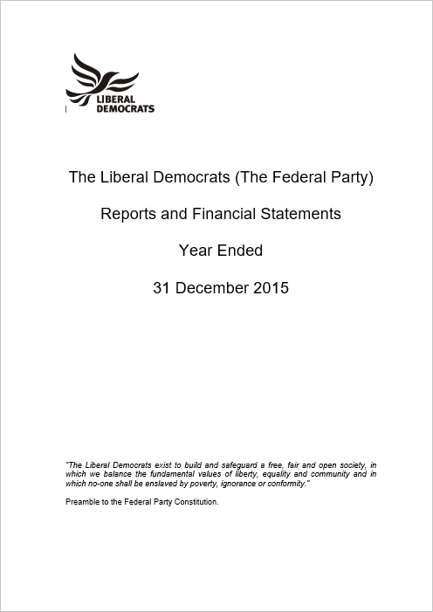
Federal Party Accounts
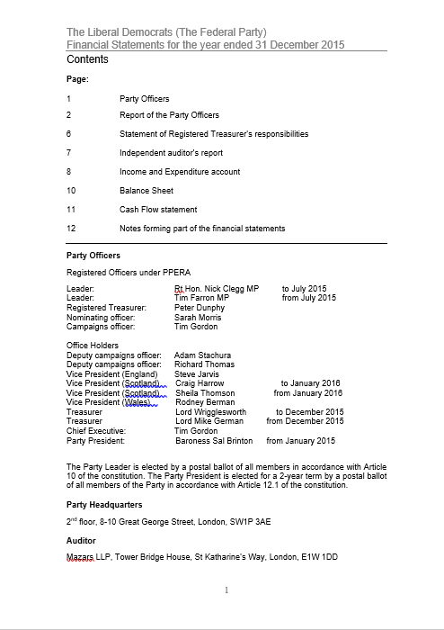
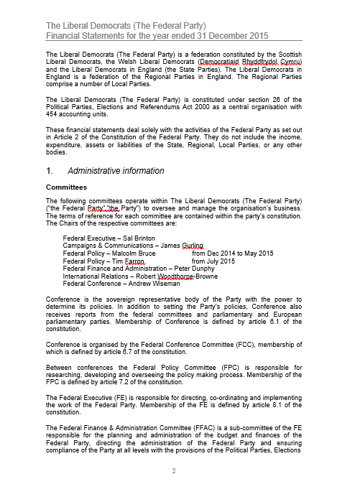
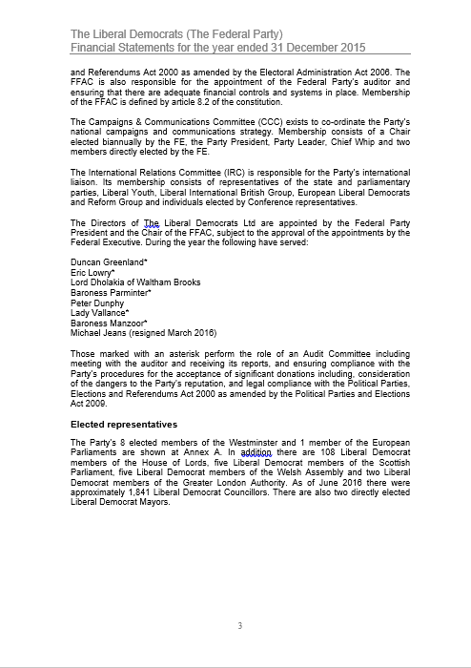
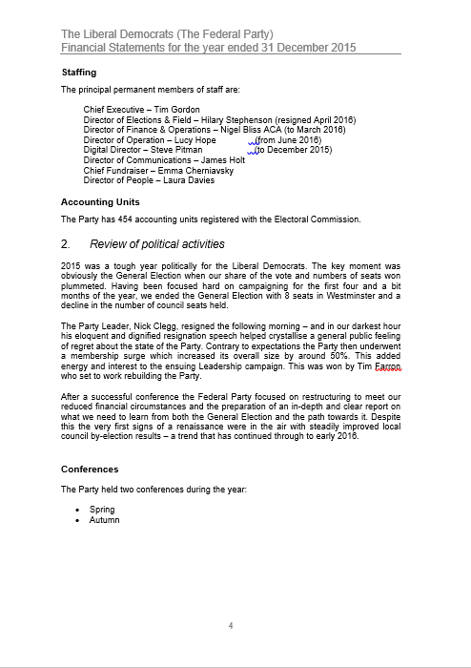
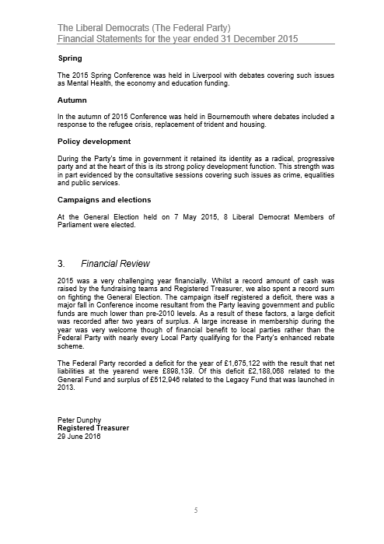
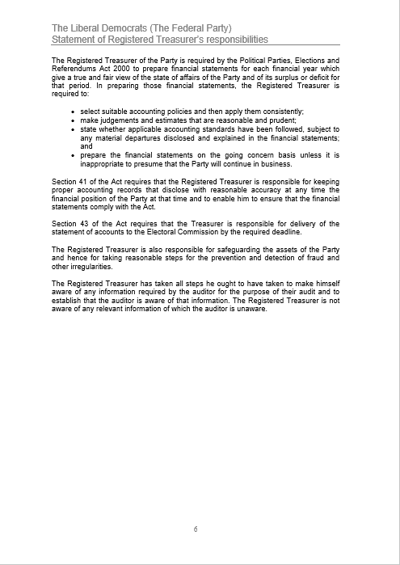
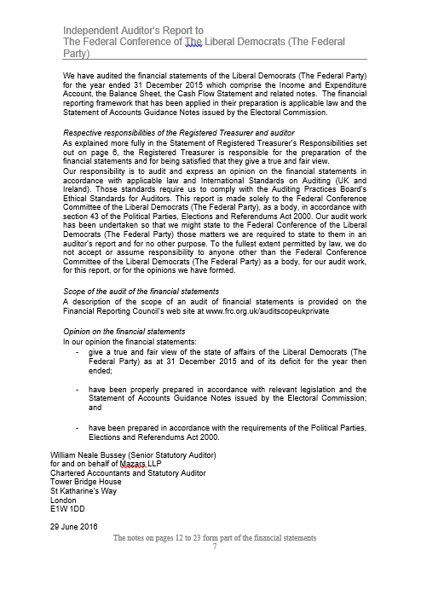
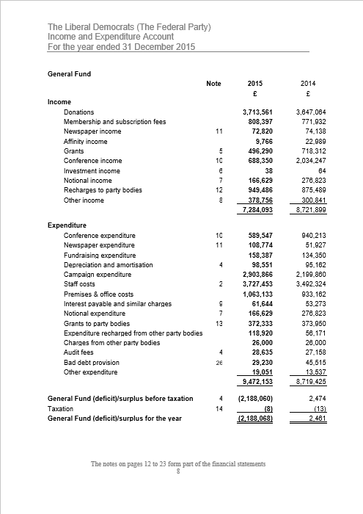
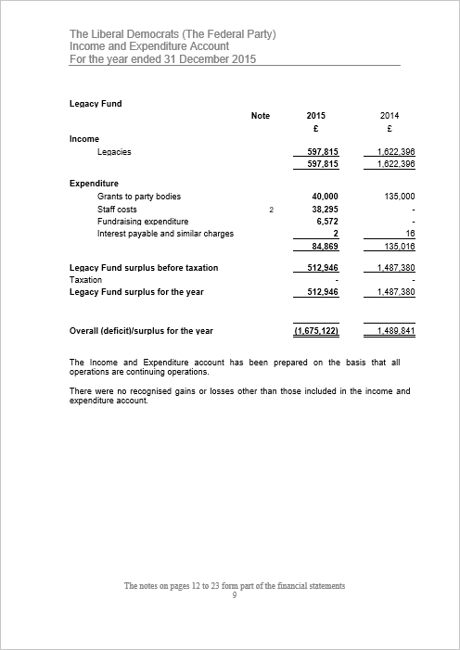
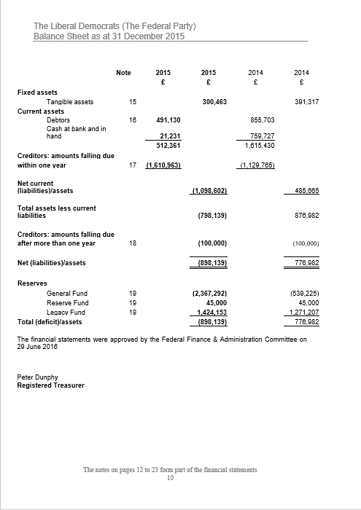
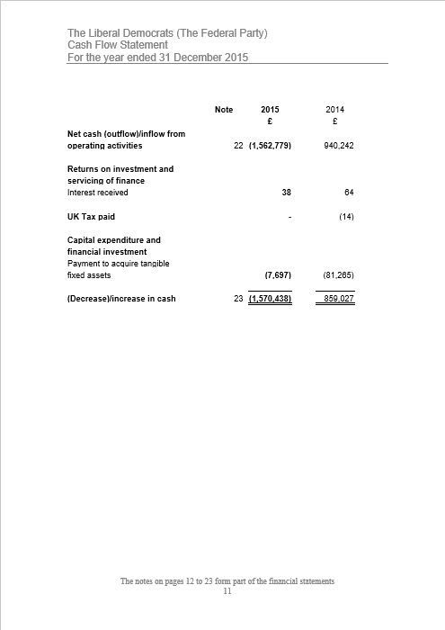
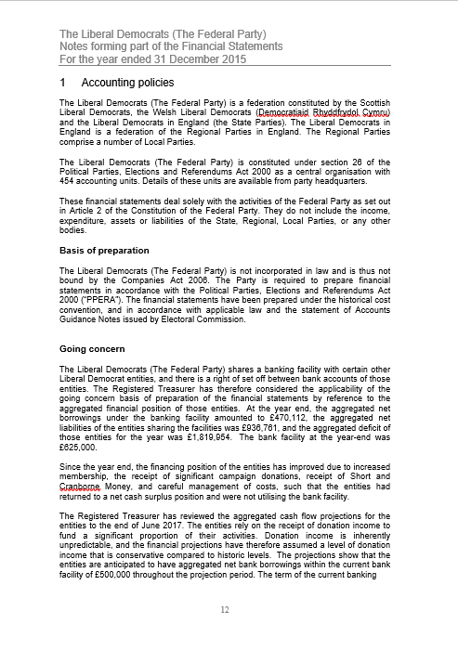
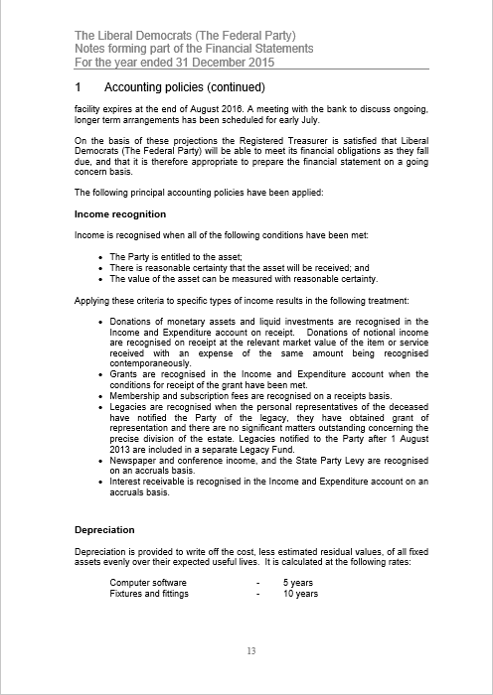
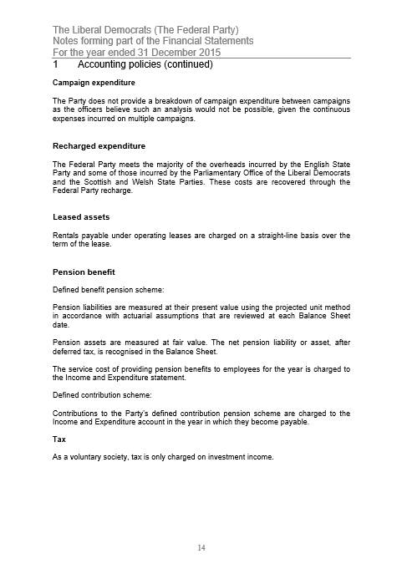
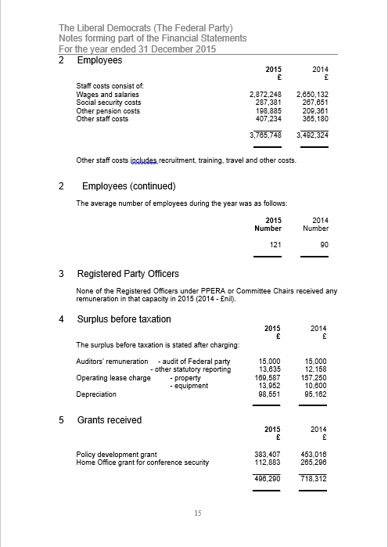
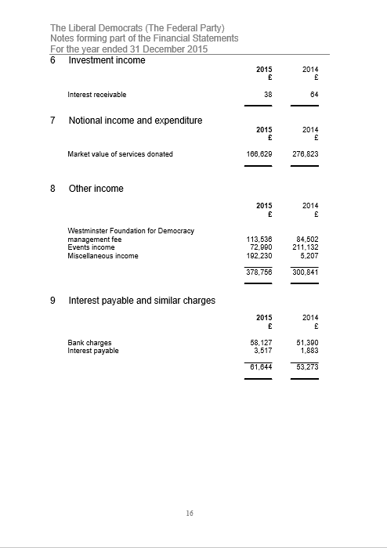
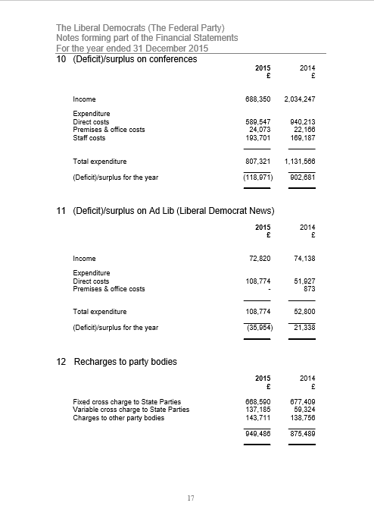
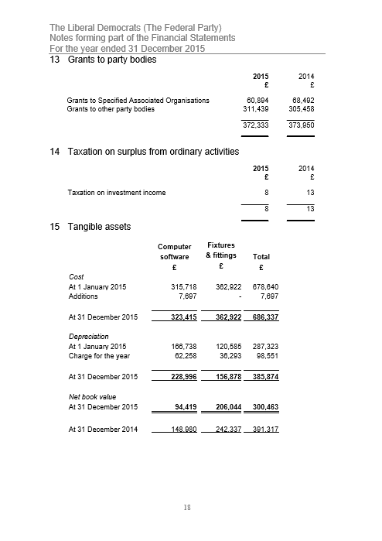
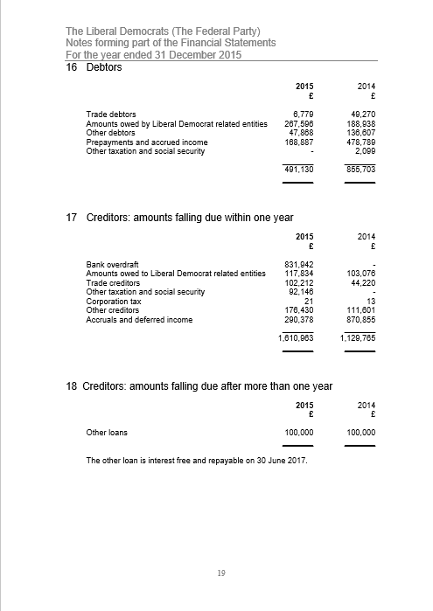
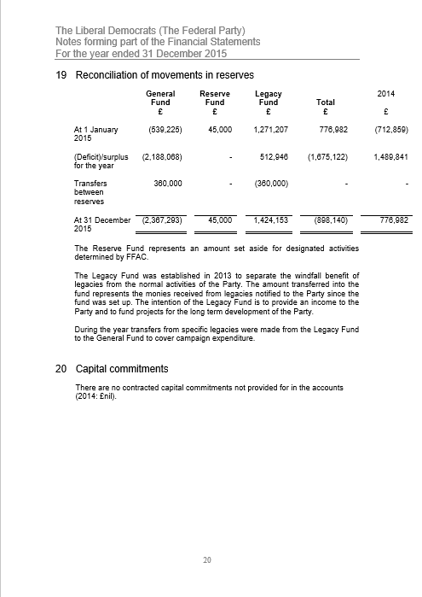
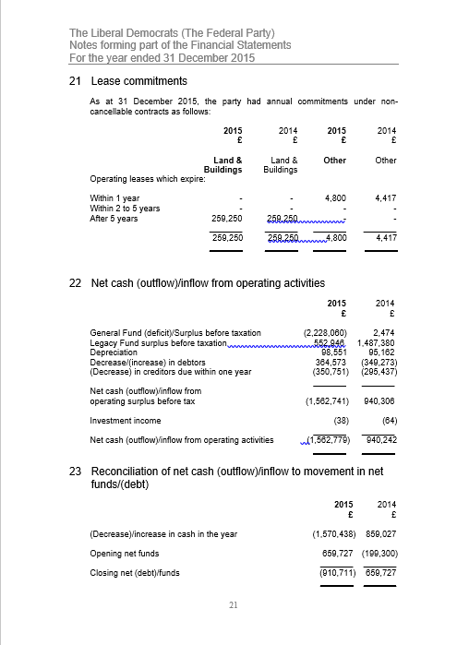
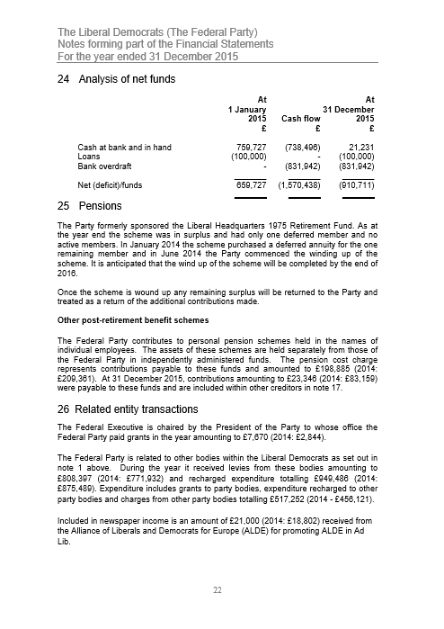
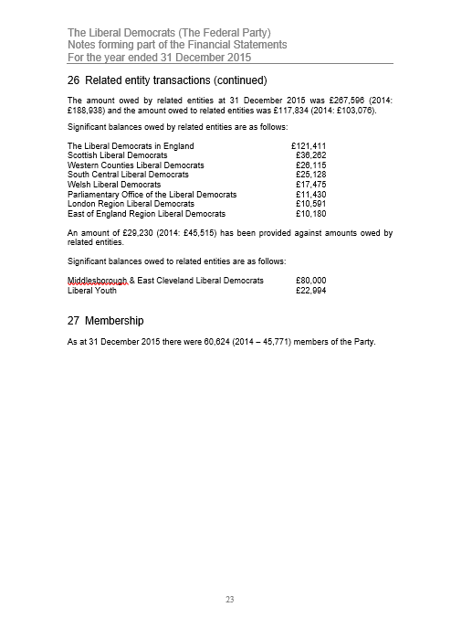
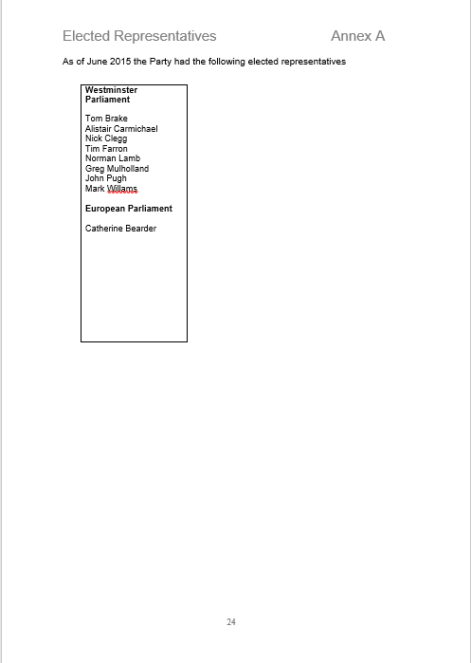

THE LIBERAL DEMOCRATS LIMITED
Directors' Report to the Members for the year ended 31 December 2015
The Directors submit their report for the year ended 31 December 2015, and the Company's balance sheet as at that date.
By virtue of Article 8.3 of the present Constitution of the Liberal Democrats ("the Party"), the function of the Company is to acquire, hold and dispose of such assets of the Federal Party (as defined in that Constitution) as the Federal Executive (as so defined) may from time to time direct.
Where the Company enters into any transaction, it does so as trustee and/or agent for the Party. On this basis, the Company is dormant within the meaning of Section 1169 of the Companies Act 2006 and does not prepare a profit and loss account.
The Directors of the Company during the year ended 31 December 2015 were:
- Duncan Taylor Greenland (Chairman)
- Lord Dholakia
- Peter Dunphy
- Michael Jeans (Resigned 16 March 2016)
- Eric Lowry (Company Secretary)
- Baroness Parminter
- Baroness Manzoor
- Lady Vallance
Signed on behalf of the Board

Eric Lowry
Director
14 June 2016

Registered in England
No. 2231620

Registered Office
LDHQ, 8-10 Great George Street, London, SW1P 3AE
THE LIBERAL DEMOCRATS LIMITED

Balance Sheet as at 31 December 2015

£
Assets NIL
Liabilities NIL

The Company is entitled to exemption from audit under sections 475 and 477 of the Companies Act 2006 for the period ended 31 December 2015. No members have required the company to obtain an audit of its financial statements for the period ended 31 December 2015 in accordance with Section 476 of the Companies Act 2006.

The Directors acknowledge their responsibilities for complying with the requirements of the Companies Act 2006 with respect to accounting records and preparation of accounts.

These financial statements have been prepared in accordance with the provisions applicable to companies subject to the small companies’ regime.

Approved by the Board on 14 June 2016

Eric Lowry
Director

Parliamentary Party Report (Commons)
It has been a turbulent couple of months in British politics since we last met in York. My colleagues and I, like many of you, have spent much of that time campaigning, whether for the elections in May or for the EU Referendum in June.
To start with a positive, we saw some extremely encouraging results in May, particularly in the Local elections in England as well as the Scottish parliamentary elections. This is a trend which has continued on almost every Thursday evening as we watch council by-election results roll in. Unfortunately, we can’t say the same for the EU referendum result which colleagues are deeply disappointed about as I’m sure many of you are. The impact of the result in Westminster has been palpable. We have a new Prime Minister, a restructured Whitehall and a new look cabinet. In her first speech as Prime Minister, Theresa May tried to outline her credentials as a compassionate, One Nation Conservative, dedicated to social justice – my colleagues and I will use Parliament to ensure that this translates to action rather than being simple rhetoric. The perception she sought to cultivate, that she was a safe pair of hands, was in tatters within hours of taking up the role when she appointed Boris Johnson as Foreign Secretary.
With attention geared towards the referendum, and with a government focused mainly on preserving Party unity, the past few months have been what might be referred to as a ‘Zombie-Parliament’. We have seen relatively little from a legislative perspective. That which we have seen however has been deeply concerning. In particular the Investigatory Powers Bill - the reincarnation of the ‘Snoopers Charter’ which we fought hard to block in coalition. Whilst there were areas of improvement, it remains a deeply flawed bill, which undermines the rights of citizens and lacks any evidence indicating it will help the security services. Alistair Carmichael worked tirelessly to ensure the Bill received the necessary scrutiny however a bizarre alliance between Labour and the Conservative front benches saw the Bill leave the Commons with little alteration. I know my colleagues in the Lords with their greater numbers will continue to give the Bill the scrutiny it deserves and hope that their counterparts in the Labour party see more sense than their colleagues in the Commons on this issue.
This transitions me nicely onto the Labour party, whose spineless opposition does the country a huge disservice. The divisions I mentioned in my last report are even rifer now, and Jeremy Corbyn barely has enough support amongst his Parliamentary Party to fill his front bench. Whilst this offers an opportunity for the Liberal Democrats, Labour’s inept opposition is fundamentally damaging to the country. At a time when the Conservative party are healing their wounds from a deeply divisive referendum campaign, and Theresa May is having to pander to the right of her Party, there is more need than ever for an effective opposition. In the Labour Party’s absence, my parliamentary colleagues and I will continue to offer this.
Looking forward, I imagine much of our parliamentary time will be spent debating the terms of our exit from the European Union. We will ensure that the government, and in particular Boris Johnson, David Davis and Liam Fox achieve the best results for Britain, whilst reaffirming our credentials as an outward looking, progressive and pro-European Party. In addition to this, looking back to the Queen’s Speech (which seems a long time ago) there are further pieces of legislation which we will have to remain vigilant to. In particular the Counter-Extremism Bill. It is hard to say how the planned legislation will be affected by the change in Prime Minister, but if Theresa May’s record in the Home Office is anything to go by, we will have to pay particular attention to ensure there is no further erosion of our civil liberties and human rights.
Following the referendum result there is a great deal of uncertainty. We know that the country faces a huge challenge economically, and it will be up to us to ensure that the greatest burden is not shouldered by the poorest in society. In addition, many EU citizens who have put down roots in the UK have been plunged into a period of uncertainty, not knowing whether they have the right to remain in the country. The Government have taken the callous attitude that these people should be used as a bargaining chip in exit negotiations. As a Party the Liberal Democrats fundamentally disagree with this position and believe that the most effective way of ensuring the right to stay for EU citizens in the UK, as well as UK citizens in the EU, is to show compassion, and set a positive example for the rest of Europe. As I mentioned in York, in the last parliamentary session we enjoyed success in securing Ten Minute Rule Bill slots, and this is a technique we hope to use further in this session to promote our campaigns. In July I managed to secure a Ten Minute Rule Bill, which I used to promote exactly this issue, and sought to provide EU Citizens in the UK the right to stay. Over the next few months we hope to exert further pressure on the Government to ensure they do the humane and passionate thing, and guarantee this right.
With eight MPs, it is undoubtedly difficult to make our voices heard, however I would like to take this opportunity to thank my colleagues for their work and their support over the last few months. I would also like to thank my colleagues in the Lords who have used their additional numbers to great effect, and who I know will continue to do so. In particular, I would like to pay tribute to Jim Wallace for his excellent leadership of the Lords group, and know that he will continue to be a formidable member of our team from the back benches. Furthermore, I would like to welcome the huge number of new members who have joined the party in the last few months. You have been a silver lining in what has been a dark period in British politics, and I encourage you to throw yourselves wholeheartedly into fighting alongside us for the values we hold dear and for the Britain we want to achieve.
POLD
Since my last report, our Whips Office, Parliamentary Advisor Unit and Parliamentary Support Teams, have benefitted hugely from continuity in staff, with all members growing into their roles. Their support to our Parliamentarians, both in the Commons and the Lords, is absolutely invaluable and I would like to note my thanks, on behalf of my colleagues and me for their hard work and dedication.
Jack Fletcher and Joe Edwards, who comprise our Whips Office, offer great support and a much needed sense of humour. Our Parliamentary Advisor Unit, made up of Giles Derrington, Vinous Ali, Claire Mathys, Rosie Shimell, Fiona Tod and (our newest addition) Rosy Cobb continue to offer expert advice and creativity in each of their portfolios. Last but not least, our Parliamentary Support Team made up of Rosie Gray, Euan Stone and Jenny Steinitz have each developed within their roles excellently and offer further expert advice to our parliamentarians.
Tom Brake MP
Chief Whip (Commons)
July 2016

Parliamentary Party Report (Lords)
Jim Wallace
In July Jim Wallace sadly announced his intention to stand down as Leader of the Liberal Democrats in the House of Lords. Jim was first elected to the House of Commons in 1983, and, amongst other posts, has served as Chief Whip in the Commons, Leader of the Scottish Liberal Democrats, Deputy First Minister of Scotland, and Advocate General for Scotland. We will miss his wisdom and guidance.
Jim has spent much time this year focused on the EU Referendum campaign. Following the result he pressed the Government to explain the role of Parliament, and in particular the House of Lords, in carrying out its scrutiny functions and its important constitutional duty of holding the Government to account during the process of negotiation with the other EU member states. He also responded to the Chilcot Report on behalf of the party in the Lords, highlighting Charles Kennedy and our party’s principled stance against the war in Iraq.
Legislation
We continue to provide the real scrutiny of the Government in the House of Lords. On numerous occasions in the last 12 months we have taken the lead in challenging the Conservative Government, resulting in the Liberal Democrats providing the effective opposition to the Government’s legislative programme.
Last session, the Government accepted Robin Teverson’s suggestion in the Enterprise Bill that when the Green Investment Bank is privatised, it will continue to retain its environmental purpose through the creation of a ‘special share’.
Sally Hamwee and Brian Paddick made progress on allowing unaccompanied asylum seeking children to relocate to the UK in the Immigration Bill, by working with other Peers across the House to require the Government to relocate a specified number of refugee children from Europe. As well as limiting the length of time that pregnant women can be held in immigration detention, we also pushed on long-standing Lib Dem policies on immigration, including the right for asylum seekers to work if their claim has not been decided within 6 months.
Cathy Bakewell led a large team of Peers on the Housing and Planning Bill, including John Shipley and Kate Parminter, in which we secured a number of significant concessions such as ensuring that all higher-value council homes sold will be replaced on a one-for one basis; protecting vulnerable tenants from wrongful evictions; limiting the sale of high-value council homes in rural areas; making renting safer with electrical safety checks; and making the government’s flagship policies of ‘pay to stay’ and ‘starter homes’ fairer. We also continued to fight for local communities and the environment by arguing for stronger protections against flooding, giving communities a stronger voice in the planning process, protecting social housing, and making homes greener.
Ben Stoneham, Lorely Burt, Paul Tyler and Jonny Oates helped to protect the delicate relations between Unions and some employers in the Trade Union Bill, by securing Government concessions on electronic balloting in industrial disputes, check-off, reporting requirements, facility time transparency, and a gradual transition to a political levy opt-in.
Judith Jolly, Martin Thomas and Julie Smith secured a review of some of the current arrangements to the Courts Martial system to improve public confidence, in the Armed Forces Bill. They also used the bill to champion mental health support for service personnel.
This session, three Government Bills have started in the House of Lords. Jenny Randerson is leading on the Bus Services Bill, with support from Bill Bradshaw, John Shipley, Cathy Bakewell and Ros Scott. During Committee we have championed the rights of passengers, calling on the Government to tackle disability access to bus services, promote bus services in rural areas, and to provide a concessionary fare scheme for young people.
Kath Pinnock, Mike Storey, Claire Tyler, Joan Walmsley and Cathy Bakewell are working on the Children and Social Work Bill. Key issues for the team are providing proper mental health support for children in care, ensuring better financial support, and early intervention to prevent children from being placed into care in the first place. We are also working to ensure that greater innovation in the sector does not compromise standards for children in care.
Jane Bonham-Carter, Rupert Redesdale, Lindsay Northover and Don Foster welcomed the Cultural Property (Armed Conflicts) Bill, which ratifies the 1954 Hague Convention to protect cultural property in armed conflicts.
Private Members’ Bills
20 Lib Dem Peers have tabled Private Members’ Bills this session. Olly Grender’s Renters’ Rights Bill aims to provide a range of protections to private renters; Judith Jolly has brought forward a Bill to introduce a Register of Arms Brokers and Kishwer Falkner’s Armed Forces Deployment (Royal Prerogative) Bill provides for the prior approval of the House of Commons to be obtained for any conflict decision.
Debates
Liberal Democrat Peers have led debates in the Lords during through the spring and summer on important topics for the party, such as renewable energy, and refugees and migrants. We used our last Liberal Democrat debate day in the Lords to highlight the key issues of local democracy, and skills and lifelong learning.
Campaigns and Visits
The group has been extremely active in the last 12 months. Since the election last year, we have participated in over 360 visits to local parties, AGMs, campaigning sessions and EU events. Since the beginning of the year we prioritised visits for local elections and elections in Scotland, Wales and London, and the EU Referendum Campaign. All this is in addition to all the campaigning that Peers are constantly doing in their local areas.
Peers
Very sadly, Eric Avebury passed away in February following a long battle with myelofibrosis. As Eric Lubbock he won the famous Orpington by election in 1962, and entered the Lords as a hereditary peer in 1971. Eric was a determined civil rights campaigner, and passionately championed many causes - freedom of information, electoral reform, human rights and civil liberties, for prisoners, immigrants and asylum seekers at home, and political activists abroad, an ending to the blasphemy laws, and assisted dying.
John Thurso was returned to the Lords in the hereditary by election following Eric’s death.
Margaret Sharp has announced her decision to retire from the Lords at the end of July. Margaret made her valedictory speech on poverty in the UK, highlighting the important link between education and qualifications to earnings and prosperity.
Staff
I would like to extend my thanks to the staff of the Leader’s Office and the Whips’ Office in the Lords who support us in all our work – Humphrey Amos, Polly Martin, Elizabeth Plummer, Sarah Pughe and Dave Shaw. We are also grateful to the staff in the Parliamentary Adviser Unit and the Parliamentary Support and Correspondence Team for their invaluable work.
Lord Dick Newby
Chief Whip (Lords)
July 2016

Parliamentary Party Report (Europe)
EU referendum campaign
My focus over the last few months has been the EU referendum campaign, spending much of my time campaigning and attending debates in the UK as well as organising cross-party talks with pro-Remain MEPs in the European Parliament to see how we could best work together. Despite the deeply disappointing outcome of the vote, I am proud that the Liberal Democrats fought a passionate and positive campaign. I would like to thank all the activists, staff, peers and MPs who campaigned tirelessly up and down the country, the sheer energy and enthusiasm shown gives me hope for the years ahead as we carry on making the optimistic case for Britain’s place in the European Union.
In the European Parliament MEP colleagues in the ALDE Group, and in many other groups, are very sad to see the UK vote to leave. However, many now want to get on with planning for the process so that disruption can be minimised. The EU needs to deal with the many other challenges it faces as well as managing the exit of its third largest member. Within days of the vote I was delighted to welcome Tim Farron to Brussels for a meeting with the seven Prime Ministers from the European Liberal family and their lead MEPs. Tim made it clear that the Liberal Democrats are the only unambiguously internationalist and a pro-European UK party and will continue to maintain the closest possible ties with the EU whatever the coming months bring.
The European Parliament will have to approve any post-Brexit deal negotiated under Article 50, so involving MEPs in the negotiations will be important in the years ahead. I will be working closely with other MEPs to try and ensure that whatever happens, the UK can still participate in vital EU deals and policies such as the Erasmus student and apprentice exchange schemes, the Horizon 2020 research programs and the European Arrest Warrant. Until the UK actually leaves the EU I will continue to represent my constituents, sit and speak for the UK in the European Parliament and together with my liberal colleagues stand up for the values that are important to me and our voters.
Environment Committee
I was proud to receive the Green Ribbon MEP of the Year Award in May for my work fighting for stronger EU targets to tackle air pollution. In June, after months of negotiations, the European Parliament and national governments in the Council finally reached agreement on the EU’s new air quality law. Throughout the talks I have fought hard as negotiator for the ALDE group to get the strongest limits possible. While the final deal was not as ambitious as we would have hoped, due in large part to fierce opposition from governments including the UK, it will still result in huge improvements in air quality. National limits on major pollutants to be met by 2030 are expected to prevent 200,000 premature deaths a year across the EU. We now need to make sure the UK government respects these limits - even after Brexit.
I am currently writing my report calling on EU countries to step up efforts to tackle wildlife trafficking, responding to the European Commission’s Action Plan proposed earlier this year. Time is running out for many of our most endangered species and Europe remains one of the biggest markets and transit points for global illegal wildlife trade. I am calling for stricter penalties across the EU to fit the seriousness of this crime, more funding from governments for the EU’s crime fighting agency Europol and coordinated efforts to take on the criminal gangs exploiting this trade. The final report will voted on by MEPs in November. I have also just been appointed to follow a forthcoming European Parliament report on the links between palm oil and deforestation.
Women's Rights Committee
My report on the gender dimension of human trafficking was overwhelmingly passed by MEPs in May. The report urges all governments to fully implement the EU's anti-trafficking directive, which guarantees minimum rights for victims of human trafficking including free legal aid, accommodation and medical treatment. I also called for the current minimum recovery period of 30 days to be extended for victims of sexual exploitation. Finally the report calls for unaccompanied minors, who are particularly vulnerable to being trafficked, to be registered upon their arrival in the EU and included in child protection systems.
Quaestor
I have continued in my role as a Quaestor for the Parliament, as one of the five MEPs who are elected by our colleagues to manage the day-to-day running of the European Parliament. This role means I am the only British MEP to sit on the Bureau, the highest decision-making body of the Parliament, where I represent the interests of fellow MEPs. This will become more important as the negotiations on the future of British MEPs and other British citizens working in the EU institutions start to become clearer as we move towards Brexit.
Catherine Bearder MEP
January 2016

Diversity Engagement Group
The Diversity Engagement Group (DEG) was established to oversee the achievement of the Party’s equality and diversity priorities. The group brings together nominated ‘Champions’ from all sections of the Party in leading the strategic and accountable body responsible for delivering our diversity agenda and reporting back to every Federal Conference. DEG acts as a steering group for the Diversity and Outreach team based at Liberal Democrat HQ, and is chaired by Baroness Meral Hussein-Ece.
DEG Restructure
The restructure is currently taking place under the leadership of the.
DEG’s role is to define, agree and carry out the diversity strategy for the party, (including pro-active campaigning and producing recommendations to HQ staff, Parliamentarians and Party members based upon expert advice from its members).
All members have a responsibility for diversity at all levels in the party.
The work of DEG is structured in the following ways –
- Internal engagement:
Includes increasing representation within the party, as well as diversity awareness and unconscious bias training.

- External engagement:
Includes campaigning in diverse communities, community outreach projects and other work that builds the influence and reputation of the Party more widely.
- Communications:
Includes increasing the visibility of work being done within the Party and ensuring that internal and external communications reflect diversity and inclusion.
LDHQ staffing
The Diversity Office and Candidates Office have now been merged into the Diversity, Candidates & Talent Support team.
The team is comprised of:
Arfan Bhatti – Head of Diversity, Candidates & Talent Support
Natalie Chindipha – Diversity & Talent Support Manager
Richard Kember – Candidates Officer & English Party Administrator
Vicky Nevin – Youth & Student Development Officer
This merge reflects the fact that the team’s personnel are much more hybrid in nature than before to ensure a more fluid and collaborative approach to diversity as well as candidate recruitment.
DEG would like to give their thanks to Lucile Kamar, the recently departed Diversity & Outreach Manager for her work in the team over the past two years as she moves into her new role.
Internal Engagement
Implementing the Electing Diverse MP’s motion - aimed at increasing the diversity of our parliamentary candidates by setting up a 2020 Candidate Diversity Task Force and ensuring that seats take proactive measures to select a candidate from an underrepresented group.
Candidates from under-represented groups have been monitored, targeted, mentored and actively encouraged to go for candidate approval days.
Similarly, with the prospect of a general election, those candidates have been mentored for selection as Parliamentary candidates, and candidates already on the approved list have been encouraged and mentored to stand.
Unconscious Bias training continues to be delivered at every Federal Conference and for local and regional parties on request – and the training is being rolled out to all Parliamentary as well as Federal staff.
Regional Diversity Champions are pro-actively offered advice and support needed to carry out their regional activities including (but not limited to):
Training days for BAME activists
Inspiration Days
Encouraging local parties to appoint a Diversity Officer
Running Engagement Matters training sessions
Proactively encourage individual from underrepresented groups to be involved at all levels in the party
The HQ team continues to run key activities on behalf of LDW Campaign for Gender Balance (see separate report), providing support for potential women candidates going for Parliamentary approval and selection. This includes a package of women-only training at Conference.
The team are working closely with party’s Training, Volunteering as well as Membership teams to engage, activate and train members.
There is also training…
External engagement
The HQ team is working with MPs and organisers in held seats with the most diverse populations in order to identify and discuss best practice, and how further work can be done.
Links are being built and developed with a range of relevant external organisations including Patchwork Foundation, 3FF, Young Black Grads, Islamic Relief, etc.
Community briefings are available on request
“Whose Vote are you missing: Campaigning in Diverse Communities” has been updated and is being distributed to key party stakeholders.
Key issues briefings for diverse communities have been discussed with the policy team, produced and distributed.
Communications
A BAME media event lead by Tim Farron took place in June 2016 aimed to promote the INtogether campaign to Britain’s BAME media audience and readership.
MPs, Peers and senior Lib Dems have been supported and encouraged to mark multi-faith and equality calendar dates.
The Diversity and Outreach Twitter feed informs on opportunities and relevant campaigns and policies– follow us @LibDemDiversity
A training event at Conference is also scheduled in order to promote engagement with BAME media by campaigners and candidates.
Baroness Hussein-Ece
Chair, Diversity Engagement Group, July 2016

Campaign for Gender Balance
The Campaign for Gender Balance was established by the Federal Executive in response to the conference debate on gender balance in September 2001. Since the launch of Liberal Democrat Women in June 2013, CGB’s aims and objectives have been incorporated into the new LDW Constitution, with Candy Piercy (Coordinator, Representation of Women Group), taking forward the CGB remit.
The Representation of Women Group, working with the Diversity and Outreach team in LDHQ, continues to form a key central initiative for attracting and supporting women candidates within the Party, and it implements a range of training, mentoring and support activities in order to increase the number of women standing for Parliament.

I would like to begin my report by thanking Lucile Kamar, the former Diversity and Outreach Manager for her invaluable help and support to CGB over the past few years. I would like to welcome Natalie Chindipha to the role.
After the General Election, we began the groundwork for setting up an Inspiration Day for Women in Scotland, England and in every region in England. We contacted Diversity Champions in the Regions. The aim of these Inspiration Days was to generate new women applicants to become Parliamentary candidates. Unfortunately, Lucile's time was diverted to supporting the Post General Election Candidates Review. As a result, the Inspiration Days were put on hold.
Now that Natalie is in post we hope these In I hope to set up with the help of both Natalie and LDW will be setting up CGB Circles. These will be informal support networks for groups of women candidates at different stages in their political careers.
However, in early 2016 we were able to run a successful series of webinars. These were designed to develop the ability of accredited Party trainers to deliver Inspiration days, Interpersonal Skills Workshops and Unconscious Bias workshops. The last two are the core competency areas we have identified for creating and maintaining a positive attitude towards diverse individuals and communities.
Our other focus this year has been the identification of potential new mentors for women candidates. We are working on a training programme for new mentors.
Existing CGB mentors have been working with women who have been standing to be Westminster candidates in the snap selections over recent weeks.
Candy Piercy
Head of LDW Representation of Women Group CGB Project
July 2016

Federal Appeals Panel
The Federal Appeals Panel is established under Article 14 of the Constitution, and adjudicates over a variety of disputes that fall outside the remit of State Appeals Panels. The FAP is made up of 18 members – 9 of whom are elected by the Federal Executive and confirmed by Conference, with 3 being elected by each State Party. The Chair of the FAP is elected by the Panel from amongst the members elected to it by the Federal Executive.

- INTRODUCTION
The Panel exists under Article 14 of the Federal Party Constitution to resolve internal conflicts falling within Article 14.3. Its composition is as set out in Article 14.1. The panel was appointed at the York conference for a term ending in December 2020. Alan Masters former Chair of the Welsh Appeals Panel, was elected Chair in 2010 and was re-elected chair for a second term in 2016.
The panels registrars have been reconfirmed as:
David Allworthy - Registrar
Darren Briddock – Deputy Registrar
This is the Federal Appeals Report to the end of June 2015.
In certain instances, the Chair of the Panel may provide a ruling on his own authority under the Panel’s procedures in other instances he will appoint a panel of members to determine the issue.
- RECENT RULINGS OF THE PANEL
The panel have made no rulings on matters since the last report to conference.
- RECENT RULINGS OF THE CHAIR OF THE PANEL IN REGARD TO THE INTERPRETATION OF THE CONSTITUTION
  - Request for constitutional clarification
I have received several request for the ruling set out below. I have power under our procedures to make a rulings and give opinions where it is appropriate to do so, such rulings will be definitive but subject to further timely challenge to a full panel.
These reply’s set out the criteria that will be used to judge any cases of conflict described in the question above and should not necessarily be taken to prejudge any appeals that may be lodged in connection with such cases which will be judged on their merits according to the Panel’s published procedures.
Question form Mark Pack: I would like the Federal Appeals Panel to make a ruling on how the party's rules should be interpreted in any cases where the Federal Constitution and rules made under it are in conflict, and similarly for any cases where the Federal Constitution and other constitutions within the party, or rules made under them, are in conflict. As this covers a large number of potential combinations of documents, if there is no simple across-the-board ruling which it is appropriate to make, I would be happy with a ruling setting out the criteria the Federal Appeals Panel decides should be used in cases of such conflict.
Answer: The Federal Party Constitution clearly sets out that the Party is a Federation with different powers reserved to different levels of the Party and that other matters can be determined at lower levels under the principle of subsidiarity.
The powers reserved to the Federal Party are clearly set out in Article 2, clauses 2.2 and 2.3 of the Federal Constitution, this includes a specific clause in 2.7 to protect the relative powers of the State Parties. The following clauses are examples of where powers are reserved to the Federal Party or State powers are qualified by the Federal Constitution: 2.6, 3.2, 3.3, 3.4, 3.5, 3.9, 4.2, 4.3, 4.9, 4.10, 4.11, 4.12. 5.1, 8.5, article 11 especially 11.8a, 13.1, 14.3 (this is not necessarily an exhaustive list of such clauses).
Each of the State, Regional and Local Party Constitutions also set out the powers reserved to themselves and the limitations on powers set out in subsidiary documents.
From this is it clear that there is a precedence of Constitutions and associated documents within the organisation and it appears to me that the precedence would exist in the following order:
- The Federal Constitution
- Rules made under The Federal Constitution
- State Party Constitutions
- Rules made under State Party Constitutions
- Regional Party Constitutions
- Rules made under Regional Party Constitutions
- Local Party Constitutions
- Rules made under Local Party Constitutions
- Branch Constitutions
NB: in the list above the word rules shall be interpreted to include other documents such as procedures and standing orders referred to in the relevant Constitution.
As a result normally where any conflicting clauses exist in a subsidiary document without amendment to the relevant senior document(s) or the written approval of the senior body, as in the case of Local Party Constitutions in all three State Parties, then those contradictory clauses and are likely to be unenforceable and subject to challenge and being overturned upon appeal to either the State or Federal Appeals Panels.
Where any conflicting clauses have been passed to a senior document without amendment to the relevant subsidy document(s) they should normally make it clear what subsequent amendments are required to subsidiary documents or make it clear who is responsible for ensuring that a timetable is produced to make certain those amendments are implemented in a reasonable time frame.
  - Questions from the Federal Executive Constitutional Drafting Group on the Governance Review and Election Rules Review.
This is a reply that sets out the criteria that will be used to judge any cases relating to the issues described in the question below and should not necessarily be taken to prejudge any appeals that may be lodged in connection with such cases which will be judged on their merits according to the Panel’s published procedures.
    - Question: Is the re-organisation of the Joint States Membership Committee and the incorporation of it’s powers into the Federal People Development Committee and it’s sub-committees an amendment to the Federal Constitution that would trigger the provisions of clause 2.7 of the Federal Constitution relating to the relative powers of the State Parties and the Federal Party?
Answer: In my opinion, given that it is at least 8 years since the Joint States Membership Committee (JSMC) has met and that this is a reorganisation and not anything more I do not consider that clause 2.7 is triggered.
In coming to that view, I understand that the membership powers transferred to the Federal People Development Committee or its proposed sub-committees, do not in the opinion of the drafters exceed the powers that were already allocated to the JSMC in the constitution or are reserved to the Federal Party in Article 3 or 8.5
    - Question: Is the re-organisation of the Joint States Candidates Committee and the incorporation of it’s powers into the Federal Communications and Elections Committee and it’s sub-committees an amendment to the Federal Constitution that would trigger the provisions of clause 2.7 of the Federal Constitution relating to the relative powers of the State Parties and the Federal Party?
Answer: Again in my opinion, as with the JSMC I do not consider that clause 2.7 is triggered.
I have no problem in principle with the re-organisation of the Joint States Candidates Committee (JSCC) into the Federal Communications and Elections Committee or its proposed sub-committees. I note that there is already an emergency power for the JSCC to intervene in the State processes in clause 11.8a of the Federal Constitution that therefore you exceed the powers that were already allocated to the JSCC in the constitution or are reserved to the Federal Party in Article 11.
    - Question: How should the Conference motions on elections to the ALDE (ELDR) Delegation (Autumn 1992) and Interim Peers Panel (Spring 1999 and Spring 2004) relating to elections created by Conference Motions rather than the Constitution and carried out previously with Conference Representatives as the electorate be dealt with in future after the ‘one member one vote’ constitutional amendments in Autumn 2015?
Answer: Having examined the wording of the original Conference motions passed I would make the following rulings:
1 The election is to be by all elected Conference Reps and that is now all members as reflected in my ruling from September 2015 about one member one vote.
2 Conference has made it clear that it wanted to remove the double the number of nominations rule in the debate about quotas so that should now fall.
3 That the quotas for each State Party and for an Under 26 rep should be maintained and incorporated into the quota provisions in the committee election rules.
4 That the Interim Peers election rules should be amended accordingly and the new Quota rules for elections being added to the Federal Constitution when adopted should apply to those elections as a minimum standard. That does not stop the Federal Executive setting high quotas for these elections if it sees fit.
- PUBLISHED PROCEDURES UNDER 14.6

1 Mission Statement
  - The Panel exists under Article 14 of the Federal Party Constitution to resolve internal conflicts falling within Article 14.3.
  - In discharging its duties the Panel shall act in accordance with the principles of natural justice; and shall be accessible, transparent and expeditious.
  - Where appropriate, the Panel will encourage mediation; where necessary, it will make firm decisions by proper process.
1.4 In dealing with any complaint the Panel will have regard to the Human Rights Act 1998 and in particular to Article 6 of the European Convention of Human Rights.

2 Officers
2.1 There shall be a Chair of the Panel elected in accordance with Article 14.1.
2.2 There shall be two Vice-Chairs of the Panel approved by the Panel.
2.3 There shall be a Registrar and a Deputy Registrar of the Panel approved by the Panel. The Registrars shall normally be a employees of the Federal Party, and the Chair of the Panel shall consult with the Chief Executive of the Party in relation to any such appointment.

3 Initial Procedures

3.1 Any complaint, interpretation of the constitution or request for informal advice, shall be made in the first instance to the Registrar within 6 weeks of the event, ruling or issue of to be determined subject the right of the panel to extend this time in exceptional circumstances.
3.2 The panel will be careful not to hear disputes which are in the first instance outside their jurisdiction, for instance where another remedy exists that has not been exhausted, such as an appeal to a state body.
3.3 The Registrar shall contact the Chair, who shall designate their self, or one of the Vice-Chairs, as the Case Manager in respect thereof. The Registrar shall ensure that any complaint is in a form which is both coherent and acceptable to the complainant.
3.4 The Case Manager may give informal advice, and may recommend (and, if so, assist) with mediation; however, if the Case Manager conducts an unsuccessful mediation, he may take no further part in the determination of the complaint, and the Chair shall if thought fit appoint a different Case Manager.
3.5 The Case Manager, in consultation with the other Officers, will determine;
(a) whether or not the case falls within the jurisdiction of the Panel (and the Officers shall have power to determine that a case falls outwith such jurisdiction because it is deemed to be untimely, insubstantial, unmeritorious, vexatious or where the complainant has not exhausted his remedies elsewhere); and

(b) the timetable and preliminary procedures for that case and a power to the case manager to impose deadlines (and so that any appeal must, unless the case manager extends this deadline in exceptional circumstances, be concluded within three months of being lodged, and may be dismissed if the appellant does not co-operate with the related timetable).
3.6 If the complainant does not comply timeously with such procedures, the Officers may determine the case without any evidence not supplied by a deadline.
3.7 The Officers may also determine, in relation to any complaint where there is no (or no material) dispute as to the facts, that the matter should be determined without an oral hearing.
3.8 Subject to the foregoing the Case Manager shall have power:
(a) to seek further information from the complainant;
(b) to determine the appropriate respondent(s); and
(c) to determine the procedures to be used, and the issues to be adjudicated, by the Case Panel appointed to determine the case.
4 Determinations
4.1 In the case of a request for an interpretation of the constitution or rules or standing orders made under it. The case manager shall be empowered to make definitive rulings by their self. Such rulings shall be definitive subject to further challenge to a full panel which shall be subject to the terms of 3.5 a) above.

4.2 The Members (and the Chair) of the Panel to hear a particular case (“the Case Panel”) shall be selected by the Chair in accordance with, and subject to, Article 14.4.
4.3 Where there is an oral hearing, it shall be conducted as far as possible in accordance with the Appendix to these Procedures, a copy of which shall be given to each party in advance thereof, together with details of any proposed deviations therefrom. If any party fails to attend such an oral hearing, the Case Panel may nevertheless determine the matter.
4.4 Following or in the absence of an oral hearing, the Chair of the Case Panel shall produce a draft determination for approval by the other Members of the Case Panel. Such draft determination shall also be sent to the other Officers by way of consultation on matters of law (but not fact), and the Case Panel shall have regard to any comments they make.
4.5 Such determination, or a summary thereof, shall normally be made available to all parties, and to all Members of the Panel. In the case of an oral hearing, this shall be within 21 days thereafter.
4.6 The Officers shall determine upon any form of publication or other circulation of a determination, and in so doing shall have regard to Article 14.6 and to the desirability of publishing any part of any decision which may be of precedental or other useful effect.

5 Report to Conference

5.1 The Report will be a matter of record. A sanitised version giving the facts but not identifying the parties* would normally be sufficient to go before Conference (*in the interests of protecting the parties from unnecessary publicity), together with any recommendations that have been made. Another safeguard may be that this is done during a session of Conference where members of the press are excluded.

Appendix

Normal Process during an Oral Hearing

1 Normally, the complainant will speak first, to put her or his case. The complainant may call witnesses as to disputed fact only, although these may also give their evidence in written form. The complainant may be assisted by a friend, who may speak for the complainant at any time. The friend should avoid simple repetition of points already made by the complainant.
2 Each respondent or representative may cross-examine a witness, the friend or the complainant, as directed by the Chair of the Case Panel.
3 The case for the complainant should not last longer than 45 minutes, unless the Chair believes that the case has not been properly put in this time.
4 The respondents have equivalent rights as to witnesses, a representative to aid her or him and time limit.
5 The complainant may also cross-examine as directed by the Chair.
6 Members of the Case Panel may ask for clarification or cross-examine at any time.
7 Each side may sum up, taking no more than five minutes.
8 The Case Panel will then consider their conclusion.
- SUMMATION
As Chair of the Panel I have been committed to making sure that the work of the Panel is accessible, transparent and truly independent. Last year in particular was a very busy period for me a Chair in particular and I am pleased to report back and set out above the details of the work done over this period. Members will see, the nature of the complaints and conflicts that have arisen, that they have been varied, sometime controversial and not always easy to deal with. My aim as Chair is that members will continue to have confidence in the way their matters have been handled and in the independence of the Panel in their continuing role to protect members’ rights under the Constitution.
Alan Masters
Barrister at Law, LL.B BL
Chair of the Federal Appeals Panel
July 2016

