REPORTS TO CONFERENCE
AUTUMN 2017

Table of Contents
Federal Conference Committee 2
Federal Policy Committee 7
Federal Board 14
Federal Communications and Elections Committee (FCEC) 18
Federal People Development Committee (FPDC) 23
Federal Finance and Resources Committee (FFRC) 25
Federal International Relations Committee (FIRC) 28
Federal Audit and Scrutiny Committee (FASC) 30
Federal Party Accounts 31
The Liberal Democrats Limited 57
Parliamentary Party Report (Commons) 60
Parliamentary Party Report (Lords) 66
Parliamentary Party Report (Europe) 71
Campaign for Gender Balance 75
Federal Appeals Panel 77

Federal Conference Committee
York 2017
This spring we went back to York. In previous years it proved to be a popular venue and this time was no different, it received excellent feedback. A good percentage of attendees completed the online questionnaire which is sent to all members who register for conference. This document is incredibly useful to the conference office and FCC. You will receive one for this conference by email shortly after we leave Bournemouth. I would urge all members to take the time to complete it.
81% of respondents rated the venue as good (38%) or excellent (43%). These figures are similar to previous years and York continues to be one of our most popular venues. We will continue to monitor and put pressure on the venue in areas where negative feedback is received with a view to improving the experience for attendees.
FCC continues to keep a close eye on the number of debates on the agenda against non-debate items such as speeches and Q&A items. Feedback from York showed 90% of people believed the balance was about right. This is the highest rating that has been received in recent years. Getting the balance right is always difficult and we will continue to monitor the feedback received from attendees.
We are continuing to develop the conference App. 61% of those that returned the questionnaire used the App and the average rating for those who used it was 3.84 out of 5. This is an increase on previous conferences. FCC will continue to develop ways to make this even better and more useful.
Bournemouth 2017
This autumn we have returned to Bournemouth. FCC is very mindful of the cost of attending conference. The cost of coming to conference is often raised in feedback from members. As well as keeping registrations rates as low as possible to members, launching the conference access fund and negotiating discounts on travel costs we have been looking at other ways to reduce the costs to members. One major cost for people is the cost of accommodation (and taking the time off work). There is also increasing pressure on all political parties to reduce the length of all political conferences to minimise the impact on parliamentary time.
With this in mind we are continuing with the second year of our trial where we make the full use of the Saturday to help those who can only come for a weekend as well as reducing the length of conference to try and keep down accommodation costs, while maintaining the amount of time available for 'member led policy motions'.
Though conference does remain a significant income generator, we have also looked at ways of reducing the cost of conference to the Federal Party.
The autumn conference in Bournemouth this year (as with Brighton last year) will start at 9.00 am on Saturday morning. This will be the start of conference proper and the consultations sessions will be run as part of the main agenda. We will finish at approximately 3.30pm on Tuesday. This means we will have the same amount of time for member initiated motions. Many members will still use the opportunity to enjoy an extra day or two by the seaside but it is hoped the revised timing will save some members money and also enable more members to come to conference. It will also mean that those who just can come for a weekend get a full day on the Saturday.
We will again be trialling this change for this conference and will consult with people as to how they felt it worked before deciding whether to do it again in 2018. Please do let us know what you think.
Motions
As always, every item on the agenda is still open to amendment. The deadline for submitting amendments – and also emergency motions and questions to reports – is 13.00 on Monday 4th September.
We continue to provide a drafting advisory service, and I would encourage all emergency motion and amendment submitters to make use of it – those who have used it in the past have had a much higher chance of having theirs accepted. The deadline for the advisory service for amendments and emergency motions is 13.00 on Monday 21st August, please do use the service; drafts should be sent to motionsadvice@libdems.org.uk.
Agenda
Due to the ‘snap’ General Election Federal Policy Committee is not bringing any full policy papers to this conference however we do have a number of interesting motions and consultation sessions. These range from consultations on party strategy, Europe and the manifesto process to motions on the natural environment, safe building standards, Israel / Palestine and the ‘gig economy’. There will also be the opportunity to participate in a Q&A with the new leader as well as question the various Party committees as to what they have been doing.
Once again it looks like we have a record number of first time attendees at conference this time. We have organised a full programme to help them understand how conference (and the wider party) works. We hope they find this useful and that they receive a warm welcome from those who have attended conference for many years, ensuring that they keep coming back.
Spring 2018
Next spring our conference will be in Southport. This will take place from 9th to 11th March 2018.
Stewards
As always, conference can only take place due to the massive contribution and efforts of the volunteer stewarding team, who look after the exhibition, fringe, information desk, stage and auditorium, and ensure that we all get the most out of conference. If you would like to be a steward why not contact me or speak to a member of the stewarding team.
Federal Conference Committee
FCC members are here to help you make the most of conference – do feel free to ask us any questions you may have relating to the agenda and how to speak in debates. You can identify us by the badges we wear, with ‘FCC’ prominently displayed; there are also pictures of us (although looking at some of the photos it may be difficult to see the true likeness!) at the front of the Agenda.
Thanks
The vast bulk of the hard work of organising conference throughout the year falls on the professional staff in the Conference Office at HQ.: Lydia Dumont, Emma Price, Laura Brody and Jack Everitt. I would also like to express my grateful thanks to all the others who make conference possible: to all my colleagues on the Conference Committee; to all the staff at HQ, in particular the Policy Team, led by Christian Moon, who process the motions and prepare much of the agenda material; and of course to the stewards’ team.
One member of FCC recently left the committee and was replaced by James Holt who I would like to welcome to the committee.
Conference is a fantastic event to be involved in and I’m proud to chair your FCC. I look forward to seeing you in Bournemouth.
Andrew Wiseman
Chair, Federal Conference Committee

Federal Policy Committee
The Federal Policy Committee is responsible for researching and developing policy and overseeing the Federal Party’s policy-making process. This includes producing policy papers for debate at conference, and drawing up (in consultation with the parliamentary party) the Federal election manifestos for Westminster and European elections.
The FPC has 29 voting members: the Party Leader, six other parliamentarians, the Party President, two councillors, three state party reps, one rep from the Federal Communications and Elections Committee and fifteen directly elected members. It is chaired by the Leader.
Committee Issues
This is my first report to conference since assuming the leadership of the Party and the chair of the Federal Policy Committee. I should therefore like to take this opportunity to thank Tim Farron on behalf of the committee for his two years’ service in the chair. This was a busy time for the FPC with a major policy review in the form of Agenda 2020, a provisional manifesto being agreed in September 2016 and then another manifesto being signed off for the June 2017 snap election. Despite the many other calls on his time as leader, Tim was a diligent chair of FPC and this close alignment between the party’s overall political leadership and its policy development has undoubtedly been of great benefit.
I look forward to working with my Vice Chairs Baroness Ludford, Duncan Brack and Jeremy Hargreaves, and the whole membership of the committee.
2017 General Election Manifesto
On 18 April the FPC found itself faced with the daunting task of having to draft, cost, agree and publish a general election manifesto within four weeks. Fortunately we were not starting entirely from scratch as a Manifesto Working Group had been established in the summer of 2016 under the chairmanship of Lord Newby, which produced a draft manifesto in September 2016, and had conducted an online consultation exercise with party members. Given the short deadline to produce the 2017 election manifesto, the full working group was not recalled and the drafting was done by Lord Newby, the FPC officers and staff. Party spokespeople, SAOs and FPC members were also asked to feed in ideas. The manifesto was signed off on 2nd May and launched on 18th May.
The manifesto was generally very well received. In particular the costings of our manifesto stood up to scrutiny far better than those of our opponents. Unlike some other parties we also made our manifesto available in a variety of alternative formats including audio and Easyread.
The fact that we were able to put together very quickly a manifesto which had broad support across the party is also a tribute to the way in which we make policy. The manifesto was as always drawn from policy approved democratically by the party at conference. By then consulting widely with spokespeople, parliamentarians and party interest groups, as well as the party’s campaigns and communications teams, we were then able to put together a manifesto which told a consistent liberal story, and contained robust well-thought through proposals which had broad support across the party. This contrasted strikingly with the Conservatives, whose narrow approach to creating their manifesto led to the disaster of their ‘dementia tax’ proposals which unravelled their whole campaign, and Labour’s collection of ill-thought through and uncosted proposals which they were often unable to defend.
However the FPC is very conscious that we did not have time undertake the wide consultation within the party that normally happens in the course of producing a manifesto. For this reason we are conducting a consultation session on Monday afternoon in Bournemouth 16.30-1800 to give members a chance to feed back their views on the 2017 manifesto. This input will be very helpful in the event that we have to do another snap election manifesto in the near future. Comments can also be emailed to policy.consultations@libdems.org.uk – please put Manifesto Feedback in the header.
Alongside the Manifesto, a much shorter Micro-Manifesto document summarising headline policies was sent to every party member.
In addition, the FPC has also organised a consultation session on Europe to take place between 10.45 and 12.30 on the Sunday of conference. This will allow members to express views on our Europe policy in greater depth than in the session covering the whole Manifesto. The FPC intends to follow this session up with a substantive motion to the Spring Conference. Comments can also be emailed to policy.consultations@libdems.org.uk – please put Europe Consultation in the header.

FPC Work Programme
Because of the disruption to our normal schedule of policy development caused by the general election, we have had to put back all the policy working groups.
The new schedule of consultation and policy papers is set out below:
Working Group | Consultation Session | Policy Paper
Education | Already Done (Spring 2017) | Spring 2018
Rural Communities | Already Done (Spring 2017) | Spring 2018
21st Century Economy | Already Done (Spring 2017) | Autumn 2018
Britain in the World | Already Done (Spring 2017) | Autumn 2018
Immigration and Identity | Spring 2018 | Autumn 2018
Power to People and Communities | Spring 2018 | Autumn 2018
FPC had also decided to set up four new working groups this summer: Health, Tax, Race Equality and Climate Change/Energy. As a consequence of the other groups being delayed, these are also being put back and FPC will consider how to reschedule them after the Autumn Conference.
The FPC is very grateful to all those who give up a great deal of time to serve on our working groups. This is not the most glamorous role in the party but it is absolutely vital to our democratic policy-making process.
In the absence of any full policy papers to debate at Bournemouth, the FPC has put forward five ‘stand-alone’ policy motions: The Impact of Brexit on Public Services; Safe Building Standards for All Homes; Defeating Terrorism, Protecting Liberties; Employment in the 21st Century; and Encouraging Companies to be Responsible Corporate Citizens.
Member Engagement
The FPC is reviewing our processes to widen and deepen members’ involvement in our policy development, building on the work already done in the last few years. For example, alongside the full consultation papers produced for the Sex Work and Nuclear Weapons papers last year, we ran online surveys which received over a thousand responses. We have also been advertising for membership of policy working groups more actively, generating larger numbers of applicants and greater diversity.
We recognise that given the recent expansion in membership we need to do more to communicate party policy to members. Priorities include improving party policy on the website as well as producing pocket guides to party policy and philosophy.
A task group of FPC members is taking all this work forward. If you would like to suggest ways of doing this to discuss with them, please contact the Policy Unit on policy.consultations@libdems.org.uk with Member Engagement in the header.
FPC Links
To encourage policy debate across the party FPC representatives take responsibility for promoting policy debate within the regions of England, including attending regional conferences where appropriate.
Region
Devon & Cornwall | Jim Williams
East of England | Geoff Payne
East Midlands | To be confirmed
London | Duncan Brack
Northern | To be confirmed
North West | Lizzie Jewkes
South Central | Catherine Royce
South East | To be confirmed
West Midlands | Chris White
Western Counties | Richard Cole
Yorkshire & the Humber | Kamran Hussein
The FPC has also appointed representatives to liaise with Party SAOs:
SAO
ALDES | Richard Cole
ALDC | Chris White
LGBT+ | Jonny Oates/Alisdair McGregor
WLD | Belinda Brooks-Gordon
Liberal Youth | Jim Williams
PCA | To be confirmed
Liberal Democrat Lawyers | Geoff Payne
EMLD | Marisha Ray
LDDA | Belinda Brooks-Gordon

In addition, the FPC has decided to co-opt as non-voting members of the committee a representative from Young Liberals (Ciaran Morrissey) and from EMLD (Marisha Ray).
Policy Staffing and Volunteers
The Policy Unit currently consists of Christian Moon (Head of Policy). We are currently in the process of recruiting a new Deputy Head of Policy to replace Rachael Clarke who has moved on after serving the party for six years in various roles. The Policy Unit has also benefitted from the efforts of volunteers including Kevin Callanan, Ellie Persellin and Sasha De Orio. The FPC is grateful for the hard work of all the staff, and in particular would like to express their best wishes to Rachael.
Sir Vince Cable MP
Chair, Federal Policy Committee

Federal Board
The Federal Board (FB) is the governing body of the Federal Party. It is responsible for, co-ordinating and overseeing the implementation of the Party’s strategy and the work of the Federal Party. The Federal Board also has responsibility, at least once per Parliament, for preparing a document outlining the Party’s Strategy, for submission for debate and agreement by Conference.
The FB has 35 voting members: the Party President (who chairs it); the Leader and three other Parliamentarians; the chairs of the three state parties; the chairs of each of the Federal Committees including a vice-chair of the Federal Policy Committee; a councillor; a Young Liberals representative; three state party representatives; and 15 members directly elected by party members.

At Spring Conference we were preparing for the local elections, and the likelihood of a snap General Election seemed to have reduced. Once again, the unpredictable world of UK politics has meant that we have all spent most of April, May and June in local elections and then with the General Election. Following Tim Farron’s resignation as Leader, Vince Cable has been elected unopposed. We send our warm congratulations to him and look forward to seeing his vision for our Party become a reality over the coming years.
I want to thank Tim Farron on your behalf for his excellent service as Leader. His commitment to Liberal Democrat values, perhaps best demonstrated by his passion for the plight of refugees and especially unaccompanied minors, long before other politicians joined in, showed he was not afraid to tackle difficult issues. He was determined that we would increase our MPs in the Commons and we achieved that, taking our Parliamentary Party to 12, four of whom are women. Thank you to your hard work to help make that happen. We also lost some valued colleagues from Parliament, and I want to thank Nick Clegg, Sarah Olney, Greg Mulholland and Mark Williams, for their contribution to their constituencies, the country and the Party. In addition this election saw the retirement of John Pugh who provided a strong liberal voice as MP for Southport for 16 years.
As is usual practice, the Federal Board suspended its regular work during the General Election. This included suspending the Alderdice Review on race equality in the party, the Macdonald Review on the Party's Disciplinary Processes, and the regular review of SAOs/AOs. All of those groups are now re-starting their work. This does mean that there have been some delays, which are frustrating, but the Board is clear that we must not shortcut consultation and discussion on these important issues.
We will bring a consultation paper to Autumn Conference on party strategy and I look forward to hearing your comments. We will return next year with a motion on the Party’s strategy for debate at Conference. This strategy will then inform the work of your Federal Committees.
Because of the changed political circumstances, with a hung parliament, the Federal Board met immediately after the election and agreed that we should make preparations for another snap General Election within the next two years. Arrangements for an emergency snap election in the autumn have to be made quickly, but the three state parties and the Federal Communications and Elections Committee (FCEC) have been working together to ensure that we are as ready as we can be, and seat selection for 2018 and beyond will start in the Autumn, in priority order decided by the regions in England, and in Wales and Scotland.
This is the first Conference with the new reporting structures and the FCEC, Federal People Development Committee, Federal International Relations Committee and the Federal Audit and Scrutiny Committee reports are appended to this report. All of these committees have taken on their new duties with enthusiasm and we look forward to working with them to deliver the Party’s strategy. As usual, the Federal Conference Committee and Federal Policy Committee will continue to report directly to Conference.
On a separate note, I am saddened to report that the Liberal Democrat Friends of Kashmir and the Liberal Democrat Friends of Pakistan have been suspended as Associated Organisations (AOs). Despite efforts by the Associated Organisations Review Group to ensure these AOs could continue their work, there was not sufficient support from members for them to do so. New organisations focusing on these areas can still be created if there is appetite from amongst members to do so. For more information on the criteria for becoming an AO, please email the Party’s Governance Officer Chris Adams at: chris.adams@libdems.org.uk.
I want to thank all the staff across the country who have, once again, given everything, above and beyond the call of duty. Many of them have accrued weeks of time off in lieu, and I hope that they have the chance of a proper and refreshing break over the summer.
Finally, I want to thank Chris Adams, Sarah Pughe and Laurent Frapaise, who have helped me enormously over the last four months.
Sal Brinton
President of the Liberal Democrats

Federal Communications and Elections Committee (FCEC)
The FCEC has been primarily focused on the conduct of the recent local and general elections. We await the outcome of the official review of the General Election campaign, to be conducted by the Federal Audit & Scrutiny Committee, and are preparing for future campaigns locally in 2018 as well as potential General Elections which may be called at the whim of the Conservative / DUP alliance.
Local Elections
By April this year the Party had experienced its best ever performance in local by-election results. Year on year we made a net gain of 33 Councillors. The extent of the improvement offered extremely good prospects at the May local elections, where it was clear that substantial gains were possible in a post Brexit referendum environment. But it was not to be. Theresa May’s decision to call a ‘snap’ general election mid-way through the local election campaigns meant that the electorate reverted to ‘type’ and voted for the strongest available option to their earlier positions.
Despite this, 441 Lib Dems were elected in the face of sustained national opposition – down by 42. Labour lost over 380 seats. UKIP were wiped out (-145) as their vote effectively transferred to the Tories who made a net 563 gains. The Greens and Plaid Cymru gained just under 40 seats between them.
General Election
The FCEC met weekly during the period of the General Election receiving reports of the campaign activities and approving targeting and key seat priorities as necessary. Having taken precautionary measures for a snap election, the Party was in a stronger position that it would otherwise have been. That we were far more successful in terms of candidate selection for a ‘snap’ election than we had been in a fixed term Parliament two years before, is testimony to the hard work and dedication of the Candidates Chairs in the States and English regions. Despite the lack of time available, much time was spent in discussions with other Parties around the concept of a ‘progressive alliance’. Most notably the Party stood down in Brighton Pavilion in favour of Green Party co-leader, Caroline Lucas.
Air War
The election campaign started after only the first phase of the ongoing messaging and branding project had been concluded. Nonetheless we had what we though was a clear understanding of our core audience and a clarity over the broad messages and approaches which appealed to them. The three main elements of the message were that:
- Theresa Mays Conservatives are cold and heartless – they want a hard Brexit that will cost jobs, increase prices, cut schools and hospitals
- Jeremy Corbyn’s Labour voted with May and Farage for a hard Brexit – they let you down.
- You can Change Britain’s Future – the Liberal Democrats will give you a say on any deal Theresa May brings back from Brussels. We will fight for better hospitals & schools.
In Scotland the SNP were putting independence ahead of everything else.
We were clear about two further things.
- Unlike 2015, you could vote for you hardworking local Lib Dem candidate because there was no doubt that the Conservatives would be returned as the Government
- We would not enter into any pacts or deals with either Conservative or Labour parties
7 Weeks out we expected an election that would be determined by a popular movement against a ‘hard Brexit’ and by a lack of unity within Jeremy Corbyn’s Labour Party. To say it did not turn out that way is an understatement.
That said, there were many successes in the campaign such as the increased use of targeting in social media. Our digital campaign once again grew in strength securing 82 million impressions over the course of the campaign. In terms of media coverage, there is no doubt that the new Ofcom guidelines – which removed the ‘larger parties list’ and encouraged editorial freedom to consider ‘previous electoral performance’ – considerably disadvantaged us in comparison to previous elections. The net result was a ‘two-Party’ news narrative.
Ground War
Applying lessons learned in the 2015 General Election, targeting constituency seats in both volume and frequency was a priority. There were two categories of supported seats (Tier One and Tier One Plus) which had been identified in advance on the basis of a significant seat polling programme, assessments of activity since 2015, profile of the candidates and local election results, etc.
Working with experienced campaigners from the Canadian Liberal Party, in an extremely short period of time we unleashed new possibilities within Connect and targeted on-line advertising. There is however still much to be improved in the accessibility that Connect provides, and there is no doubt that some of the lessons learned will be of significance in years and campaigns to come.
In a situation in which our air-war is extremely challenged and the national media is reinforcing the notion of two-party politics, our ability to sustain ourselves locally against the major party attack messages without substantial resource is clearly challenged. Finally, while some constituencies applied themselves to targeting with aplomb – moving readily to target seats even before being asked – there were many that didn’t.
Conclusion
Much concern is raised (and rightly so) at the reduction in national vote to a level not seen since 1959. Compared to 2015 our national vote went down by 0.5% while our seats increased by 4 (50% of the 2015 Parliamentary Party). We elected 4 female MPs and our Parliamentary Party in the Commons now includes ethnic minority and disabled representation.
Yet for less than 500 votes the Party might well have doubled the size of its Commons team with 4 further seats (NE Fife, Richmond Park, Ceredigion and St Ives). The frustration and dismay at the proximity of these results should not deter the Party from building capacity and re-gaining these seats at the earliest opportunity. Particular care will need to be applied to rebuilding the Party in Wales.
The loss of Leeds North West and the failure to regain both Cambridge and Bermondsey & Old Southwark, despite two of the most sizeable ground campaigns in the country, is testimony to the efforts of the Labour Party machine in the second half of the campaign. The loss of Sheffield Hallam denuded the country of one of its best Parliamentarians and most vocal proponents of the EU cause. It also added intensity to the scale of the future fight against Labour that the Liberal Democrats face.
The 2017 General Election was too soon for the Liberal Democrats still rebuilding from the impact of the devastation of 2015. The result was alarming and disappointing in equal measure. Yet the return to growth in Parliamentary seats, and the diversity of the new MP team are substantial achievements in themselves, and offer the new Leader the prospects of concrete foundations on which to build and sustain. In the coming months and years ahead, it is likely that national politics will shift again. The impact of the Brexit debate, the shifting sands of Scottish Independence and the sustainability of Corbyn’s populism mean that firm predictions are few and far between. The challenge for the Party is to ensure that it is organisationally equipped to respond swiftly and authoritatively to new circumstances as they arise.
James Gurling
Chair, Federal Communications and Elections Committee

Federal People Development Committee (FPDC)
The Federal People Development Committee is a new committee, established in the Party Governance Review. We have met twice this year so far; once for our inaugural meeting and once for a full day Strategy meeting. We had planned to meet in May and June, but postponed these meetings due to the General Election campaign.
We have elected myself as Chair, Adrian Hyyrylainen-Trett as the Chair of the Diversity Subcommittee, Claire Halliwell as the Chair of the Membership Subcommittee and Sarah Green as the Chair of the Training Subcommittee. The Subcommittees have yet to meet, as the election interrupted plans to get these going, but plans are being developed to move these forward now.
At the time of writing (early July) we have two meetings planned before conference – one whose sole purpose is to debrief the General Election campaign and review the activity that falls within our remit to see what work the committee can undertake to improve the next campaign’s resources or impact. The second meeting is a “regular” meeting, to take the ideas suggested at our Strategy meeting and develop these into objectives and actions.
We have also already made good connections with the excellent new Director for People, Rachel Palma Randle, who has just started in her new role. I am very optimistic about what we can achieve working alongside Rachel and the HQ People Directorate team.
In future reports to Conference I will include a great deal more information about actions taken, outcomes achieved and various metrics. However the General Election has sadly made this impossible this time.
Miranda Roberts
Chair, Federal People Development Committee

Federal Finance and Resources Committee (FFRC)
2016 Financial Outturn and 2017 Forecast Outturn
Following a deficit position in 2015 it was important that in 2016 the Party reported a surplus and this was achieved with a surplus of just over £800,000. Whilst conference income fell, fundraising and membership income outperformed targets and a number of cost savings were identified from Autumn 2015 through to March 2016 and approved by the FFRC’s predecessor FFAC and the FE. These savings were implemented in a wide range of areas whilst seeking to maintain campaigning capacity and high quality service to members and respecting the need for consultation with Party staff and the State Parties. Non-conference expenditure on the operational fund has been closely in line with budget.
The timing of the receipt of a very large donation at the end of 2016 spent almost entirely in 2017 meant that a budget deficit was budgeted for, and remains forecast for, 2017. As expected there was a significant increase in office rent and rates during 2016. This increase was largely budgeted for. The preferred option of the Party in relation to HQ accommodation is to assign the lease on the premises and occupy offices more appropriate for our uses whist encompassing as much flexibility as possible. It has however proven very difficult to assign the lease at the higher rent level and as time progresses this option reduces in financial attractiveness due to dilapidation charges and fit out costs associated with a move.
The General Election meant that both income and expenditure in 2017 were very much higher than core budget levels. The Party fundraising team, led by Lord German, The Chief Executive and the membership team can be congratulated for their successful efforts and we are pleased to report that General election fundraising covered the General Election expenditure budget and the campaign remained within this budget.
The Party’s banker (RBS) has agreed to extend the current overdraft facility of £500K to March 2018 and Conference is asked to approve this. This overdraft is not currently being utilised.
PPERA compliance
Thank you to all local party treasurers for assisting with PPERA requirements. Full national returns have of course been required in 3 consecutive years with 2 General Elections and the Referendum.
All donations are checked thoroughly for permissibility, initially by the Party’s compliance officers, quarterly by the Chair of FFRC and also, depending on the donation size by the FFRC Chair, the Chair of Liberal Democrats Limited and the Party Leader. These checks become weekly during General Election periods.
The declarations of donations made, statement of accounts submitted and campaign expenditure made by the Party can be viewed on the Electoral Commission's website at
https://pefonline.electoralcommission.org.uk/search/searchintro.aspx
The overall responsibility for PPERA compliance was transferred to the new Federal Audit and Scrutiny Committee on its formation in 2017.
Party business
Conference is asked to approve the outline budget for 2018, adopt the audited accounts for 2016 and to reappoint the Party’s auditors, Mazars LLP.
Conference is further requested to confirm that:
- The Party renew its overdraft facility of £500,000 with the Royal Bank of Scotland.

- The President and Chair of the Federal Finance & Resources Committee for the time being, on behalf of the Party and with the specific prior agreement of the FFRC, may agree the terms of the overdraft with the Royal Bank of Scotland, and that such delegation will also extend to the operation of the Party’s bank accounts.

- The President and Chair of the Federal Finance & Resources Committee are hereby indemnified by the Federal Party of the Liberal Democrats for any personal commitments made to the bank but only insofar as they relate solely to this resolution.
Peter Dunphy
Chair, Federal Finance and Resources Committee, and Registered Treasurer

Federal International Relations Committee (FIRC)
The Committee has, continued to actively promote the Liberal Democrat brand among the international expatriate community in the United Kingdom and, through the activities of Brussels and Europe Liberal Democrats (BELD), signing up members and encouraging potential UK voters in European countries. We contributed to the appropriate section of the General Election Manifesto, which aided the marketing efforts of our Europe-resident colleagues.
Members of the Committee have attended the launch of the Liberal International Manifesto "Liberalism in the 20th Century" at Harris Manchester and Wadham Colleges in Oxford. The Chairman attended the signing ceremony at the Liberal International Congress in Andorra in May, signing on behalf of the Party President who was, of course, detained by General Election duties. Although we had a somewhat reduced delegation, we were able to make our mark on the proceedings.
We are distributing the Manifesto to members attending the Bournemouth Conference at which President Juli Minoves Triquell and Deputy President Hakima El Haite are presenting the document at a special fringe meeting, organised by FIRC and the Liberal International British Group (LIBG) with support from the National Liberal Club.
We were represented at the Alliance of Liberals and Democrats for Europe (ALDE) Council Meeting in Ljubljana, also during the General Election period, at which Bureau Member Baroness Ros Scott chaired a major session, while the FIRC Chairman led the smaller than usual delegation. He offered Lib Dem assistance to former Estonian Prime Minister Toivas in the work of drafting the 2019 European Parliamentary Elections Manifesto, but stated that Lib Dems will not vote on the outcome as, more than sadly, we are may well be out of the EU by that time. President Hans van Baalen and Prime Minister both welcomed our offer and emphasised that the Lib Dems will always be at the heart of the European Liberal Family.
The Chairman, Party President and others have been involved in the discussions concerning the future status of Lib Dem groupings both in Europe and the wider abroad. The enormous growth of numbers, notably in France, mean that new structures are required to ensure the retention of new members and continued expansion.
A plan and structure is also being designed for Lib Dems living outside Europe, notably in Commonwealth Countries where we have links also with their diaspora.
FIRC will welcome investment in the International Office, whose costs are borne in total by the Westminster Foundation for Democracy. Harriet Shone is assisted by 2 interns from Scandinavian sister parties - who bear their costs - and the team cannot have the time to take forward projects which may be too burdensome for volunteers. This is an issue which the Party must take seriously, resorting to specific fundraising if necessary.
Robert Woodthorpe Browne MBE
Chair, Federal International Relations Committee

Federal Audit and Scrutiny Committee (FASC)
Whilst we used the first meeting to understand the strengths and skills of the appointed members of this new committee, we got straight to work meeting the auditors and being briefed on the scope of the Audit for 2016. Using the knowledge from our existing or previous business roles we made a number of changes to the format of the Audit Strategy Document in particular adding Action Owners, and Start and Completion Timings.
Following the Snap General Election, we met with the Auditors who briefed us on their Audit Findings and we will be following up on a number of items and holding a number of fact finding sessions on the internal mechanisms.
In addition, following the Federal Boards request to run a General Election Review we will have held a meeting on Thursday 13 July to determine the scope and decide on the members of the Review Panel.
I acted as Interim Chair for the first two meetings and the committee has agreed that I should continue as Chair of the FASC.
Ros Gordon
Chair, Federal Audit and Scrutiny Committee

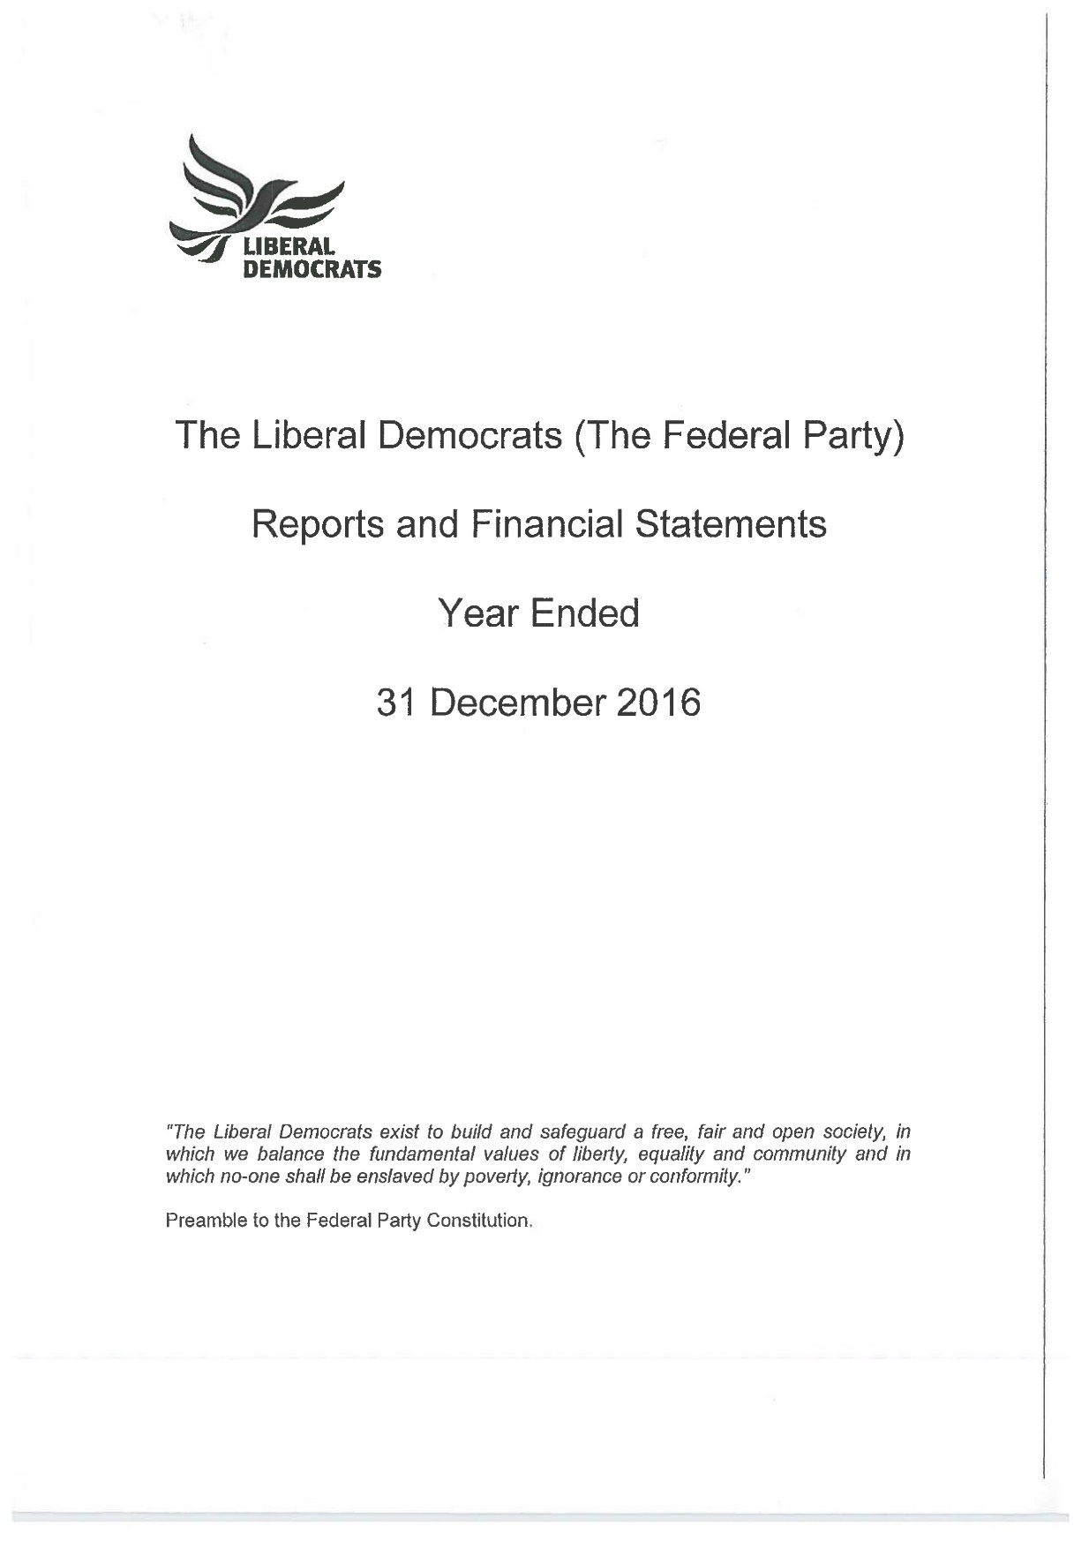
Federal Party Accounts
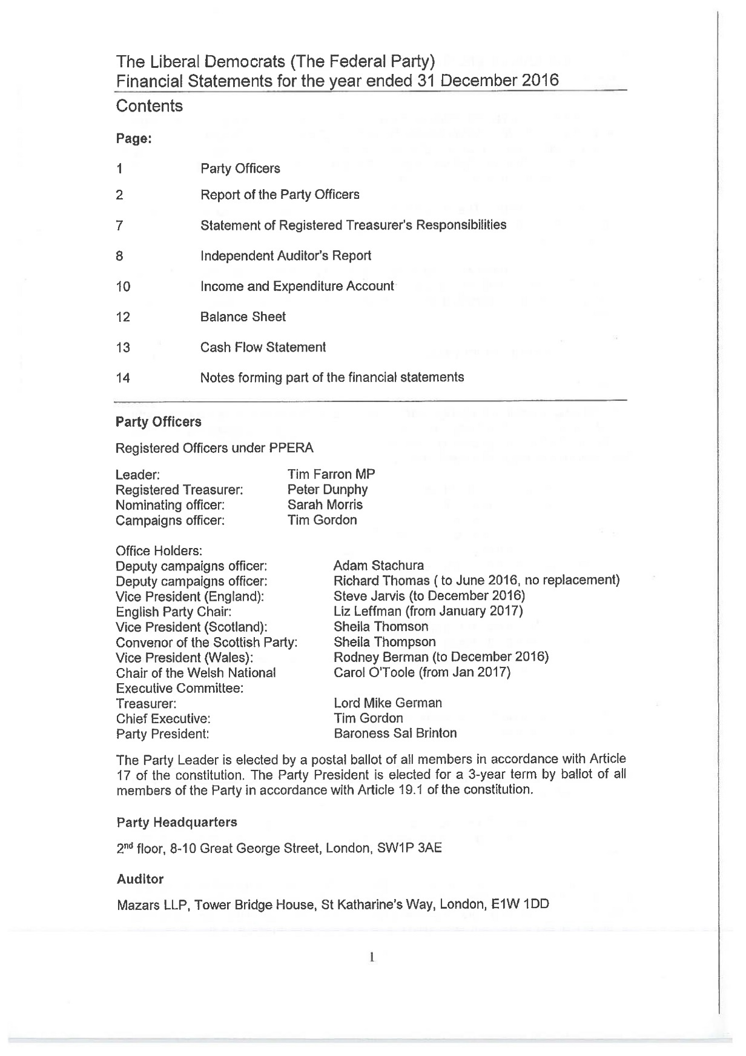
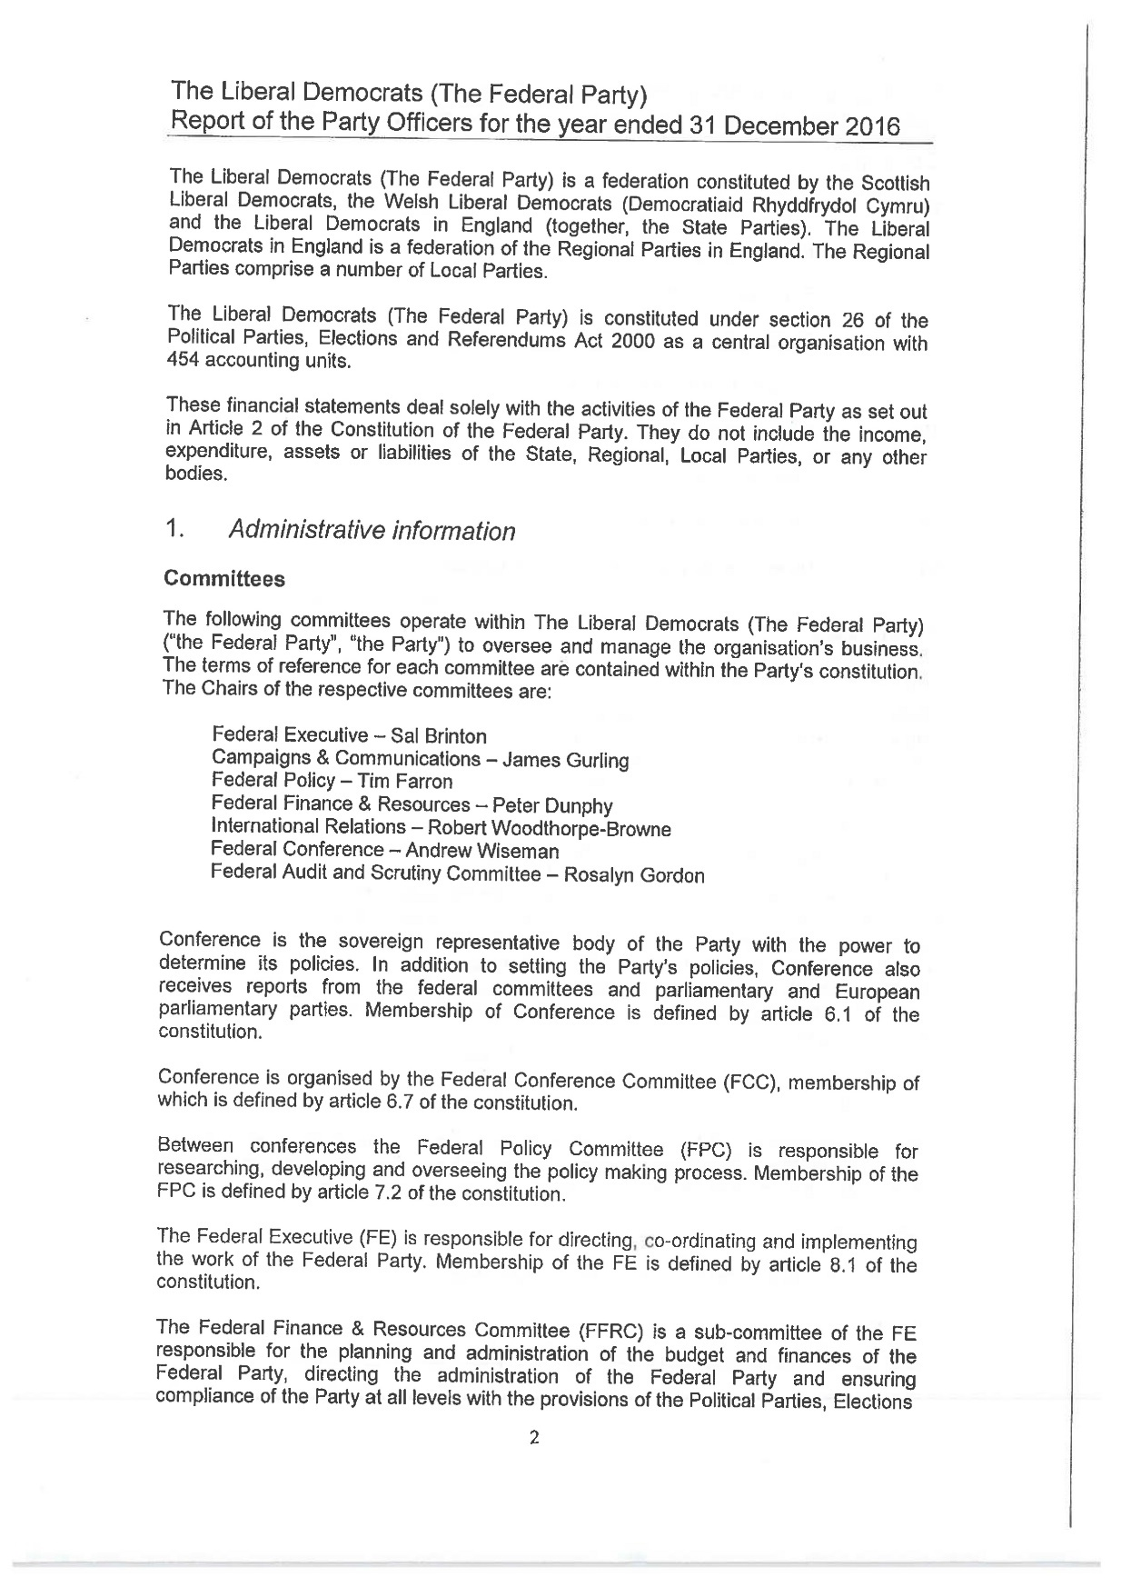
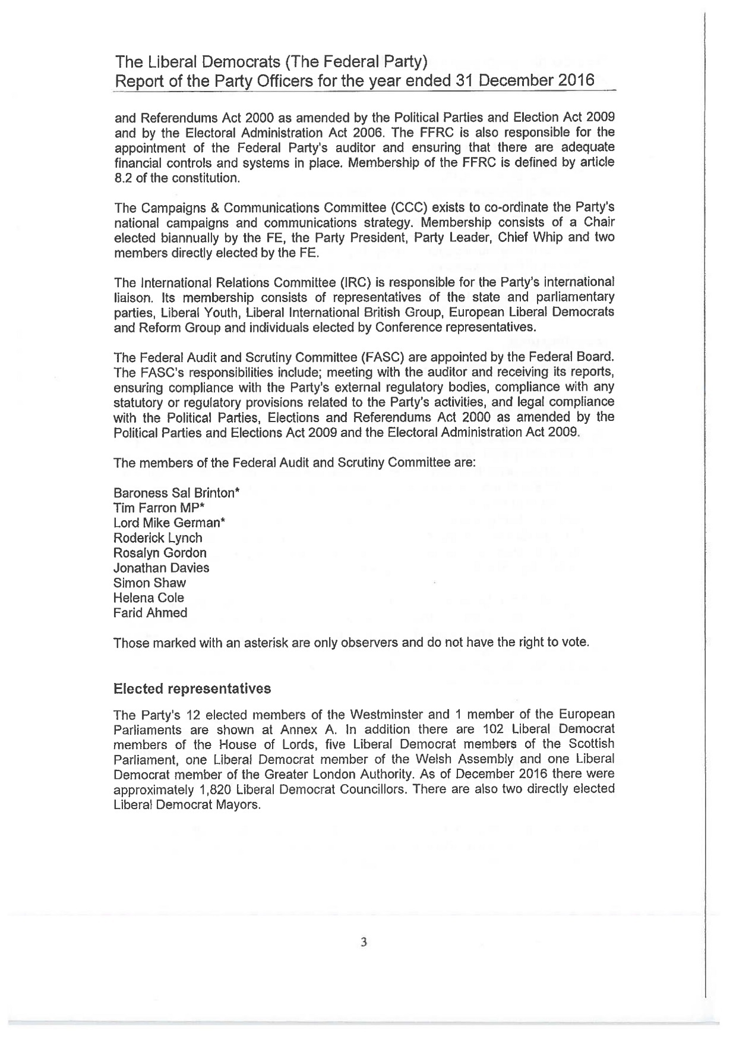
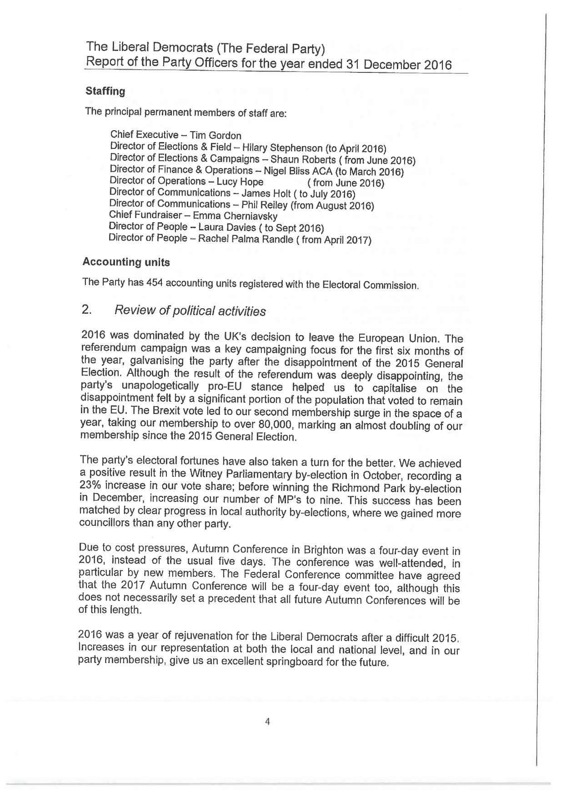
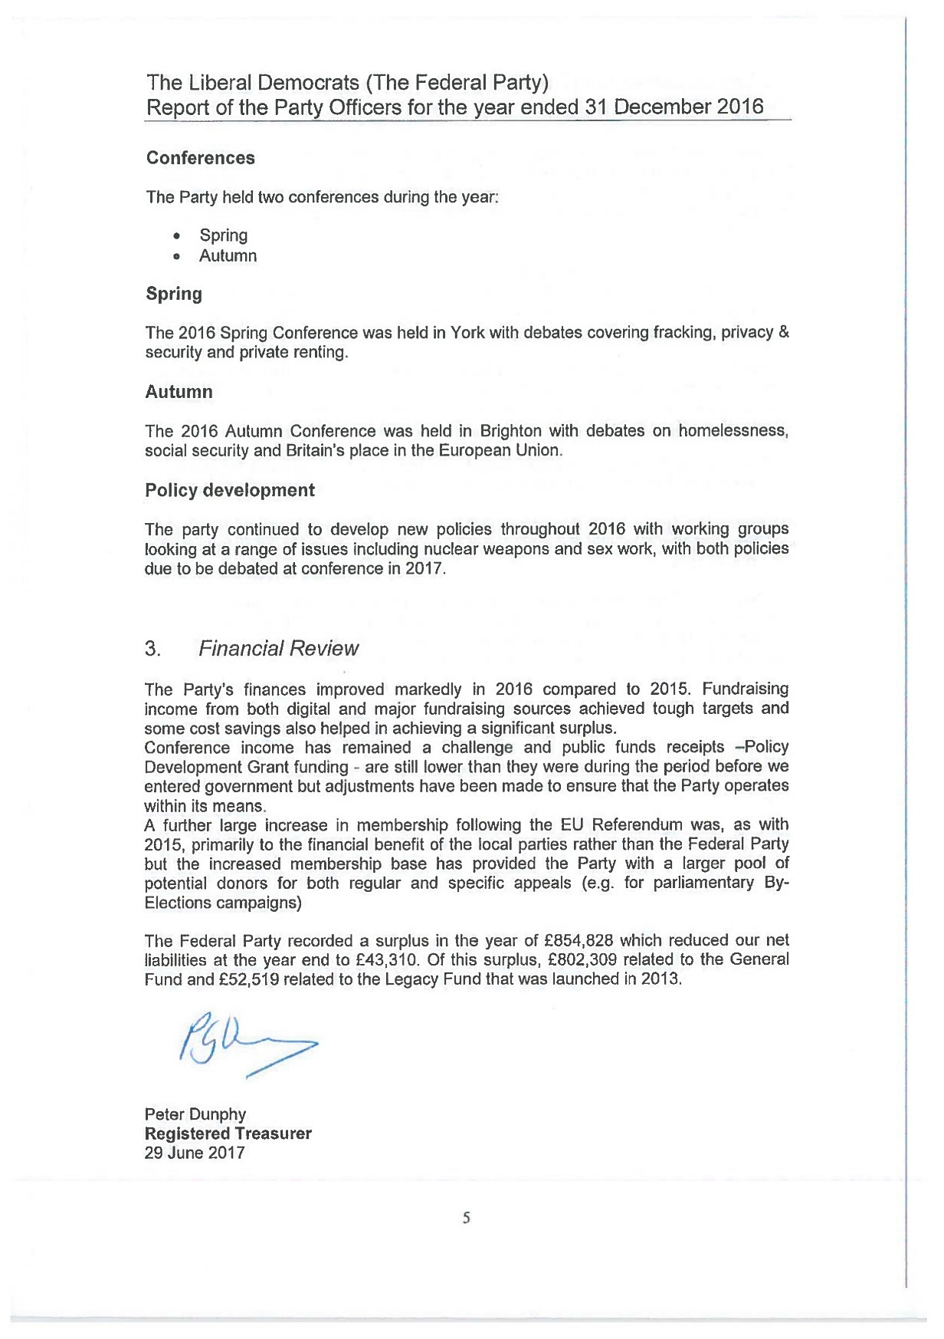
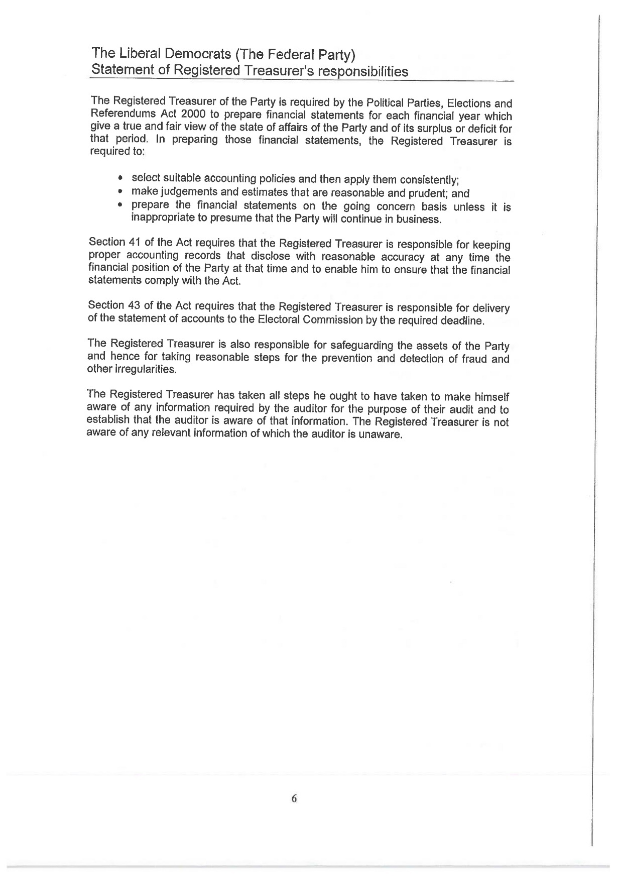
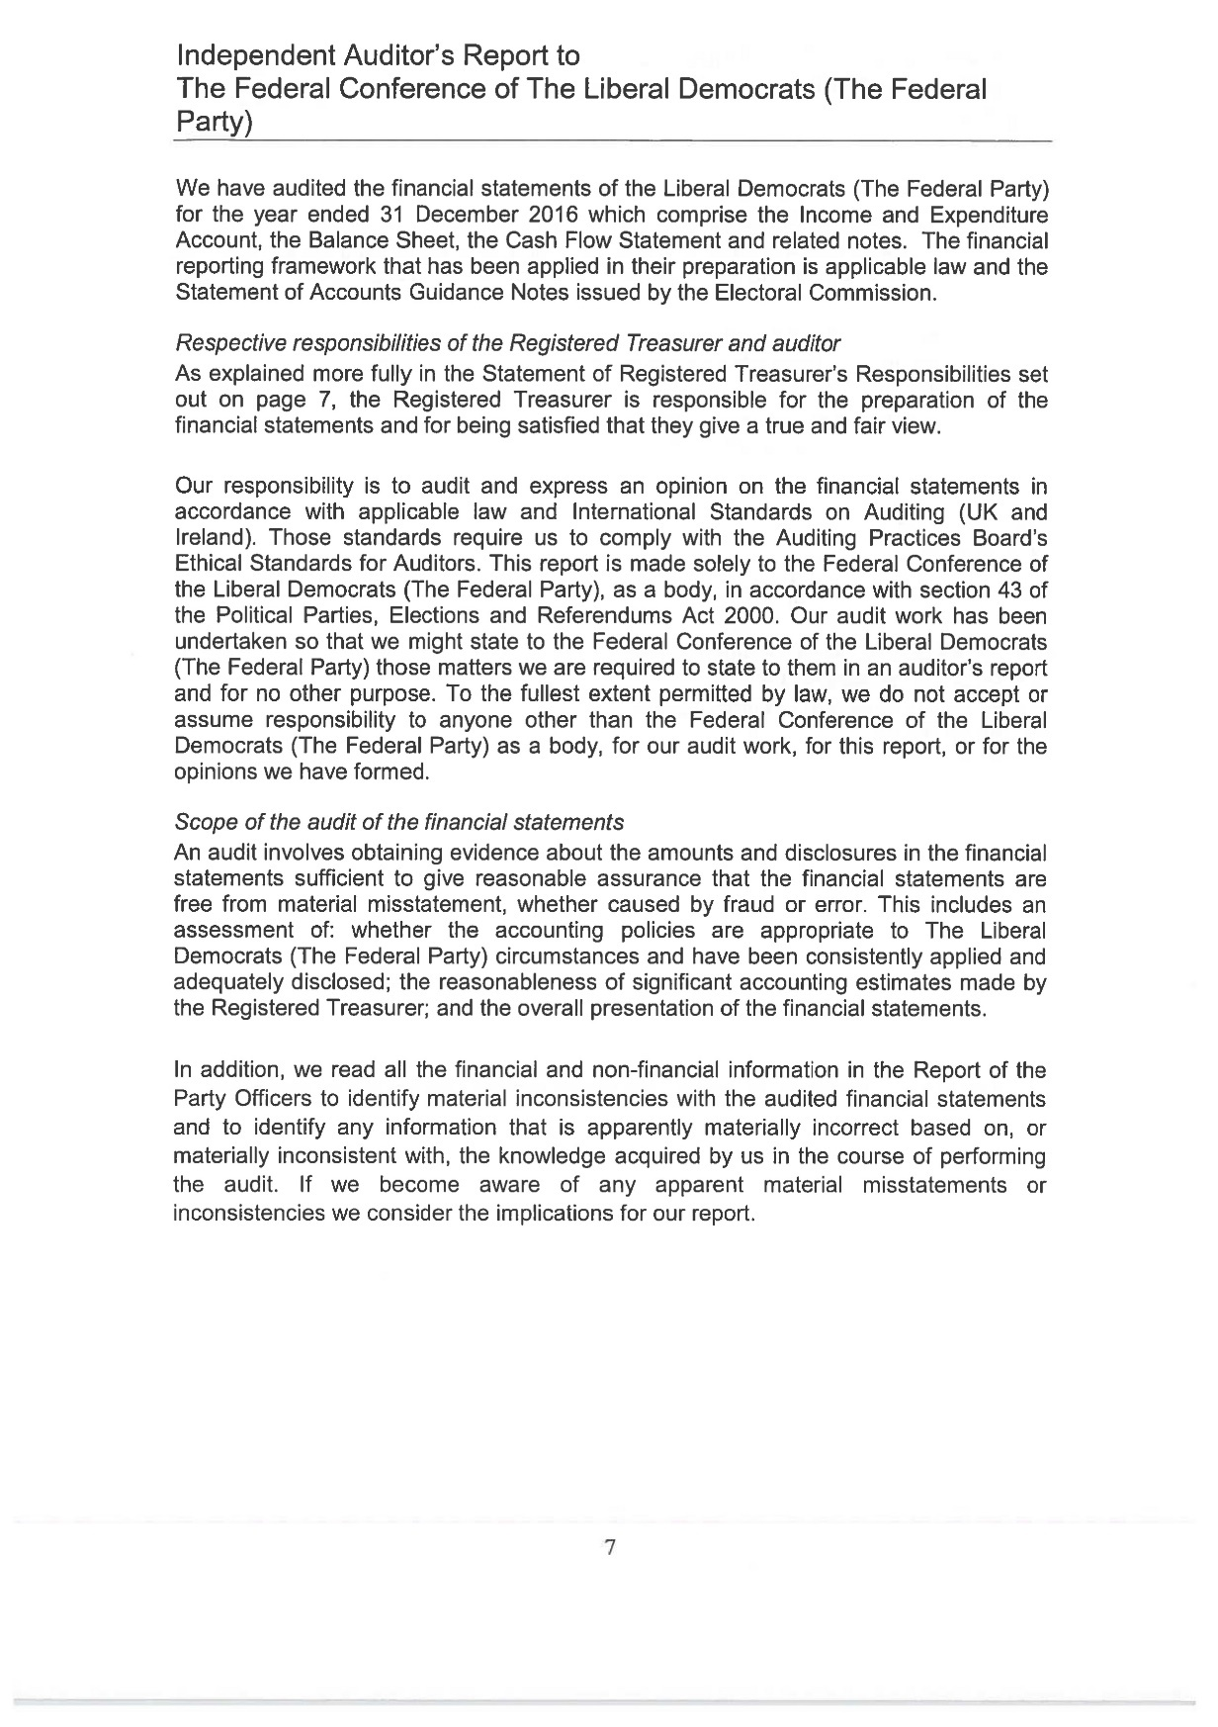
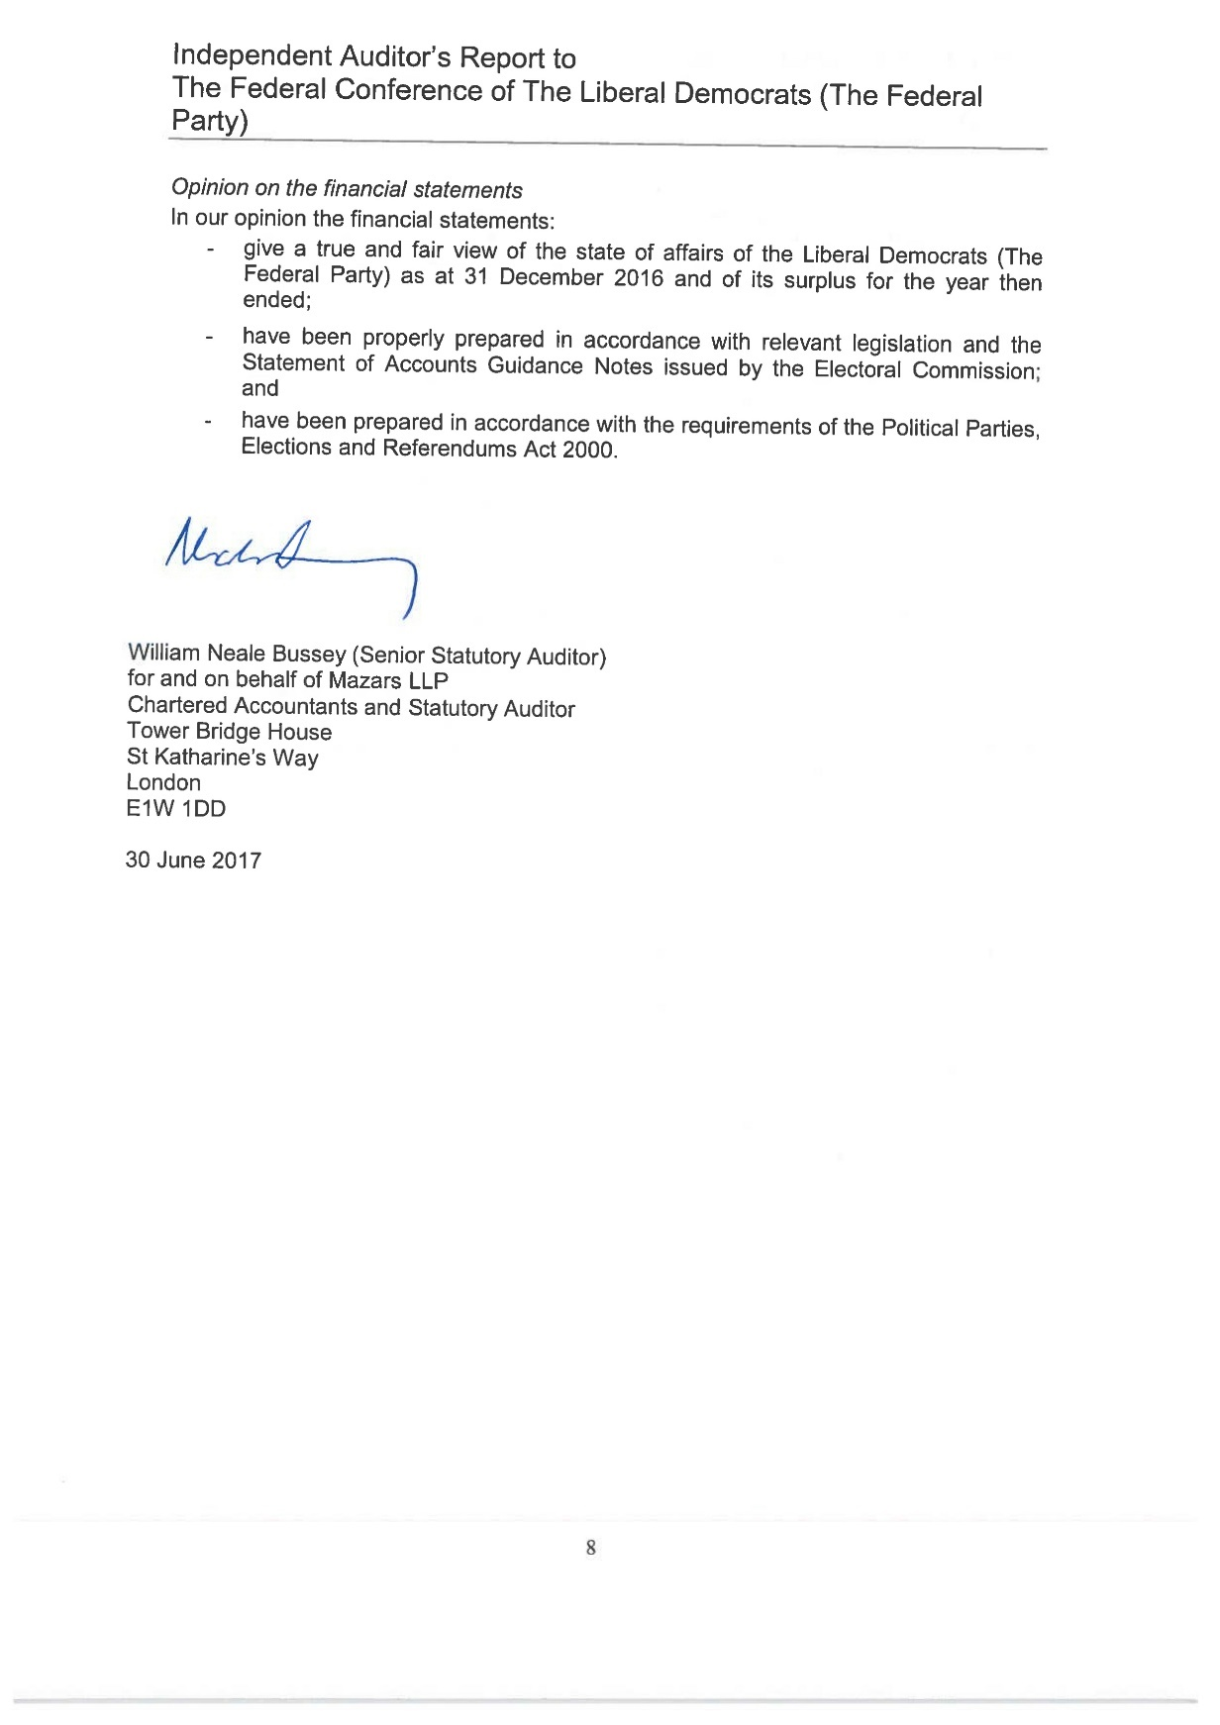
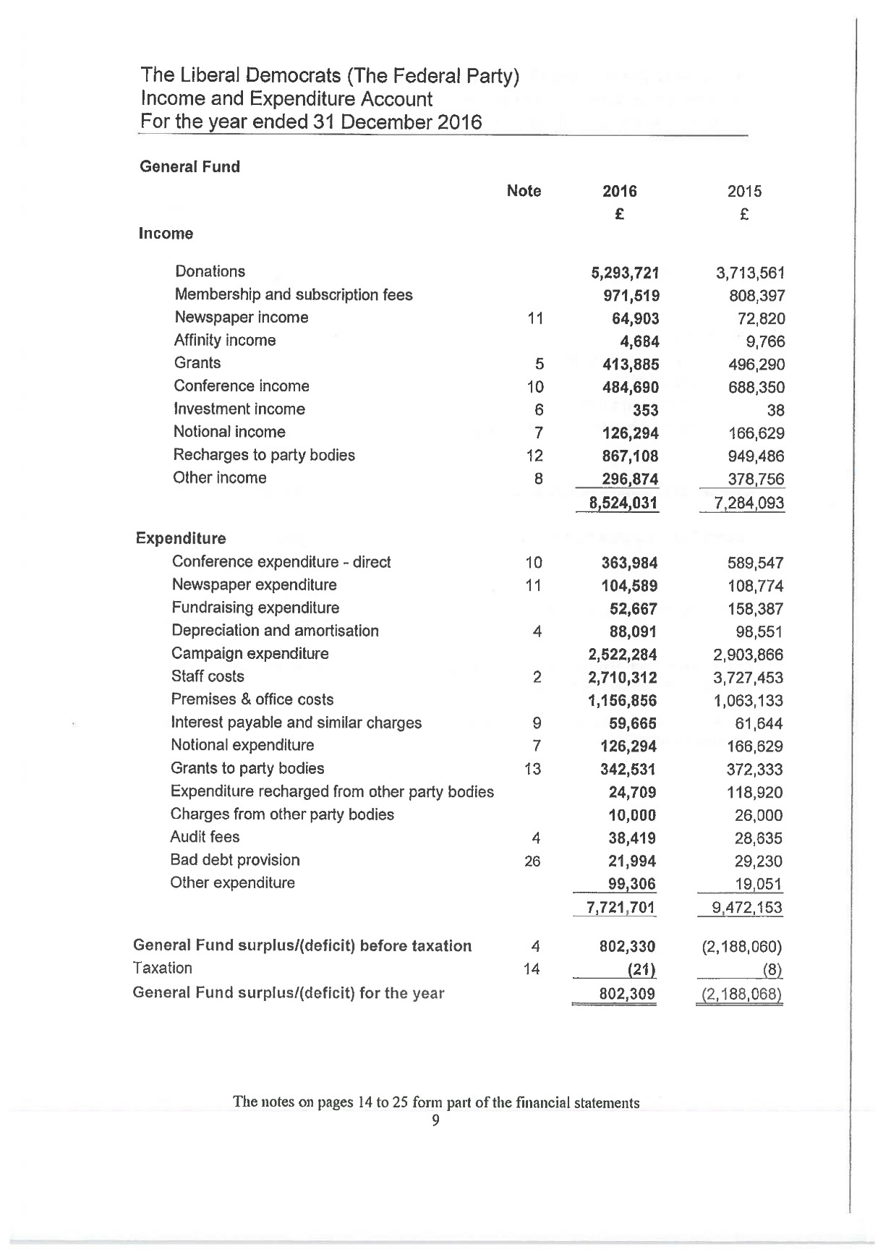
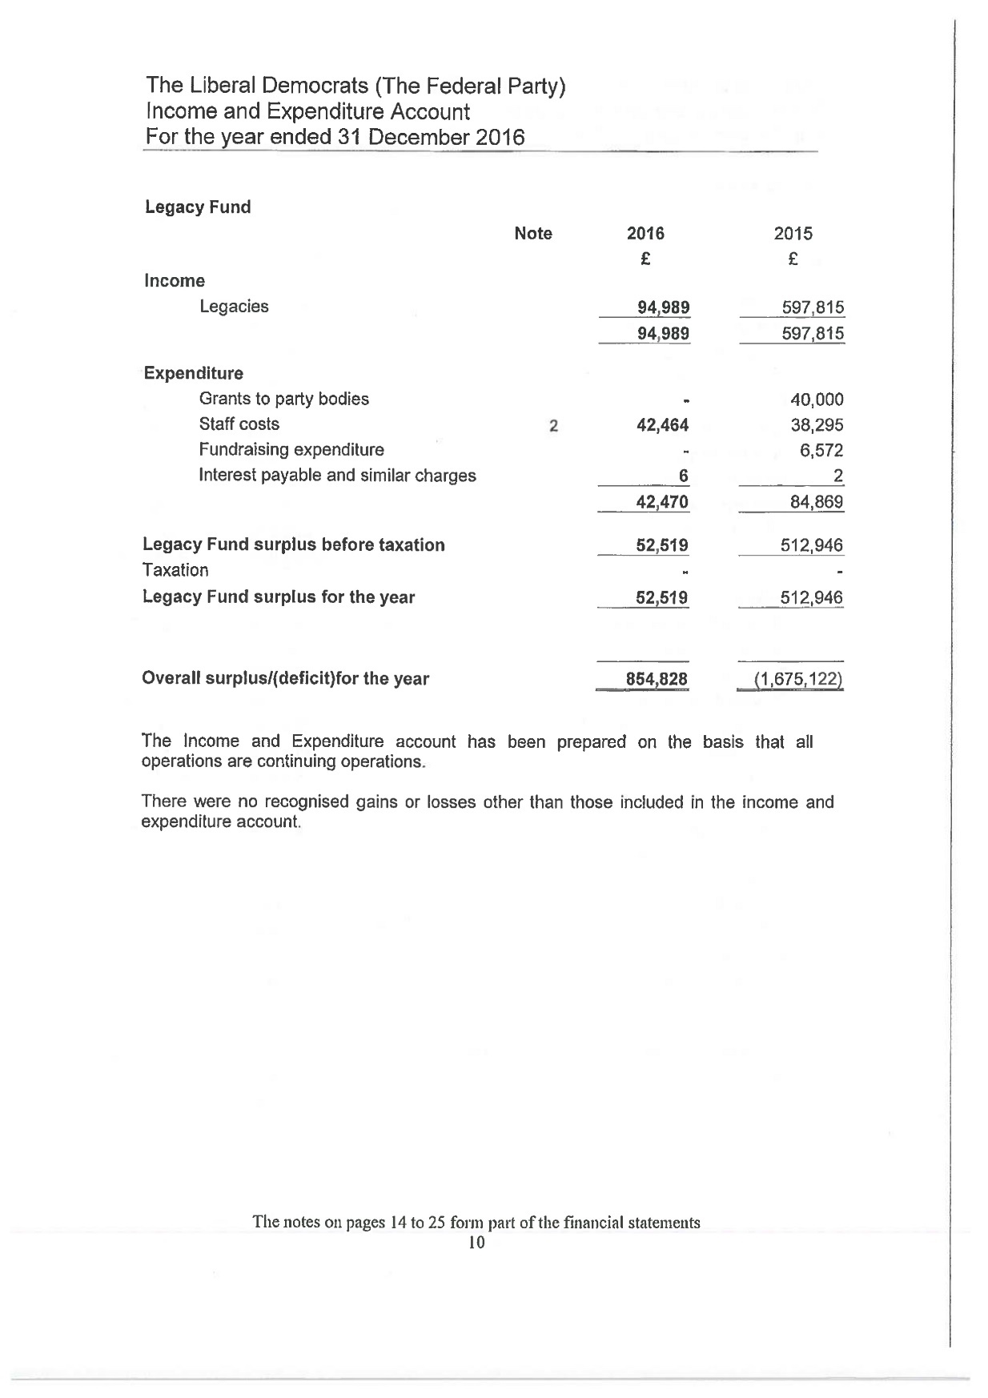
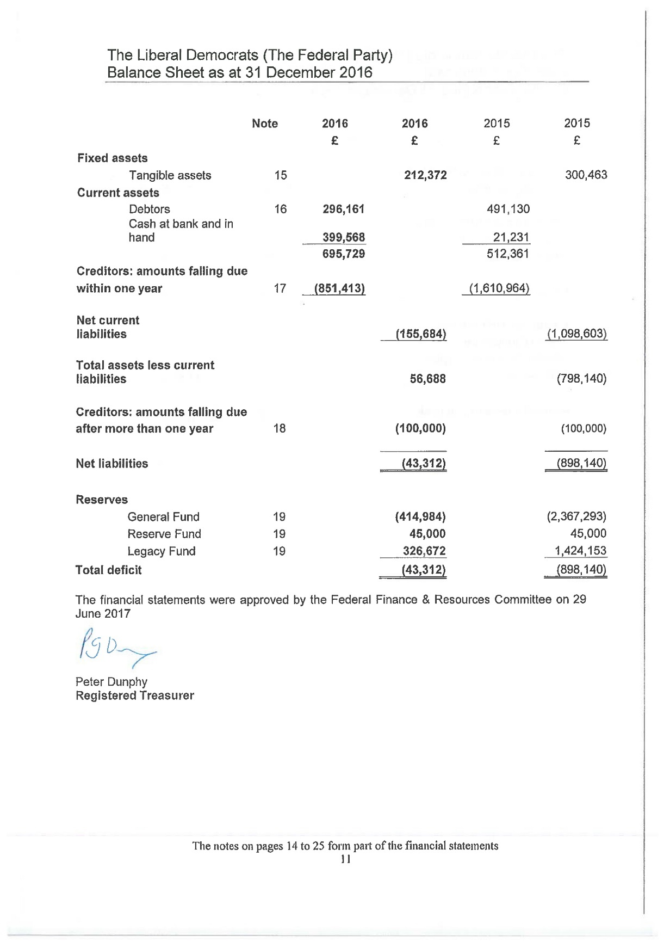
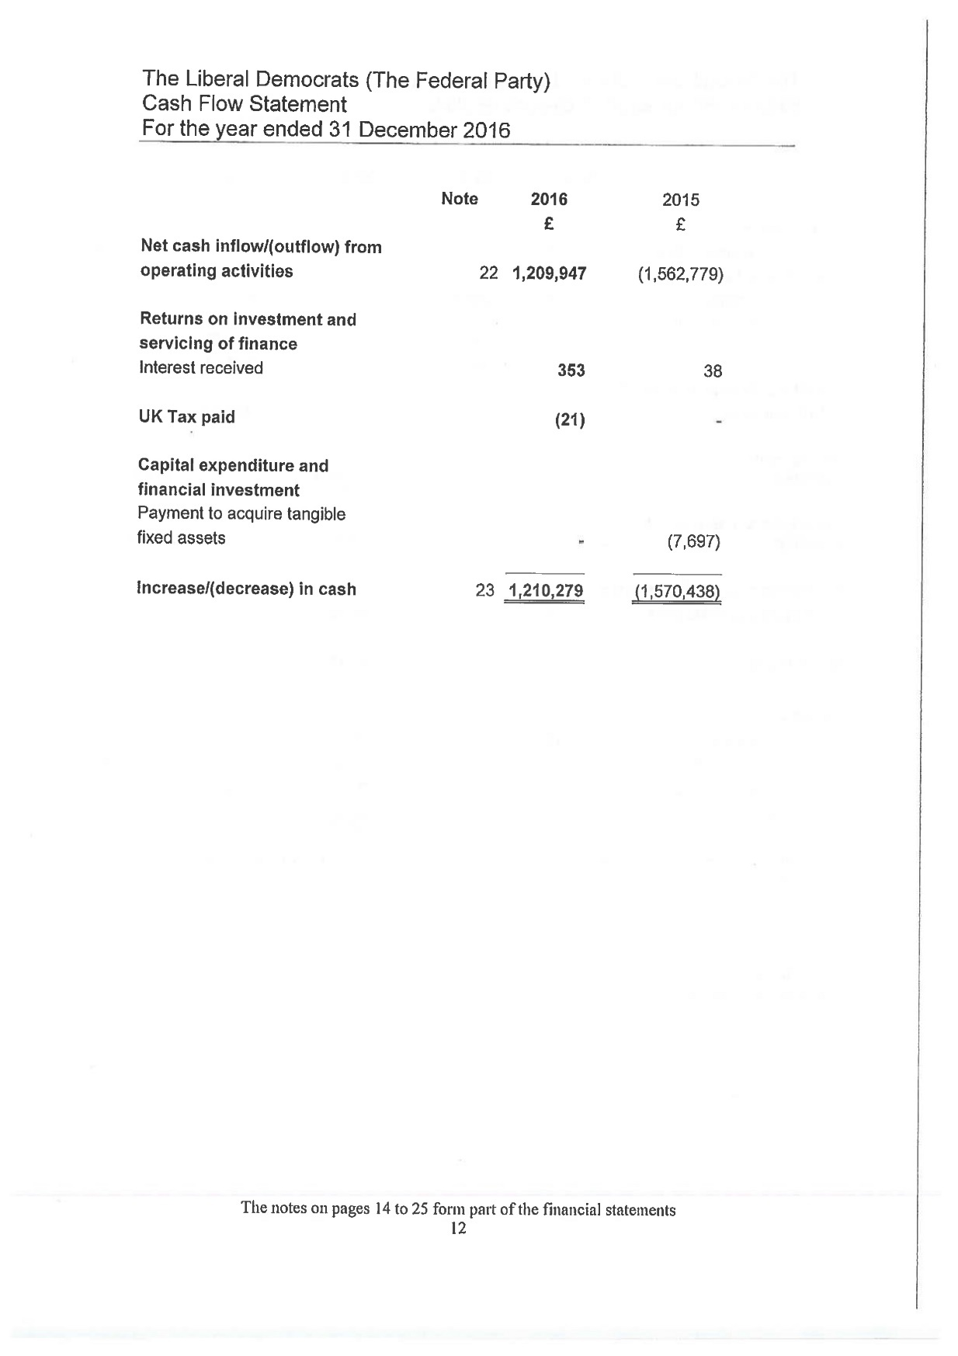
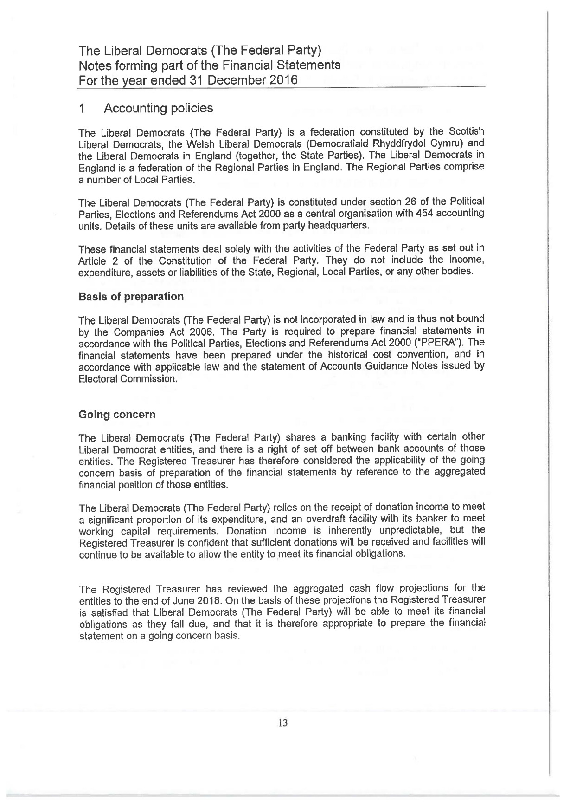
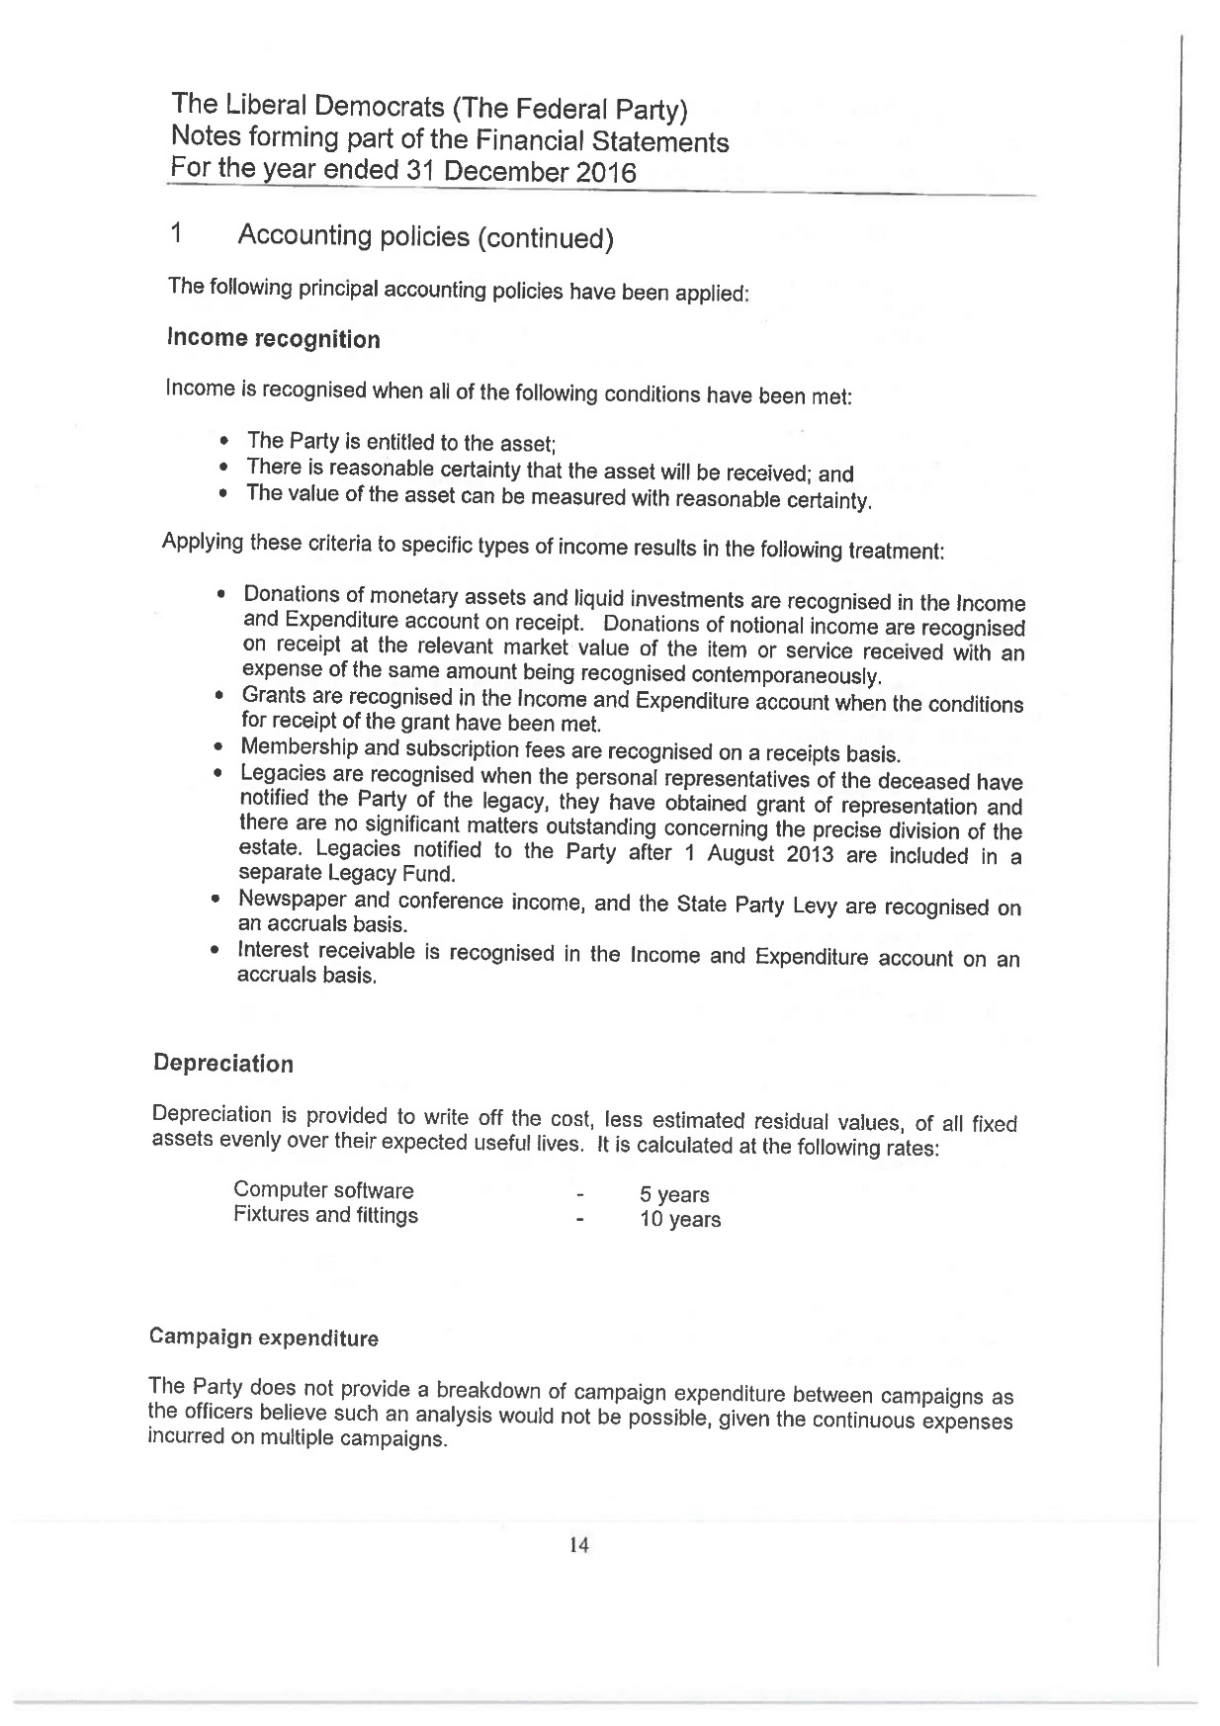
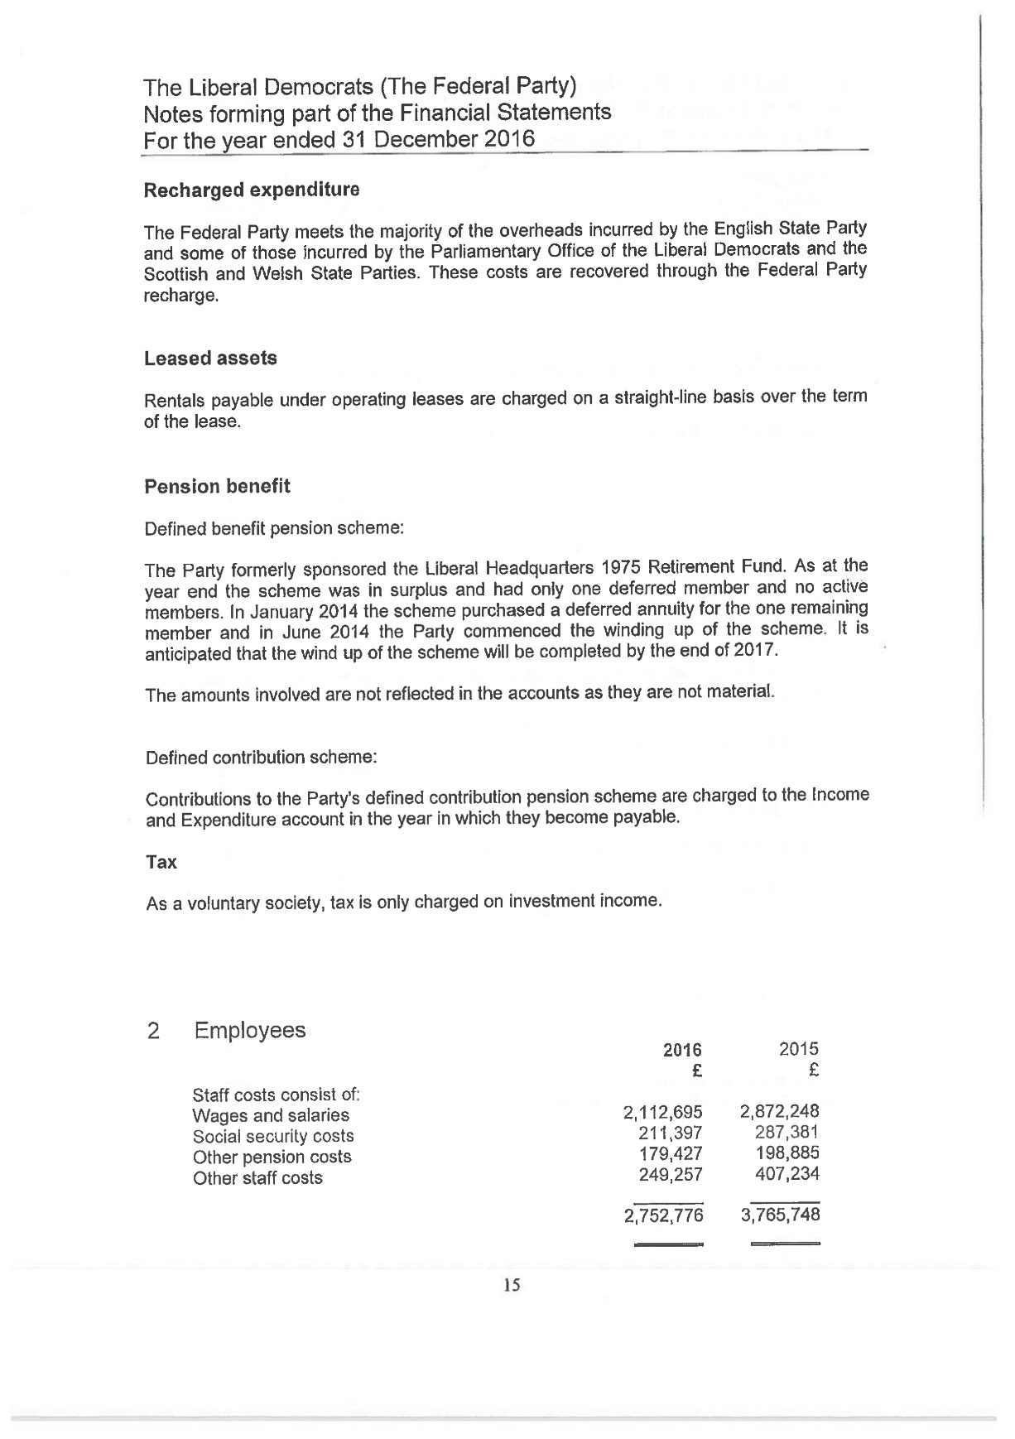
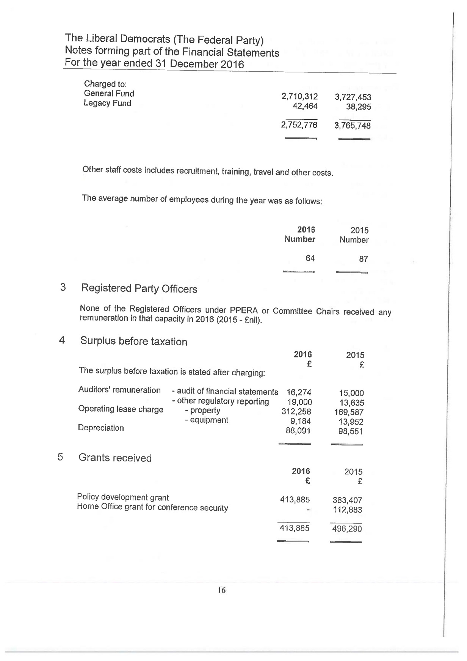
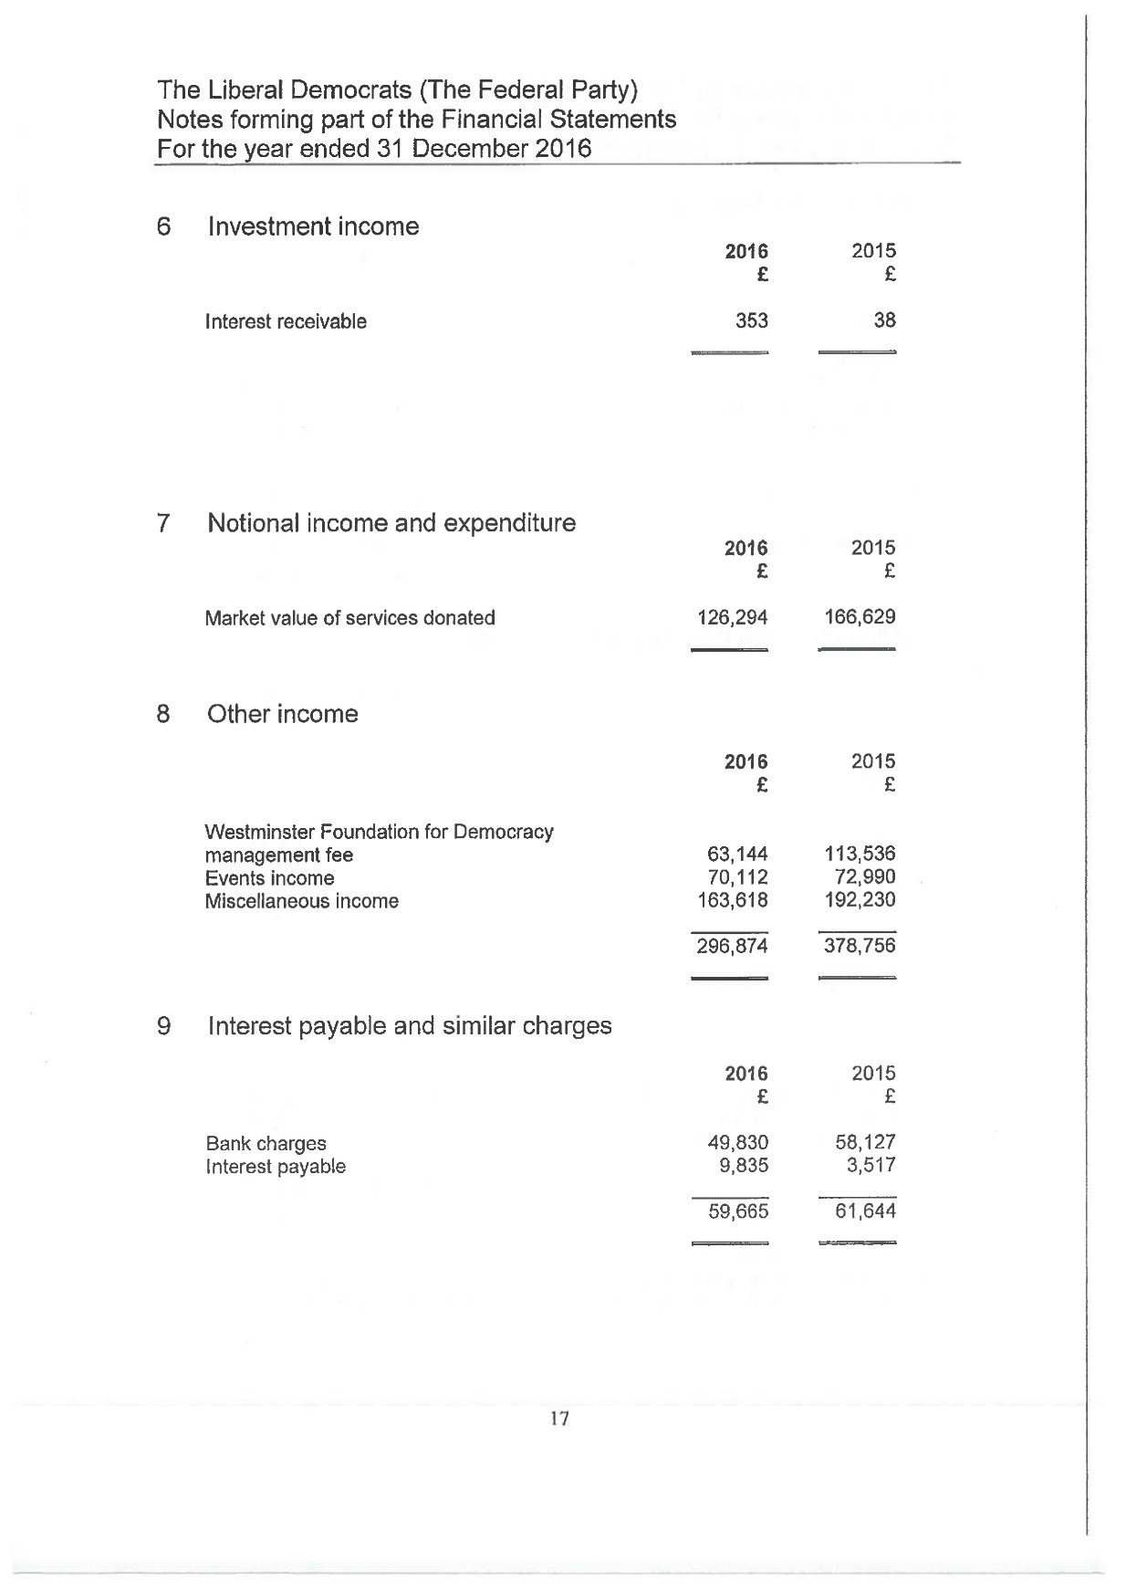
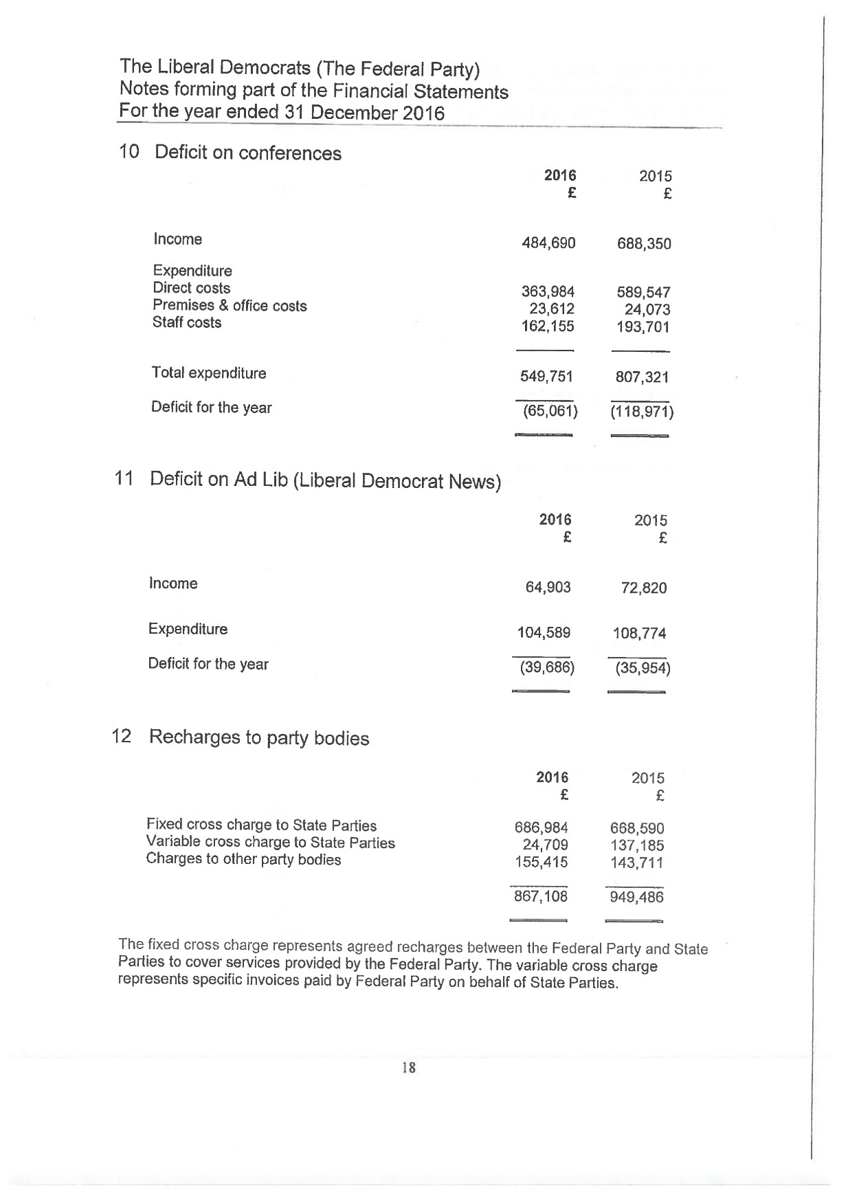
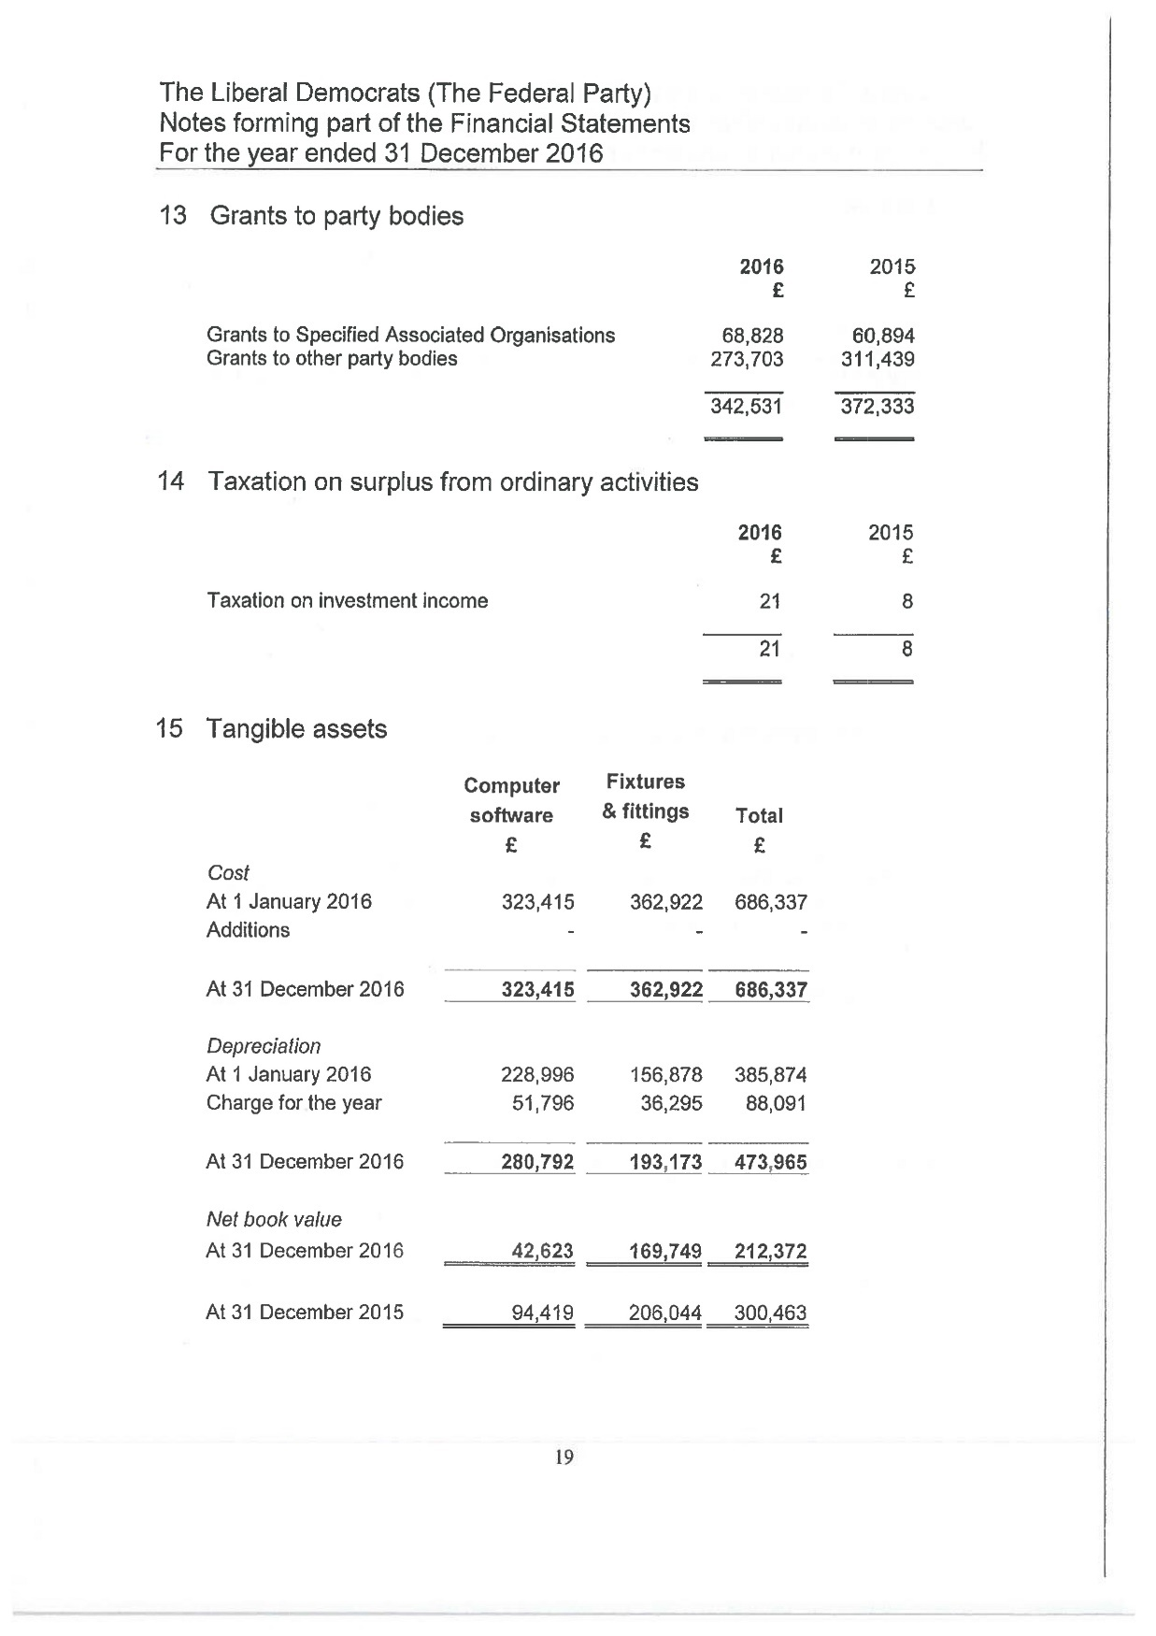
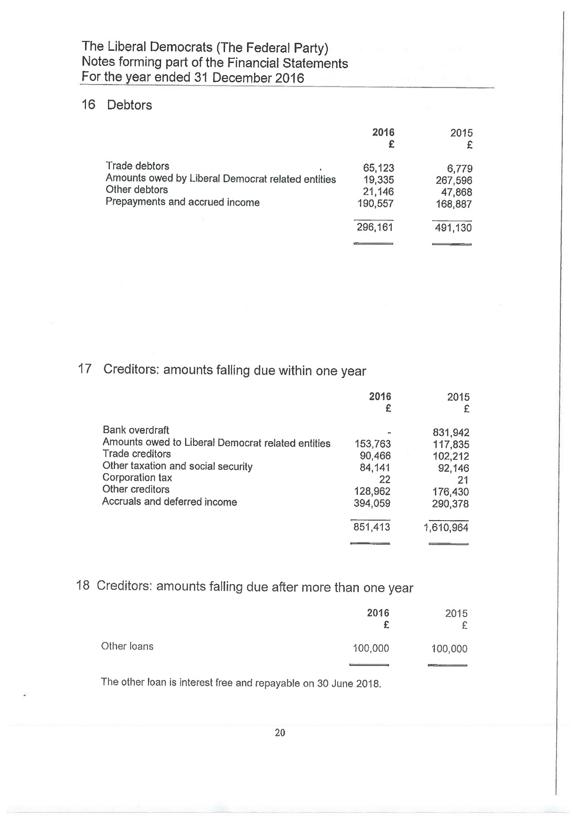
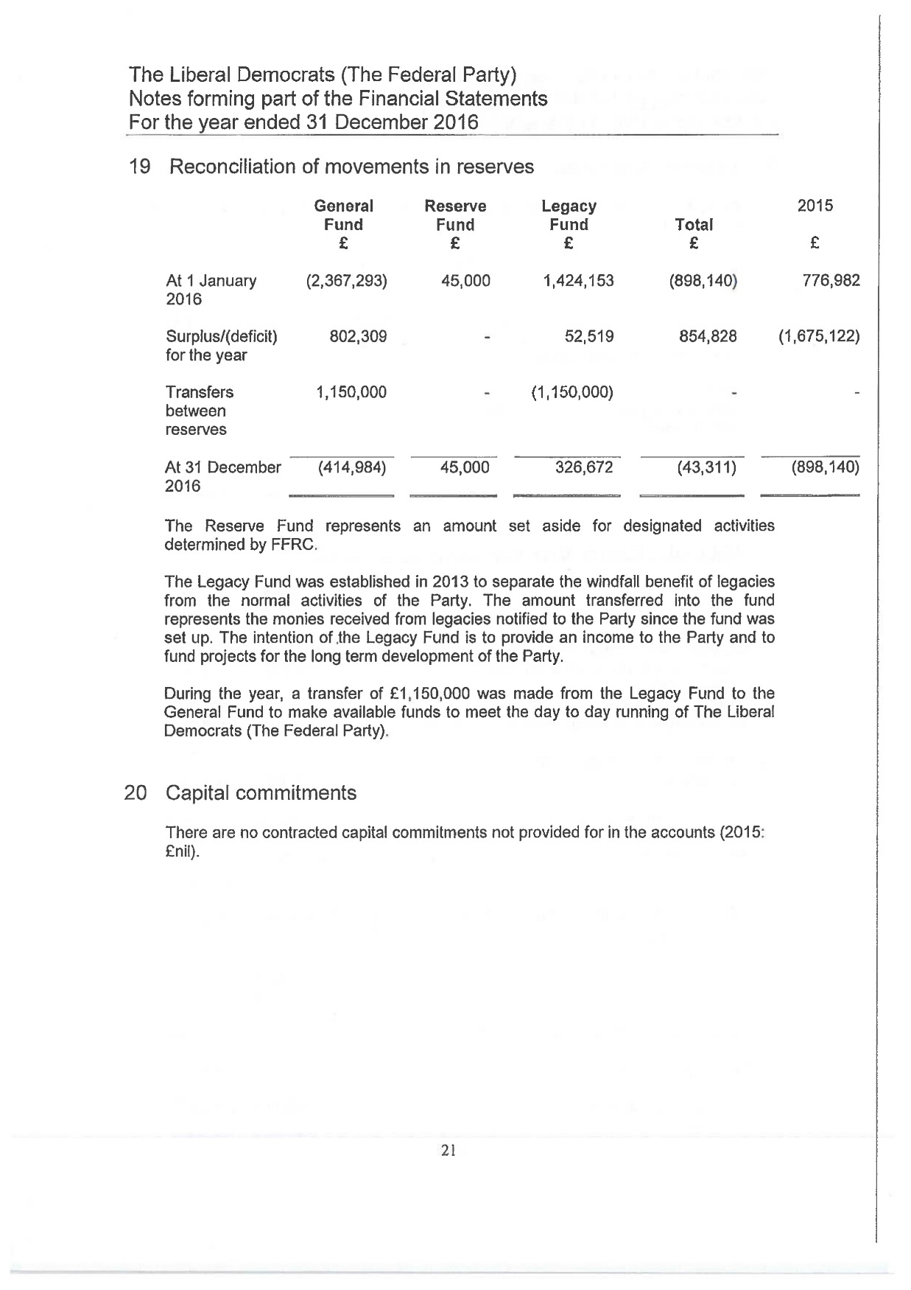
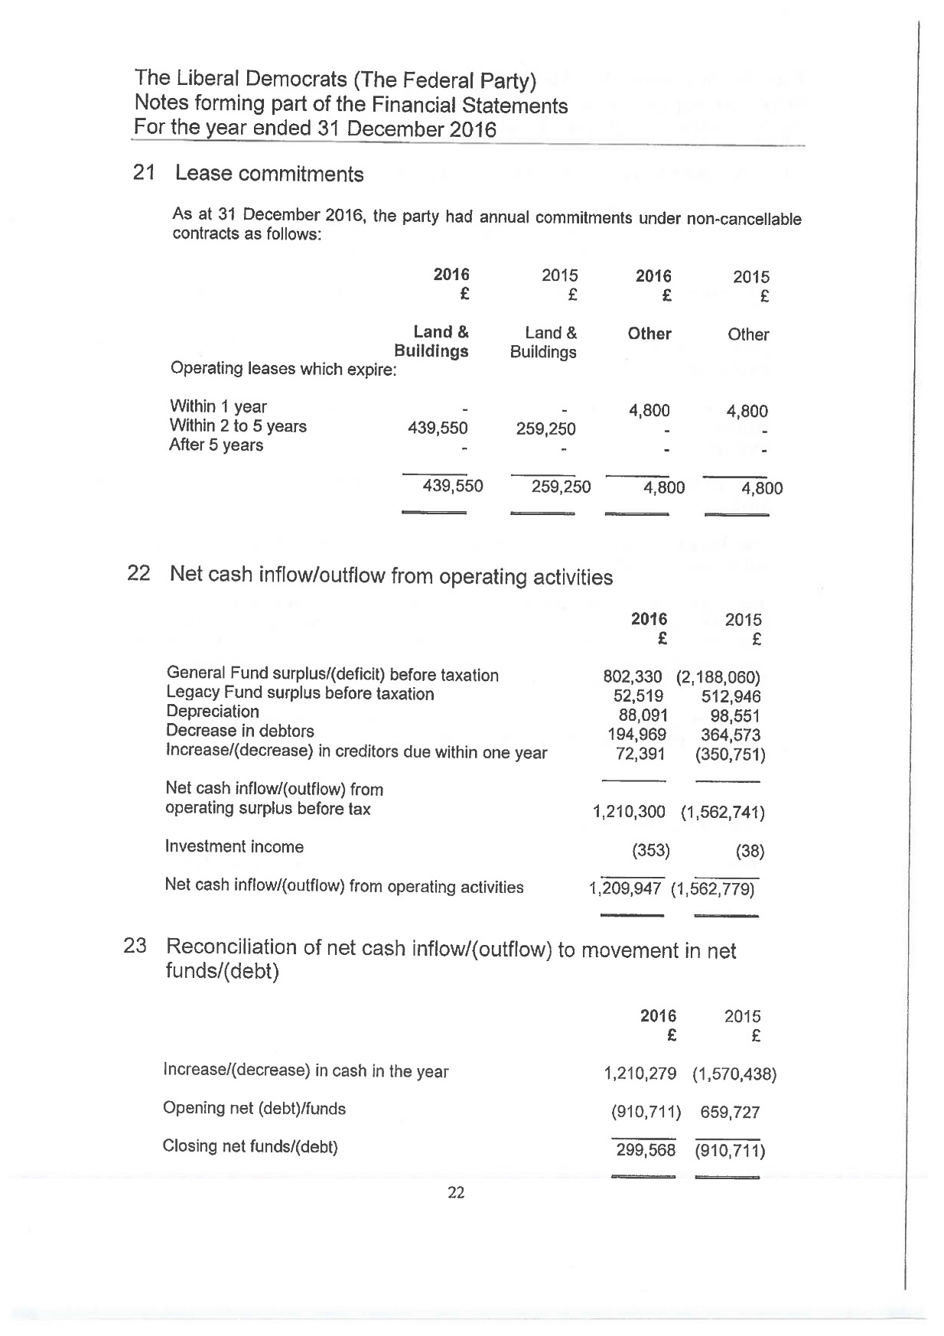
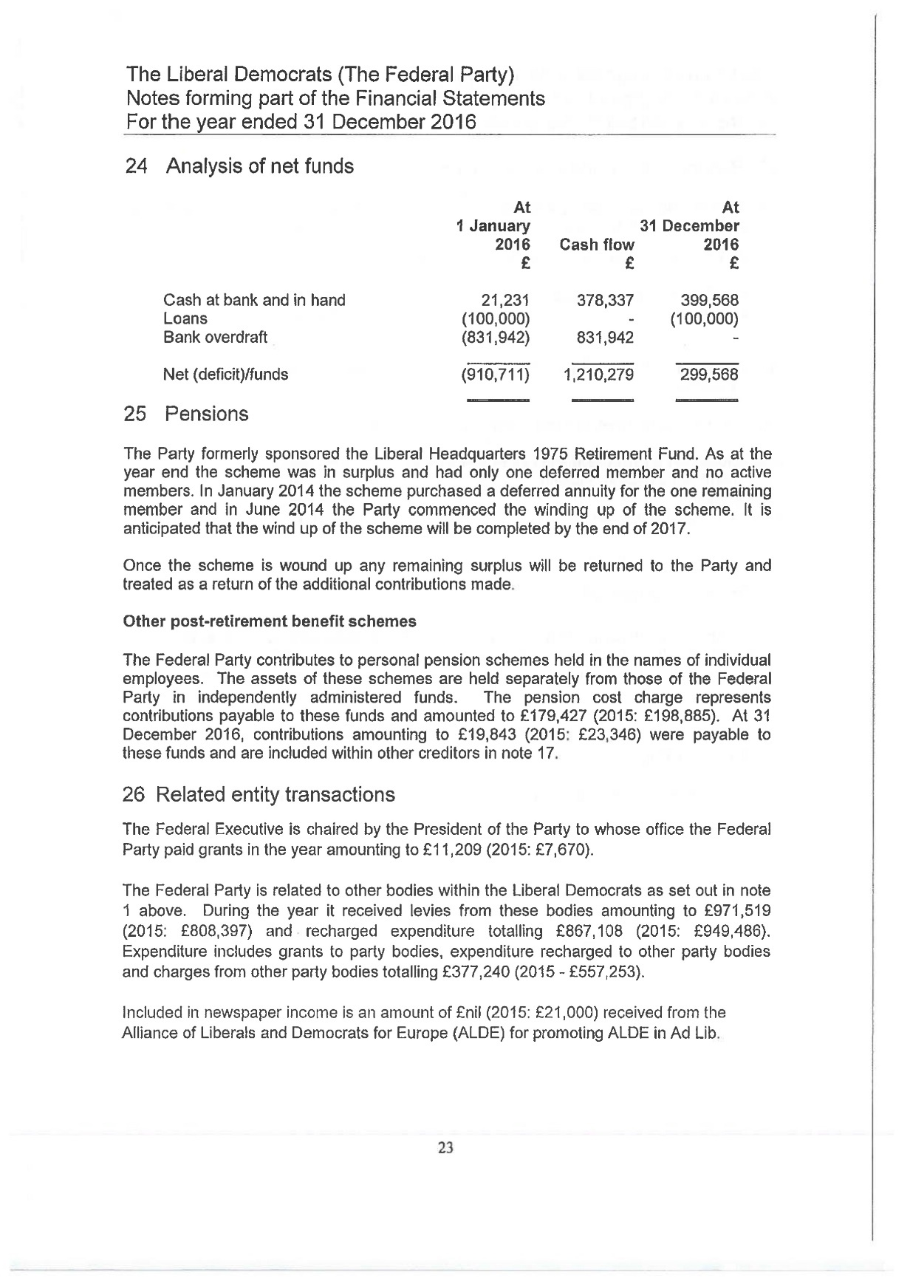
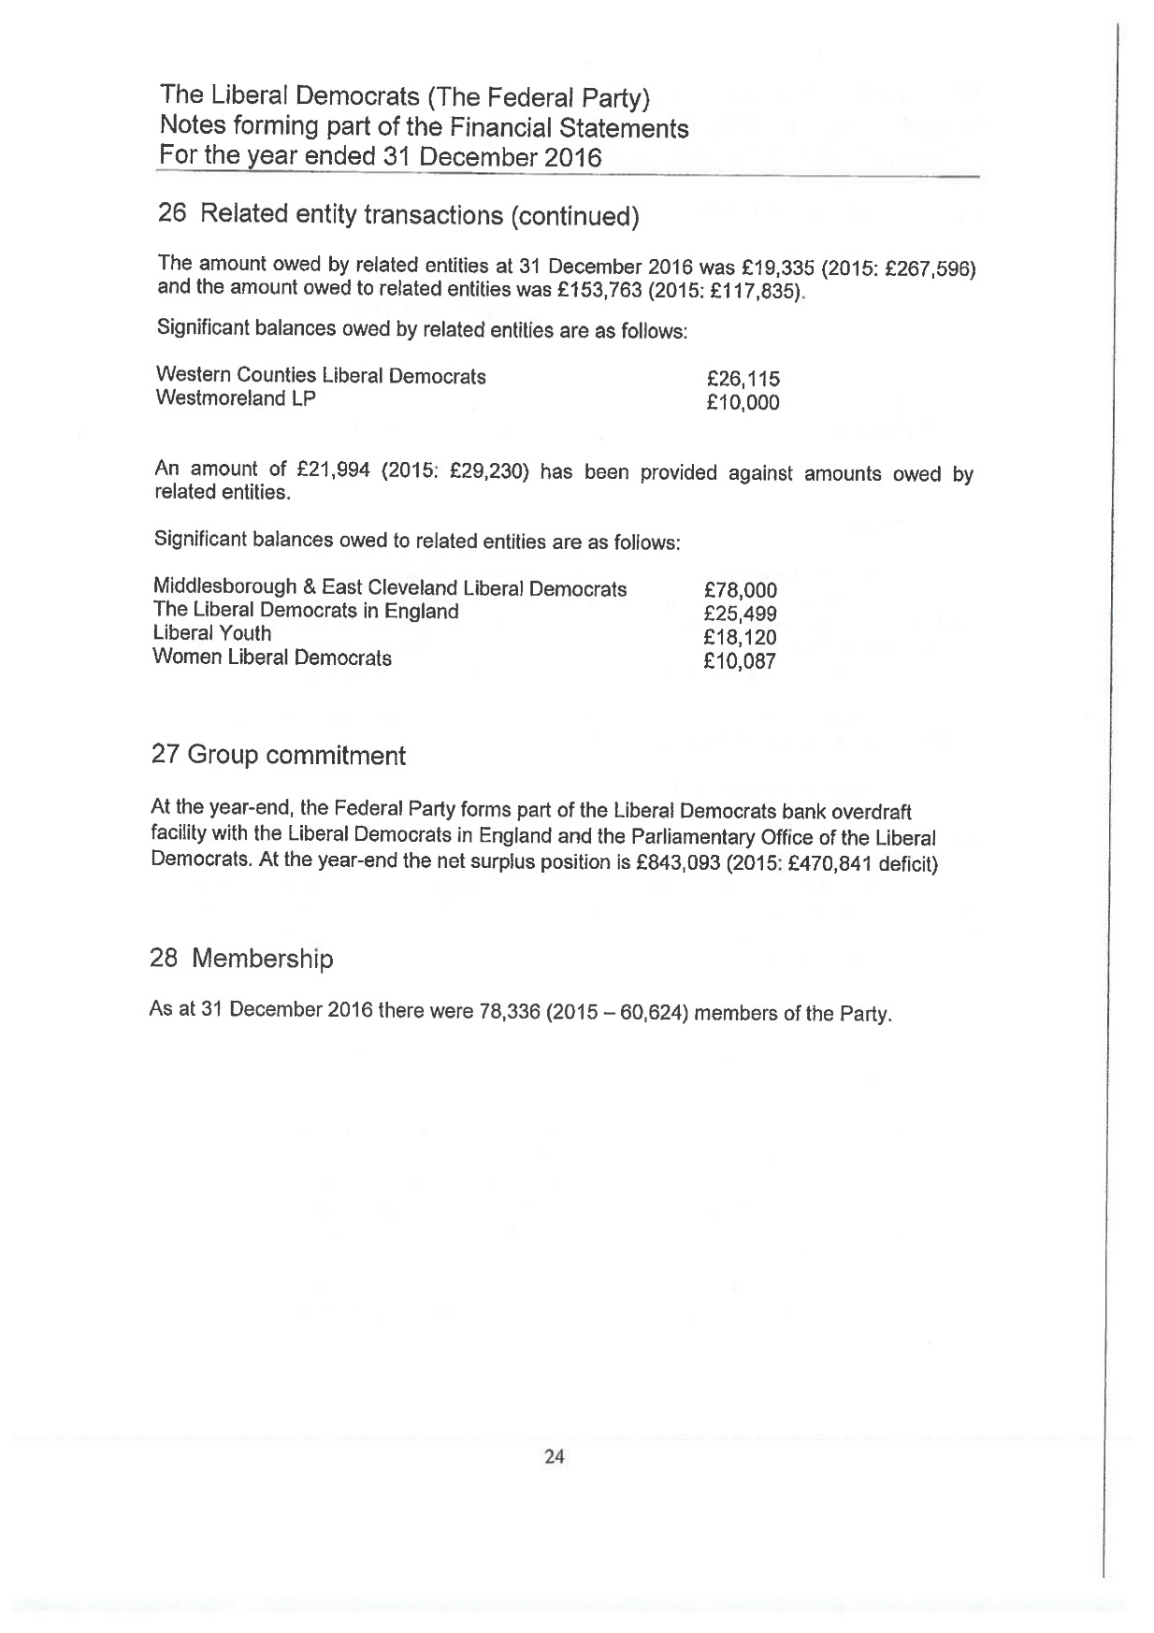
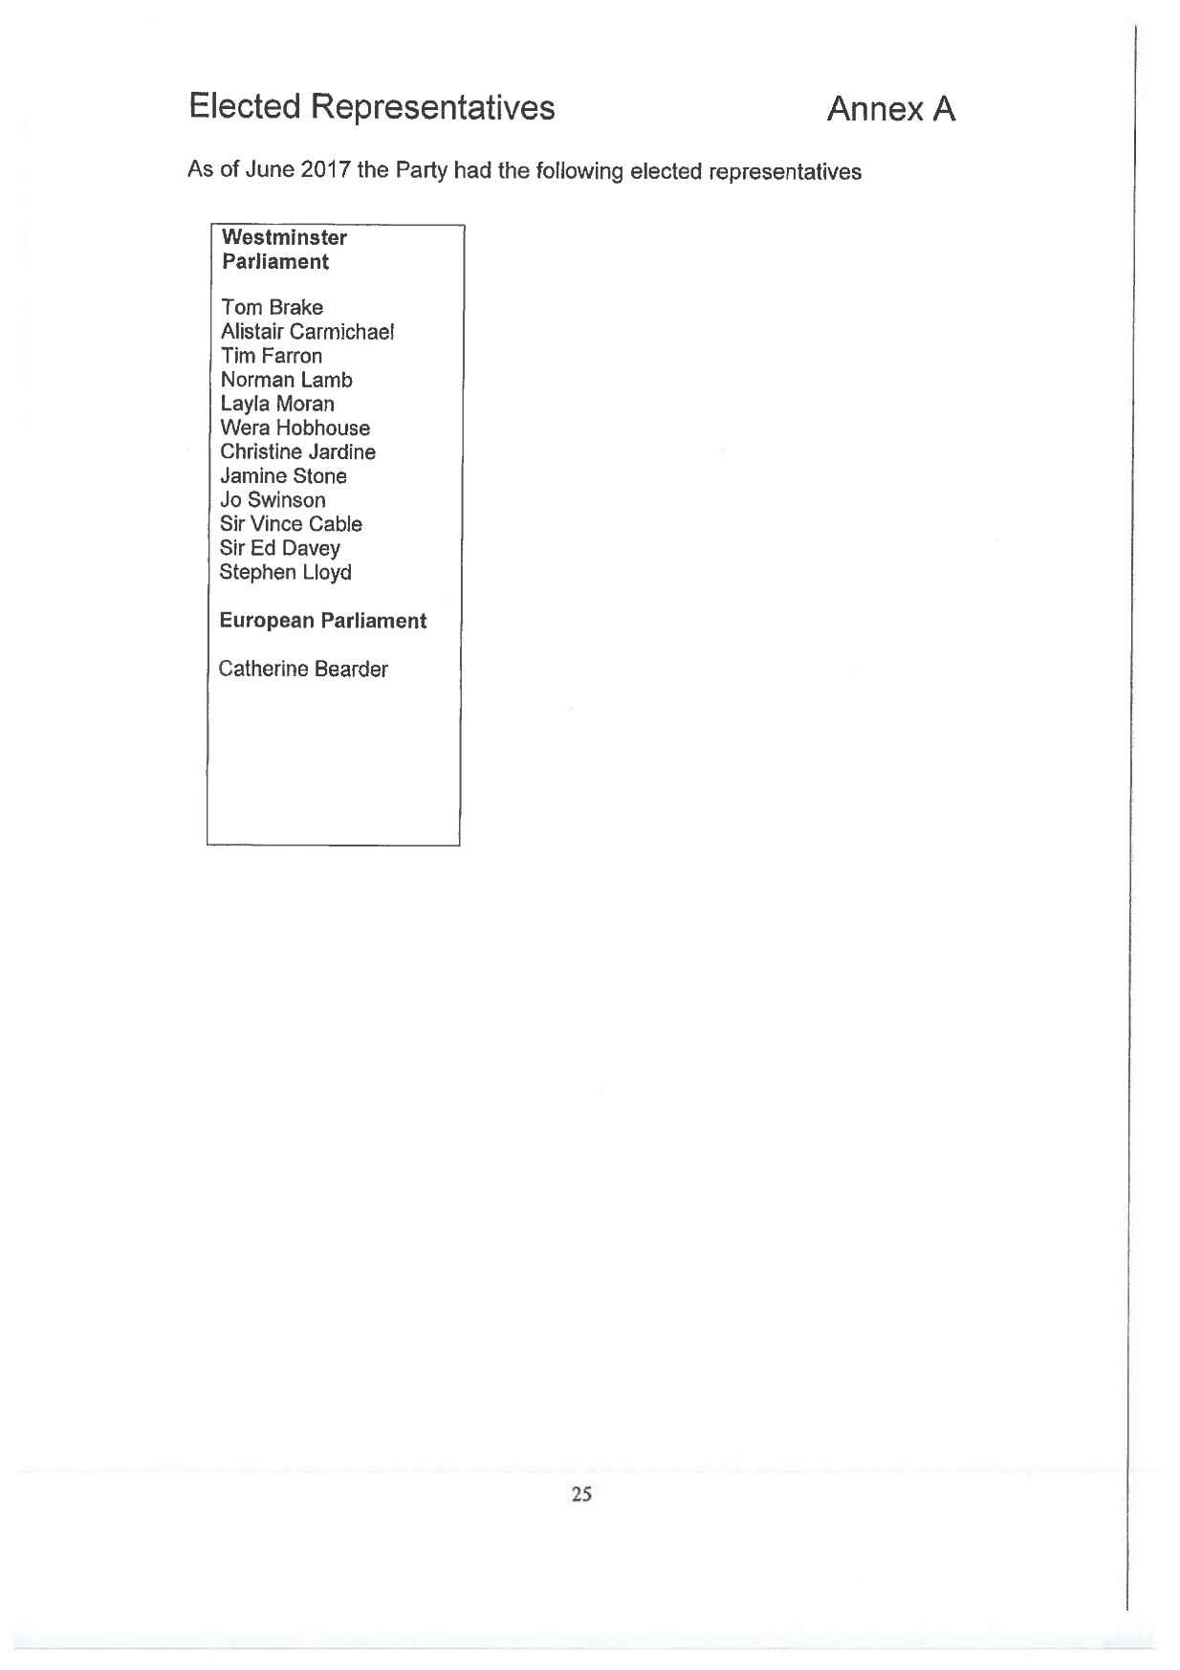

THE LIBERAL DEMOCRATS LIMITED
Directors' Report to the Members for the year ended 31 December 2016
The Directors submit their report for the year ended 31 December 2016, and the Company's balance sheet as at that date.
By virtue of Article 8.3 of the present Constitution of the Liberal Democrats ("the Party"), the function of the Company is to acquire, hold and dispose of such assets of the Federal Party (as defined in that Constitution) as the Federal Executive (as so defined) may from time to time direct.
Where the Company enters into any transaction, it does so as trustee and/or agent for the Party. On this basis, the Company is dormant within the meaning of Section 1169 of the Companies Act 2006 and does not prepare a profit and loss account.
The Directors of the Company during the year ended 31 December 2016 were:
- Duncan Greenland (Chairman)
- Lord Navnit Dholakia
- Peter Dunphy
- Eric Lowry (Company Secretary)
- Baroness Kate Parminter
- Lady Elizabeth Vallance
Signed on behalf of the Board
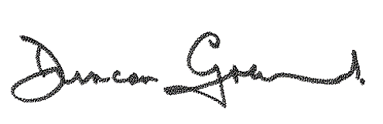
Duncan Greenland
Director
18 July 2017

Registered in England
No. 2231620

Registered Office
LDHQ
8-10 Great George Street
London
SW1P 3AE
THE LIBERAL DEMOCRATS LIMITED
Balance Sheet as at 31 December 2016

£
Assets NIL
Liabilities NIL
The Company is entitled to exemption from audit under sections 475 and 477 of the Companies Act 2006 for the period ended 31 December 2016. No members have required the company to obtain an audit of its financial statements for the period ended 31 December 2016 in accordance with Section 476 of the Companies Act 2006.
The Directors acknowledge their responsibilities for complying with the requirements of the Companies Act 2006 with respect to accounting records and preparation of accounts.
These financial statements have been prepared in accordance with the provisions applicable to companies subject to the small companies’ regime.

Approved by the Board on 18 July 2017
Duncan Greenland
Director

Parliamentary Party Report (Commons)
Since we last met in Brighton the parliamentary party has seen big changes. We have new MPs, a new Leader and a new Chief Whip writing this report. Politics since the last conference has been dominated by Brexit and the snap General Election and while neither were particularly welcome, I am pleased to be able to report to you from a larger and more diverse Commons parliamentary party.
It was however a tough campaign and I would like to thank every single one of you for your help.
I would like to put on record my thanks to our former colleagues: Nick, Mark, Sarah and Greg. They were great servants to the party and their constituents and to a person deserved to be returned. It was a real sadness to lose them from our ranks but everyone connected with their campaigns deserves a huge amount of thanks and appreciation for their efforts in fighting until the end.
My tributes also to Dr John Pugh who decided not to re-stand in June. John was in the 2001 intake with me and I am lucky enough to be able to consider him a friend during our time in Parliament.
Losing Sarah so soon after her by-election victory in December is particularly difficult blow. In her short time in Parliament she made a real impact and showed tremendous skill and judgement. She can’t return to the Commons soon enough in my view and with Brexit looming Parliament certainly needs as many Sarah Olneys as it can get its hands on.
I must pay tribute to Tim Farron. Leading the Party following the defeat we suffered in 2015 was never going to be easy for anyone but Tim brought much needed energy to the role and his legacy is one of a party off life support and enjoying its largest ever membership – for which we will all be grateful. His hard work and bold judgement following the Brexit referendum result was not easy but it has undoubtedly reaped dividends and made us relevant in a way felt near impossible in the days following 2015’s result. Tim’s early focus on the refugee crisis made the Government take notice and has saved lives. Whilst the Government continues to fail to live up to its own promises, I know that Tim will continue to highlight the humanitarian crisis that continues on Europe’s southern boarders in the years to come.
My congratulations go to our new Leader, Vince Cable. Having returned to Parliament with a huge majority, Vince will no doubt do an excellent job of leading the party in the Commons and across the country. His credentials and record speak for themselves and using the platform that 2017’s results have delivered I’m sure he will use his significant political weight and intellect to help us fight this Tory government and a disastrous Brexit.
The Commons
You may have notice that Parliament kicked off with a ‘dressed down’ Queen’s Speech this year. Quite undeliberately I’m sure, Her Majesty has quite fittingly reflected what a lukewarm start to this Parliament we have experienced.
As we’ve come to expect, the Conservatives are coming up with many ways to avoid meaningful votes in the Commons. The establishment of Select Committees and the like has also been painfully slow even by Parliament’s standards. Playing for time is perhaps no surprise given that they have no majority in either the Commons or the Lords, a Leader without support, and a Labour Opposition with a false sense of confidence and their backs up.
As we know Brexit continues to dominate Whitehall’s thinking. May’s hubristic decision to go to the country has not only left her without the majority she had hoped for, but substantially less time from which to prepare for Brexit – and the real possibility of having to return to the polls in the near future. Her purchasing of ten DUP votes for £1b will only get her so far in this Parliament. I’m reliably informed that this makes these right wingers are more expensive individually than Cristiano Ronaldo (whoever he may be). But I know for myself that they will be flaky, difficult and unreliable bedfellows giving our twelve votes a premium.
Predictably the Tories showed their true colours in the very first vote in Parliament where they voted against a much needed increase in public sector pay. At this first hurdle we have seen the fragility of their party and the power of May’s backbenchers with the Government giving way to Stella Creasy’s amendment to the Queen’s Speech. We were very happy to support Stella’s amendment which ensures that the NHS pay for women from Northern Ireland travelling to England, Scotland and Wales to have abortions. With it passing without a vote we learnt very early on in this Parliament both how fragile this Government is but also received a timely reminder of the mess the Labour party continues to be in with it’s brightest people restricted to the backbenches.
Cross-party cooperation is going to be a key feature in the new Parliament and we all look forward to working with colleagues across the House. If we are to prevent Theresa May from forcing through her own agenda and a damaging Brexit this work is essential and one of the reasons I wanted to return to the Whips Office. Politicians continue to have a low stock in public life and I hope that this Parliament can prove to the public that politicians are capable of delivering positive change.
By the time we are in Bournemouth we will have begun the first piece of Brexit legislation this Parliament – the European Union (Withdrawal) Bill or Repeal Bill for short. As we learnt during the Queen’s speech votes, the Labour party continues to support the Government’s hard Brexit despite what their new supporters may believe. This is especially worrying given the Bill’s proposals for Henry VIII powers and a total lack of respect for the devolution of powers to our national assemblies. Our hope remains that sensible Conservative and Labour MPs follow our lead and use this Parliament’s arithmetic to not leave our fate in the hands of May, Fox, Boris and Davis.
To end with a positive also, I would like to take this opportunity to thank both my new colleagues and returning MPs for the hard work they have put in in Parliament so far. It is great to be part of a larger parliamentary party with more women and more Scots! I would also like to thank the continued support of party members and the hard work and passionate campaigning that helped us during this election. I hope you are all ready to campaign again when the next snap election is called!
POLD
The work of my colleagues and I in the Commons is the result of an accumulated effort from a highly skilled and hardworking individuals from the teams we have around us. The staff we have as MPs are vital in the Commons and I would like to pay tribute to all researchers, caseworkers, office managers, diary managers, communication officers and secretaries that make the Commons work.
Since the last report, Joe Edwards, the Deputy Head of the Commons Whips Office has left us to join the Royal Society. Joe was a fantastic asset to the team and worked in several posts across the party before his departure. Following the general election, Emma Camp moved from John Pugh’s office to support the Whips Office and will join Jamie Stone’s new team in August. Thanks must go to Emma for helping our new MPs settle in quickly. Lucy Kay joins the Commons Whip team in September and will be the Deputy to Jack Fletcher who continues as Head of the Office.
Our Parliamentary Support Team has also seen some changes with Euan Stone and Jenny Steinitz moving on to study a Masters in Holland and take up a policy position at BEIS respectively. They have both been excellent help and we wish them the best for the future.
Our fantastic Parliamentary Advisory Unit continues to provide excellent support to our spokespeople across both Houses and guide the work we do. Max von Thun joined us during the general election and is settling in well.
Thanks therefore goes to Fionna, Vinous, Max, Claire, Rosie, Rosy, Jenny, Euan, Sophie, Andrew, Emma, Joe, Lucy and Jack for their efforts in the last few months.
Alistair Carmichael MP
Chief Whip, House of Commons

Parliamentary Party Report (Lords)
Leadership
Dick Newby was re-elected as leader of the group, following the start of the new Parliament in June. Ben Stoneham was re-elected as Chief Whip and Kate Parminter and Navnit Dholakia were re-elected as the Deputy Leaders. We have a strong team of party whips who support the leadership team – Diana Maddock, Chris Humphreys, Mike Storey and Qurban Hussain. We have welcomed back Brian Paddick and Meral Hussein-Ece as whips, and are delighted that John Shipley and Barbara Janke have also joined the team. Alison Suttie and Cathy Bakewell both stood down as party whips after the General Election, and we thank them both for all their service.
Legislation
We continued to provide the real scrutiny of the Government in the House of Lords. We have taken the lead in challenging the Conservative Government, resulting in the Liberal Democrats providing effective opposition to the Government’s legislative programme.
- There were seven government defeats on the Digital Economy Bill when it was in the Lords, and the Government accepted the principle of many of those defeats in the few short days before the election. Earlier in the bill they had also accepted a Liberal Democrat amendment to increase the provision of children’s programmes on Public Sector Broadcasters, and increase the amount of original British-made children’s programmes.
- We were supportive of the provisions of the Health Service (Medical Supply Costs) Bill and supported a cross-party initiative to promote the life sciences sector of the economy.
- We had significant concerns about the Higher Education and Research Bill, particularly given the impact of Brexit on universities in the UK. Working effectively with other parties across the House we defeated the government seven times when the bill was in the Lords and helped to ensure some good concessions before the election.
- We fought hard against the Government’s illiberal Investigatory Powers Bill, pushing on a number of issues including establishing an independent civil liberties board to ensure that civil liberties are always considered in the development and implementation of policy; and measures to protect people’s privacy.
- We were critical of the Government’s decisions to spend £1bn on the one project in the National Citizenship Service Bill, at a time when public services for young people are being severely reduced.
- Working with Labour on the Neighbourhood Planning Bill, we successfully made changes to the bill to protect pubs, scoring a significant victory for Greg Mulholland’s long-running campaign.
- Following the collapse of the power-sharing Executive in Northern Ireland we supported a piece of fast-track legislation to extend deadlines for talks and to allow Westminster to set regional rates for domestic and non-domestic property for the 2017-18 rating year.
- In the Technical and Further Education Bill we won a Government concession to require Ofsted to consider the quality of careers provision when conducting standard inspections of further education colleges.
Europe and Brexit
- We fought hard in the EU (Notification of Withdrawal) Bill to try and ensure that there would be a referendum on any deal the Government negotiates with the other EU countries; to protect the rights of EU citizens living in the UK; and to maintain membership of the Single Market. Sadly, we could not sustain this once the Commons had sent the amendments back as we lacked support from Labour in the Lords.
- The group will continue to provide real scrutiny to the Government’s Brexit plans and we expect the first Brexit-related legislation to arrive in the House of Lords towards the end of the year.
Private Members’ Bills
17 Liberal Democrat Peers have tabled Private Members’ Bills this session. Those towards the top of the ballot, and therefore likely to get time for debate in the next few months include Navnit Dholakia’s bill to increase the age of criminal responsibility from 10 to 12, Paul Tyler’s bill to reform party funding, and Sally Hamwee’s bill to ensure that refuges who have family members who are British citizens or settled person are given leave to enter or remain in the UK.
Campaigns and Visits
The group continues to be very active around the country. Peers took part in have over 500 visits to local parties, AGMs, campaigning sessions and EU events in the 2015-1017 Parliament, and then played a huge part in the party’s General Election campaign, both locally and nationally.
Peers
Jamie Mar and Kellie retired from the group in June. We thank him for all his work and dedication to the liberal cause in Britain during his 23 years in the House of Lords.
Staff
I would like to extend my thanks to the staff of the Leader’s Office and the Whips’ Office in the Lords who support us in all our work – Humphrey Amos, Elizabeth Plummer, Sarah Pughe and Emma Cutler.
We are also very grateful to the staff in the Parliamentary Adviser Unit – Fionna Tod, Vinous Ali, Rosie Shimell, Rosy Cobb, Claire Mathys and Max von Thun - and the Parliamentary Support and Correspondence Team – Jenny Steinitz, Sophie Lyddon and Andrew Burrell for their invaluable work in advising and supporting our group in the Lords. From these two teams, we have said goodbye to Giles Derrington and Euan Stone in the last few months. We thank them both for all their hard work.
I am also very grateful to the party’s press office who give support to so many of the peers who do media work, particularly Dave Shaw in the press office who has specific responsibility for the House of Lords.
Ben Stoneham
Chief Whip, House of Lords

Parliamentary Party Report (Europe)
Since my last report, Article 50 has been triggered, signaling the start of the Brexit negotiations.
One of my main preoccupations is ensuring that our parliamentary team, our campaigns team and our Councillor teams are well briefed on Europe. With this in mind, I am organising a series of information days in Brussels. Before the local elections I welcomed over 30 Councillors from across the UK to Brussels and I am looking forward to welcoming a team of key Parliamentarians from the Lords and Commons for a programme of meetings with the Commission, the Parliament and the British embassy. These meetings will help our Parliamentarians as they approach the Repeal Bill.
Environment Committee
I have continued to focus on protecting wildlife and the natural environment with crime a high priority. Europol’s security agenda did not have the resources to fight wildlife trafficking as it did for human or drug trafficking. I hosted a hearing in the European Parliament which invited EU governments to hear from anti-wildlife trafficking specialists and Europol officers about the growing challenges to protect wildlife. The EU Council have now agreed that wildlife trafficking will be a high priority for the next four years meaning Europol gets two extra environment crime officers to help national police forces crack down on wildlife trafficking. In addition, the main wildlife treaty CITES will receive extra funding to its secretariat allowing them to increase their operations.
The Chinese Ivory ban is a real game-changer. China is the biggest importer of ivory goods which is driving mass poaching of elephants and destabilisation in impoverished communities across Africa. I met with the Chinese Mission to the EU in Easter for a progress update. They have been rapidly closing down ivory processing factories across the nation and engaging the public with social media campaigns to turn consumers off buying ivory gifts. The EU also introduced a raw-ivory export ban in July. Member States are now expected to ban the export of all raw ivory. The Commission called for this ban as evidence showed that forged CITES ivory permits were allowing poached ivory to enter the legal raw ivory network. The scale of ivory poaching is threatening to take elephants to extinction within decades. EU countries must adhere to this ban – we must ensure pressure is kept up on the government to transpose this EU legislation into national - if we leave the EU.
More generally, ensuring all environmental legislation remains key to the Brexit debate – especially as the Repeal Bill goes through Parliament - will be an important plank of my work. The government has shown little will to protect environmental legislation and it is my concern that much of it will be seen as ‘red tape’ and be watered down without proper recourse to full parliamentary processes.
Cross-Party MEP Group
Since September 2016 I have coordinated a monthly cross-party pro-European MEP group to monitor Brexit. We meet to discuss the major topics on the Brexit agenda: citizens’ rights, the Single Market, the Customs Union, the financial settlement, Northern Ireland, the environment and so on. We also meet the European Parliament’s Brexit coordinator and leader of the ALDE group Guy Verhofstadt MEP. The European Parliament has a veto on the Brexit deal, so it is vitally important we stay in touch throughout the process and flag up concerns.
Citizens’ Rights Task Force
I have been working with my liberal colleague Sophie in t’ Veld to set up a Task Force to hear the views of EU citizens living in the UK and UK citizens living elsewhere in the EU. We have had thousands of responses to emails sent out from people who are understandably concerned about their pensions, healthcare, family separation and right to residency among many other things. There are huge concerns on both sides of the channel and we are continuing to gather evidence and work with key stake holders to apply pressure.
Euratom
Since the invocation of Article 50 I have become increasingly concerned about the UK’s relationship with legal entities that don’t form part of our membership of the EU. The Government’s apparent distaste for the European Court of Justice means we will be withdrawn from vital bodies and instruments such as Europol, Eurojust and, of particular concern to many, Euratom – the European Atomic Energy Community. I have attended Culham, the research facility on nuclear fusion in my constituency, with Layla Moran MP to hear concerns from the industry. The priority now is to continue highlighting that our membership of Euratom is not dependent on our membership of the EU.

Quaestor
I was re-elected as one of five Quaestors of the European Parliament making me the only British MEP to sit on the Bureau of the Parliament, where I represent the interests of fellow MEPs. I continue with the same portfolio of overseeing artworks (many of them from Britain) and exhibitions, and I am member of the Bureau’s ICT Working Group and the High-Level Group on Gender Equality and Diversity for the parliament and its staff. I am also a board member of the Former Members Association and the Pension Fund.
Finally, I am still your Liberal Democrat MEP. If, or until, the UK leaves the EU, British MEPs will continue their work as full members of the European Parliament representing their constituents. I will continue to work on your behalf in the ALDE group to deliver liberal values and policies. I have a strong team around me who are eager to help so please don't hesitate to contact us if we can help with any issue. catherine@bearder.eu
Catherine Bearder MEP

Campaign for Gender Balance
The Campaign for Gender Balance was established in response to the conference debate on gender balance in September 2001. The current Chair is Candy Piercy and the Vice Chairs are Julia Cambridge and Helena Cole.
The CGB, working with the Diversity and Outreach team in LDHQ, continues to form a key central initiative for attracting and supporting women candidates within the Party, and it implements a range of training, mentoring and support activities in order to increase the number of women standing for Parliament.
It has been a very busy six months for CGB. I am delighted to welcome our new Vice Chairs Julia Cambridge and Helena Cole.
CGB is very proud that the women who were elected as Lib Dem MPs had attended CGB training over the years.
We have kept up that momentum. CGB ran a series of very well received training sessions at Spring Conference.
After conference we began the process of supporting and mentoring a number of women who wanted to go forward for Candidate Approval.
The pilot for the CGB Circles was launched at Conference – this project links a circle of three or four women with a senior mentor for mutual support and training. This proved successful and we intend to build on this in the next year.
Shortly after Conference the General Election was announced. Many more women sought help for both Approval and selection. We are delighted to say that all the women we worked with were approved and most then stood in the election.
The CGB Team went into overdrive as a small number of target seats came up for selection. I would like to pay particular thanks to the Selection Mentors who worked with women going for target seat selection. We offer support to women who have been shortlisted and then set up separate support teams for each women going for a targets seat.
We initiated a joint approach with LDW to support women candidates in June. My particular thanks to Kat Bavage who led the team to design and create a ground-breaking interactive map on the LDW website. The map showed members how to find and help women candidates closes to their location.
My thanks also to the donors who helped us to provide additional support for women candidates and to LDW for helping by donating themselves and providing Admin support for our projects.
CGB has a packed agenda for the next year. We look forward to reporting back at the next Conference on more exciting initiatives to help even more women get elected to Westminster and other parliaments across the UK.
Candy Piercy
Chair, Campaign for Gender Balance

Federal Appeals Panel
The Federal Appeals Panel is established under Article 21 of the Constitution, and adjudicates over a variety of disputes that fall outside the remit of State Appeals Panels. The FAP is made up of 18 members – 9 of whom are elected by the Federal Executive and confirmed by Conference, with 3 being elected by each State Party. The Chair of the FAP is elected by the Panel from amongst the members elected to it by the Federal Board.

- INTRODUCTION
The Panel exists under Article 21 of the Federal Party Constitution to resolve internal conflicts falling within Article 21.3. Its composition is as set out in Article 21.1. The panel was appointed at the York conference for a term ending in December 2020. Alan Masters was re-elected chair for a second term in 2016.
The panels registrars are:
David Allworthy – Registrar Darren Briddock – Deputy Registrar
This is the Federal Appeals Report to the end of June 2017.
In certain instances, the Chair of the Panel may provide a ruling on his own authority under the Panel’s procedures in other instances he will appoint a panel of members to determine the issue.
- RECENT RULINGS OF THE PANEL
2.1 Zack Polanski submitted an appeal about the emergency General Election candidate selection process.
Whilst his individual complaint was not upheld the following three general recommendations were made as a result of the Appeal:
a) a parliamentary constituency candidate selection procedure should be drawn up by the States Candidates Committee for use when a snap general election is likely to take place. A modification of the by-election process may be appropriate but it should reflect the longer timescale for which candidates may be in post and for the larger number of constituencies likely to be selecting candidates at the same time.
b) in designing an emergency selection process, it is recommended that the candidates' committees should consider what safeguards can be put in place, particularly during the shortlisting process, if appeals are going to continue to be prohibited.
c) in a shortened selection process without any right of appeal, it is vital that experienced Returning Officers are available and that local selection committees have been instructed on the procedures involved and on the absolute necessity to guard against any unconscious bias in their deliberations.
- RECENT RULINGS OF THE CHAIR OF THE PANEL IN REGARD TO THE INTERPRETATION OF THE CONSTITUTION
  - A question was submitted regarding the use of the new equality quotas in various party elections in 2016 (the questioner wished to remain anonymous so their name is not included). The ruling made was:
Your application to the Federal Appeals Panel was ruled out of order due to it asking the Panel to decide something that was outside of its remit. It is the duty of the Federal Appeals Panel to uphold the constitution as agreed by Party Conference. On your second point the authority to use these rules in the English Party elections is clearly set out in section 1.7 of the English Constitution which was subject to consequential amendments after the Federal Autumn 2016 Conference.
- PUBLISHED PROCEDURES UNDER 21.6
There has been a recent tendency by a few members of the party to instruct outside agents (who are not contracting parties to the Constitution), to correspond on their behalf, when other members of the party who may be involved in the same dispute but who are not financially so blessed must represent themselves.
It is important that Members of the Party as contracting parties to the constitution must exhaust the internal dispute resolution procedures available to them personally under the Constitution before involving third parties and seeking remedies outside of those established procedures.
The purpose of the amendment is to clarify the situation in regard to all internal correspondence regarding a dispute. The full procedures were last published in the 2016 report. The amendments are:

1.5 When dealing with a complaint, members are reminded that this is an internal dispute resolution procedure between the complainant, respondent and Panel and all communications must be direct and cannot be conducted with third parties.
3.9 All communications must be direct between the parties and cannot be conducted with third parties.
- SUMMATION
As Chair of the Panel I have been committed to making sure that the work of the Panel is accessible, transparent and truly independent. My aim as Chair is that members will continue to have confidence in the way they matters have been handled and in the independence of the Panel in their continuing role to protect members’ rights under the Constitution.
Alan Masters, Barrister at Law, LL.B BL
Chair, Federal Appeals Panel

