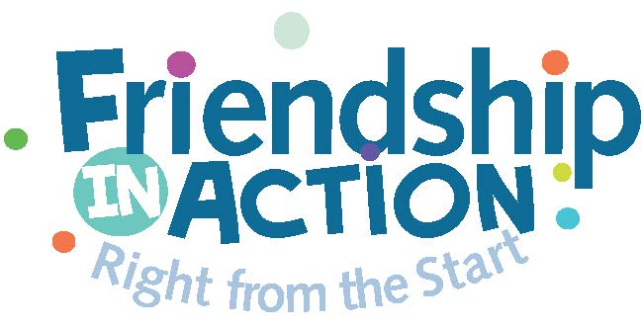
March 9, 2018

Dear Parent or Guardian,

Grade 7 is a time of great growth. The Linden School has invited Friendship In Action (FIA) to run a group within our guidance program where the girls will work on their communication, friendship and leadership skills in a safe space. The sessions will run during the school day and be led by experienced educators. This is a special opportunity and complements the work done by our guidance department.

Thank you!

----------------------------------------------------------------------------------------------------

I give permission for _________________________ to participate in this program. I understand that she will complete a pre and post survey and a Strengths and Difficulties questionnaire for the purpose of evaluating the effectiveness of our program and for sharing group results with our program sponsors.

I also DO or DO NOT (circle one) give permission for my child to be photographed or videotaped by Friendship In Action for promotional purposes only.

________________________________ _______________________
Parent Signature Date

