Dialogue to Overcome Society’s Divisions
Everyday we see and hear clear evidence of deepening divisions within our society all around us, in our nation, in our states and in our communities, in the Anglican Communion and in our churches. The need for reconciliation that builds on mutual respect and appreciating differences has never been greater.

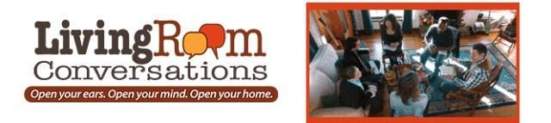

A Workshop for People with Opinions
Saturday, August 6, 9 am-12 noon, The Center

The Living Room Conversations (LRC) vision is a world in which people with fundamental differences of opinion and backgrounds work together with respect — and even joy — to realize the vibrant future we all desire. On June 25, we held our first Living Room Conversations at Saint Andrew’s and began to help make that vision a reality right here in our own community. We hope that you will join us!
LRC is the brainchild of Joan Blades, one of the co- founders of MoveOn.org, a very liberal online activist movement. She and other liberal and conservative leaders, including Mark Meckler, co-founder of Tea Party Patriots, recognized that partisanship is polarizing our country. They had shared concern that people in America are not talking with each other — that we’re either on the left or the right with no one in the middle. Their concern led them to develop a format that supports conversation about difficult issues.
At the May diocesan workshop, six people from Saint Andrew’s tried the format and experienced talking about messy stuff in a way that felt energizing and holy. We want to share it with as many people as possible, so we committed to bring the program to Saint Andrew’s. The thirty people who attended our first workshop gave the program positive evaluations, and we look forward to continuing the discussion on Saturday, August 6. For more information, contact Canon Linda at CanonLinda@st-andrews.org

