Review of: ‘Groundwater level assessment of selected bores in the Acland and Kulpi area of the Darling Downs’, by the Queensland Department of Natural Resources and Mines, 2017.
Assoc. Prof. Matthew Currell
School of Engineering
RMIT University
Melbourne, VIC, 3000
30th August, 2019

- Introduction
This is a review of the report: “Groundwater level assessment of selected bores in the Acland and Kulpi area of the Darling Downs” published by the Queensland Department of Natural Resources and Mines (DNRM), in December 2017. The report analyses the possible cause(s) of changes in groundwater levels experienced in some landholder bores in the eastern Darling Downs. I was engaged by EDO Queensland, acting on behalf of the Oakey Coal Action Alliance (OCAA), to conduct this review, in accordance with the letter attached as Annexure A.
- Qualifications/relevant expertise
I am an Associate Professor in the School of Engineering at RMIT University, Melbourne, Australia. I received my PhD from Monash University in 2011, in the field of hydrogeology & geochemistry. For the last eight years I have taught hydrogeology, geochemistry and groundwater modelling courses to hundreds of environmental and civil engineering students, and supervised Masters and PhD projects in applied hydrogeology research. I have been awarded more than $800,000 in research funding as the lead chief investigator on more than 10 grants, supporting projects examining groundwater sustainability and contamination issues. I have published more than 40 peer-reviewed international journal articles, which have been cited more than 1000 times, and served on the editorial board of the Hydrogeology Journal (the journal of the International Association of Hydrogeologists) from 2014 to 2017. I have acted as an independent hydrogeology expert witness on many occasions, including during the Victorian Parliamentary Inquiry into Unconventional Gas and in Independent Planning Commission hearings in NSW.
- Summary of my Opinion
The report by DNRM is an investigation of the hypothesis that mining and/or groundwater extraction at the New Acland coal mine may have contributed to recently observed declines in groundwater levels in landholder bores east of Kulpi on the Darling Downs. The major finding of the report is that there is no evidence mining operations or groundwater extraction associated with the New Acland Mine has contributed to this issue.
While relevant data and information on the topic are presented and analysed in the report, and these do to some degree support the major findings, it does not constitute a comprehensive analysis of the problem. Major gaps include:
- A lack of clear explanation regarding the nature of the problem itself. There is almost no detail regarding the rationale for the investigation or how and why it came about. No details are included about the affected landholders’ bores - e.g., the depths of the screened intervals and/or pumps, typical historic bore yields, bore codes (if they are registered), the degree of water level change that has been reported/experienced, how and when the change was noticed and reported to DNRM. While much of this information may only be available in an incomplete or anecdotal form (e.g. precise water level monitoring records are unlikely to exist), it is vital this information is included in order to conduct a rigorous analysis of the problem. A sequence of events outlining when DNRM were first notified of the issue, what details were provided, and the timing and nature of any follow-up investigation work are required. A summary of all relevant anecdotal as well as observational data should be included in the introduction section as context for the rest of the report.

- Gaps in the investigation data and methods of analysis: For example, while there are some monitoring bores in the affected aquifer(s) near the New Acland Mine (e.g. in the Marburg Sandstone north of the mining lease), there is also a significant gap in the coverage of the monitoring network – e.g. between an area of significant historic groundwater extraction for the mine site’s water supply (northwest of the mine), and the affected landholder bores. Basic information such as local climatic data, which are likely to be an important influence on groundwater levels, are also absent in the report. The report notes that faulting is an important factor potentially affecting the response of the aquifers to groundwater extraction; however, this is excluded from any further analysis. The difference between short-term, localised responses to groundwater extraction (e.g. in the immediate vicinity of mine water supply bores), and longer-term regional changes in water levels as a result of these and other extractions – e.g., the impact on the water budget of the aquifers in question - are not properly distinguished or analysed in the report.

- There is also a lack of exploration of alternative/additional explanations for the reported water level declines in the bores (aside from some brief speculative statements). The possibility of delayed effects from historic groundwater extraction for the New Acland site (particularly in the deeper GAB units) is one possible contributor to the water level declines, but this appears not to have been explored. Some of the monitoring bores in the Marburg Sandstone (for instance) exhibited an overall decline in water levels over the period 2002 to 2016. While these overall declines are small relative to the large localised declines experienced during peak water extraction for mine water supply (2006 to 2010), they may indicate a longer-term, more regional effect on the water budget of the Marburg Sandstone aquifer in response to the period of intensive groundwater extraction at the mine (for example). Without knowing the magnitude and timing of water level declines in the landholder bores, and without systematic analysis of climatic data and other possible influences, it is difficult to further explore this.
The absence of such data and analysis contributes to ongoing uncertainty regarding the findings of the report. While not all data that could effectively resolve the problem may be available, an attempt to identify key data gaps and potential steps that could be taken to further increase certainty in the findings is warranted. Similarly, there is further analysis that could have been done with the existing information which also could have improved the rigor of the analysis.

- My opinion (detailed review of the report)
General comments
In the following, key areas where gaps in the information and/or methods used to analyse the problem of water level declines in bores east of Kulpi (Mt Darry) are discussed:
Background information
The introduction to the report (page 1-2) outlines the purpose and scope of the report and provides a brief overview of the hydrogeology of the area. Major gaps in this section include:
- A description of what information has been provided regarding the affected landholder bores, and the sequence of events which led to the investigation. For example, how many landholders have reported a decline in bore water level(s)? How did the landholders assess that changes in water level had taken place (e.g. has there been a decline in bore yields)? Over what time period has the effect been noticed? What information was collected to further investigate the issue (e.g. did DNRM or any other agency install loggers in the wells or begin to monitor levels regularly after the issue was reported?)

- Information about the affected landholder bores (e.g. construction details, screen and pump depths, any water level or yield information, bore codes). An analysis of the possible effect of groundwater extraction or mining activity on bores in a region requires a comparison of the lithologies and depths in which the different bores are constructed. This is important for assessing likely connectivity between areas of extraction and areas of possible drawdown effects, as well as the possible role of hydrogeological heterogeneity on drawdown propagation. Such information is also required to assess whether a monitoring bore network is well-equipped to detect relevant changes in water levels. At present, the only information about the bores consists of a map showing the location of four landholder bores (green dots on Figure 1).
The lack of such information necessarily makes a conclusive analysis of the cause of water level declines much more difficult than might otherwise be the case.
Lack of coverage in monitoring bore network
The coverage of monitoring bores is not comprehensive enough to have detected any propagating drawdown influence related to mine site water extractions (as is stated in the executive summary in paragraph 2). It is stated in the report that the landholder bores in question are primarily in the Marburg Sandstone. Monitoring bores in the Marburg Sandstone north of the mine are located on the eastern part of the site (e.g. no such bores exist west of the town of Acland). As shown in Figure A below, there don’t appear to be any Marburg Sandstone monitoring bores directly between the area where much of the historic water supply extraction has taken place (e.g. the large symbol marked 271 ML on Figure 3, which corresponds to bores 96, 98, 129, 130 and 131) and the area where the affected landholder bores are located. Bore 41 is the closest to being on a path between these two areas, but lies on an oblique line between the mine site extraction bores and landholder bores. The monitoring network thus can’t be used to map the water level patterns in detail between the mine site (including extraction bores) and the affected area or characterise the geometry of any drawdown effects.
Given this, the finding regarding the ability of the existing monitoring network to detect any propagating influence from the New Acland mine (including historic extraction from water supply bores) needs to be re-evaluated.
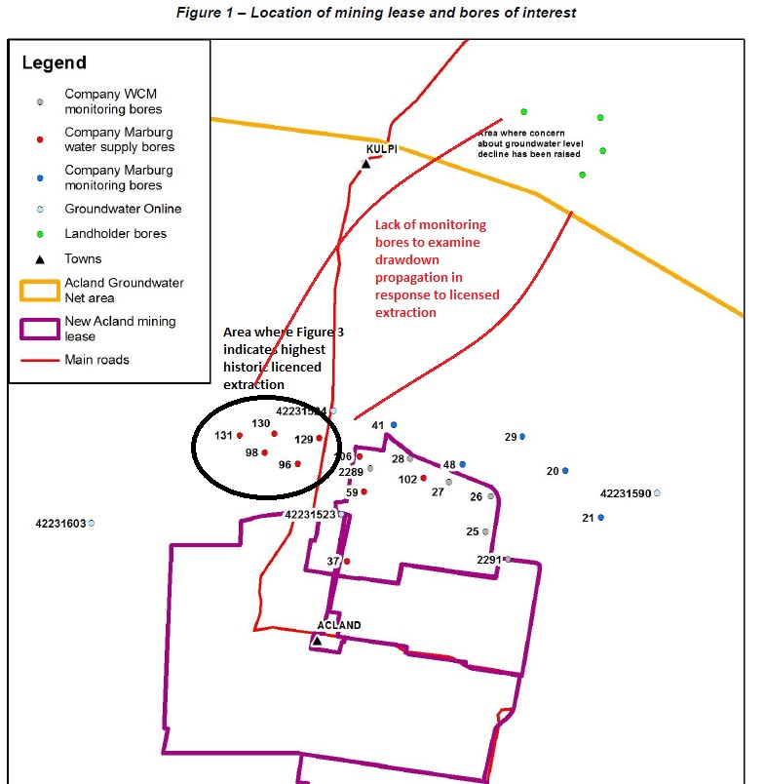
Figure A – Annotated version of Figure 1 from DNRM, 2017, showing area where monitoring bores are lacking.
This point is further underscored by the following:
- The depths of the affected landholder bores, and their correspondence with the depth(s) from which water supply bores at the Acland site have been pumped are undocumented in the report;
- There are no monitoring bores located within the area of concern itself (e.g. among the affected landholder bores) to show the timing or magnitude of changes in water levels (or yields). Nor are there any bores at intermediate distances between the mine site and the affected bores, which could show a more regional picture of the propagation of drawdown effects;
- It is known that the strata in the vicinity of the New Acland coal mine are faulted, which may have a significant effect on the pattern/shape of any drawdown propagating from areas of groundwater extraction. Heterogeneity in the lithology may also influence the shape and timing of drawdown propagation from areas of water extraction and/or mining activity.
- Propagation of drawdown from an area of groundwater extraction may be delayed, due to hydraulic properties of the geological strata. While groundwater extraction from water supply bores in the Marburg Sandstone declined sharply after 2011, this does not guarantee that drawdown associated with such extraction could not propagate further through the aquifer with an associated time delay (see below).
Taking these factors into consideration, the monitoring network is not particularly well equipped to make a confident assessment of whether water supply extraction and/or mining activity at the New Acland coal mine has affected water levels in bores where concerns have been expressed.
Lack of analysis of climate data and/or other possible influences on groundwater levels
No climate data (e.g. from nearby Bureau of Meteorology stations) are included or analysed in the report. Analysis of climate data is a fundamental part of any groundwater level assessment. Long and short-term variation in rainfall is likely to be an important influence on the water levels of the affected bores, on top of which other factors such as groundwater extraction may play a role to varying degrees. Without presenting the over-arching climate data, analysis of individual hydrographs or more general water level trends in the relevant aquifers is missing a key driving influence. Related to this, in general, alternative hypotheses regarding the possible cause(s) of groundwater level declines in the landholder bores (e.g. groundwater usage from other parts of the region) are also not examined or analysed in any depth. This results in ongoing uncertainty with respect to the cause of the problem.
Possible effect of faulting
As is documented in the New Acland Stage 3 mine AEIS and other relevant documentation (e.g. the mining company’s recent associated water license application), there is extensive faulting of the strata surrounding the New Acland Mine. The effect of faulting on the propagation of drawdown has not been investigated in this water level investigation. Faults may act as barriers to water flow (and thus drawdown) in certain directions, or conversely, act as conduits for groundwater flow, affecting the propagation of drawdown (e.g. modifying drawdown cones from typical radially symmetrical patterns). Where possible, maps of the extent, depth and orientation of known faults should at least be included in the report to help analyse their possible effect, along with maps of water levels in the relevant aquifers (such data/maps could for example be requested from the mining company).
While it is stated that analysis of the effect of faults (and other ‘complex hydrogeological interactions’) are outside the scope of the assessment, the influence of faulting should not be ruled out, and the confidence with which the findings are presented needs to be tempered in this context.
Role of geological heterogeneity
The Marburg Sandstone is a thick geological unit (exceeding 100 m thickness in many places) and bore logs show that it is a heterogeneous unit. There may therefore be horizons in the unit which are more or less permeable, and more or less connected in the horizontal and vertical directions. This issue is not explored in the report. For example, monitoring bores in the Marburg Sandstone (shown in Appendix B) mostly target two depths – either approximately 100m or 150m. This does not always correspond to the depth of water supply bores in the unit (e.g. in some cases, water supply bores are deeper than these monitored depths – See Appendix A). Propagation of drawdown in the aquifer may not be homogeneous throughout; it may occur to a greater degree at certain depths, for example, deeper than monitored by the 5 monitoring bores examined in the report (note that extraction of groundwater from deeper in the underlying Helidon Sandstone also has occurred at the site historically). Drawdown may not necessarily propagate homogeneously throughout the Marburg sequence. Due to the lack of depth information about the affected landholder bores, there remains uncertainty regarding the correspondence between depths where water extraction has been most intensive and the affected landholder bores.
Lack of consideration of transient/delayed effect from groundwater extraction
One of the lines of evidence used to discount the hypothesis that activity at the New Acland Mine site may have been responsible for the declines in landholder bore water levels, is that the most intensive groundwater extraction from the Marburg Sandstone at the mine site ceased in around 2010. Thus, it is inferred that a water level effect observed in 2016-17 is unlikely to relate to pumping for the mine site. This fails to consider the possible influence of regional aquifer hydraulics, which may result in significant delays in the full transmission of water level effects (e.g. propagation of drawdown) following water extraction. Many transient numerical models in which groundwater extraction takes place and drawdown is simulated show that ‘peak’ drawdown effects can be delayed, and occur after peak water extraction (e.g., there are residual, delayed effects). Such a scenario can’t be ruled out in this case without more detailed mapping of water level changes over time, and/or examination of the relevant hydraulic properties of the aquifer(s) involved – particularly the hydraulic diffusivity (which governs the speed with which water level effects transmit through an aquifer). Monitoring changes in water levels more distant from points of intensive extraction would help explore this issue further; however, unfortunately monitoring bores to allow this are not present at the site.
Distinguishing between short-term localised responses to groundwater extraction (which are typically rapid and pronounced in response to pumping/non-pumping periods in confined aquifers), and longer-term, regional responses to the changes in water balance resulting from pumping is another key area which is not touched on in the report.
For example, Figure 6 shows water usage and water level time-series at bore 41. This bore is close to the point of water supply extraction and experienced a significant drawdown effect corresponding with the timing of peak extraction nearby. The water level in the bore recovered relatively rapidly once extraction declined in 2010-11. However, bores further away from the point(s) of extraction – e.g. bores 48 and 21 (Figure 5) dis not recover as quickly and remained at a lower average level in 2016-17 than when they were first monitored. This may indicate a residual effect from the pumping occurring more distant from the extraction bores (e.g., some bores may not have been able to recover as effectively or rapidly following cessation of pumping).
This issue is further compounded by a lack of time-specific information about the water level changes observed in the landholder bores. While 2016-17 may have been the first time water level changes were reported, this does not mean such changes were not occurring prior to this (e.g. a gradual decline in levels may only have been noticed some time after it commenced, for example, when it began to affect yields significantly).
Specific comments:
Page i (executive summary): the nature of the information regarding the problem should be indicated clearly – e.g. was the issue raised through formal/informal correspondence from landholders, or have data/measurements been collected to determine the number of bores affected, magnitude and timing of the effect? What work has been done by DNRM to try to quantify the issue (e.g. inspections of the affected bores, installation of monitoring devices)?
‘These bores will detect any propagating influence’: Language is too strong here. Given that the monitoring network is not fully comprehensive (see Figure A above), it is not demonstrated that any influence propagating from the mine will be detected (considering the positions and depths of the monitoring bores shown on Figure 1, and the possible influence of geological heterogeneity).
Paragraph 4: This is a generally reasonable statement, however, drawdown propagating from the mine site in the underlying aquifer(s) (below the basalts) could indirectly provide a pathway for these effects to transmit to the affected areas, despite the basalts not being continuous with those affected by mining operations (through vertical connectivity).
Statement regarding depth of the Marburg sandstone (~75m) below the mine pits: bore logs would assist in showing this (e.g. what is the nature of the low permeability material between the base of the mine pits and top of Marburg aquifer? How continuous are any possible confining layers?)
Last paragraph of p.i: has this been determined through monitoring of nested sites? This is not clear without a more comprehensive description of the monitoring network and specific sites used to analyse changes in particular aquifers.
  - Purpose and scope
P.1: The report would benefit greatly from a more detailed description of the type of information that has been made available describing the landholders’ concerns. For example, has the department established any of the following:
- Number of bores affected, and which particular bores (e.g. are these registered bores, and if so what are the bore codes and location on Queensland Globe?)
- Depth of the affected bores – e.g. which lithology/lithologies are they screened across?
- Magnitude of the decline in water levels, and how this has been assessed – e.g. are landholders reporting a decline in bore yields? Have any measurements been taken which indicate how much decline in water level has been experienced? Is the information all of an ‘anecdotal’ nature, or have measurements been taken?
- Timeframe of the effect – e.g. when was the first time the decline was noticed? When were the first measurements of declines taken? Is there any clear evidence to determine the timing of the onset of the water level effects (e.g., just because it was first reported in 2016-17, does not mean that this was when the effect first started).
These issues are all important in the assessment of the possible cause(s) of the impact. Typically, landholders will notice a water level decline only when a significant drop in yield is experienced, and/or water levels begin to drop below the height of a bore’s pump intake.
Fig. 1 (Monitoring bore locations): While there are a reasonable number of monitoring bores to the north of the mine site in the Marburg Sandstone and Walloon Coal Measures (shown in Fig. 1), there is a gap in the monitoring coverage to the northwest of the mine. There also aren’t any monitoring bores shown in the Tertiary Basalts. Even if the basalts are not continuous between the mine and the affected area, some monitoring records to show how water levels in the basalts have responded to various stresses (e.g. mine site water extraction in the past and climatic fluctuation) would be helpful to show the typical response of this aquifer to different possible influences.
Section 1.2
Fig. 2: The inclusion of some key indicative bore logs (e.g. as an appendix) matched to the bores shown on the cross section would allow for a more complete analysis of the possible role of lower/higher permeabilities and heterogeneity within the sequence. Limitations associated with the simplification of the profile (e.g., potential for heterogeneity within the Basalts, Walloon Coal measures and Marburg Sandstone and influence from faults) should be discussed more in the text and acknowledged as sources of uncertainty with respect to the findings.
Based on the profile shown in Figure 2, it appears the Tertiary Basalts directly overlie the Marburg Sandstone in the area of concern. It is thus possible drawdown propagating from areas of historic water supply extraction in the Marburg Sandstone to the affected region could also thus result in drawdown propagating (from below) into the overlying basalts.
Sections 2 & 3
P.5, Fig.3 & Fig. 4: The extraction volumes shown in this section are aggregated (e.g. not attributed to specific bores), which introduces limitations in the interpretation of the possible magnitude and extent of drawdown impacts to and from specific regions. For example, if a large proportion of extraction has occurred from a small number of specific bores, then greater drawdown responses in the vicinity of these would have occurred; if extractions are more diffuse, then a more regional influence on water levels would be expected. This is important context for assessing the affected landholder bores – e.g. is the effect that has been noticed likely to relate to a more diffuse regional decline in aquifer water levels, or is it a localised effect? Again, without key background information about the affected bores it is difficult to say more.
The monitoring bore data (e.g. Figure 5) indicate a trend of decline in groundwater levels in the Marburg Sandstone between ~2002 and ~2016, on the order of 1.5 to 2.5m in some bores (e.g. 21, 29, 48). Localised drawdown near the main point(s) of water supply extraction, followed by recovery once extraction was significantly reduced (after 2010) is also evident (e.g. Bore 41). The relationship between localised vs. more regional drawdown responses and the effect of groundwater extractions at the site warrants further investigation and discussion.
At the regional/aquifer level, pumping for water supply may lead to overall declines in groundwater storage which result in relatively steady, but smaller magnitude long-term declines in water level, as distinct from the pronounced local-scale effects experienced near the point(s) of extraction. Without an assessment of the water budget (e.g. recharge/discharge) for the Marburg aquifer, and comparison to the volumes extracted during 2003 to 2014 it is difficult to assess whether the overall long-term decline observed in certain Marburg Sandstone monitoring bores is related to the extraction from water supply bores. The volume of extraction near the mine has been significant, and this has historically been the largest single licensed extraction source within the study area (Figure 3). Again, without information about the amount of decline experienced in the landholder bores and the timing of the decline(s), it is hard to assess whether a regional water level decline of 1.5 to 2.5m over the monitored period is a significant effect or not. Likewise, without analysis of climate data, it is hard to say whether this regional decline is likely to be related to historic water extraction (and/or other mine-related activity) or whether it is a response driven to a greater extent by climate.
The analysis in section 3 does not give a clear spatial representation of the drawdown related to extraction from the Marburg Sandstone (or other aquifers). Even with the relatively limited number of monitoring bores, it is important to examine the water level declines in map view, to gain an understanding of the likely lateral extent of drawdown in response to pumping, and the geometry of any drawdown effects. Contour maps showing water levels and/or drawdowns at different key time periods would aid this and may reveal something significant regarding the propagation of drawdown effects in the region.
Section 4
Figure 7 – the statement ‘Figure 7 does not show any correlation between water levels in the Walloon Coal Measures and Marburg Sandstone’ does not appear to be entirely accurate. At a qualitative level, there does appear to be some correspondence between the hydrographs in the two different aquifers – e.g., period of relatively low water levels between 2006 and 2010 (albeit significantly more pronounced in the Marburg compared to Walloon Coal Measures), followed by a general rise in all bore water levels beginning around 2011. There are statistical methods which could be applied to examine the level of correlation between water levels in the different hydrographs, as well as more reliable techniques to examine inter-aquifer connectivity.
Section 5
P. 11 (paragraph 1): the extraction of water from basalts near the mine site is mentioned here for the first time, without details being given regarding the nature of this extraction (e.g. location(s), amount(s), historic volumes, nearby monitoring points). Such information should have been described in section 2 with the other groundwater extraction information.
The statement regarding water levels in monitoring bores from the Marburg Sandstone in paragraph 2 is not strictly correct – there are bores which have exhibited an overall decline (of between 1.5 to 2.5m) in the Marburg sandstone during the monitored period. The report is presumably referring here to the larger drawdown and recovery pattern observed in bores close to the area of historic mine site groundwater extraction (where indeed water levels have recovered to pre-peak extraction levels), but there needs to be a distinction made between localised short-term effects, and more subtle, long-term effects on overall levels in the aquifer.
The statement in paragraph 4 is also somewhat misleading, as discussed above. While there are indeed multiple monitoring bores in the general area ‘north’ of the mine site, these do not lie on a direct path between some water supply bores in the Marburg Sandstone and the affected Landholder bores.

Declaration
I confirm that the factual matters stated in the report are, as far as I know, true; the opinions stated in the report are genuinely held by myself; the report contains reference to all matters I consider significant on the topic and I have not received or accepted instructions to adopt or reject a particular opinion.
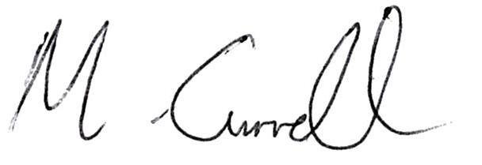
……………………………..
30th August, 2019.

Note, there is one bore on Figure 1 marked ‘Groundwater Online’ – 42231524, which is to the northeast of the area of water supply extraction. Depth information (e.g. aquifer/depth monitored) or water level records from this bore are not included in the report.
New Hope Group, 2018. Associated Water Licence Amended Application Report: New Acland Coal Mine Stage 3 Project. New Acland Coal Pty Ltd.
Bense et al., 2013. Fault zone hydrogeology. Earth Science Reviews doi:10.1016/j.earscirev.2013.09.008
New Hope Group, 2018. Associated Water Licence Amended Application Report: New Acland Coal Mine Stage 3 Project. New Acland Coal Pty Ltd.

