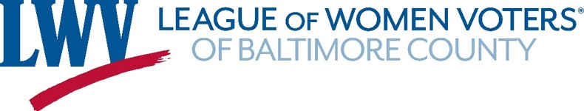

Founded in 1966, the League of Women Voters of Baltimore County is a non-partisan, charitable organization designated as tax exempt under Internal Revenue Code Section 501 ( c )(3). All dues and contributions are tax deductible as allowed by law.
Dues
______ $60 Individual member _____ $110 Household membership
______ $100 Individual sustaining member _____ $150 Household sustaining membership
______ Student* member – FREE; anticipated date of graduation: _______________
* must be 16 years or older and full time student
Additional contributions
______ to the Jessa Goldberg Endowment Fund _____to LWV Baltimore County
______additional contribution to cover postage for PRINT copies of monthly Voter newsletter.
Please make your check payable to LWV Baltimore County, or use PayPal or credit card
through our website, www.LWVBaltimoreCounty.org

Name _______________________________________________________________________________
Address______________________________________________________________________________
City ______________________ State_________________ Zip ____________
Telephone (Home)_______________________ (Cell) _______________________
Email _____________________________________________________________________
Thank you for your support!
Fold- - - - - - - - - - - - - - - - - - - - - - - - - - - - - - - - - - - - - - - - - - - - - - - - - - - - - - - - - - - - - - - - - -- - -- - -- --------

6600 York Road, Suite 211
Baltimore, Maryland 21212

Email: contact@lwvbaltimore.org Phone: 410-377-8046 www.LWVBaltimoreCounty.org

The League promotes voter participation, civic involvement and advocacy.
Do you have a friend who might like to receive a prospective member packet?

Name________________________________________________________________________________

Address______________________________________________________________________________

