PROGRAMME

LYMEC / VVD / D66
Summer school

EU-Russia Relations

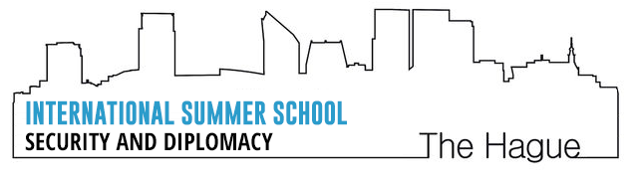

The Hague, 17-20 September 2015
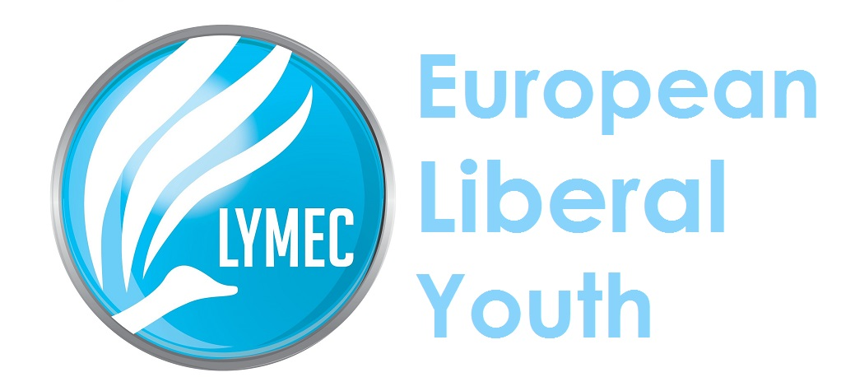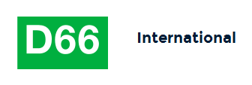
Venue: Mercure Hotel Den Haag Central
Spui 180
2511 BW DEN HAAG
To reach the venue, take the train to Den Haag Central station and walk.
Head northwest toward Kon. Julianaplein. Turn left onto Kon. Julianaplein. Turn left onto Rijnstraat. Turn right onto Schedeldoekshaven. Destination will be on the right.

Help desk

LYMEC | Igor Caldeira  0032.496.897.213 office@lymec.eu | Timo Roeleveld  0031.622.926.286 timo@lymec.eu

IN CASE OF EMERGENCIES CALL 112
LYMEC EVENTS ARE PAPER FREE

Thursday |  | 17 September

15:00 – 19:00 |  | Arrival of participants

20:00 – 22:00 |  | Dinner and teambuilding

Friday | 18 September

07:00 |  | Breakfast

09:00 |  | Visit to the Peace Palace |  | Carnegieplein 2  2517 The Hague

12:00 |  | Lunch

13:30 |  | Workgroup session 1  Basics and principles of negotiation

15:00 |  | Coffee break

15:30 |  | Team Project session 1  Three teams analyse specific external policy topics

17:00 |  | The Relations between the EU and Russia

19:30 – 21:30 |  | Dinner debate: the Eastern Partnership in the context of EU-Russian relations

Saturday | 19 September

07:00 |  | Breakfast

09:00 |  | Public statements and their effect on outcomes of negotiations

11:00 |  | Coffee break

11:30 |  | Team Project Session 2  Preparation for presentation.

12:30 |  | Lunch

14:00 |  | Keynote speech on Diplomacy

15:00 |  | Coffee break

15:30 |  | Team Project Session 3  Presentation of results.

17:00 |  | Evaluation and Round up

19:00 |  | Dinner –debate: Is a European army a valid project?

Sunday | 20 September

07:00 |  | Breakfast

10:00 |  | Departure

