Volume 2, Issue 4

April 2011

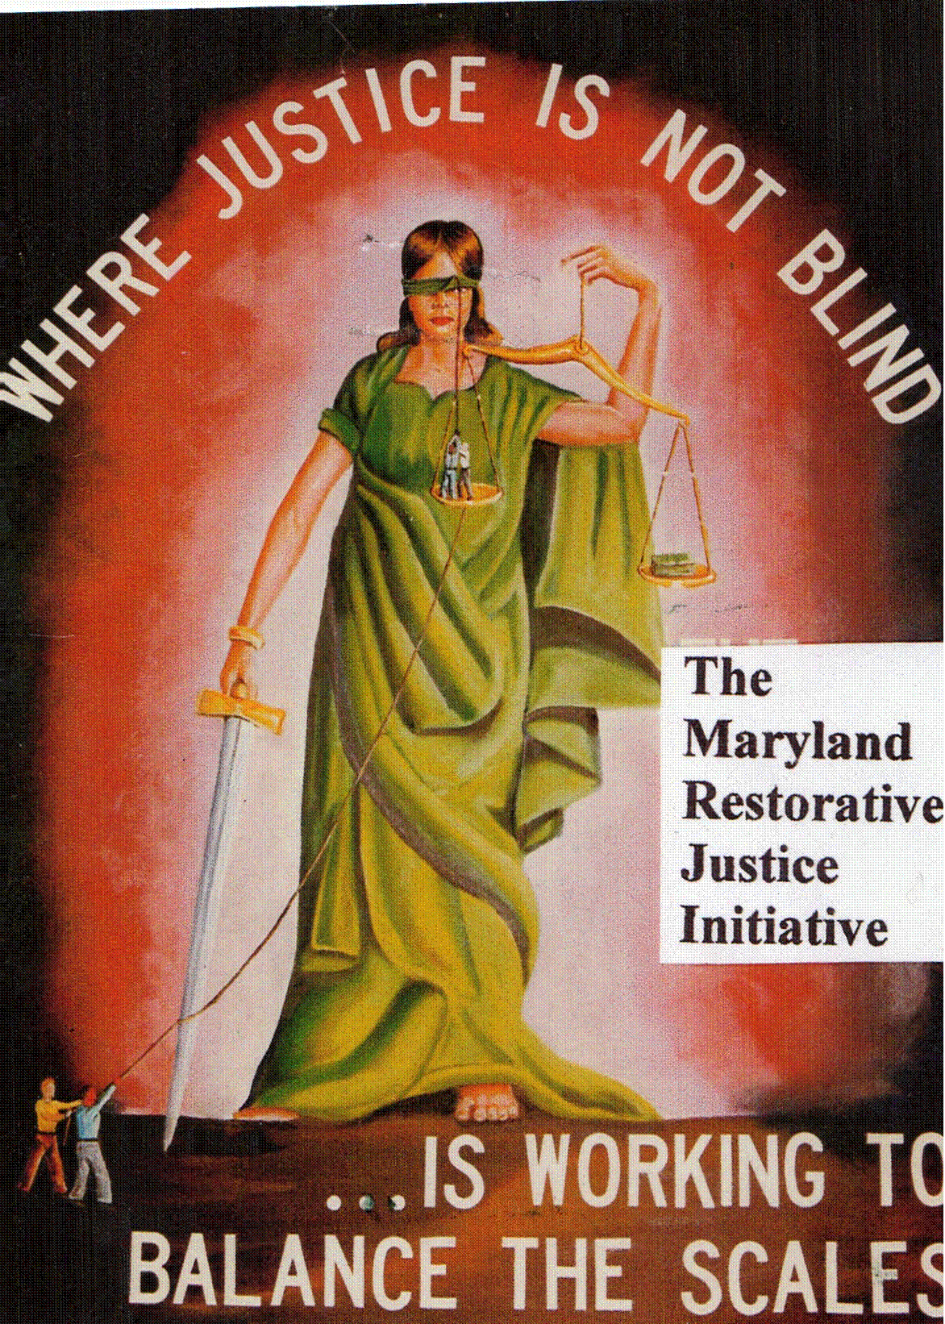

Volunteer meeting
We are scheduled to have our first official Volunteer meeting of 2011 April 23. The meeting will be held before the screening of the Documentary, ‘Blocking the Exit’ produced by the Justice Policy Institute to further our efforts. We will also be celebrating the passing of our legislation.

Legislative Update:
Most of you know by now that our legislation passed in this year’s general assembly session. The House adopted the Senate’s version by a vote of 75-65, giving the Governor 180 days to either sign for, or deny the recommendation from the Parole Commission, if he does neither, the parole commissioner’s decision become final.

Jessup Region:

JCI
Letters from or To: James Wells, Glen Watkins, Donald Young, James Grayson
MCI-J
Letters from or To: Nathaniel Gales

MCI-W
Letter from or To: Etta Myers,

Hagerstown Region:

MCTC:
Letters From or To: Alfred Brown,

MCI-H
Letters From or To: Michael Fitzgerald, Ra’uf Matin

RCI
Letters from or To: Robert Stewart, Nicholas Marshall-Bey
Cumberland Region:

WCI
Letters From or To: Robert Watson

NBCI
Letters From or To: Mr. Jermaine Holt, Kenneth Pasco, Curtis Parker, Charles Hopkins

Easton Shore Region:

ECI:
Letters From or To: Yahya Z. Hakizimanah, Wayne Brewton, Richard X. Preston

Patuxent: Letters From or To: Karriem Saleem El-Amin

Out of State:
Dennis Wise

Family members and Friends Registration forms & letters:
Gina Stoos, Gindy Johnson, Ronald Thorne-El, Lisa Newkirk, and Byron Warnken

General News
JCI, MCI-J, MCI-W, RCI, MCI-H, and WCI have all viewed the documentary “Blocking the Exit,” the other institutions are waiting for approval. Those who have viewed it were impressed, and inspired.

Resource Manual: Copies of the Resource manual has been sent to Lifer Coordinators in all the Institutions with instructions to have them placed in the institution libraries: James Wells, Nathaniel Gales, Etta Myers, Alfred Brown, Michael Fitzgerald, Robert Stewart, Robert Watson, Jermaine Holt, Wayne Brewton, Richard X. Preston, Karriem Saleem El-Amin, Dennis Wise

RCI is sponsoring a Walkathon for C-I-C-B (Criminal Injury Compensation Board) June 25, 2011 from 9:00 am – 2:00 pm. For additional information contact their VAC Ms. Exline.

MCIH is sponsoring a Walkathon for MADD (Mother Against Drunk Driving) June 4th 2011 from 9:00 am – 2:00 pm. For additional information contact their VAC Mr. J. Peterson (204-420-1325)

Supported in part by a grant from
OSI- Baltimore


