Volume 2, Issue 7

July 2011
Quote of the month: Resolve to listen more & talk less. No one ever learned anything by talking.

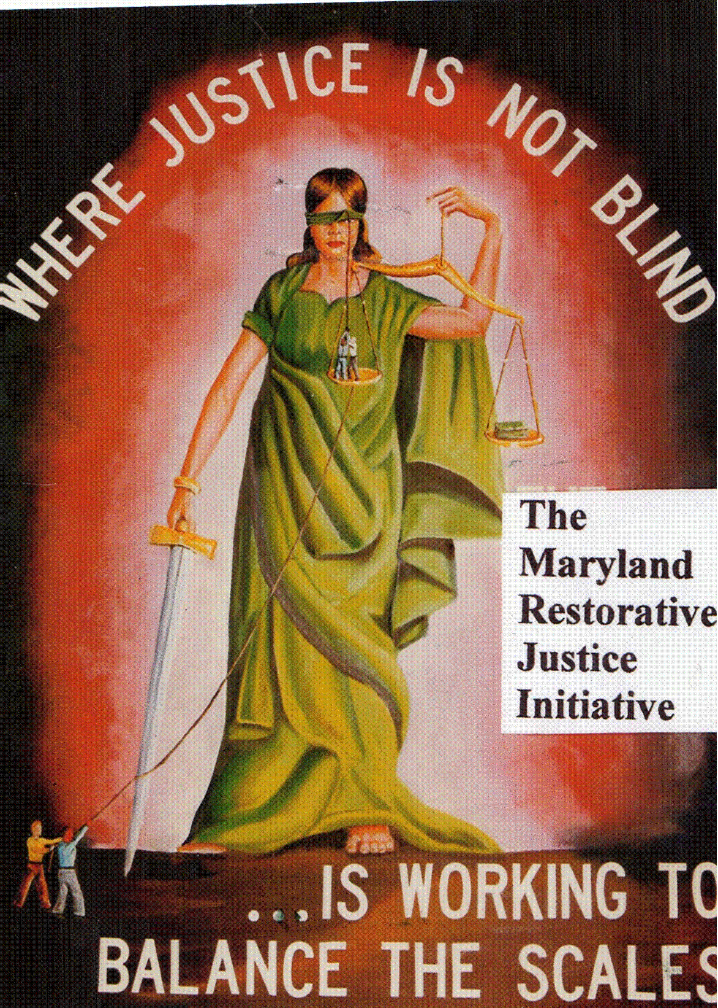
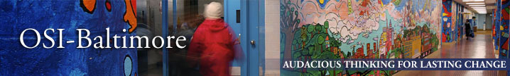
Volunteer meeting:
Our Volunteer’s meeting was held before the taping of the off campus interview with WEAA 88.9 radio program. The agenda primarily dealt with the taping of the program, but we also addressed the need for programming, and access to reentry resources. The radio program will address the documentary, “Blocking the Exit” , its accompanying Booklet, also titled “Blocking the Exit,” and the importance of getting the community involved, especially the faith based community.

Documentary Screening
The screening of ‘Blocking the Exit’ on June 25, at the New Africa Committee of the, Muslim Community Cultural Center was a huge success, and we plan to host more in the coming months.

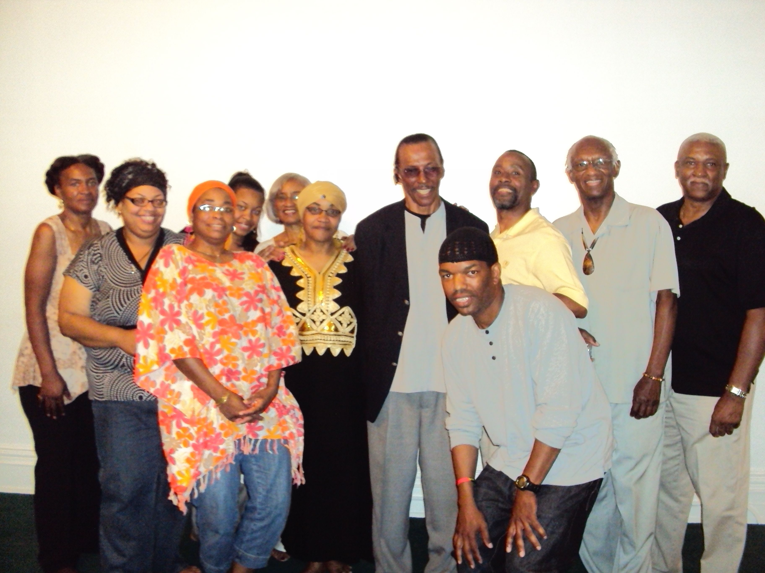

Legislative Update:
Jessup Region:
/JCI Letters from or To:

MCI-J
Letters from or To:

MCI-W
Letter from or To:

Hagerstown Region:
MCTC:
Letters From or To:

MCI-H: Letters From or To: Mr. Michael Ringgold,

RCI: Letters From or To:
Mr. Hercules Williams

Cumberland Region:

WCI: Letters From or To: Mr. James D. Proctor Sr., Mr. Joachim Abdul Wallace

NBCI: Letters From or To: Mr. Charles Hopkins, Mr. Wayne Stockstill, Mr. Wayne Roberson
Easton Shore Region:
ECI: Letters From or To: Mr. James D. Proctor Sr.,

Patuxent: Letters From or To
Out of State: Mr. Dennis Wise

Family members and Friends Registration forms & letters:

General News: The awards celebration held June 18 is something the recipients will remember for a life time. Lots of photos were taken, and we also had the event videoed. We toasted with Champaign (Do not take this to mean that we have money, we do not.) at the Fusions headquarters, (It is where we’ve gotten the majority of our work done.) to celebrate this historic moment in history. The photos and video will posted on our web site, and FB page soon, have your family members and friends check them out. The following individuals received Plaques: MRJI 2011 person of the year, Mr. Arnold Hopkins; MRJI 2011 Unsung Hero Mr. Keith Wellington; MRJI 2011 Patron of the year Ms. Mary Brown-Bey; MRJI 2011 Volunteer of the year Mr. Marvin Williamson; MRJI 2011 humanitarian of the year Senator Lisa Gladden; MRJI 2011 Visionary of the year Mr. Roland Knapp; MRJI 2011 Special thanks Mr. Ralph Randall; MRJI 2011 Special thanks Ms. Beverly Nur; MRJI 2011 Special thanks Ms. Betty Armwood; MRJI 2011 Special thanks Former Del. Salima Merriott; MRJI 2011 Special thanks Senator Thomas V. Mike Miller, President of the Senate; MRJI 2011 Special thanks Delegate Michael E. Busch, speaker of the House.

The following individuals received Certificates: Mr. Adrian Muldrow, Executive Director of We can Achieve; Ms. Strong-Heart Stone, Fusion Partnership Inc.; Mr. Michael Hynes, Intern, Delegate Curt Anderson; Ms. Jeanette Kingsbury, Activist and Supporter; Mr. Ernest Steward, Intern, Senator Nathaniel McFadden; Ms. Melissa Goemann, ACLU Legislative Director; Ms. Pat Bruce, Senior Legislative Assistant, Delegate Curt Anderson’s; Ms. Dominique Mattdocks, second 45th legislative Senator, Senator Nathaniel McFadden’s; Ms. Claire E. Rossmark, Principle analyst department of legislative services; Del. Joseph F. Vallario, Chair Judicial committee; Senator Brian E. Frosh, Chair, Judicial Proceeding Committee; Mr. Robert Watson, WCI Legislative Director; Mr. Dan Rodrick, Columnist & Radio Talk show host; Mr. Scott Oakley MSBA Chair Correctional Reform Section; Ms. Zerline Hugh JPI; Ms. Lea Green, Activist and Supporter; Ms. Orisatolu Tolu Aduke , Activist and Supporter; Ms. Connie Smith, Activist and Supporter; Mr. Frank Dunbaugh, Maryland Justice Policy Institute, Inc; Sister Nzenga, Activist and Supporter; Mr. Marc Steiner, WEAA Radio; Ms. Alison Park-LoGrande, Morgan State University Department; Delegate Chryl D. Glenn

MCI-H Walk-A-Thon was a success; they raised 2,100 dollars for M.A.D.D.
RCI held a successful Walk-A-thon June 25 for the Community Injury Compensation Board, and WCI raised about $800.00 at their walk-A-Thon June 18 for the Community Mediation Program of Glen Burnie.

Supported in part by a grant from Baltimore OSI


