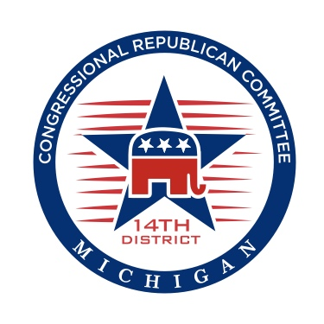
Fair and Transparent Rules
Proposed Rules for MIGOP Wayne County Convention – Mar 22nd 2016

District Convention
- There will be an election for the Permanent District Convention Chairperson, which shall be conducted as follows:
- The Temporary District Convention Chairman shall accept nominations from the floor and conduct a voice vote first. Only duly elected Precinct Delegates at the Aug 5, 2014 Primary Election, as certified by the County Clerk and the list of At-Large Delegates as outlined in Section 5(a) of the MRP Rules and from the appropriate/designated District are permitted to make nominations and/or vote.
- Should the vote outcome be contested, the Temporary Chairperson shall use other voting methods as appropriate.
- The nominee receiving the majority of votes of the Delegates and At-Large Delegates present, shall become the Permanent District Convention Chairperson.
- Upon election of the Permanent District Sub-Caucus Chairperson, they shall appoint Secretary, Tellers, Rules Committee Chair, Rules Committee, Parliamentarian, Sergeant at Arms and Nominating Committee
- The Rules Committee shall prepare rules to govern the affairs of the District Convention. Any competing rules from the floor need to be provided in writing with copies for the convention attendees present (approx. 100).
- Vote for approval of the Rules of the District Convention.
- The Permanent Distict Convention Chair shall open the floor for discussion of rules by which the election of Delegates to the State Convention shall follow: (i.e. use of slates, individual nominations, nominations committee, preferences for non-attending elected delegates or non-elected delegates, in attendance or not in attendance, etc.)
- The Permanent District Convention Chair shall begin the process of accepting nominations for Delegates to the Michigan State Party Convention to be held in Lansing, April 8th and 9th, 2016.
- MIGOP Convention rules provide the Precinct Delegate preference which states in Rule 9, “In order to
recognize the importance of precinct delegates, a precinct delegate duly elected at the Aug 4, 2014 primary election shall be given preference (over a non-precinct delegate) to be elected as a delegate or alternate to the State Convention. Between two or more such precinct delegates, no preference shall be given.”
- The nominees receiving the majority of votes of the Delegates and At-Large Delegates present shall be placed
as Delegate to the State Convention.
- The Delegate list will be completed first. Anyone that was not elected as a Delegate can be nominated as an
Alternate.
- If the District Convention permits the nominees to address the Convention, it must be for 60 seconds or
less.
- Only after all duly elected Delegates from the Aug 5, 2014 Primary Election, present at the District Convention,
with intention of attending the State Convention have been seated as either a Delegate or an Alternate shall others who are in attendance or by proxy be seated in any open seats that may remain for the State Convention. Those in attendance take priority over those in proxy
- All Delegate/Alternate selections must be completed and voted on within the time limit set for the Convention to meet. Delegates and Alternates must provide name, email, phone and address to the Permanent District Chairperson prior to departure from the convention.
- Upon completion of the Delegate voting and elevation process, the Permanent District Sub-Caucus is to call for Adjournment.

