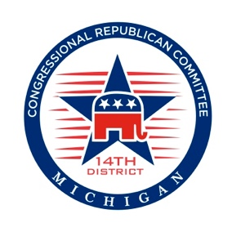
Dear Fellow Republicans, August 2016

Now that our national convention has passed and our nominee is official, party members and supporters such as you are faced with a choice and a mission come November 8th, 2016, and beyond. ‬‬‬‬‬

Many of you joined with a record number of new Republican primary voters in choosing Donald Trump as our party's nominee. No matter what your stance, we are faced with the prospect of a Hillary Clinton presidency, which we can all agree would be detrimental.

The officers and members of our party are committed to promoting and assisting with the election of candidates under our banner who will advance our party’s ideals contained within our platform.

What we ask of you as supporters of the Republican Party is to join with us to support our Presidential nominee and candidates who seek public office under our banner, and if elected to help support their oath to persevere, protect, and defend our Constitution and Bill of Rights.
Together, we invite you to join us in our commitment to elect Mr. Trump to the White House; ensuring a strong national defense, a "Rule of Law" Supreme Court, and a Commander in Chief who in the words of Speaker Ryan will "help improve people's lives" by supporting the Republican agenda.

Thank you for all you do for the Party.

Chairman Jesse Osmer Chairman Tom McMillin
1st Congressional District 8th Congressional District

Chairman Michael Hewitt Chairwoman Pam Williams
2nd Congressional District 9th Congressional District

Chairman Sam Moore Chairman Stanley Grot
3rd Congressional District 10th Congressional District
Chairwoman Judy Rapanos Chairman Paul Cusick
4th Congressional District 11th Congressional District

Chairman Scott Bennett Chairman Bill Runco
5th Congressional District 12th Congressional District

Chairman Victor Fitz Chairwoman Janine Kateff
6th Congressional District 14th Congressional District

Chairman Hank Choate Dr. Robert Steele
7th Congressional District RNC National Committeeman

Kathy Berden Jeff Sakwa
RNC National Committeewoman Co-Chair, MI Republican Party

Ronna Romney McDaniel
Chairwoman, MI Republican Party

