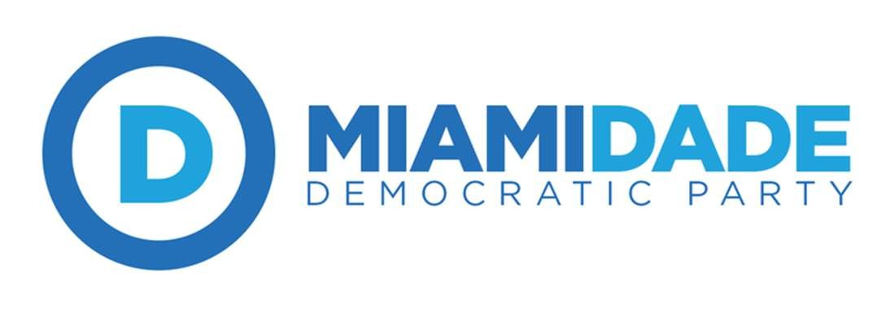

Miami-Dade Democratic Executive Committee Meeting
June 21, 2017
Prepared by Secretary Anaruth Solache

- Chair Juan Cuba called the meeting to order at 7:03pm
- Sergeant at arms Deltravis Williams led us in a Pledge of Allegiance
- President of the SDDBC Chester Fair led us in a moment of silence
- Chair Juan Cuba presented a plaque in remembrance of the honorable Mayor Daisy Black to the South Florida AFL-CIO.
- Chair Juan Cuba announced quorum has been established.
- Motion to set the Agenda was made by Deltravis Wiliams & seconded by Eleazar Melendez.
  - Motion passes unanimously.
- Motion to approve the meeting minutes from the May 30, 2017 Special Meeting made by Seth Sklarey and seconded by Javier Estevez.
  - Motion Passes unanimously.
- Chair’s Report
- Chair Juan Cuba addresses the DEC members regarding the comments made by the FDP Chair Stephen Bittel.
- Chair Juan Cuba discusses the probability of having a listening tour to engage with minority communities.
- Chair Juan Cuba discusses creating a working group that will work towards creating reform policy for law enforcers.
- Chair Juan Cuba appoints Elizabeth Judd as historian of the DEC.
- Chair Juan Cuba announces the appointed At-Large Precinct Committee Captains.
- Motion to accept the Chair’s Report by Edwin Pagan & seconded by Steve Dloogoff
  - Motion passes unanimously.
- Treasurer and Budget Report
- Motion to approve the budget report made by Eleazar Melendez & seconded by Steve Dloogoff.
  - Motion passes unanimously.
- Credential’s Report (link report)
- Motion to approve the credentials report by Alejandro Flores & Seconded by Javier Estevez.
  - Motion passes unanimously.
- Unfinished Business
- Resolution on the Death of Darren Rainey
- Motion to approve the resolution on the Death of Darren Rainey made by Chris Riker & seconded by Steve Dloogoff.
  - Motion passes unanimously.
- Resolution on the shooting of Jamar Rollins
- Motion to approve the resolution on the shooting of Jamar Rollins made by Deltravis Williams & seconded by Erika Peralta.
  - Motion passes unanimously.
- Resolution on the Medical Examiner’s Report
- Motion to approve the resolution on the Medical Examiner’s Report made by Deltravis Williams & seconded by Victoria Rivera.
  - Motion passes unanimously.
- Resolution on the County’s Independent Review Panel
- Motion to approve the resolution on the County’s Independent Review Panel made by Chester Fair & seconded by Adam Schachner
  - Motion passes unanimously.
- Resolution on Campaign Finance Reform
- Motion to amend the resolution by Seth Sklarey to add “The Miami-Dade Democratic Executive Committee will not support any candidate or elected official that takes donations from the groups mentioned in the resolution. Candidates and Elected Officials will have a chance to give back any donations accepted from the groups mentioned in the resolution or will lose all support of any form from the Miami-Dade Democratic Executive Committee.”
- Motion to table the amendment made by Phyllis Lehman & seconded by Steve Dloogoff.
  - Motion passes unanimously.
- Motion to table the resolution regarding Campaign Finance Reform made by Steve Dloogoff & seconded by Johnny Farias.
  - Motion passes unanimously.
- Resolution on Temporary Protected Status
- Motion to approve the resolution on Temporary Protected Status made by Victoria Rivera & seconded by Steve Machat.
  - Motion passes unanimously.
- Resolution in Support of the People of Venezuela
- Motion to approve the resolution in Support of the People of Venezuela made by Marco Ibarra & seconded by Annette Taddeo.
  - Motion passes unanimously.
- Resolution endorsing a Health Care for All plan
- Motion to approve the Resolution endorsing a Health Care for All plan, made by Javier Estevez & seconded by Annette Taddeo.
  - Motion passes unanimously.
- New Business
- Resolution on US-Cuba Policy
- Motion to approve the resolution on US-Cuba Policy made by Steve Dloogoff & seconded by Elizabeth Wells.
  - Motion passes unanimously.
- Special Guests: Democratic Candidates for SD 40
  - Ana Rivas Logan
  - Annette Taddeo
- Motion to adjourn made by Seth Sklarey & seconded by Fayola Davis.

