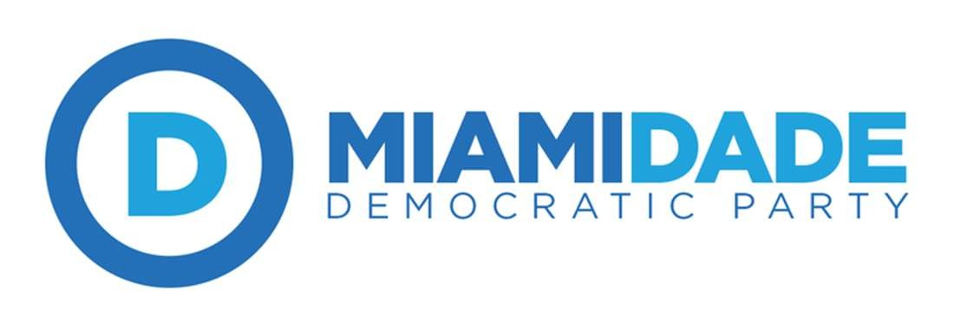
DEC General Meeting (Firefighters Memorial Building)
August 28, 2017 ~7:00pm-9:00pm
Prepared by Secretary Anaruth Solache
- Chair Juan Cuba called the meeting to order at 7:00pm
- Sergeant at arms Deltravis Williams led us in a Pledge of Allegiance
- Kevin Chambliss led us in a moment of silence
- Motion to approve the meeting minutes from the previous Meeting made by Seth Sklarey and seconded by Deltravis Williams.
  - Motion Passes unanimously.
Chair’s Report
- Chair Juan Cuba has made Rick Ibrria as the designated person to setup icebreakers to get to know fellow DEC members.
- Chair Juan Cuba recognizes Hector Caballero for his contributions to the Democratic Party. As well as Stephanie Maitre for her work with the party and the Senate 40 Campaign.
- Volunteers are needed for the SD 40 election; they need phone bakers and canvassers.
- The Blue Gala is coming up, please purchase your tickets! Prices go up after sept1.There are advertising opportunities available as well, contact Steve Dlogoff for more information.
State Committeeman Report
- The State Convention will be taking place at Coronado Springs Resort during the weekend of October 27-29. Delegate Applications have gone out, the registration fee is $60.00.
- There will be a Resolution Committee process at the convention; they will be only taking very few resolutions.
Credential’s Report (link report)
- ***Add list of members who have stepped down and those who were added into the DEC***
- Motion to approve the credentials report by Phyllis Lehman & Seconded by Javier Estevez.
  - Motion passes unanimously.
Campaign Committee Report
- The Re-certification program is almost complete; there are 20 clubs, & 11 caucus. There are 3 clubs missing their certification application.
- There is a Jewish and Environmental Caucus in the works.
Unfinished Business
- Resolution on People-Powered Politics over Corporate Interest
  - Motion to approve the resolution of People-Powered Politics over Corporate Interest made by Alex Flores & seconded by Javier Estevez
  - Motion passes unanimously.
New Business
Resolution on Women’s Right to Choose
- Motion to approve the resolution on Women’s Right to Choose made by Tomas Kennedy & seconded by Javier Estevez.
- Motion passes unanimously.
Resolution on Moratorium of Charter School Expansion
- Motion to approve the resolution on the Moratorium of Charter School Expansion made by Chris Riker and seconded by Deltravis Williams.
- Motion passes unanimously
Resolution on: Save the Fillmore, Miami Beach at Jackie Gleason Theater
- Motion to approve the resolution on Save the Fillmore, Miami Beach at Jackie Gleason Theater made by Chris Riker and seconded by Javier Estevez.
- Motion passes unanimously.
Resolution on DACA
- Motion to approve the resolution on DACA made by Seth Sklarey and seconded by Phyllis Lehman.
- Motion Passes unanimously.
Speakers
- Mayor Andrew Gillum, Candidate for Governor
- Ryan Torrens candidate for State Attorney
Motion to adjourn by Seth Sklarey and seconded by Martin Culver

