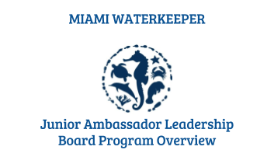

Position Description:

The Junior Ambassador Leadership Board was designed to give previous Junior Ambassadors the opportunity to become leaders within the program. As alumni, JALB members will welcome incoming Ambassadors and participate actively in trainings and service events. Leadership Board members will be exemplary graduates of the Junior Ambassador program and must have completed all program requirements before being eligible to apply. This is a great opportunity for alumni Junior Ambassadors to develop their leadership skills, further their professional growth and team management abilities, and demonstrate their commitment to Miami Waterkeeper, environmental advocacy, and the Junior Ambassador program.

Qualifications:
- Completion of the Junior Ambassador Program
- Availability to attend all events and trainings
- Commitment to participate actively
- Ability to write blog posts about the program or environmental topics
- Willingness to be featured in Miami Waterkeeper outreach materials or media
- Demonstration of leadership and role model skills to fellow peers
- Commitment to helping others learn
- Ability to give positive constructive feedback
- Dedication to the protection of South Florida’s watershed and surrounding resources

Junior Ambassador Leadership Board Experience:
As a member of the JALB, you will gain valuable near-peer mentoring experience. Leadership Board members will facilitate group discussions, guide training activities, and leader community service events. Leadership Board members will get to experience the Junior Ambassador Program once more, but with a leadership role.

NAME:
AGE:
GENDER:
SCHOOL:

Application Questions:
- What did you most enjoy about being a Junior Ambassador?
________________________________________________________________________
________________________________________________________________________

- How can you help a new Junior Ambassador feel welcomed?
________________________________________________________________________
________________________________________________________________________

- What qualities make you a good leader? What qualities do you hope to build on by being part of the Junior Ambassador Leadership Board?
________________________________________________________________________
________________________________________________________________________

- What do you look forward to in becoming part of the Junior Ambassador Leadership Board?
________________________________________________________________________
________________________________________________________________________

