The Maritime Union Of Australia National Office | 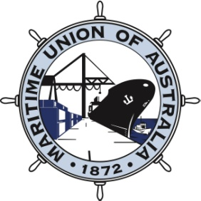
Paddy Crumlin - National Secretary I Will Tracey - Deputy National Secretary
Ian Bray and Warren Smith - Assistant National Secretaries
Monday 29 February, 2016

Workers sacked for being Australian speak out in new TV ads

The Maritime Union of Australia is placing protection of Australian jobs on the national political agenda with the launch of hard-hitting television ads and an associated campaign.

This follows the highly successful Jobs Embassy, which has been running on the lawns outside Parliament House for several weeks.

Under the banner of “Sacked for being Australian”, MV Portland workers Zach Kinzett and Dale Eaton share their stories about being replaced by foreign crew, earning as low as $2 an hour.

At 0100 on January 13, five crew members from the MV Portland were forcibly removed by dozens of security guards from their bunks, marched off the ship and abandoned on the wharf.

MUA National Secretary Paddy Crumlin said the plight of the seafarers had touched a chord with Australian workers because if it can happen to them it can happen to anyone at any time.

“The outrageous part of this story is the selling out of local jobs to overseas workers on domestic coastal shipping routes by Alcoa and a complicit federal government,” Mr Crumlin said.

“These decisions are consistent with a government that has actively overseen the destruction of the automotive industry, and given the green light for 457 visa workers to undermine local jobs in the construction industry.

Mr Crumlin said recent events in Senate Estimates and a Senate Inquiry had confirmed former Deputy Prime Minister Warren Truss and Minister for Employment Michaelia Cash knew in advance that a foreign crew would replace Australian seafarers.

“Everyday Australians don’t accept a government that is actively destroying the jobs of its own people - these are coastal shipping jobs that serve domestic freight shipping routes,” Mr Crumlin said.

“The Senate voted last November to retain cabotage laws and disappointed by the decision, the Government is now pressing ahead by issuing so-called temporary licences without requiring any evidence or reasoning whatsoever.

“The ships don’t leave Australian waters, and should be crewed by Aussie seafarers. These blokes have been sacked for being Australian. If this can happen to an Australian crew who thought they had secure employment and were covered by national laws, it can happen to anyone."

“This is a message that we will be taking to every community before the federal election and making sure that people know that the Turnbull Government is selling off Australian jobs.”

To more details go to www.protectaussiejobs.org.au

For a high resolution version of the advertisement go to: https://www.hightail.com/download/ZWJYaUNLa0RCSWNFSzhUQw

Or for an MP3 version go to: https://www.hightail.com/download/ZWJYaUNLa0RZY1J2TzhUQw

Media Contact: Darrin Barnett 0428 119 703

