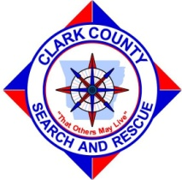 | OZAN POINT WORKSHOP | Ozan Point Workshop  Track 1 Workshops  Track 2 SAR Tech 2 Workshop/Tests  Track 3 Briefings

Friday, March 11, 2016
4:00pm – 7:00pm | Registration/Camp Set Up
7:00pm – 8:00pm | Weather Resources for SAR Operations  National Weather Service Little Rock
8:00pm – 10:00pm | Maps (Tabletop)  Bill Rogers Clark County SAR

Saturday, March 12, 2016
7:00 – 12:00pm | Registration/Camp Set Up
7:00am – 7:45am | Full Breakfast Provided by Baptist Men Disaster Relief  (fee applies)
7;45 – 8:15am | General/Safety Briefing  Workshop Schedule
8:30am – 9:50am | GPS Operations  John Trauger Hempstead County SAR
10:00am-12:00pm | SAR Technology for the 21st Century (DRONE)  Trey Johnson Union County SAR
12:00 pm – 12:45pm | Full Dinner Provided by Baptist Men Disaster Relief  (fee applies)
1:00pm-2:15pm | Calculating POD  Kathy Nunez Franklin County SAR
2:30 – 3:45pm | National Association for Search and Rescue  Bryan Enberg Director of Education NASAR
4:00pm – 5:00pm | Writing SAR Assignments  Bryan Enberg Director of Education NASAR
5:00pm – 5:45pm | Full Supper Provided by Baptist Men Disaster Relief
6:00pm-10:00pm | SAR Initial Action  (Lecture Only)  Bryan Enberg Director of Education NASAR | SAR Tech 2 Written Exam  Registration is required  Earl Tilton Director NASAR
7”:00am-7:45am | Full Breakfast Provided by Baptist Men Disaster Relief (fee applies)
8:00am-10:45 am | Patient Packaging and Litter Handling  Bryan Enberg Director of Education NASAR | SAR Tech 2 Field Test Begins  Registration is required  Earl Tilton Director NASAR
11:00am- 12:00pm | Crime Scene Preservation  Sergeant Kevin Yeagle Clark County Swat Commander
12:00am – 12:45pm | Full Dinner Provided by Baptist Men Disaster Relief (fee applies)
1:00 – 2:00pm | Debriefing
Sunday, March 13, 2016

3rd ANNUAL OZAN POINT WORKSHOP INFORMATON

DATE: MARCH 11-13
PLACE: Brushy Creek/ Ozan Point, DEGRAY LAKE

WORKSHOP INFORMATION- This workshop is open to all ground search teams or sar individuals. A schedule of events has been set up to accommodate new and experienced searchers. The workshop is free. Meals will be provided Saturday March 12th and Sunday March 13th for a cost of $20 per person. This fee will include all 5 meals. Please indicate if you plan to purchase these meals.

Campground Information: There are bathrooms and water but no electricity. Due to campground restrictions, we are requesting that only command trailers be brought into the area. All camping is primitive with tents being used for lodging. Please bring your own tent. There will be no charge to you for campsites.

Meals: Friday night meals will be your responsibility. For Saturday and Sunday, Baptist Men Disaster Relief will provide meals for the day. The cost will be $20 per person or a little over $4.00 per meal. If you want to purchase a meal ticket, please indicate on your registration. This money will be collected at registration Friday night or Saturday Morning.
Code of Conduct: We are professional search teams using Corp of Engineer land free of charge for this workshop. Please be sure to conduct yourself in a manner appropriate for the public eyes. Please clean up after yourself. If you bring it in, please take it out. Treat other searchers with the respect you would like to be treated with. There will be no alcohol will permitted at the workshop.

Supplies: Many workshops require equipment from your 24 pack. Please bring your supplies with you when you come. You will be on your own for meals Friday night.

Registration: Preregistration is requested for logistical purposes. Please indicate when you plan to arrive and how long you will be staying with us. Meal tickets will be available upon check in but please indicate your meal intentions so we can plan accordingly.

SAR TECH 2 EXAMS: As a courtesy to those who may not be certified, we will offer a Tech II Written Exam on Saturday March 12thand Field Certification March 13th. We will also be offering a SAR Tech II Evaluator Workshop.

SAR Tech II Information: Evaluator Workshop: Potential SARTECH II evaluators are requested to be current NASAR individual members. Evaluator candidates will be required to submit an Evaluator Application packet which includes an Evaluator Application, a current background check, a letter of reference by their supervisor or AHJ and Evaluator evaluation form signed by the Lead Evaluator. The workshop will consist of setting up the SARTECH II evaluation stations and understanding of the process and curriculum. Evaluator candidates will set up the 5 SARTECH II practical stations, proctor the written exam, review the NASAR Program Administration Manual and culminate with evaluation of the incoming SARTECH II candidates.
SARTECH II Evaluation: Candidates will have the opportunity to take the NASAR SARTECH II written exam and challenge the 5 SARTECH II practical stations. Candidates will be required to wear their 24 hour search pack during the entire course. Practical stations will include Basic Man-tracking, Area Search, Route Search, Basic Knots and Navigation. Candidates will be required to supply their own navigation equipment, 25’ of 1” tubular webbing and 5’ of 8mm accessory cord (for knot tying purposes only).

From the host:
UTM For SARTECH II is 8102/8865. If they are staying for the workshop, UTM for campground is 7618/8847
All candidates need to be prepared for all weather instances. We will test rain or shine. To register for SAR Tech II please RSVP at http://www.nasar.org/sartech_ii_evaluation_evaluator_workshop

NOTE: WE WILL TRY TO BE WONDERFUL HOSTS AND PROVIDE YOU WITH ALL THE NESSESSITIES YOU WILL NEED TO HAVE A GOOD TIME AND LEARN A LITTLE FROM OTHER SEARCHERS. YOUR COMFORT HOWEVER MAY BE IN QUESTION. SINCE YOU ARE A WILDERNESS GROUND SEARCHER, PLEASE COME PREPARED TO “ROUGH IT”. CAMPERS FOR LODGING WILL NOT BE ALLOWED FOR THIS EVENT SINCE WE HAVE CAMPGROUND RESTRICTIONS AND LIMITED SPACE

Special Thanks To the National Association for Search and Rescue for their continuing support of this workshop.

Workshop Registration

Name__________________________________________________________________________.

Address_________________________________________________________________________

_________________________________________________________________________

Team Affiliation__________________________________________________________________

Meal Plans (please check mark below)
- I plan to provide my own meals
- I plan to purchase a meal ticket ($20 for 5 meals)

Previous Training Level (please check mark below)
- No previous SAR Training
- ISAR/ TECH 3
- FUNSAR
- SAR TECH 2
- SAR TECH 1

When will you be staying with us?
- Friday-Sunday
- Friday only
- Saturday only
- Sunday only

I understand that this is a free workshop offered by The Clark County Office of Emergency Management and The Clark County Search and Rescue Team in partnership The Arkansas Corp of Engineers. I understand that The CCOEM, CCSAR and ACE are not responsible for any injuries or losses I may incur due to this workshop and exercise.

NAME___________________________________ Signature_________________________________Date_________

Please email your completed registration to mikki@clarkoem.com

If they are staying for the workshop, UTM for campground is 7618/8847 address is 2368 Brushy Landing Road, Arkadelphia AR 71923.
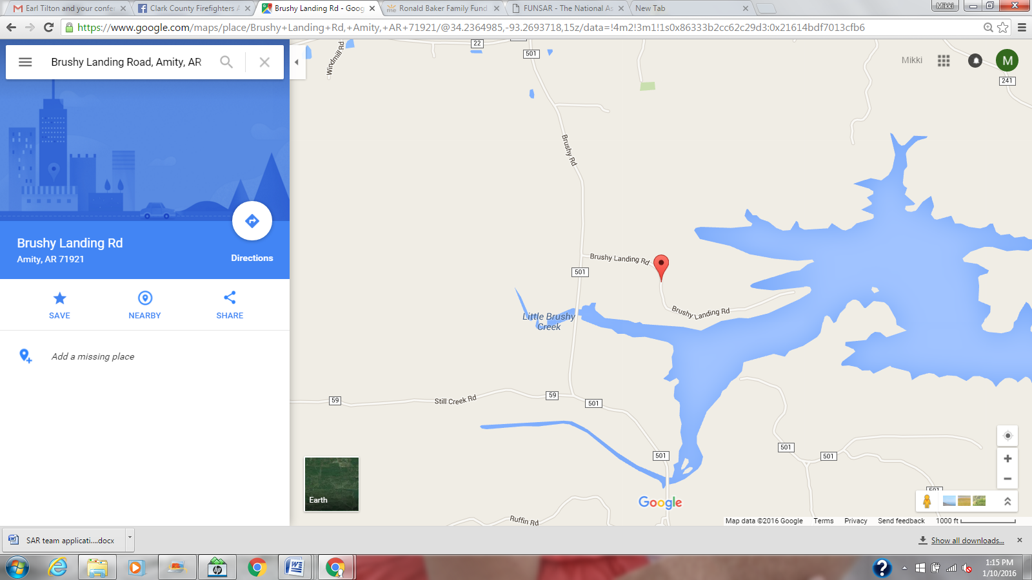

+
UTM For Sar tech 2 is 8102/8865.

