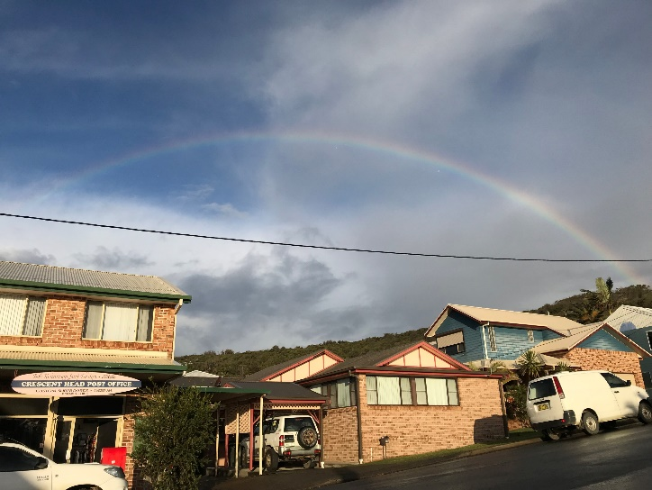
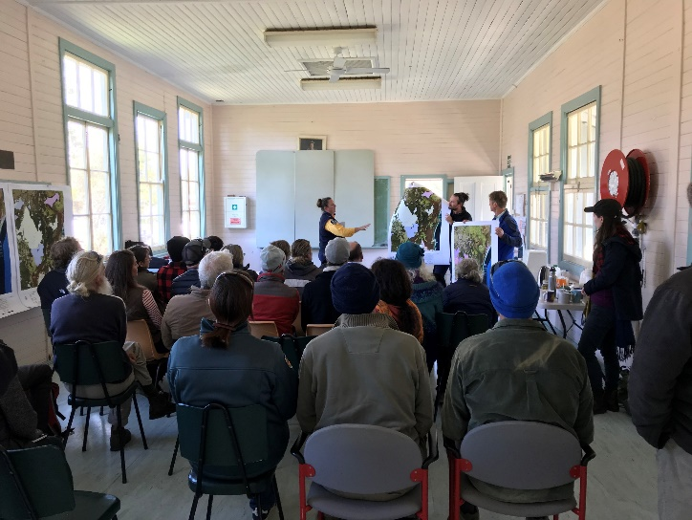
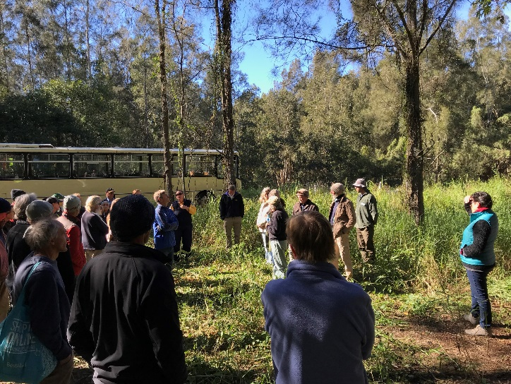
Bushfire Program Workshop Report
Crescent Head Hinterland Fire and Biodiversity workshop 2019
Nature Conservation Council of NSW (NCC) hosted a Fire and Biodiversity workshop in the Crescent Head Hinterland on Tuesday 4th June 2019, bringing together 32 local residents and 6 representatives from the NSW Rural Fire Service, Kempsey Shire Council, NSW Biodiversity Conservation Trust, Macleay Landcare, Hastings-Macleay Koala Recovery Partnership, and NSW National Parks and Wildlife Service.
This community workshop aimed to:
- Introduce bush fire risk and fire history of the area.
- Increase understanding of fire behaviour, fire ecology and fire management principles.
- Communicate a broad understanding of the unique biodiversity values of the region including threatened species, old growth forests, swamp sclerophyll forests, and key habitat features.
- Discuss the effects of fire and weeds on biodiversity values and introduce potential management activities to maintain/improve these values.
- Provide opportunities for conversations between community members and agencies.

Facilitation and Discussion
NCC’s Evelyn Chia and Mark Graham led interactive discussions for community members at this workshop, drawing on a wealth of local knowledge and expertise.
The program featured an introduction to bush fire risk and fire management of the area by the Lower North Coast District of the NSW Rural Fire Service. Bush fire risk management plans were actively discussed and maps of the local area displayed.
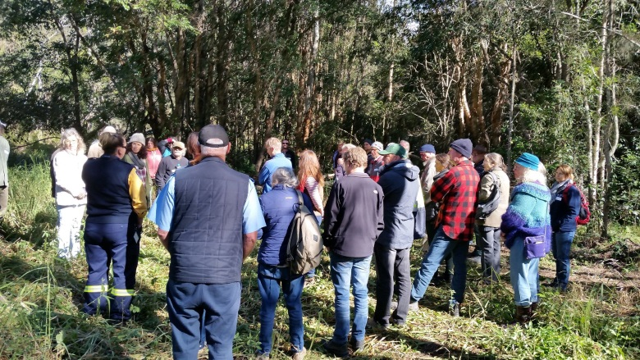
An active field component followed which involved visits to three selected sites via an organised bus in the Crescent Head Hinterland, where the complexities of managing fire for different objectives were highlighted. This included raising the awareness of the importance of the local coastal floodpain wetlands and the sensitivities of these ecosystems to fire.

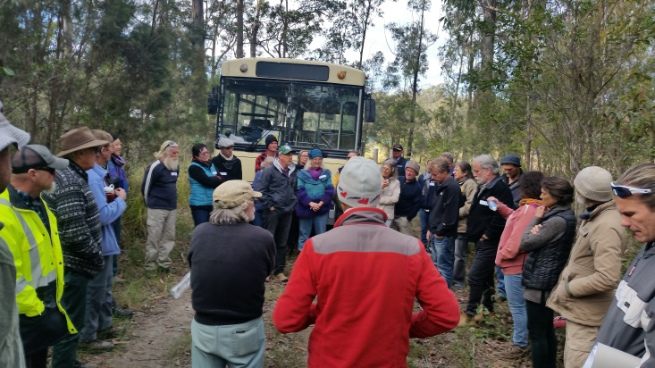
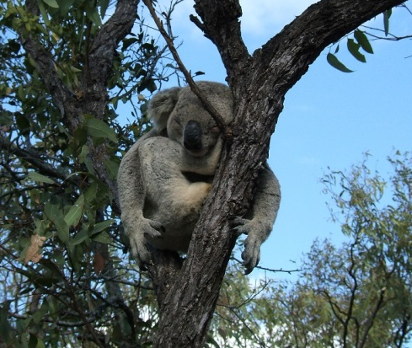
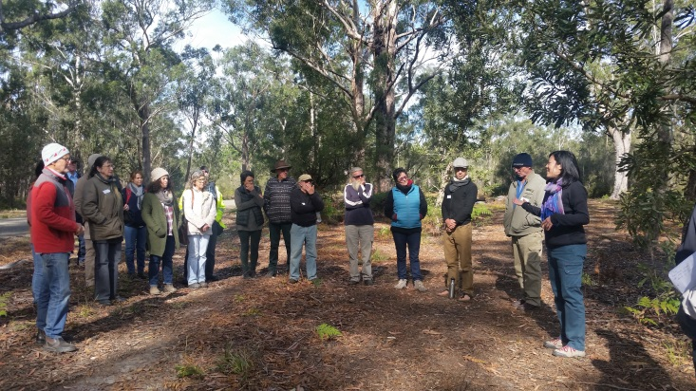
Image: Andrew France
Next, members of the Goolawah Co-operative generously shared knowledge and learnings of fire management activities on their property, which stimulated thoughts on how to achieve a desired fire regime and mosaics, in different vegetation types, with considerations to different animal species, and how to balance these.
At the last site, the significance of the large expanse of old growth forest in the landscape was highlighted, particularly in and around Beranghi Road, as corridors and habitat for wildlife and a large number of threatened species. The impact of fire and potential mitigation measures were introduced including protection of hollow-bearing trees. Participants then travelled back to Crescent Head Community Hall to enjoy lunch with their neighbours of old and new connections, and shared ideas stimulated from the workshop sessions.

Participant Feedback

Participants provided positive feedback on the program; 94% recorded that it fulfilled their expectations, 95% indicated that the workshop was relevant and covered topics important to them, and 100% thought that the workshop was well organised and facilitated.
“Fantastic collaboration and opportunity has deepened my understanding”
“Really rich conversation and knowledge coming from a range of experts in overlapping fields.”
Workshop participants

Participants reported that they gained a greater understanding of key topics including: how protection from bushfire is a shared responsibility, fire management, bush fire risk and fire behaviour, fire ecology, threatened species in the local area, fire and fauna, fire and flora, and fire and weeds. People particularly valued learning about fire management, ecology, and the significant biodiversity present in their area, hearing from different agencies, and the opportunity to meet new people. Community members also indicated that as a result of the workshop they would act by thinking more about their own properties and how to manage them for fire and biodiversity and concentrate on the protection of habitat e.g. consideration to old growth trees and coastal habitat/peat forests and putting up more nest boxes.
“Realising our old growth forests are naturally and internationally significant.”
“Excellent interaction between facilitators and participants”
Workshop participants

This workshop enabled local residents to learn about bush fire risk, fire management, fire ecology and of the unique biodiversity of the area via valuable discussions, and connections with their local agencies and neighbours. There is a desire to learn more about fire management planning and biodiversity, providing an opportunity for future community engagement activities.

Additional Resources
For further information and resources mentioned during the workshop, please see the following websites:
- An overview of the NCC’s Bushfire Program:
https://www.nature.org.au/healthy-ecosystems/bushfire-program/

- NCC Bushfire Program fact sheets and resources available below including:
https://www.nature.org.au/healthy-ecosystems/bushfire-program/fact-sheets/

- A series of training webinars on how to use numerous online environmental tools
- Creating bird-friendly gardens in fire-prone areas
- Information on fire ecology
- Integrated fire and weed management

- NCC Bushfire Program’s fire and restoration website where we share project stories and engage people in discussions about how fire is being used to support ecological restoration:
http://fireandrestoration.org.au/

- Additional resources available from the Hotspots Fire Project including:
http://hotspotsfireproject.org.au/ecological-resources
- Ecological Site Assessment & Monitoring of Bush Fire Management Landholder Guide
- Fire, Weeds and Native Vegetation of NSW
- Fire and Weeds Landholder Booklet
- And many others (please visit website to view the full range)

