Contact: Sue George FOR IMMEDIATE RELEASE
Phone: (505) 277-5089
Email: sgeorge2@unm.edu

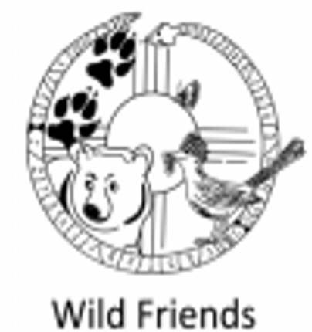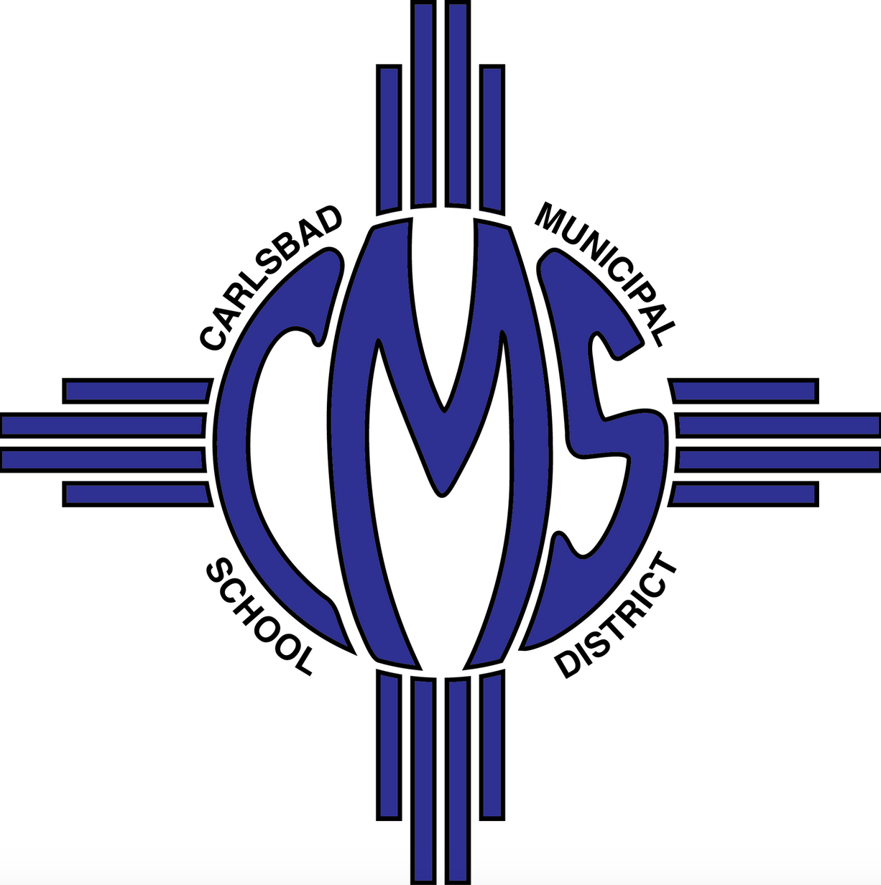

Wildlife Conservation Student Program Receives Grant from XTO Energy
Wild Friends’ civics and science program expands to all Carlsbad eighth graders

CARLSBAD, N.M. (November 17, 2020) — Wild Friends, an award-winning conservation and civics program through the University of New Mexico School of Law, today announced a $50,000 grant from XTO Energy. This grant expands the Wild Friends program to southeast New Mexico and enables all eighth-grade students enrolled at Carlsbad Intermediate School to participate.

“Wild Friends is a fantastic program that brings conservation and education together for a practical hands-on learning experience,” said Rick Cannon, Delaware Basin Production Manager at XTO Energy, an ExxonMobil subsidiary. “Through Wild Friends, Carlsbad intermediate students will have an opportunity to provide input on real legislation on a wildlife conservation issue and then advocate to pass it in the New Mexico State Legislature.”

As a statewide, experiential education platform, Wild Friends integrates civics and wildlife law to help students in fourth through 12th grades understand the democratic process, develop good citizenship skills and contribute to wildlife conservation by involving them in public policy projects.

“We have been looking for a way to bring our program into southeast New Mexico. With XTO’s contribution—the largest toward this program—we will be able to do just that,” said Wild Friends Director Sue George. “We are very excited to share our unique blend of conservation science and civics to the students in Carlsbad and look forward to the possibility of expanding to other schools in Eddy County.”

During the most recent 60-day session of the New Mexico State Legislature, Wild Friends students learned about the importance of pollinators, researched the threats against them, and helped with a bill establishing the first-ever pollinator protection license plate for New Mexico. Proceeds from sales of the plate go to the New Mexico Department of Transportation to help increase pollinator-friendly plantings on roadsides. The plates are currently available for purchase at http://www.mvd.newmexico.gov/license-plates.aspx

“We always welcome the opportunity for our students to learn how our government works and that they have a voice,” said Andrea Edmonson, principal at Carlsbad Intermediate School. “We are thrilled to offer the Wild Friends program to our eighth graders, thanks to the support of XTO Energy.”

The Wild Friends program started in the 2020 fall semester at Carlsbad Intermediate School. For more information on Wild Friends, go to wildfriends.unm.edu.

