Memorandum

To: Open Communities Alliance

From: Florence Roisman, William F. Harvey Professor of Law, Indiana University Robert H. McKinney School of Law
Myron Orfield, Professor of Law; Director, Institute on Metropolitan Opportunity, University of Minnesota School of Law
J.L. Pottenger, Jr., Nathan Baker Clinical Professor of Law; Supervising Attorney, Yale Law School

Re: Intersection of HB 6640 and federal law governing the Low Income Housing Tax Credit Program

Date: May 27, 2015

Question Presented:

This legal memorandum considers whether, HB 6640 (see Exhibit A), a bill creating priorities for certain geographical areas when awarding tax credits through the federal Low Income Housing Tax Credit Tax Credit (LIHTC) program, runs afoul of a preference for placements in Qualified Census Tracts (QCTs) in federal law, as asserted by Hawkins, Delafield, and Wood LLP, bond counsel for the Connecticut Housing Finance Authority, in a memorandum of April 21, 2015 (Hawkins Memo, attached as Exhibit B).

Short Answer:

No. The Hawkins Memo relies on the wrong part of the LIHTC statute, so it misreads the law to conflict with HB 6640 and federal and state civil rights obligations. There are five reasons HB 6640 is in accordance with federal law:

- The federal LIHTC statute, 26 U.S.C. Section 42, does not, on its face, require QCTs to be prioritized in the selection of projects. According to the statute, once projects are selected based on the “housing priorities of the housing credit agency which are appropriate to local conditions,” those in QCTs with concerted communities revitalization plans are to be given preference in the allocating of the exact amount of LIHTC benefits among selected projects.

- If the Hawkins Memo is correct, Connecticut and at least nine other states are operating their LIHTC programs illegally because they do not currently provide significant preferences for QCTs in their LIHTC selection processes. The Connecticut Housing Finance Authority currently awards only 1 point out of 110 to proposed developments in QCTs in the competitive process used to allocate LIHTCs and this extremely low preference has not generated concern on the part of regulators. At least nine other states, including Massachusetts and New Jersey, put other state priorities above preference for QCTs.

- Section 42 does not preempt the legislature’s ability to comply with civil rights obligations. Section 42 and civil rights laws do not conflict and Connecticut and CHFA retain considerable discretion in the development of the point allocation for the LIHTC program, and the program itself.

- CHFA’s financing activities are governed by the federal Fair Housing Act and HB 6640 brings Connecticut’s LIHTC program into conformance with federal requirements.

- HB 6640 will assist CHFA and the state to comply with federal civil rights obligations and their obligations to affirmatively further fair housing.

Background

The Low Income Housing Tax Credit Program

The Low Income Housing Tax Credit (LIHTC) program, which was created in 1986, supports the development, purchase, and rehabilitation of rental housing developments that include units affordable to low-income individuals and families. It is a program of the federal Department of Treasury administered in Connecticut by the Connecticut Housing Finance Authority (CHFA). Nationally, the program produces more units of affordable housing than any other federal program. Connecticut currently has approximately 20,000 LIHTC units. LIHTCs are allocated to developers through a competitive process using a point allocation developed by the CHFA staff and board called the Qualified Allocation Plan (QAP).

Location of LIHTC Units in Connecticut

According to the 2015 Analysis of Impediments to Fair Housing Choice produced by the Department of Housing (AI Report), 73% of LIHTC units are located in high poverty and minority concentrated areas, which make up less than 11% and 6% of the land area of the state, respectively.

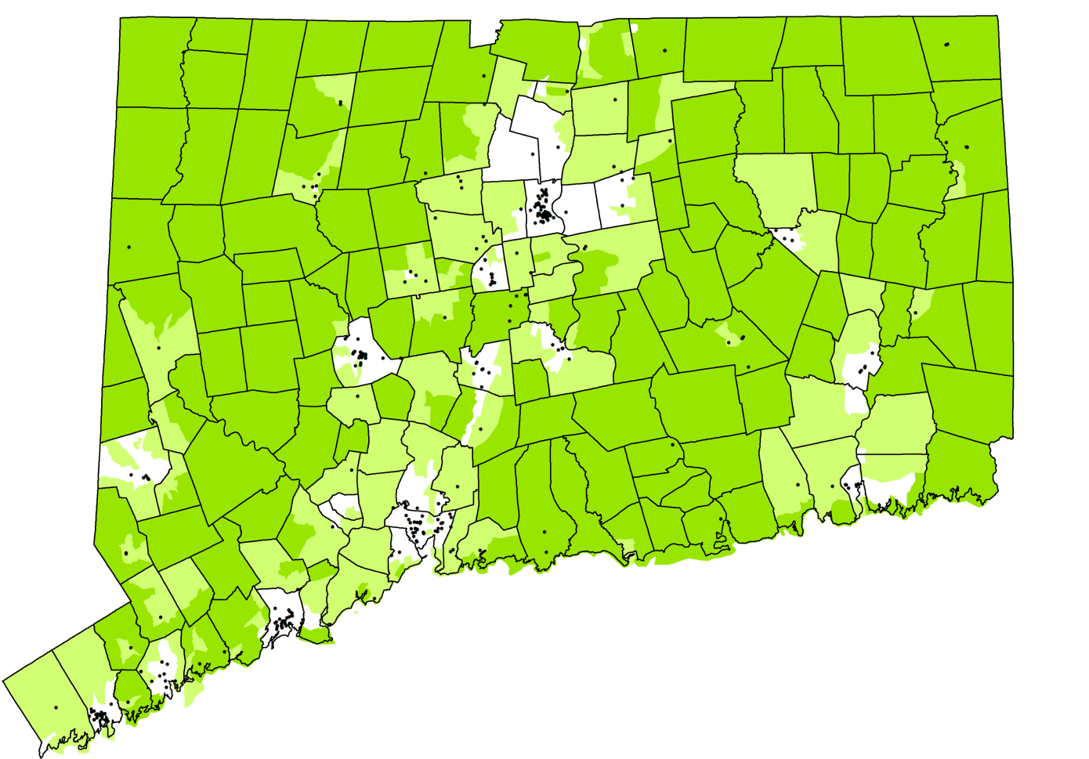

Figure 1: LIHTC Units by Race, Poverty and RCAP (by tract)
Demographic Served | Total Units | Dispropor-tionately Minority Areas  (30% or >) | High Poverty Areas  (9.2% or >) | Racially & Ethnically Concentrated Areas of Poverty  (50+% minority + 3x regional poverty)
% of CT Land Area |  | 5.8% | 10.5% | <1%
All | 20,018 | 73% | 73% | 40%
Open to All | 13,560 | 76% | 76% | 37%
Elderly | 4,740 | 58% | 55% | 36%
Supportive | 734 | 96% | 96% | 63%

The AI Report also found that Blacks and Latinos in Connecticut earn half or less of what Whites earn, meaning that Blacks and Latinos have a greater need for the kind of affordable housing created by the LIHTC program. The report further found that Connecticut is one of the most racially and ethnically segregated states in the country and this kind of segregation isolates Blacks and Latinos in areas of lower opportunity where families, and especially children, have considerably less access to the building blocks that lead to success in life.

Mounting evidence demonstrates that moving to thriving communities has dramatic and life-changing effects on lower income families who opt for such a change. In particular, two companion reports issued in May 2015 by Raj Chetty and his colleagues at Harvard found that children in low-income families who moved from struggling areas to thriving areas were, as adults, more likely to attend college, avoid single parenthood, and earned more money. In fact, according to one of Chetty’s studies, a child who moved with his or her family at age eight would earn $302,000 more in their lifetime than a child in a family who remained in their initial higher poverty area.

By concentrating LIHTC developments overwhelmingly in areas that are disproportionately minority and low income, the state of Connecticut is at once denying lower income families of color the opportunity to move to thriving communities and increasing poverty concentration in areas that are currently disproportionately minority and lower income. This is problematic as the income gap between middle and upper-income families in this country becomes the largest ever recorded. Such practices also generate segregated housing patterns that will necessitate further future spending on regional magnet schools in order to comply with the school integration mandates of Sheff v. O’Neill.
What HB 6640 Proposes

HB 6640 proposes to affirmatively counter the long imbalance in Connecticut’s LIHTC program by creating three placement priorities for the program using “opportunity mapping” census tract designations created by the Kirwan Institute, a highly respected academic institution with an expertise in data connected to regional planning and racial equity. Kirwan’s mapping, which was updated in 2015 by Open Communities Alliance in partnership with the Kirwan Institute and the CT Fair Housing Center, is in the process of being integrated into priorities of the Connecticut Department of Housing and will shortly be available on its website. The assessment generates an opportunity ranking across five opportunity levels (very high, high, moderate, low and very low) based on 12 data points that reflect conditions social science research has found predicts success in life. An opportunity map for Connecticut is available in Exhibit C.

If HB 6640 were enacted:

- 60% of credits would be prioritized for non-age-restricted developments in higher opportunity areas.

- 15% of credits would be prioritized for age-restricted projects in higher opportunity areas.
- 25% of LIHTCs would be prioritized for catalytic projects in areas of “moderate” “low” and “very low” opportunity areas.

- To ensure that Connecticut does not lose any LIHTCs, if an insufficient number of qualifying applications are received for any of these categories, other applications can be considered under the regular QAP analysis.

Requirements of the LIHTC Statute
The LIHTC statute provides some parameters for how LIHTCs are to be prioritized through its definition of the Qualified Allocation Plan, the tool used to layout the allocation of competitive points within the program, in 26 U.S.C. § 42 (m)(1)(B). The relevant section states:

(B) Qualified allocation plan

For purposes of this paragraph, the term “qualified allocation plan” means any plan—

(i) which sets forth selection criteria to be used to determine housing priorities of the housing credit agency which are appropriate to local conditions,
(ii) which also gives preference in allocating housing credit dollar amounts among selected projects to—

- projects serving the lowest income tenants,
- projects obligated to serve qualified tenants for the longest periods, and
- projects which are located in qualified census tracts (as defined in subsection (d)(5)(C)) and the development of which contributes to a concerted community revitalization plan…
Emphasis added.

Section (C) also sets forth selection criteria that must be used. These include
project location, housing needs characteristics, project characteristics, including whether the project includes the use of existing housing as part of a community revitalization plan, sponsor characteristics, tenant populations with special housing needs, public housing waiting lists, tenant populations of individuals with children, projects intended for eventual tenant ownership, the energy efficiency of the project, and the historic nature of the project.

Qualified Census Tracts in Connecticut

Qualified Census Tracts are census tracts in which “50 percent or more of the households have an income which is less than 60 percent of the area median gross income for such year or which has a poverty rate of at least 25 percent.” There are 164 Qualified Census Tracts in Connecticut. Of these, 162 are located in very low, low, and moderate opportunity areas where HB 6640 would prioritize 25% of the LIHCTs.
Discussion

I. On its face the LIHTC program’s statutory preference for Qualified Census Tracts does not override other priorities identified by states.

On its face, the language of 26 U.S.C. § 42 (m)(1)(B) does not require that LIHTCs be awarded primarily to developments proposed in QCTs. Several components of the statutory language severely limit such an interpretation. First, before even applying the preferences outlined in subsection (B)(ii), the selection criteria in subsection (B)(i) must be applied. Subsection (B)(i) outlines the “selection criteria to be used to determine housing priorities of the housing credit agency which are appropriate to local conditions…”

The QCT preference is applied for the purposes of allocating the dollar amount of credits only after the projects are selected. The specific language in (B)(ii) states, “…preference in allocating housing credit dollar amounts among selected projects to projects…”(emphasis added) meeting the three preferences, including the QCT/revitalization plan preference. As the federal court for the Northern District of Texas found when considering exactly this question in the LIHTC context,

In other words, § 42(m)(1)(B)(ii) (III) does not require that the QAP award additional points so that projects located in QCTs and the development of which contribute to a concerted community revitalization plan are preferred over other projects. Instead, § 42(m)(1)(B)(ii) (III) provides that, after projects have been selected, projects located in QCTs, and the development of which contributes to a concerted community revitalization plan, must be given preference in allocating LIHTC dollar amounts among the projects that have already been selected.

(2012 WL 3201401 at 6)(footnotes omitted).

As the Texas federal court also found, the proper interpretation of the statute, in subsection (C), envisions the balancing of multiple priorities, as identified by the state, in selecting the developments. In support of this the court stated,

One selection criterion is the “project characteristics, including whether the project includes the use of existing housing as part of a community revitalization plan.”… The inclusion of this criterion as one of several criteria confirms that Congress only intended revitalization projects that include the use of existing housing as part of a community revitalization plan to be one factor in the selection process, not a dispositive or preferred one. Congress could have, but did not, require that a QAP effectively prefer revitalization projects in QCTs by including that requirement in § 42(m)(1)(C). Accordingly, under a correct interpretation of the statute, the preference mandated by § 42(m)(1)(B)(ii)(III) comes into play after projects are selected and when LIHTC dollar amounts are being allocated among selected projects.

(2012 WL 3201401 at 6)(citations and footnotes omitted).

Taken together, these components of the statute give states considerable leeway to adapt their LIHTC selection processes to “local conditions” and set their own priorities. It is also clear on the face of the statute that any preference for QCTs is applied only after projects are selected to receive program benefits and references the allocation of the dollar amount awarded among the selected projects.

II. In practice, Connecticut, and many other states, place other priorities far ahead of the “QCT with revitalization plan” preference and the one federal court to consider this approves of such an approach.

Many states, including Connecticut, do not make QCT placement a significant priority in their QAPs. In Connecticut, the current QAP scores applications from developers on a scale of 1 to 110. Out of all of these available points a grand total of 1 point (or .9% of the total possible) is given to developments located in QCTs with concerted community revitalization plans. The Texas QAP at issue in the case cited above likewise allocated one point to developments with revitalization plans in QCTs. That Texas QAP gave the same number of points (i.e. one) for having gazebo on the property. Also, in Connecticut, over the last 10 years, 44% of the developments awarded LIHTC funding have been located outside of QCTs.

Other states similarly place greater emphasis on other, non-QCT, locational priorities.

New Jersey: The New Jersey 2013 QAP is a prime example because, like HB 6640, it strives to create access to opportunity. The New Jersey QAP states,

(d) Forty percent of the credits in this [family] cycle (inclusive of all set-asides) shall be made available to Targeted Urban Municipalities and the remaining credits shall be allocated to the remainder of the State, provided NJHMFA receives a sufficient number of eligible applications from areas outside of Targeted Urban Municipalities to result in these allocation percentages. The credits allocated toward Targeted Urban Municipalities could exceed 40 percent if necessary to fully fund a project.

Massachusetts: Massachusetts also provides an example of a QAP that prioritizes opportunity while providing minimal points for QCT location. The MA QAP includes a threshold criterion that, among ten priorities, includes advancing equity, promoting access to opportunity, and supporting regional planning. It also includes a maximum of 14 points for developments located in areas with “opportunity” benefits like thriving schools. At the same time, a combined total of 13 possible points are awarded for being part of a concerted neighborhood revitalization effort (maximum 4 points), being located in a QCT (maximum 3 points), length of affordability (maximum 3 points), and serving the lowest income population (maximum 3 points). All told, opportunity points outweigh the statutorily prescribed priorities identified for the post-selection allocation of LIHTC dollars.

Pennsylvania: The 2014 Pennsylvania QAP divides its credit into two cycles, with 50% of the credits dedicated to each cycle. Cycle 1 is for urban developments and Cycle 2 is for suburban and rural proposals. Within Cycle 2 three developments are slotted for higher opportunity areas. Within the PA QAP point allocation, 20 points are awarded for being in an area of opportunity, serving seniors “and/or” being part of a revitalization plan. No points are awarded for being in a QCT.

Tennessee: Tennessee actually has restrictions on the percentage of tax credits that may be awarded within QCTs or for preservation/rehabilitation and states in relevant part:

No more than 50% of the total amount of Tax Credits available for allocation in Tennessee will be allocated to developments located completely and wholly within a QCT.

No more than 40% of the total amount of Tax Credits available for allocation in Tennessee will be allocated to developments involving preservation or rehabilitation.

Maine: Maine’s 2014 QAP prioritizes “projects that contribute to economically diverse communities.” In addition, it limits its points for projects in QCTs to one point for rehabilitation projects and one point for QCT projects that have at least 20% market rate units. Both criteria seemed designed to limit new units of subsidized housing in QCTs.

Other states like Iowa, Colorado, and Georgia put other criteria on equal or higher footing than placements in QCTs. North Carolina’s 2012 QAP has as a threshold requirement that developments cannot be in areas of minority and low-income concentration.

These states are all designing their QAP in a manner that aligns with guidance from the U.S. Department of Housing and Urban Development. According to HUD guidance:

Qualified Census Tracts Should Not Be Used as a Substitute for Careful Analysis of Neighborhood Characteristics. For states to use LIHTC as part of a metropolitan-wide strategy means that they should avoid automatic targeting to the census tracts within a metropolitan area with the greatest current concentration of people with housing needs, measured either directly or indirectly by using poverty as a proxy. The choice of LIHTC developments in such areas should be made only when part of a well designed revitalization strategy for that neighborhood. Where such strategies are not present, the LIHTC resource may be better used to expand housing opportunities for low-income families in relatively higher-income parts of the metropolitan area.

The interpretation of the LIHTC statute provided in the Hawkins Memo cannot be correct. In addition to conflicting with HUD guidance, the Hawkins interpretation would mean Connecticut and at least nine other states are operating their LIHTC programs illegally.

III. Section 42 does not preempt the legislature’s ability to comply with civil rights obligations and HB 6640 allows CT to better align with other federal obligations

The Hawkins Memo is in error to assert that H.B. 6640 “directly conflicts with the federal statutory preference” and therefore “set[s] CHFA and the state of Connecticut on a direct collision course between state law and federal law [in which case] the supremacy clause of the United States Constitution would almost certainly prevail.” (Memo at 2). This is clearly not a case of express preemption of state law, nor is it a case of “field preemption.” Austin Apartment Association v. City of Austin, 2015 WL 918504 at *7 (W.D. Tex. Feb. 27, 2015).

The only other form of preemption recognized by federal court is “conflict preemption,” where “compliance with both federal and state regulations is a physical impossibility,” or because the state law “stands as an obstacle to the accomplishment and execution of the full purposes and objectives of Congress.” Cal. Fed. Sav. & Loan Ass'n v. Guerra, 479 U.S. 272, 280-81, 107 S.Ct. 683, 93 L.Ed.2d 613 (1987). Id. at 281, 107 S.Ct. 683 (internal quotes omitted). But, as shown above, there is not conflict at all with federal law. Furthermore, as explained below, there simply is no factual or legal predicate for application of conflict preemption in this circumstance.

CHFA has substantial discretion to formulate a Qualified Allocation Plan that is consistent with Section 42 and with its and the State’s obligations under Title VI of the Civil Rights Act of 1964, the Fair Housing Act and the obligation to affirmatively further fair housing (collectively, the “Federal Civil Rights Obligations”). As outlined above, CHFA currently awards just one (1) point, out of a total of 110 possible points for projects in Qualified Census Tracts. To the extent CHFA is currently in compliance with Section 42’s qualified preference for projects in QCTs, it can remain in compliance under HB 6640 so long as it prioritizes credit dollar funding, among all projects selected for the LIHTC program, for developments in QCTs that have a concerted community revitalization plans.

HB 6640 does not propose to eliminate points for QCTs, but simply to balance longstanding over-allocation of LIHTCs in areas concentrated on the basis of race or poverty (only some of which are located in QCTs). HB 6640 proposes to set aside a percentage of the credits for qualifying projects in higher opportunity areas, in furtherance of CHFA’s and the State’s compliance with Federal Civil Rights obligations. In other words, HB 6640 reflects the State’s efforts to comply with federal requirements other than Section 42, while maintaining CHFA’s current level of respect for projects in QCTs. Moreover, HB 6640 promotes CHFA’s compliance with an alternate qualified preference in Section 42—the one that provides additional consideration for projects in Difficult Development Areas. There simply is no basis upon which to claim that Congress impliedly preempted the Connecticut Legislature’s ability to direct CHFA to develop a QAP that complies with Federal Civil Rights Obligations.

IV. CHFA’s financing activities are governed by the Fair Housing Act

As outlined above, in the operation of its LIHTC program, CHFA is bound to comply both with Section 42 and with the Fair Housing Act. The U.S. Supreme Court and the Second Circuit have repeatedly held that courts must give the Fair Housing Act a broad and generous construction, to further its goals of equal housing opportunity and integration. See, e.g., Trafficante v. Metropolitan Life Ins. Co., 409 U.S. 205, 212 (1972)(holding that courts are required to give the Fair Housing Act a broad and “generous construction.”) See also Huntington Branch, NAACP v. Town of Huntington, 844 F.2d 926, 935 (2d Cir. 1988) (citing to Trafficante, and observing that it stands for the proposition that the “Fair Housing Act must be generously construed to foster integration.”)

Like every other entity affecting the availability of housing, CHFA’s financing activities are governed by the Fair Housing Act. See, e.g., U.S. v. Massachusetts Indus. Finance Agency, 910 F.Supp. 21, 27 (D. Mass. 1996)(holding that 42 U.S.C.§§3604 and 3605 applied to a State agency that was a conduit for bond financing by third parties). To the extent CHFA’s administration of the LIHTC program has been discriminatory, in purpose or effect, it can be enjoined under the Fair Housing Act.

V. HB 6640 will assist CHFA and the State to comply with federal civil rights obligations and their obligations to affirmatively further fair housing

Beyond the universal obligation not to discriminate, recipients of federal funds have an “obligation to do more than simply refrain from discriminating (and from purposely aiding discrimination by others)…This broader goal [of truly open housing] … reflects the desire to have HUD use its grant programs to assist in ending discrimination and segregation, to the point where the supply of genuinely open housing increases.” NAACP v. Sec’y of Housing and Urban Development, 817 F.2d 149, 155 (1st Cir. 1987). See also Langlois v. Abington Housing Authority, 234 F.Supp.2d 33, 73, 75 (D. Mass. 2002)(holding that federal regulations “unambiguously impose mandatory requirements on the [recipients] not only to certify their compliance with fair housing laws, but actually to comply.”)

The State and CHFA each receive tens of millions of dollars in HUD funding every year, and so must comply with the Spending Clause-based civil rights obligations, including Title VI, Section 504, Section 109 of the Housing and Community Development Act of 1974, and the obligation to affirmatively further fair housing (“AFFH”) expressed at 42 U.S.C. §3608. Beyond these federal requirements, the Connecticut Legislature has imposed an AFFH obligation on CHFA by requiring it to “affirmatively promote fair housing choice and racial and economic integration in all programs administered or supervised” by CHFA. Conn. Gen. Stat. §8-37cc(b).

Pursuant to federal regulations, the State is obligated to conduct an Analysis of Impediments to fair housing choice, to identify and implement appropriate actions to overcome the effects of fair housing impediments and to maintain records of the analysis and the actions. 24 C.F.R. §92.325. In fulfillment of that obligation, the State has just completed its Analysis of Impediments to Fair Housing Choice 2015, which is available at http://www.ct.gov/doh/lib/doh/analysis_of_impediments_2015.pdf. That Analysis identified racial and ethnic segregation to be a major impediment to families of color, and identified CHFA’s administration of the LIHTC program partially to blame. For instance, the Analysis found:

- “By any measure, Connecticut is highly racially and ethnically segregated. Two of every three persons of color in Connecticut live in just 15 of the state’s 169 municipalities. These towns house 35% of the State’s entire population. Put another way, 67% of the State’s population of color lives in 8% of Connecticut’s towns.”

- When [the Kirwan opportunity] map is overlaid with data on where people of color are living (Figure 3), it reveals that 81.1% of African-Americans and 79.26% of Latinos live in low and very low opportunity areas compared to 44% of Asians and 25.84% of Non-Hispanic Whites. In other words, a majority of Connecticut’s households of color live in neighborhoods with high unemployment rates, lack of access to high performing schools, and high crime rates.”

- “LIHTC developments are located in areas of minority and poverty concentration at a very high rate—and this rate is even greater for family developments.”

Faced with these fair housing impediments, the State is obligated to take appropriate actions to overcome them. 24 C.F.R. § 92.325. In furtherance of that obligation, the Analysis identified specific actions CHFA must take to overcome the effects of those impediments, including the following:

- “Key to untangling the impediments to achieving a more diverse distribution of LIHTC projects, and, in particular, increasing the number of projects and units in communities with relatively low poverty rates and a representative racial and ethnic mix of residents, is adopting selection criteria that advantages such projects. For 9% LIHTC financed projects, this means, in part, reviewing and, as needed, modifying the QAP. In recent years, the QAP has had elements that both promote and inhibit integrated mixed-income housing development outside of high density communities.”

- “For 4% LIHTC projects, CHFA can coordinate with other funders, including DOH, to prioritize projects that affirmatively further fair housing.”

- “For both 9% and 4% LIHTC projects it is equally important that CHFA and the state confront the market forces inherent in the LIHTC regulations and marketplace that directly or indirectly create incentives for developers to propose projects with a high percentage of units restricted at low-income levels in areas with high rates of poverty and segregation. These market forces may prove resistant to rapid change but must be clearly understood as part of an overall strategy to deploy the various financial resources of CHFA in a manner that affirmatively furthers fair housing.”

- The Analysis made this specific recommendation for action by State: “Encourage the creation and rehabilitation of affordable housing in a variety of locations…. In each DOH competitive funding round, and in the CHFA Qualified Allocation Plan, continue to assign a high point value for developments that achieve fair housing goals, in particular expanding affordable housing opportunities in high opportunity communities for groups that experience the most discrimination and highest degree of segregation (Blacks, Latinos, persons with disabilities, and people with a legal source of income other than employment), and continue to refine the effectiveness of the criteria used for awarding such points.”

- “Evaluate the effectiveness of DOH and CHFA funding rounds in facilitating the creation of new family affordable housing units to ensure the availability of affordable family housing in diverse areas.”

The most logical conclusion to draw from the Housing Committee’s support of HB 6640 is that it has reviewed the Analysis of Impediments and believes that it is obligated under its Federal Civil Rights Obligations and its AFFH duty to identify and implement legislative changes in CHFA’s administration of the LIHTC program. Far from raising concerns about a conflict between State and federal law, HB 6640 appears designed to improve the State’s and CHFA’s compliance with their federal obligations.

Conclusion

In summary, by the language of the LIHTC statute, and in practice in Connecticut and across the country, there is no conflict between HB 6640 and Section 42, the federal statute governing the LIHTC program. In fact, rather than creating a conflict with federal law, HB 6640 brings Connecticut’s LIHTC into alignment with the requirements of the federal Fair Housing Act and state fair housing obligations.
Exhibit A: HB 6640

General Assembly | File No. 227
January Session, 2015 | House Bill No. 6640

House of Representatives, March 26, 2015

The Committee on Housing reported through REP. BUTLER of the 72nd Dist., Chairperson of the Committee on the part of the House, that the bill ought to pass.

AN ACT CONCERNING THE ALLOCATION OF LOW INCOME HOUSING TAX CREDITS. Be it enacted by the Senate and House of Representatives in General Assembly convened: Section 1. (NEW) (Effective October 1, 2015) (a) The Connecticut Housing Finance Authority shall allocate low income housing tax credits received pursuant to Section 42 of the Internal Revenue Code of 1986, or any subsequent corresponding internal revenue code of the United States, as amended from time to time, by creating priority tiers within the Qualified Allocation Plan in accordance with the following: (1) Feasible proposals in high or very high opportunity areas shall be given priority consideration for seventy-five per cent of such credits; and (2) catalytic proposals in very low, low or moderate opportunity areas shall be given priority consideration for twenty-five per cent of such credits. If credits are not allocated pursuant to subdivisions (1) and (2) of this subsection due to an insufficient number of qualified proposals in any allocation round, any remaining credits shall be made available during the same allocation round to the general pool of applicants in accordance with the priorities determined by the Connecticut Housing Finance Authority in the Qualified Allocation Plan.

(b) For purposes of this section, "opportunity areas" means those areas designated as such using opportunity mapping analysis as developed by the Kirwan Institute for the Study of Race and Ethnicity that includes census tract level assessment of educational, economic and neighborhood characteristics, including school performance, poverty rates and crime rates; "feasible proposal" means those proposals demonstrating a strong likelihood of initiating construction within nine months of the tax credit being awarded; and "catalytic proposal" means those proposals that are part of a neighborhood plan predicted to enhance economic development in the neighborhood as demonstrated through market analysis, and do not increase neighborhood poverty levels.

This act shall take effect as follows and shall amend the following sections:
Section 1 | October 1, 2015 | New section

HSG | Joint Favorable
The following Fiscal Impact Statement and Bill Analysis are prepared for the benefit of the members of the General Assembly, solely for purposes of information, summarization and explanation and do not represent the intent of the General Assembly or either chamber thereof for any purpose. In general, fiscal impacts are based upon a variety of informational sources, including the analyst'&#8217;s professional knowledge. Whenever applicable, agency data is consulted as part of the analysis, however final products do not necessarily reflect an assessment from any specific department. OFA Fiscal Note

State Impact: None Municipal Impact: None

Explanation

The bill requires the Connecticut Housing Finance Authority (CHFA) to allocate federal Low Income Housing Tax Credits (LIHTCs) using priority tiers. There is no fiscal impact to the state as the federal tax credits are allocated to developers. Based on a per capita formula, the State of Connecticut is scheduled to receive $8.2 million in 2015 for the LIHTC program. CHFA conducts application rounds in the fall and allocates the LIHTCs based upon the project'&#8217;s compliance with the Qualified Allocation Plan. In the event that the LIHTCs are not fully funded, the federal government recaptures the credits and redistributes to other states.

The Out Years State Impact: None

Municipal Impact: None

OLR Bill Analysis

HB 6640 AN ACT CONCERNING THE ALLOCATION OF LOW INCOME HOUSING TAX CREDITS.

SUMMARY: This bill requires the Connecticut Housing Finance Authority (CHFA) to allocate federal Low-Income Housing Tax Credits (LIHTC) using priority tiers it creates in its Qualified Allocation Plan (QAP). Under these tiers, CHFA must give priority consideration to (1) “feasible proposals” in high- or very-high opportunity areas for 75% of the credits and (2) “catalytic proposals” in very low-, low-, or moderate-opportunity areas for 25% of the credits. If there are an insufficient number of proposals qualifying in an allocation round under the priority tiers, then CHFA must allocate the remaining credits to the general pool of applicants according to the other priorities in its QAP. The bill defines “feasible proposal” as a proposal demonstrating a strong likelihood of starting construction within nine months of the credit being awarded. A “catalytic proposal” is a proposal that (1) is part of a neighborhood plan predicted to enhance the neighborhood'&#8217;s economic development, as demonstrated through market analysis and (2) does not increase neighborhood poverty levels. Under the bill, “opportunity areas” are areas identified as such by the Kirwan Institute for the Study of Race and Ethnicity'&#8217;s opportunity mapping analysis, which assesses census tracts by educational, economic, and neighborhood characteristics, including school performance and poverty and crime rates. Federal law requires states to annually adopt a QAP that states the criteria it will use to select credit recipients. Among other things, QAPs must (1) give preference to certain projects, such as those serving the lowest income tenants and (2) include certain selection criteria, such as project location and energy efficiency. It is unclear whether the priority tiers required under the bill conflict with federally required preferences and selection criteria (26 USC 42(m)). EFFECTIVE DATE: October 1, 2015

BACKGROUND LIHTC PROGRAM

The federal LIHTC program, administered by CHFA in Connecticut, provides incentives for developers to acquire, rehabilitate, or build low- or mixed-income housing through the allocation of federal tax credits that may be sold to corporations or investors to raise equity for a project. The number of credits is limited; CHFA allocates them based upon how well proposals meet the priorities and selection criteria in the QAP.

Kirwan Institute for the Study of Race and Ethnicity

The Institute conducts policy oriented interdisciplinary research on racial and ethnic disparities at Ohio State University. According to the Institute, opportunity mapping is a tool used to (1) identify where opportunity rich communities exist and assess who has access to these communities and (2) understand what needs to be remedied in opportunity poor communities.

COMMITTEE ACTION

Housing Committee

Joint Favorable

Yea | 13 | Nay | 0 | (03/11/2015)
Exhibit B: Hawkins Memo

M E M O R A N D U M

TO: Connecticut Housing Finance Authority ("CHFA")

FROM: DATE: RE:
Hawkins Delafield & Wood LLP April 21, 2015
H.B. 6640

H.B. 6640

In the January Session, 2015 of the Connecticut General Assembly, the Housing Committee introduced Committee Bill No. 6640 ("H.B. 6640"). The statement of purpose therefor, as set forth in H.B. 6640, is "[t]o increase access to housing in high opportunity areas for all families in the state by creating priority tiers within the Qualified Allocation Plan for purposes of allocating federal low income housing tax credits."

Internal Revenue Code Section 42: Low Income Housing Credits Tax Credits

When the United States Congress ("Congress") passed the Tax Reform Act of 1986, it first introduced Internal Revenue Code (the "Code") Section 42, which represents a major federal program focused on the provision of affordable housing through an investment incentive in the form of federal income tax credits. Within such federal program, Congress has enacted certain federal statutory preferences for the allocation of low income housing tax credits ("LIHTCs") by State housing credit agencies. The federal preference at issue relates, in part, to qualified census tracts ("QCTs").

Whether H.B. 6640 conflicts with the federal LIHTC QCT-related allocation preference applicable to qualified allocation plans ("QAPs" or "QAP"), which are used by State housing credit agencies, such as CHFA, for the allocation of competitive (9%) LIHTCs.

Conclusion

As laudable as this effort may be, we believe it is setting CHFA and the state of Connecticut on a direct collision course between state law and federal law. In such case, the supremacy clause of the United States Constitution would almost certainly prevail (to the extent that state and federal law conflict, the federal law will control). H.B. 6640, as drafted, directly conflicts with the statutory federal preference based on both the disproportionate tier splitting and "opportunity area" designation methodology, as illustrated by the compared mapping evidence, which was prepared and provided to us by CHFA and is attached hereto. As
H.B. 6640 is drafted, and documented on the attached maps, we do not see how it would be possible for CHFA to meet the federal priority of "qualified census tracts" and the proposed state preference for "high opportunity areas." We note that there is a case pending before the United States Supreme Court that addresses the effect of the LIHTC law and a state's application of it. This case has been pending for several years with a decision expected shortly and, depending on the outcome, this Supreme Court decision could impact future QAP prioritizations.

Potential Federal (Section 42 of the Code) vs. State (H.B. 6640) Conflict

Allocation of LIHTCs. in General. Under Section 42(m) of the Code, LIHTCs are allowed only to the extent there is an allocation of LIHTCs to a qualified building or project by a State housing credit agency, such as CHFA. CHFA must so allocate LIHTCs pursuant to, among other requirements, a QAP. The CHFA QAP establishes and includes the priorities and selection criteria of CHFA in the allocation of LIHTCs.

Federal Allocation Preferences for LIHTCs. Under Sections 42(m)(l)(B)(ii)(I), (II) and
(III) of the Code, QAPs must give preference to projects serving the lowest income tenants, projects obligated to serve qualified tenants for longest periods, and projects which are located in QCTs and the development of which contributes to a concerted community revitalization plan. These three preferences are acknowledged by, and included in, the CHFA QAP.

Federal LIHTC OCT-Related Allocation Preference. For LIHTC purposes, QCTs are objectively defined as census tracts which are designated by the Secretary of Housing and Urban Development ("HUD") and, for the most recent year for which census data are available on household income in such tract, either in which 50 percent or more of the households have an income which is less than 60 percent of the area median gross income for such year or which have a poverty rate of at least 25 percent.

The federal LIHTC QCT-related priority for QAPs was enacted by Congress as part of the Community Renewal Tax Relief Act of 2000 (P.L. 106-573) (the "2000 Act") in a broad effort to spur the development of affordable housing in urban neighborhoods by generally increasing the availability of LIHTCs and broadening the requirements for LIHTC qualification. Among other LIHTC amendments to the Code in furtherance of this Congressional intent, Sections 42(m)(l)(B) and (C) of the Code were amended by the 2000 Act so as to revise the criteria for LilITC allocation among projects. Interms of specific priorities for the allocation of LIHTCs, after the 2000 Act, under Section 42(m)(l)(B)(ii) of the Code, state housing credit agencies, including CHFA, must give, among other preferences, preference to projects located in QCTs that contribute to a concerted community revitalization plan. Congress thereby added

another category of housing projects to the "preferential list". See H.R. Conf. Rep. No. 106-1033.

Federal (LJHTC QCT-Related Pre ference ) vs. State (H B. 6640 's High or Very High Opportunity Area (Feasible Proposals) Preference ) Conflict. The conflicting nature of priorities for the allocation of LIHTCs under H.B. 6640 and the Code is clearly illustrated by the Opportunity Area/QCT Map, which starts with the opportunity mapping analysis as developed by the Kirwan Institute for the Study of Race and Ethnicity and overlays HUD's QCTs. This dichotomy appears to be even greater in the map prepared by CHFA, based on data from the Connecticut Open Community Alliance. One prioritization, and possibly another based on the geographic dispersal of those households with the lowest income, mandated by the Code for LIHTC allocation is generally reflected by the QCTs and the very low and low opportunity areas, which overlap as set forth on the Opportunity Area/QCT Map. In contrast, the prioritization mandated by H B. 6640 through its Priority Tiers is generally reflected by the high and very high opportunity areas. Therefore, the map illustrates that the prioritizations are essentially mutually exclusive in that such areas are, in fact, opposite. The conflict is exacerbated by the disproportionate Priority Tiers (75% - feasible proposals in high or very high opportunity areas vs. 25% - catalytic proposals in very low, low or moderate opportunity areas). The foregoing presents the inherent conflict over priorities which we believe most likely the supremacy of federal over state law would result. Ultimately, of course, the applicability of the supremacy clause and the existence of a conflict of laws would be to need to be determined by the courts.

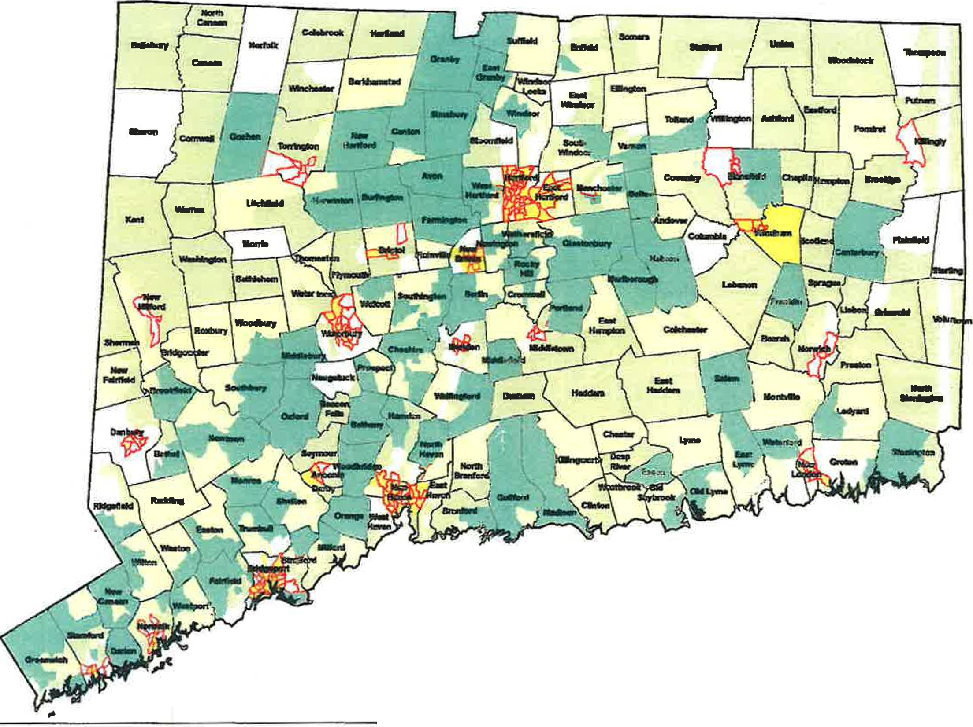
Kirwan Institute Comprehensive Opportunity Areas with HUD Qualified Census Tracts

0
N
'.C..
.
"'
I | N | Very Low | Low | Moderate | High | Very High
 |  | Opportunity | Opportunity | Opportunity | Opportunity | Opportunity

ii ·s

---- Qualified Census Tracts (2014 & 2015)
Data Sou:Depanment of Houaing and Urban Development (HUD)
www.huduser.org/qdlqclmap.hbnl

d CONNECTICUT 'IHOUSI N G FINANCE
AUTHO R ITY

ii: -

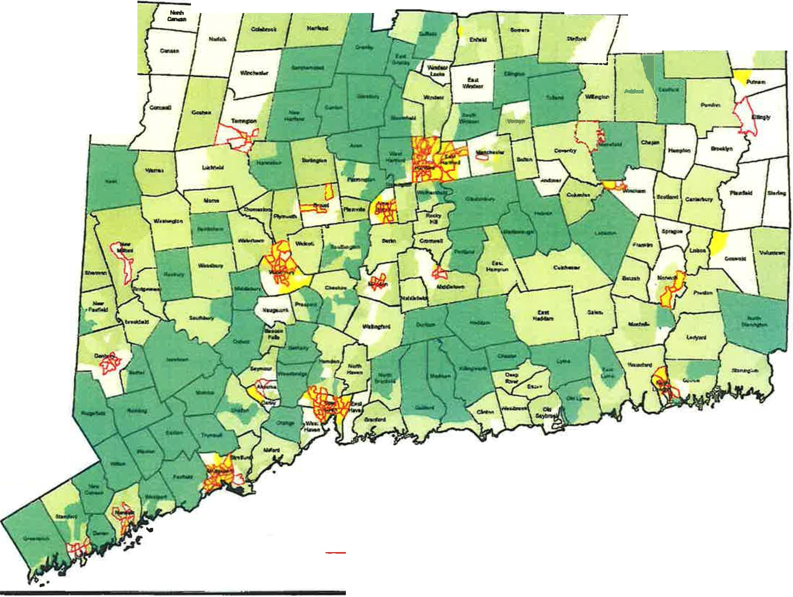
Open Communities Alliance Opportunity Areas with HUD QCT's
-· ...... - --
-

"0'
'"E'
'

CONNECTICUT
HOUSING FINANCE
AUTHORITY

Very Low
Opportunity

Low Opportunity

odetate
Opportunity

High Opportunity

"*'IHiDh
Oppor1Unlty
;
oc
'tJ
:i
.".'
c;
'2
<:.
0:

Qualified Census Tracts (2014 & 2015, 2014 only and 2015 only)
Data Source: Department of Housing and Urtan Development (HUD) - www.huduser.orglqcl/qctmap.html
Exhibit C: Kirwan/Open Communities Alliance/CT Fair Housing Center Opportunity Mapping

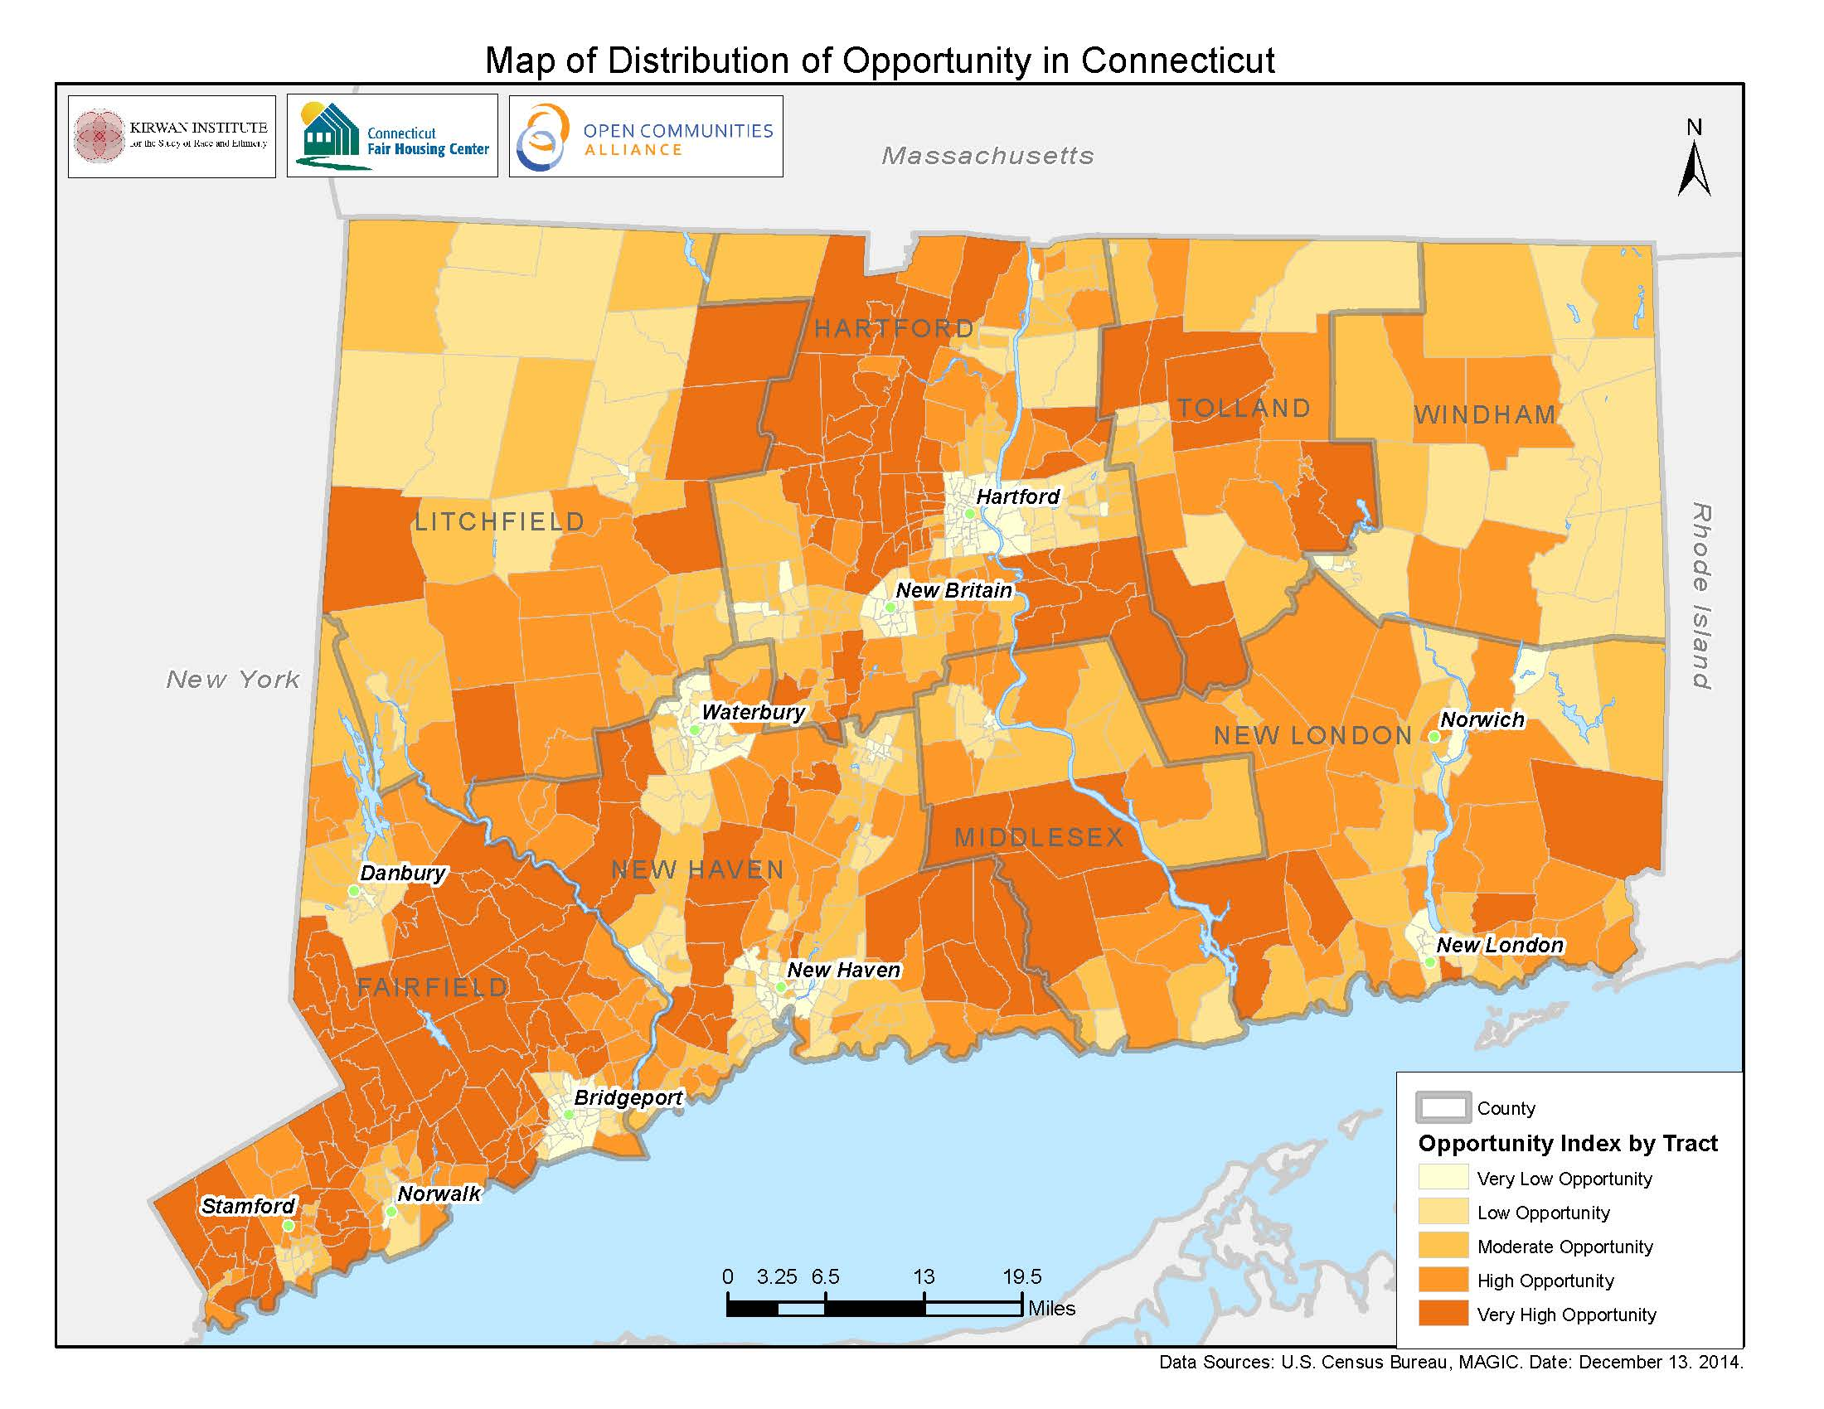

Qualified Census Tracts are census tracts in which “50 percent or more of the households have an income which is less than 60 percent of the area median gross income for such year or which has a poverty rate of at least 25 percent.” 26 U.S.C Section 42 (d)(4)(c)(5)(ii)(I), available at http://www.gpo.gov/fdsys/pkg/USCODE-2013-title26/html/USCODE-2013-title26-subtitleA-chap1-subchapA-partIV-subpartD-sec42.htm
Jill Khadduri, Creating Balance in the Low Income Housing Tax Credit Program: The Role of Qualified Allocation Plans, Poverty and Race Research Action Council & Abt Associates at 1 (May 2014), available http://www.prrac.org/pdf/Balance_in_the_Locations_of_LIHTC_Developments.pdf.
2015 Connecticut Analysis of Impediments to Fair Housing Choice at 160, available at http://www.ct.gov/doh/lib/doh/analysis_of_impediments_2015.pdf.
Khadduri at 6.
AI Report at 160.
AI Report at 160.
AI Report at 56.
AI Report at 78 and 93.
See e.g. two studies released in May 2015 by Raj Chetty et al. available at http://www.equality-of-opportunity.org. See also many other resources available at http://www.ctoca.org.
Raj Chetty, Nathaniel Hendren, and Lawrence F. Katz, Neighborhood Effects of Exposure to Better Neighborhoods on Children: New Evidence from the Moving to Opportunity Experience, Harvard University and NBER at 5, May 2015. Available at http://scholar.harvard.edu/files/hendren/files/mto_paper.pdf.
See e.g. Richard Fry and Rakesh Kochhar, America’s Wealth Gap Between Middle-income and Upper-income Families is Widest on Record, Factank: News in Numbers, Pew Research Center, December 17, 2914. Available at http://www.pewresearch.org/fact-tank/2014/12/17/wealth-gap-upper-middle-income/
For more on the Sheff v. O’Neill lawsuit, see http://www.sheffmovement.org/history-2/.
For more on the Kirwan Institute, see http://kirwaninstitute.osu.edu.
Please note that the one of the versions of opportunity mapping provided in the Hawkins Memo is incorrectly labeled. Kirwan completed mapping of Connecticut in 2009 (labeled correctly as Kirwan Opportunity Areas). This mapping was updated in 2015 by Open Communities Alliance and produced in partnership with Kirwan and the Connecticut Fair Housing Center. It is incorrectly labeled in the Hawkins Memo as Open Communities Alliance Opportunity Areas. This current updated opportunity map is the version referenced in the statute.
26 U.S.C Section 42 (d)(4)(c)(5)(ii)(I), available at http://www.gpo.gov/fdsys/pkg/USCODE-2013-title26/html/USCODE-2013-title26-subtitleA-chap1-subchapA-partIV-subpartD-sec42.htm
Inclusive Communities Project v. Texas Department of Housing and Community Affairs, 749 F.Supp.2d 486, 506 (2010), available at http://www.leagle.com/decision/in%20fdco%2020100928b03.xml.
New Jersey QAP, approved May 2013 at 17. Fifty percent of New Jersey’s LIHTCs are allocated to the Family Cycle, at 5. NJ QAP is available here, http://www.leagle.com/decision/in%20fdco%2020100928b03.xml.
See 2014 Massachusetts QAP Sustainability Principles at 6-7, http://www.mass.gov/hed/docs/dhcd/hd/lihtc/final2014qap.pdf
See 2014 Pennsylvania QAP at 3-5. http://www.novoco.com/low_income_housing/resource_files/qap/2014/pennsylvania/pennsylvania_2014_qap_final_100714.pdf.
PA QAP at 24.
Tennessee 2014 QAP at 5, available at http://www.prrac.org/pdf/BO2AppendixB/tennessee_2014.pdf.
Maine 2014 QAP at 7, 34 and 35, available at http://www.prrac.org/pdf/BO2AppendixB/maine_2014.pdf.
Iowa's 2013 QAP provides points for "Great Places” [not QCTs] designated by the Iowa Department of Cultural Affairs” 2013 Iowa QAP at 29. Available at http://www.prrac.org/pdf/BO2AppendixB/iowa_2013.pdf.
The 2014 Colorado QAP provides both one point and lists as one of the "guiding principles" that can override a point score for projects in QCTs that are "an important part of a broader or comprehensive program of neighborhood improvement, and which have the capability of fundamentally changing the character of the neighborhood." 2014 Colorado QAP at 5 and 51. Available at http://www.prrac.org/pdf/BO2AppendixB/colorado_2014.pdf.
The 2014 Georgia QAP provides competitive points for properties in areas with various types of designation by local governments or in a QCT with a concerted community revitalization plan. 2014 Georgia QAP at 12. Available at http://www.prrac.org/pdf/BO2AppendixB/georgia_2014.pdf.
Exceptions can be made for projects in distressed areas using public funds.
Jill Khadduri and David Rodda, Making the Best Use of Your LIHTC Dollars: A Planning Paper for State Policymakers, U.S. Department of Housing and Urban Development, Office of Policy Development and Research at 22, (July 2004), available at http://www.huduser.org/portal/publications/polleg/lihtcDollars.html.
AI Report at 76.
AI Report at 93.
AI Report at 161.
Id.
Id.
Id.
AI Report at 200.
AI Report at 200.

