Connecting Housing and Education:

Open Choice Vouchers
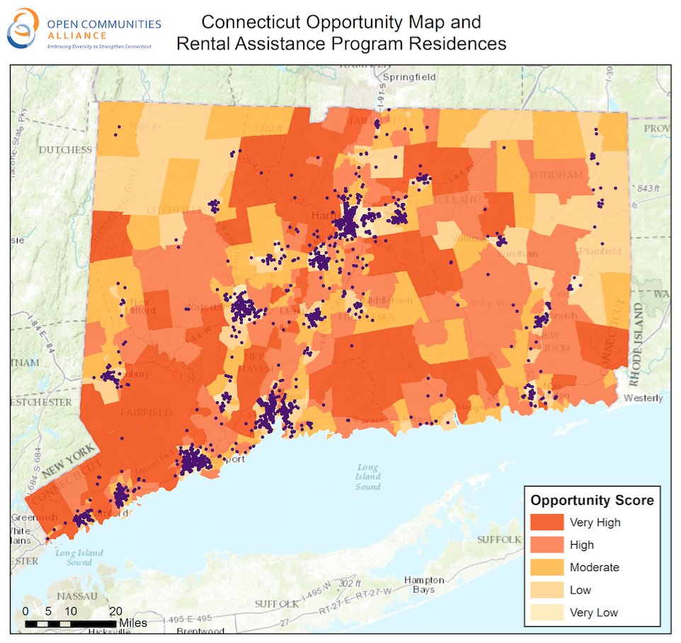

Summary
It is a critical time to connect housing choice and school choice. The state's Open Choice Program, which operates in the Hartford, New Haven, and Bridgeport areas gives the parents children in under-resourced school districts the option of participating in a lottery for a seat in participating suburban school districts. Many Open Choice families qualify for the state’s Rental Assistance Program and would consider moving to the town where their children attend school or a similar community. Such moves would free-up Open Choice slots for new participants.
Hundreds of Connecticut families opt to participate in the Open Choice school desegregation program, a voluntary program enabling children living in cities around the state to attend schools in suburban districts. Many of these families qualify for tenant-based vouchers, and studies, surveys and interview data reveal that many low-income residents of disinvested communities are interested in moving to high opportunity towns; yet, without the government assistance provided by these vouchers, many recipients cannot afford to do so.

We propose to create a special pool of state-funded vouchers (aka Rental Assistance Program Certificates) that will enable income-eligible Open Choice families to move to the town where their children are in school; then provide families access to key services like landlord recruitment and mobility counseling, which have proven highly effective in ensuring that families with tenant-based assistance actually obtain housing in higher opportunity towns; build in a one-year pre-implementation period to develop necessary procedures; evaluate the program after a two-year pilot period involving a special pool of 25 rental assistance program certificates in each year; support the pilot with sufficient funding to make the moves cost neutral for participating families and to assess the program.

