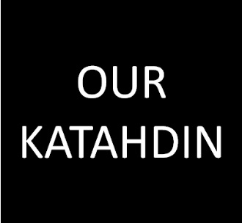
Project Development Template
Below are our “Top 10” questions to help move your ideas into projects. Please consider each of the following questions as you develop your project, and don’t hesitate to reach out to use with any questions you may have at www.ourkatahdin.com.

- Leader/s (who will drive this forward?)

- Expected short-term result (what is "the small win"?)

- Expected long-term result (what is "the big idea"?)

- Project description (what are you trying to get done?)

- Location (where will this project take place / who will benefit?)

- People (who is needed to get it done?)

- Budget (what resources are needed to get it done?)

- Timeline (when will this project take place?)

- Related, linked or follow-up projects (should your idea be broken down into several projects?)

- Additional Notes (what else should potential supporters know about your project?)

