 |  | COMMENT SHEET
Parks, Forestry & Recreation  Brenda Patterson  General Manager | Etobicoke Civic Centre  399 The West Mall  Etobicoke, Ontario M9C 2Y2 | Lori E. Ellis  Parks & Recreation  Landscape Architect  Tel: (416) 338- 1944  lellis@toronto.ca

Please take this opportunity to provide any comments you have about the two JOEL WEEKS PARK – CONCEPT PLANS on the front and back of this comment sheet. This will provide the Parks Forestry and Recreation division with valuable Community input for the design of the future park. All comments received will be reviewed and taken into consideration.
Please add your comments to this form (you may leave your comments anonymous if you wish) and deposit in the Comments Boxes at any of the following locations:
- Drop Box at 765 Queen Street E. - Ralph Thornton Centre
- Drop Box at 50 Matilda Ave.
- Drop Box at 756 Queens Street E. - Riverside District BIA Office
Alternately you can provide comments directly to Lori Ellis (lellis@toronto.ca). Fax your comments to 416-394-2485 or mail your comments to the address listed at the top of this form.
Comments will be received until 3:00pm - Tuesday May 25th 2010.

Name: ___________________________________________________

Address: ___________________________________________________

Email: ___________________________________________________

JOEL WEEKS PARK – GENERAL COMMENTS

________________________________________________________________________________

________________________________________________________________________________

________________________________________________________________________________

________________________________________________________________________________

________________________________________________________________________________

________________________________________________________________________________

________________________________________________________________________________

________________________________________________________________________________

________________________________________________________________________________

1. JOEL WEEKS PARK – URBAN GRID CONCEPT

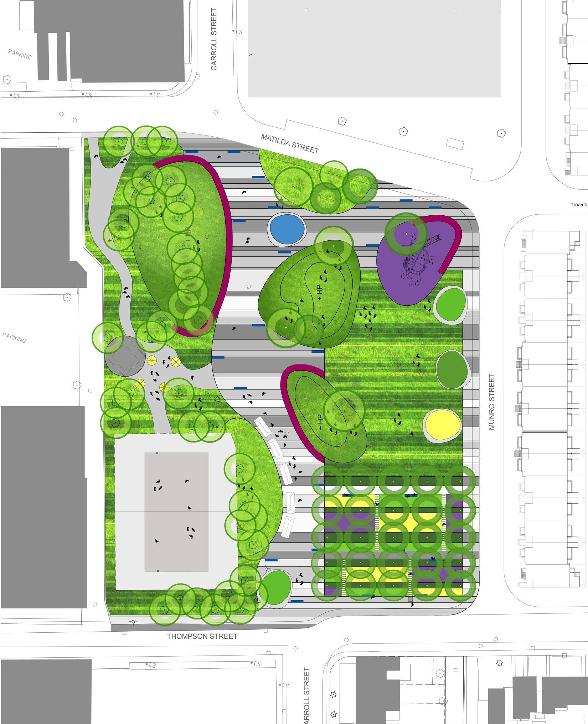
Comments:

______________________________________________
Matilda Street
______________________________________________

______________________________________________

______________________________________________

______________________________________________

Munro Street

______________________________________________

______________________________________________

______________________________________________

______________________________________________

______________________________________________

Thompson Street

______________________________________________

______________________________________________

2. JOEL WEEKS PARK – ORGANIC RIVER CONCEPT

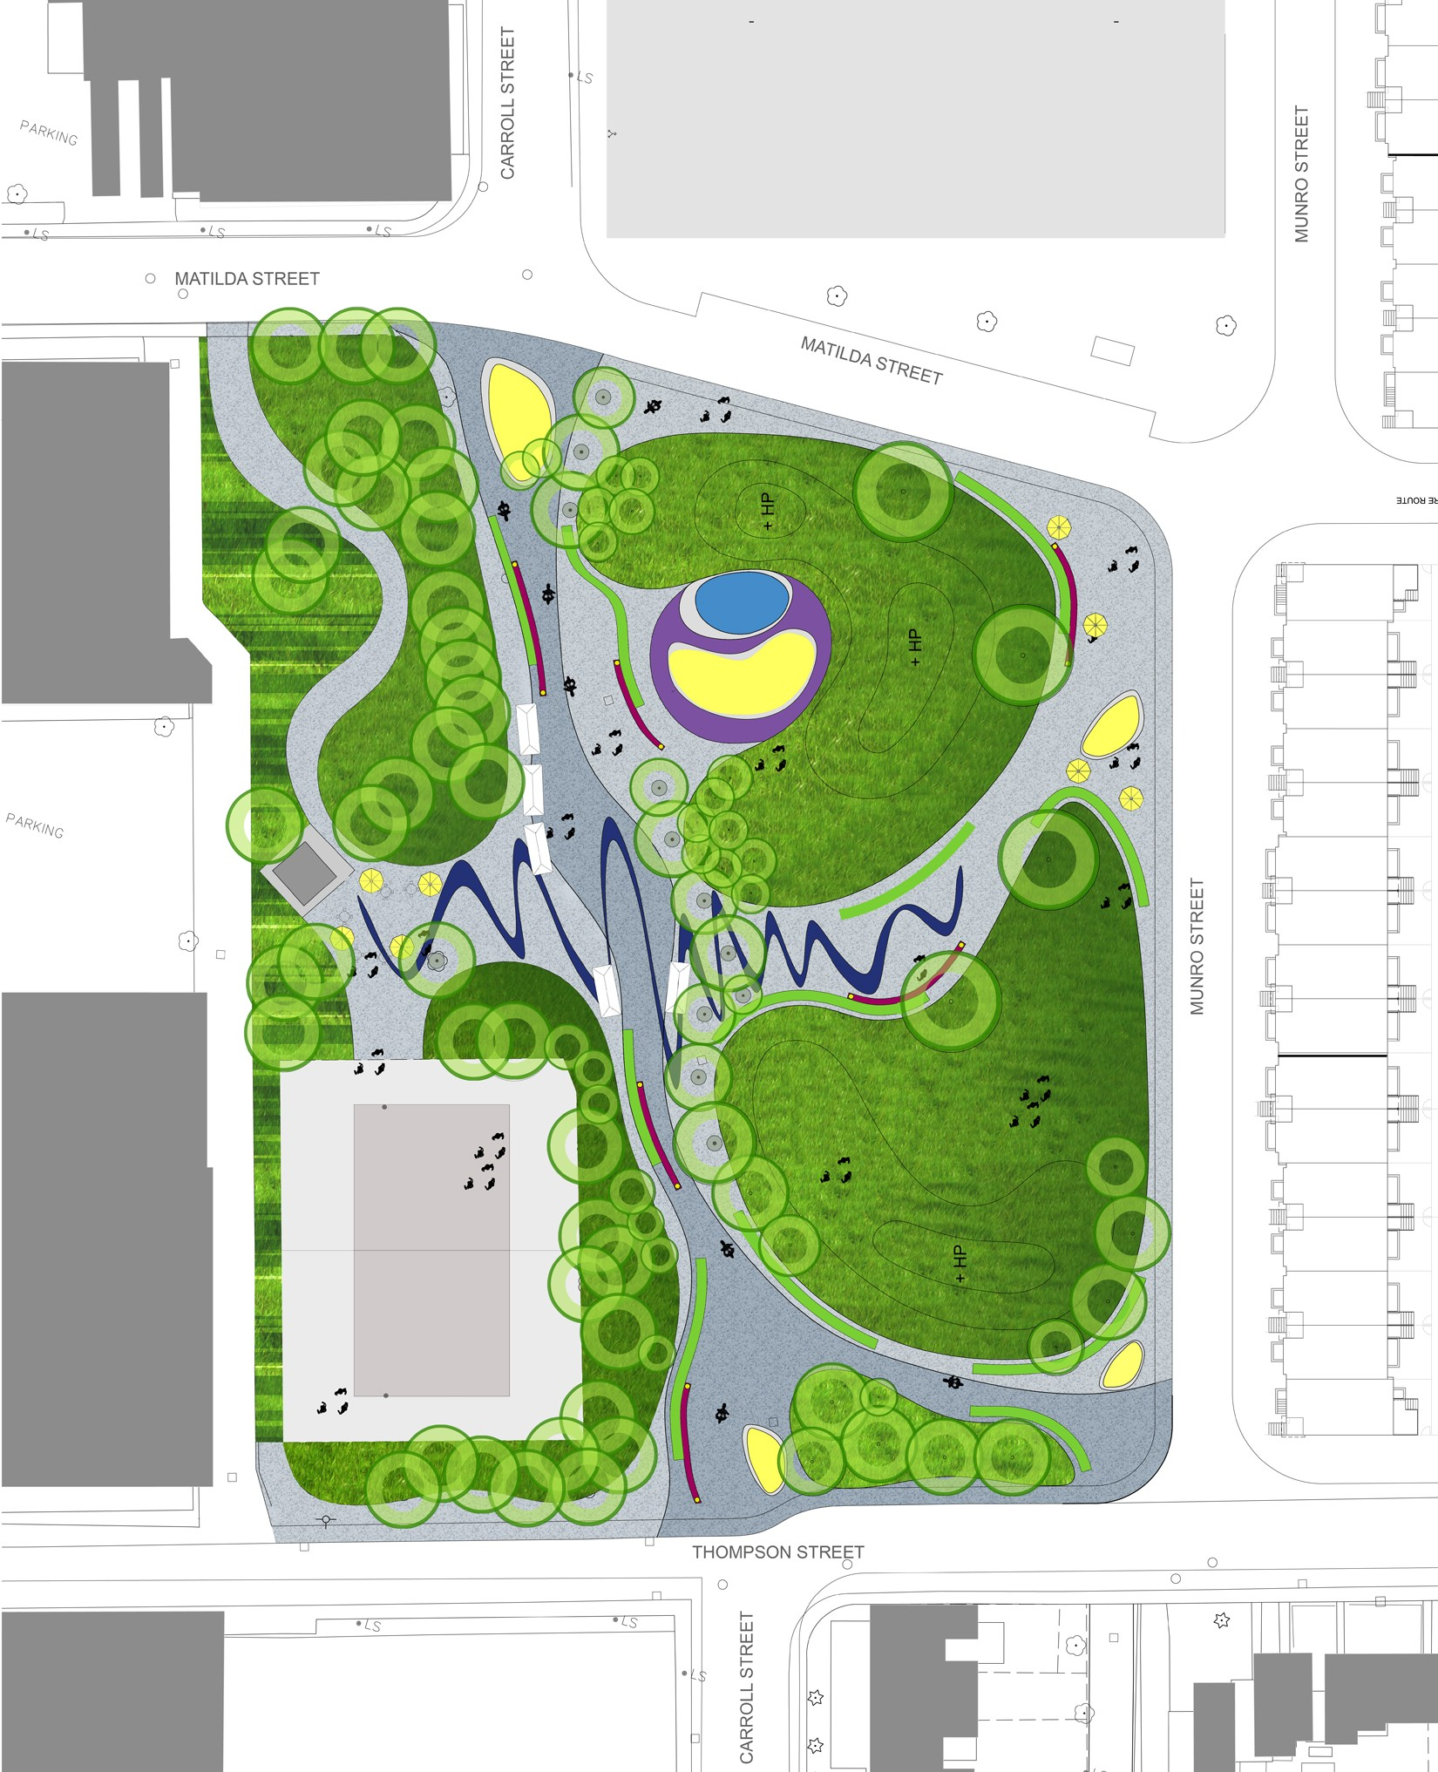
Comments:

______________________________________________
Matilda Street
______________________________________________

______________________________________________

______________________________________________

______________________________________________

______________________________________________

______________________________________________

______________________________________________

______________________________________________

______________________________________________

Munro Street

Thompson Street

______________________________________________

______________________________________________

