Declaration of Candidacy
CANDIDATE IDENTIFICATION
IMPORTANT
Your first and last names will appeared
on the ballot
First Name : ____________________________________________________
Last name : _____________________________________________________
Birthday : ___________________
YYYY / MM / DD
Profession : _____________________________________________________
Address : ______________________________________________________________________________
Appt. - Number Street City Zip code
Email : ________________________________________________________________________________
Phone : _______________________ _______________________
Home
Other

STATUS
I want to be a candidate for the following position: (choose an option)
NATIONAL PRESIDENT
OR
REGIONAL VICE-PRESIDENT
(choose one of the following choices) :
Bas-Saint-Laurent, Gaspésie-Îles-de-la-Madeleine
Montréal et Laval
Capitale-Nationale et Chaudière-Appalaches
Mauricie, Centre-du-Québec et Saguenay-Lac-Saint-Jean et Côte-Nord
Montérégie et Estrie
Nord-du-Québec, Abitibi-Témiscamingue, Outaouais, Laurentides et Lanaudière
CANDIDATE DECLARATION
I enclose a photocopy of one of the following pieces of identification:
My Quebec health insurance card (Sunny Card)
My Quebec driver's license
OR
Any other document authorized by the Elections Officer in agreement with him.
AND
A digital picture showing me on my best day, passport type format of 50mm in width and 70 mm in height.
I _________________________________________________________________, apply for the position of
_______________________________________________________________________________________________
within the National Executive Board of the Conservative Party of Québec,
and states that:
I am a member of the Conservative Party of Québec
I am not ineligible under the “Constitution du Parti conservateur du Québec”
I am not ineligible under the “Règlement sur le Congrès national et conseil général” of the Conservative Party of Québec
In witness whereof, I signed in presence of witness,
At _________________________________________________, the ________________________ 20____.

__________________________________________________
Candidate signature

Witness
Witness first name : ___________________________________________________________________________
Witness last name: ____________________________________________________________________________
Witness phone : ________________________
__________________________________________________
Witness signature

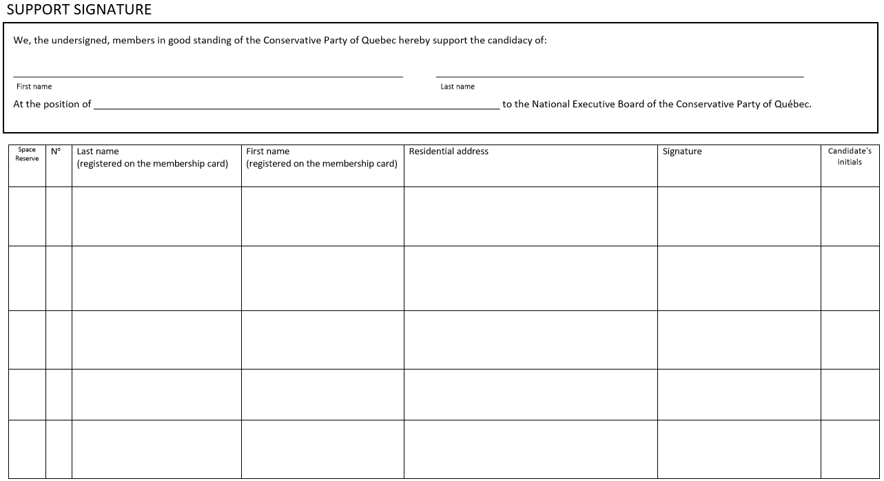
RECEPTION
I, ______________________________________________________________, Elections Officer of the Conservative Party of Québec or his delegate, receive this candidacy declaration. All the required documents are attached. Subject to verification of registration on the list of Party members supporting this candidacy, it is apparently in accordance with the requirements of the Party Constitution and the “Règlement sur le Congrès national et conseil général”.
The ________________________ 20____.

__________________________________________________
Elections Officer or his delegate signature

NOTICE OF COMPLIANCE
I certify that at least twenty (20) members in good standing of the Conservative Party of Québec who support this declaration of candidacy are registered on the list of the members of the Party and that this declaration is in conformity with the requirements of the Constitution of the Party as well than the “Règlement sur le Congrès national et conseil général”.
The ________________________ 20______, at ______h.

__________________________________________________
Elections Officer or his delegate signature

