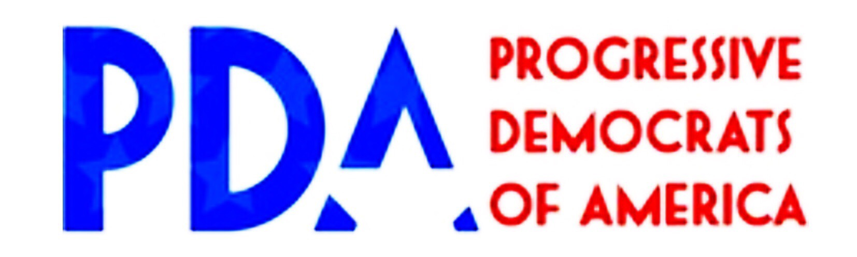

To: The Honorable [Congressperson's Full Name]
From: Constituents of [Congressional District]
February [delivery date], 2017

As your constituents, we urge you to help guarantee our access to healthcare as well as clean water, healthy food, a livable climate, and a safe environment. Your actions have a direct impact on our lives. Therefore we respectfully and strongly urge you to protect the environment and our families' health by taking the following actions:

If you haven't already, cosponsor the Expanded and Improved Medicare Act (H.R. 676) by contacting Rep. John Conyers' Senior Legislative Assistant, Daniel Riffle, at 202-225-5126.

Oppose any and all proposals that could undermine the Environmental Protection Agency (EPA), as well as any policies that could endanger the environment—including efforts to cut the EPA budget and/or staff—and defend enforcement programs from interference. Full EPA funding and staffing are essential for enforcement of critically important laws including the Clean Air Act, the Safe Drinking Water Act, and the Clean Water Act. A damaged environment would expose us, your voters, to undrinkable water, unbreathable air, and other threats to our health and lives.

Oppose President Trump’s plans to allow privatization of our water infrastructure. Water is essential to human life, and therefore must be publicly managed in the public interest. Privatization has driven up costs and driven down the quality of service. Communities across the United States have already rejected privatization, in conservative and liberal areas alike.

Support direct investment in our water infrastructure, as outlined in Rep. Conyers’ Water Affordability, Transparency, Equity and Reliability (WATER) Act, rather than privatization, to protect the health and lives of your constituents.

Protect federal lands from giveaways and exploitation. Over the past several weeks, some have floated proposals that would give away federal lands, and open large tracts to exploitation. Such drilling, mining, and fracking would endanger our water and air, and accelerate climate change.

Reject any and all proposals to privatize our federal lands, and oppose any measures that would threaten these national treasures. Federal lands, especially those directly abutting our national parks, belong to all Americans. They should be managed and protected in the public interest, not despoiled for the enrichment of a few.

We look forward to engaging you on these and other issues in the future.

Sincerely,

[ORGANIZER NAME(S) AND CONTACT INFO: EMAIL AND PHONE NUMBER]
[CHAPTER / ORGANIZATION NAME]

