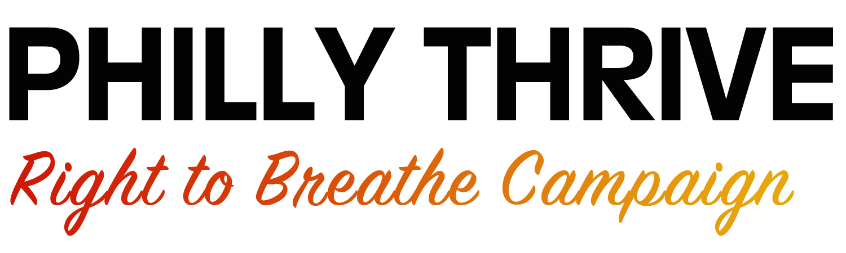

Training Fund Proposal

Building and sharing skills is very important to strengthening the Right to Breathe campaign. For that reason, there is a Training Fund available to Philly Thrive action circle members who want to attend a relevant training led by another movement organization, in order to bring those skills back to build the Right to Breathe campaign.

If there is a training you would like to attend to better support the movement, but you need financial support in order to go, you can request funding support by submitting a proposal to the Leadership Development and Training Coordinator. Send this proposal to Alexa Ross at a.ross1520@gmail.com or call Alexa at 402-310-2508 to set up a time to fill out the form together.

Name:

Phone Number/Best way to contact you:

1) What is the training you hope to attend? Include any links to information about the training.

2) What do you hope to learn and how will the training allow you to advance the Right to Breathe campaign? Describe your past work with Thrive and how the training would build on that work.

3) How much does the training cost, including registration, travel, lodging, etc.? How much are you requesting from Thrive and how much will you contribute yourself?

4) How do you plan bring your new skills back to the movement?

5) If you are granted the funds to attend the training, you may be asked to lead a short training to share some of the skills with others in Thrive. Do you agree to lead a training like this?

