Progressives in Alberta

Public opinion on policy, political leaders, and the province’s political identity

Conducted for Progress Alberta

Report prepared by David Coletto, PhD

Methodology

This study was commissioned by Progress Alberta to explore the political attitudes of Albertans on a range of current policy areas. It also seeks to understand how Albertans see themselves from an ideological perspective.

The survey informing this study was conducted online with 1,000 Albertans aged 18 and older from December 2 to 7, 2015. A random sample of panelists was invited to complete the survey from a large representative panel of Albertans recruited and managed by Research Now, one of the world’s leading providers of online research samples.

The Marketing Research and Intelligence Association policy limits statements about margins of sampling error for most online surveys. The margin of error for a comparable probability-based random sample of the same size is +/- 3.1%, 19 times out of 20.

The data were weighted according to census data to ensure that the sample matched Alberta's population according to age, gender, educational attainment, and region. Totals may not add up to 100 due to rounding.

Sample Composition

The sample of Albertans interviewed for this study is representative of the Alberta population aged 18 and older. It is also representative of those who voted in the 2015 Alberta Provincial Election as the distribution of party supporters closely matches the actual results of the election.

Subgroup | Unweighted Count | Weighted Count | Proportion of Weighted Sample
Northern Alberta | 71 | 58 | 6%
Central Alberta | 96 | 138 | 14%
Southern Alberta | 116 | 102 | 10%
Calgary | 353 | 364 | 36%
Edmonton | 364 | 338 | 34%
Male | 450 | 500 | 50%
Female | 550 | 501 | 50%
18 to 29 | 125 | 180 | 18%
30 to 44 | 308 | 281 | 28%
45 to 59 | 314 | 300 | 30%
60+ | 253 | 241 | 24%
2015 Provincial Election Vote
Alberta NDP | 274 | 300 | 40%
Alberta PC | 226 | 199 | 26%
Wildrose Party | 151 | 164 | 22%
Alberta Liberal | 55 | 26 | 3%
Alberta Party | 15 | 18 | 2%
Other parties | 19 | 7 | 1%
Cannot remember | 37 | 40 | 5%
Non-voters | 223 | 248 | 25%

Alberta: More progressive than you think.

Most Albertans consider themselves to be a progressive. Surprising eh?

In a study commissioned by Progress Alberta, we surveyed a representative sample of 1,000 Albertans aged 18 and older and found that Canada’s “conservative province” is not as conservative as you might think - in fact, more Albertans self-identify as progressive than conservative.

When asked whether they consider themselves to be a progressive, 59% said yes. And when we followed up and asked people to place themselves on a scale between very conservative and very progressive, 38% put themselves on the progressive side of the spectrum compared with 30% who staked out a position on the conservative side and 31% who put themselves squarely in the middle.

Yet despite the fact that more Albertans see themselves as progressive than conservative, a majority still describes the province’s population as conservative and most continue to vote for conservative political parties. These contradictions seem to be explained by the difference between individual identity, collective identity, and party identification: psychological orientations that effect the political behavior of people in the province.

Notwithstanding the fact that Albertans elected a NDP government last spring, this study finds plenty of evidence to contradict the “conservative” province thesis.

For example:

- Alberta’s most popular politician is Calgary mayor Naheed Nenshi (58% of Albertans have a positive impression of him) despite the fact that 55% place him on the progressive side of the political spectrum.
- Premier Rachel Notley (33% positive) is viewed positively by more Albertans than Wildrose Party Leader Brian Jean (24%) or interim PC Leader Ric McIver (16%).
- A majority of Albertans (51%) believe that the province has become more progressive in the past year. Only 15% think it has become less progressive.
- Seven in ten Albertans support the provincial government’s decision to ban corporate and union political donations to the province’s political parties.
- Two thirds support (66%) the provincial government’s decision to raise income taxes on the highest income earners in the province.
- Almost a majority of Albertans (48%) support phasing out coal-powered electricity generation by 2030.
- More Albertans support the provincial government’s plan to introduce a carbon tax than oppose it (support 47%, oppose 42%).

Urbanization, in-migration, and generational change are all shifting the province’s political attitudes and behaviour. Most Albertans think the province has become more progressive in the past five years. More identify as progressive than they do conservative. And the province’s most popular political leader is seen as a progressive himself. Perhaps it might be time to reconsider the notion of conservative Alberta.”

Do Albertans self-identify as progressive?

Most Albertans consider themselves to be a progressive. About six in ten (59%) said they consider themselves to be a progressive while 41% do not consider themselves to be progressive.

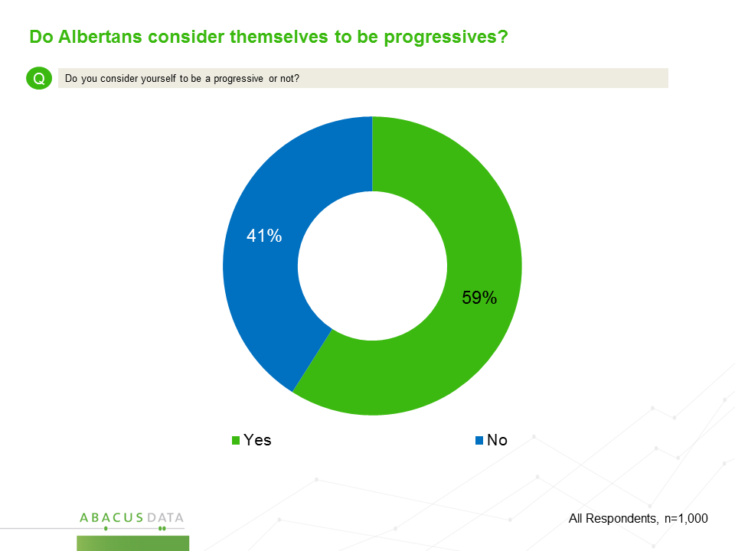

Self-identity as a progressive was fairly consistent across the province (although those in southern Alberta were less likely to self-identify as a progressive). Those aged 18 to 29 and those over 60 were more likely to identify as a progressive than middle aged Albertans.

Moreover, as one’s level of education increased, so too did the likelihood that they would identify as a progressive.

Of note, there was no significant difference between men and women on this question.

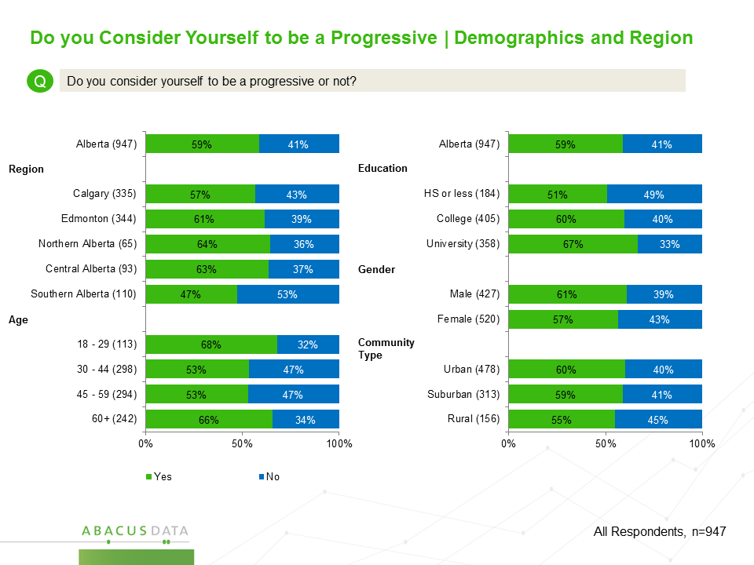

Politically, those who voted NDP and Alberta Liberal were more likely to identify as a progressive while Wildrose and PC voters were less likely. That being said, a majority of PC voters, and almost a majority of Wildrose Party voters considered themselves to be a progressive.
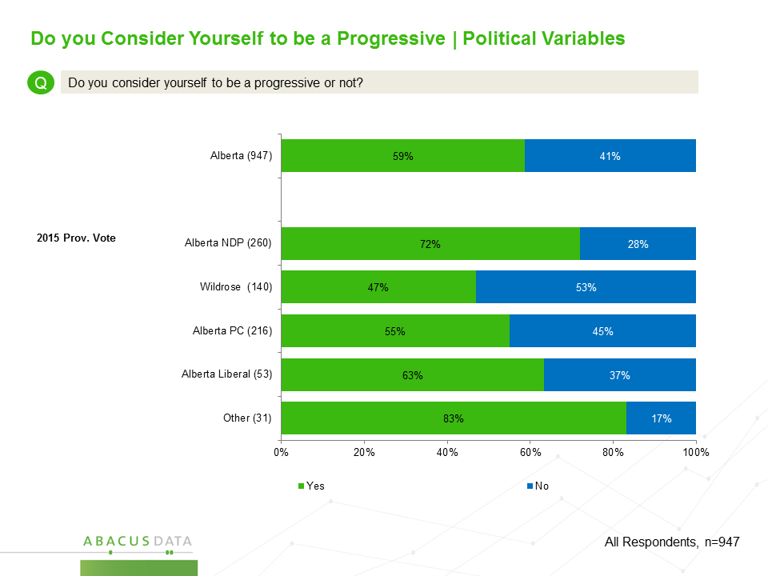

Progressive or Conservative? How Albertans place themselves, others, political leaders, and political parties on the spectrum.

To explore the ideological self-identity of the Alberta public in more detail, we asked respondents to place themselves, Albertans in general, and some of the province’s political leaders and political parties, on an eleven-point scale with very conservative at one end and very progressive at the other end. This exercise forced respondents to choose between identities.

Overall, Albertans were more likely to place themselves on the progressive side of the spectrum than on the conservative side. Thirty-eight percent of Albertans placed themselves on the progressive side of the spectrum with 7% saying they are clearly progressive (placing themselves at 9 or 10 on the 11-point scale) and another 31% saying they lean progressive.

In contrast, 30% of Albertans place themselves on the conservative side of the spectrum with 8% self-identifying as clearly conservative with another 22% leaning conservative. Finally, 31% placed themselves right in the middle of the spectrum.

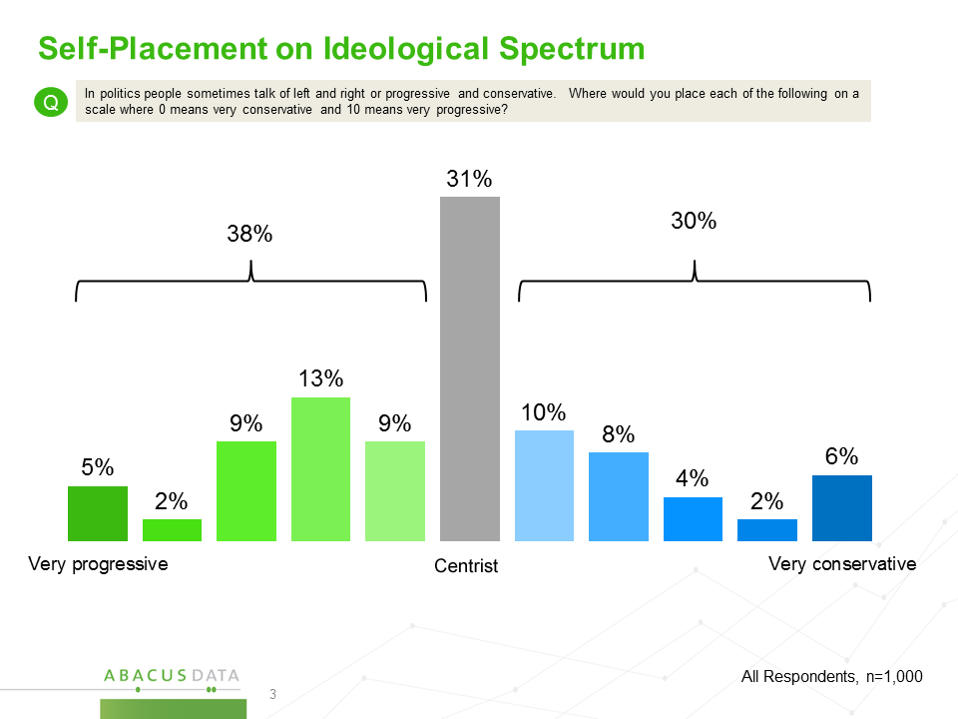

Those living in either Edmonton or Calgary were more likely to self-identify as progressive (Calgary 40%, Edmonton 45%) than those living in other regions of the province.

Progressive identifiers were also more likely to have higher levels of education, and more likely to live in urban communities. Of note, there was little variation across age groups and between men and women.

Politically, there were large differences. Six in ten NDP voters (63%) self-identified as progressive as did a majority of those who voted Alberta Liberal. In contrast, 48% of Wildrose voters and 46% of PC voters self-identified as conservative.

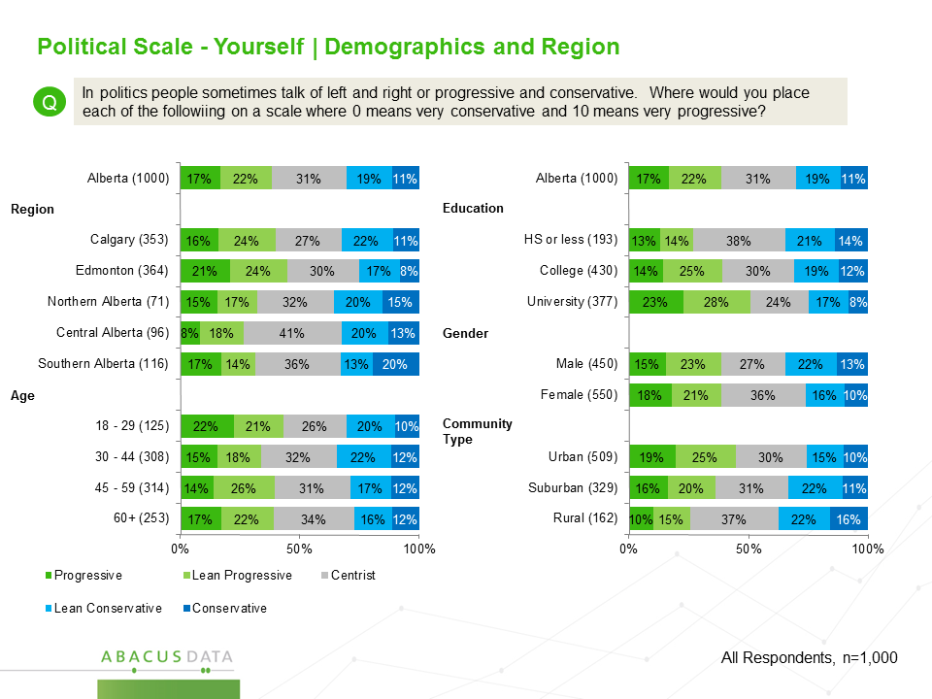
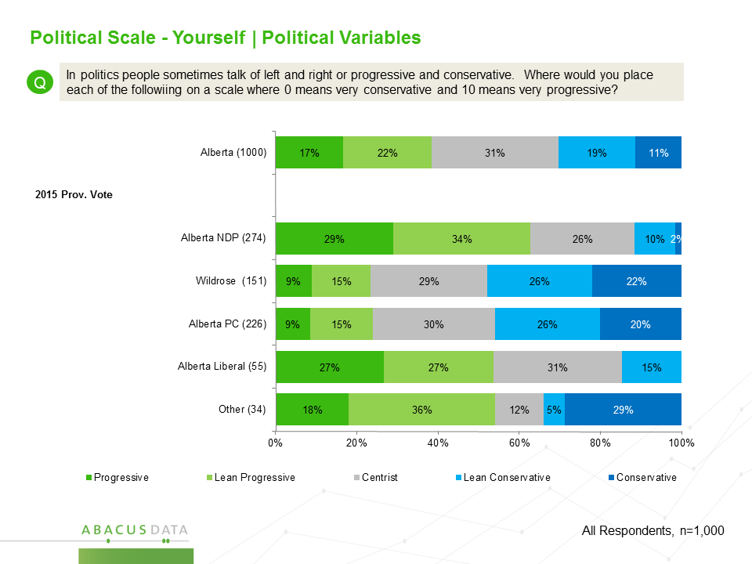

While more Albertans see themselves as progressive than conservative, most believe that Albertans as a whole are on the conservative side of the spectrum.

Although 38% of respondents saw themselves as on the progressive side of the spectrum, only 21% regarded the province as a whole as being progressive. Instead, a majority of respondents (53%) considered Albertans to be generally conservative while another 26% thought the province was generally centrist.

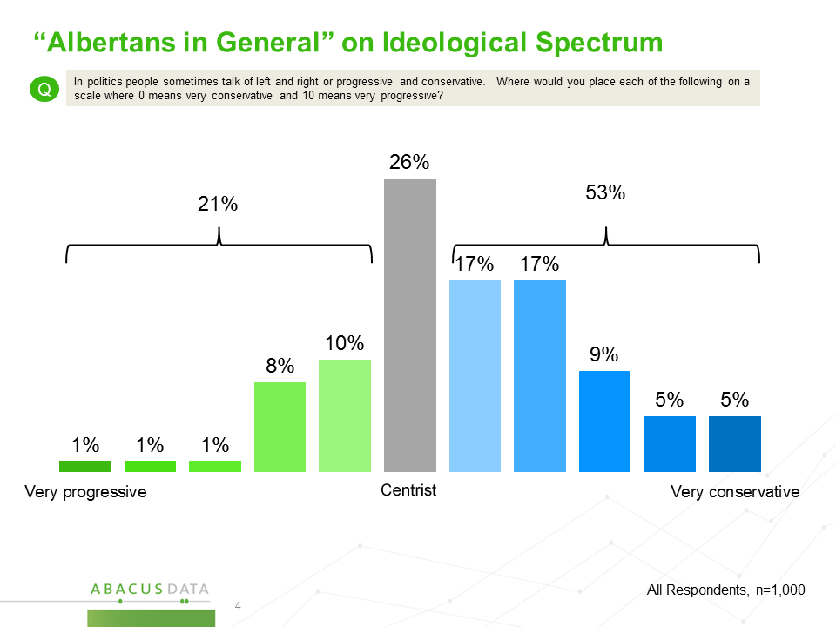

This perception gap between how Albertans see themselves and how they see the province’s population as a whole is primarily a function of self-identified progressives and centrists seeing the province as being more conservative then themselves.

For example, among the 38% of Albertans who place themselves on the progressive side of the spectrum, only one in three (33%) describe Albertans in general as being progressive while almost a majority (48%) think the province’s population leans to the conservative side of the spectrum.

Similarly, of the 31% who self-identify as being in the middle of the spectrum, only 41% consider the rest of the province as centrist with 40% thinking the province as a whole leans conservative and 19% considering Albertans to be progressive.

Conservative leaning Albertans are more likely to see their own ideology reflected in the province’s population as a whole. Over seven in ten (73%) of those who self-identify as being on the conservative side of spectrum believe Albertans as whole also lean conservative while 19% believe Albertans are generally centrist and 8% consider the province to be generally progressive.
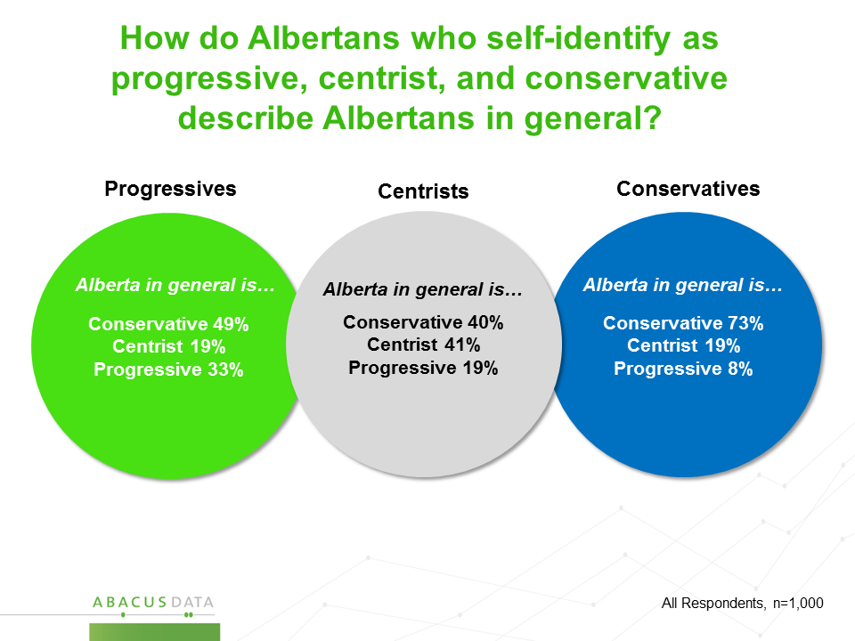

We also asked respondents to place some of the provincial political parties and leaders on the same spectrum. The results indicate that Albertans do see ideological differences between the main political parties and key political leaders in the province.

A majority of respondents placed the Alberta NDP (57%) on the progressive side of the spectrum while a majority of respondents placed the Alberta PC Party (57%) and the Wildrose Party (51%) on the conservative side of the ideological spectrum.

Premier Rachel Notley was considered to be progressive by 61% of respondents while 47% considered Wildrose leader Brian Jean to be on the conservative side of the spectrum.

Calgary mayor Naheed Nenshi was more likely to be seen as a progressive (55%) than conservative (15%) or centrist (30%) while views were more mixed about Edmonton mayor Don Iveson with 34% considering him progressive, 21% conservative, and 45% centrist.

Wildrose Party Leader Brian Jean was considered progressive by the least number of respondents (15%) with 47% considering him to be conservative and 39% placing him in the centre of the political spectrum.

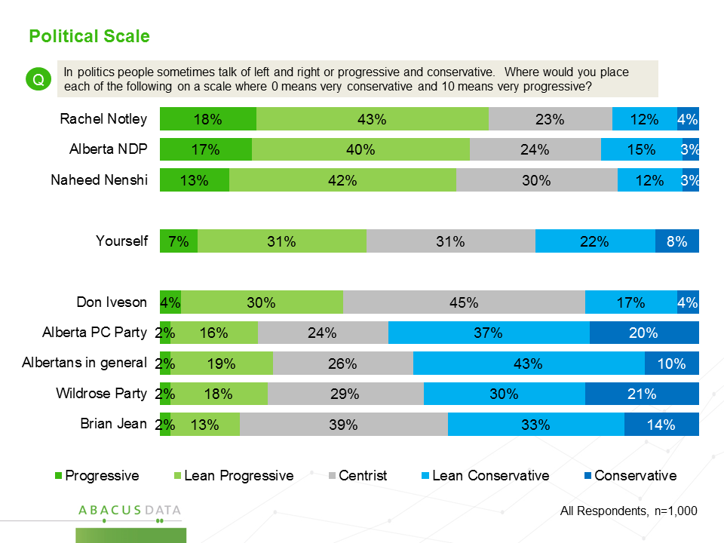

Is Alberta becoming more or less progressive?

Most Albertans we surveyed believe that the province has become more progressive in the past year and almost a majority think it has become more progressive in the past five years.

Just over half of Albertans (51%) believe that Alberta has become more progressive over the past year while 15% believe it has become less progressive. The remaining 33% think not much has changed.

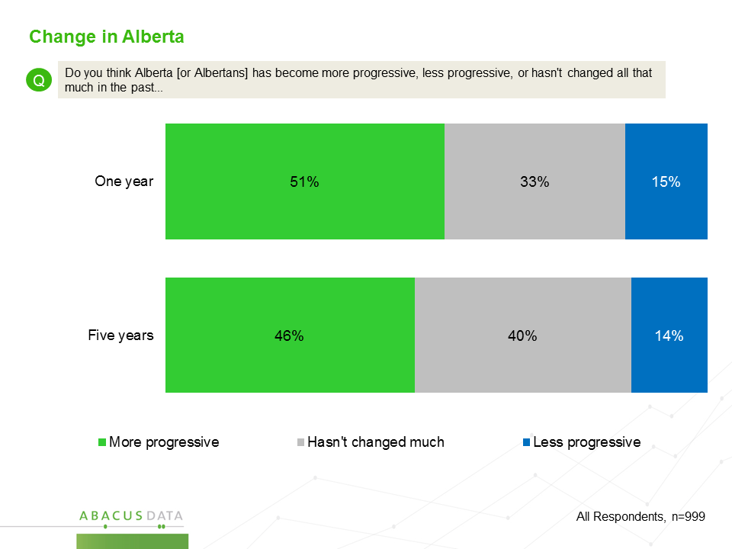

Albertans aged 18-29 and those who have completed university are most likely to think Alberta has become more progressive in the past year. These segments are also most likely to identify themselves as progressive. Northern and Central Albertans, and those who live in rural areas are more likely to think that Alberta has become less progressive.
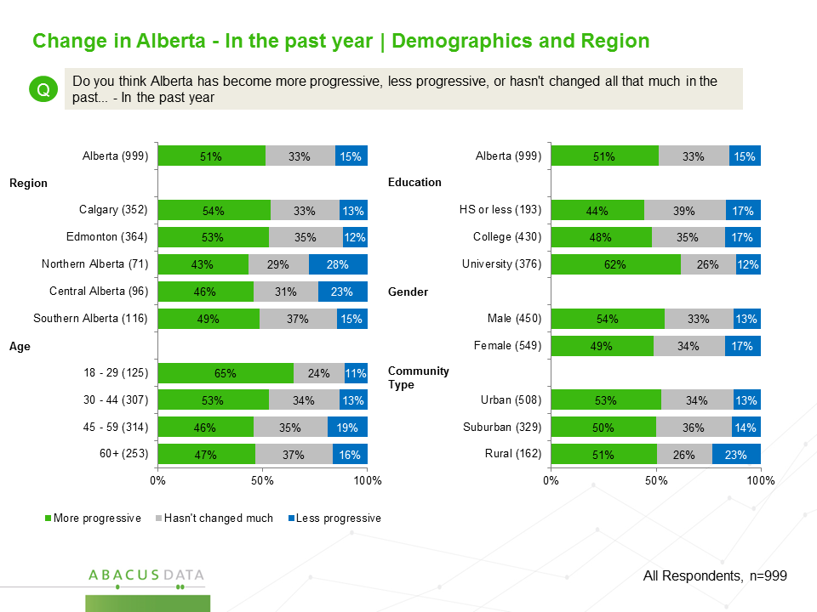

A majority of both progressives (63%) and conservatives (60%) believe that the province has become more progressive in the past year while those who place themselves in the centre of the political spectrum were more likely to say not much has changed in the past year.
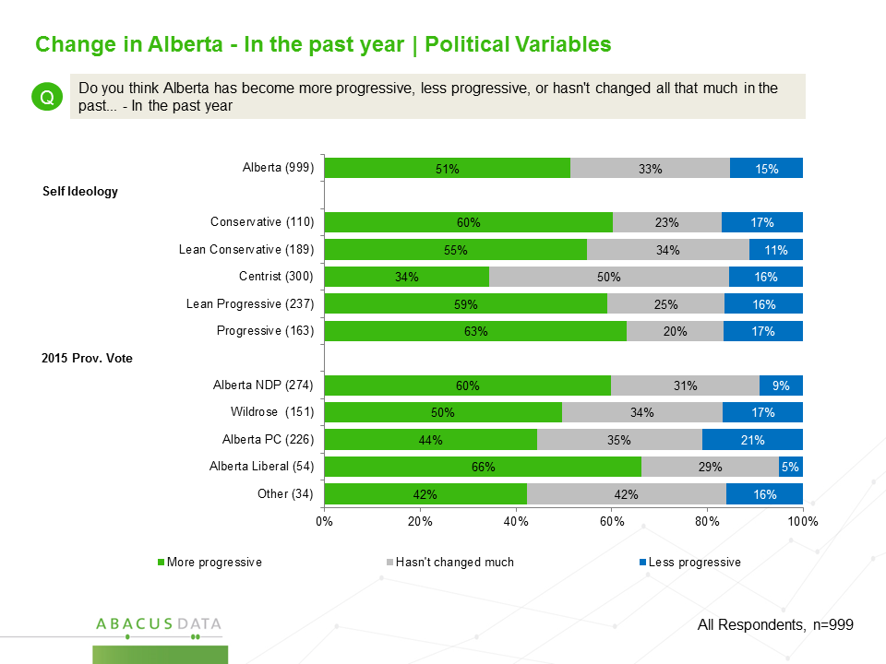

For the most part, those who believe Alberta has become more progressive in the past year think it has been a good thing.

Overall, six in ten (62%) believed it was a good thing that the province had become more progressive while 21% said it was a bad thing.

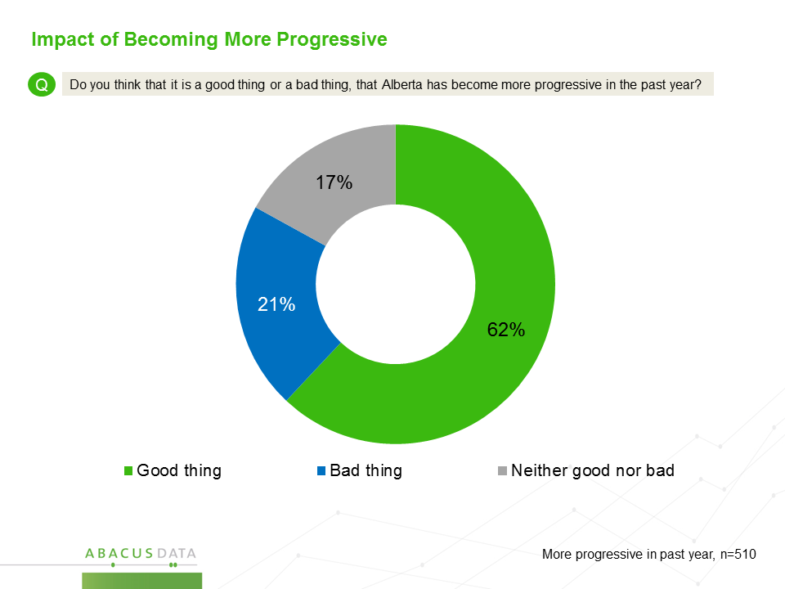

Of those who think Alberta has become more progressive in the past year, respondents living in Edmonton, Calgary, and northern Alberta were more likely to think that it is a good thing. Those in southern Alberta were most likely to consider the shift in the province’s political ideology to be a bad thing.
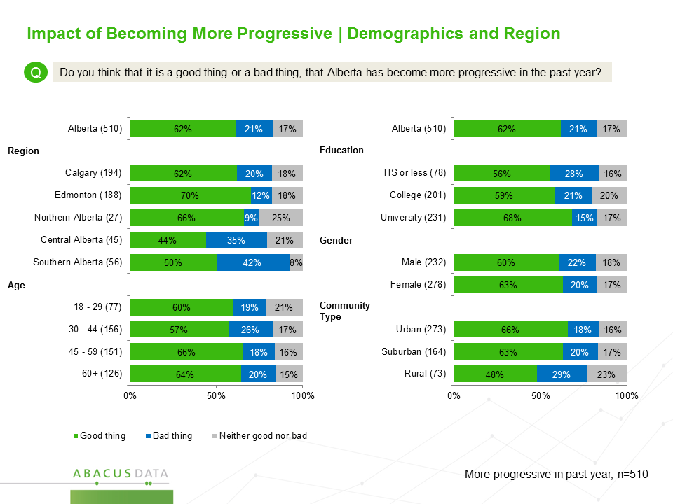

Progressives and those who voted NDP and Alberta Liberal overwhelmingly believe that the shift to a more progressive viewpoint has been a good thing while only 40% of PC voters and 25% of Wildrose voters who believed the province had become more progressive in the past year consider this to be positive.

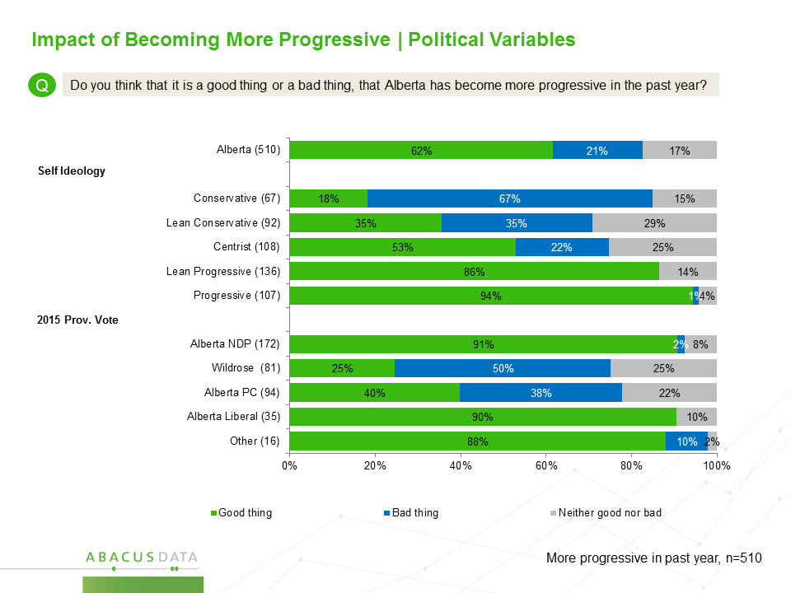

How do Albertans feel about the Notley government’s Agenda?

Along with assessing the ideological position of themselves, their fellow Albertans, and political leaders in the province, the survey also asked respondents for their opinion on a number of the high profile policy decisions the Notley government has made since it was elected in May 2015.

Overall, there is broad support for all of the policy decisions we tested with support being highest for the government’s decision to ban corporate and union contributions to political parties (72% support) and raising income taxes on the highest income earners in the province (66% support).

Opinion was more split when it came to the Notley government’s environmental agenda, although more respondents support the agenda items than oppose them.

Forty-eight percent support its plan to phase out coal-powered electricity generation (36% are opposed) while 47% support both its plan to introduce a carbon tax and a carbon emissions limit on the oil sands. Opposition to the carbon tax is slightly higher (42%) than it is for the carbon emissions limit (37%).

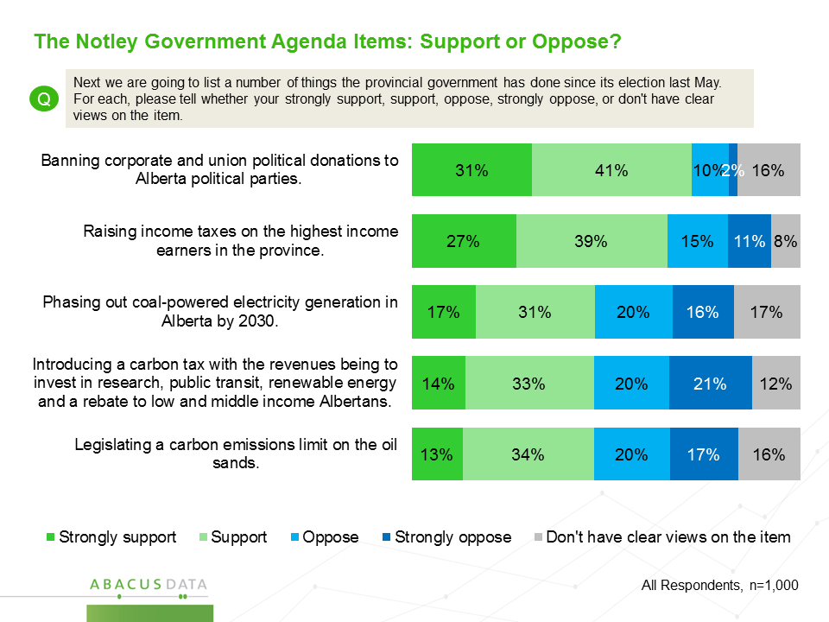

.

  - Political Finance Reform

Support for the government’s political finance reforms were high across all regions of the province with support for the corporate and union donation ban highest in Calgary and southern Alberta. There was little variation across demographic subgroups.

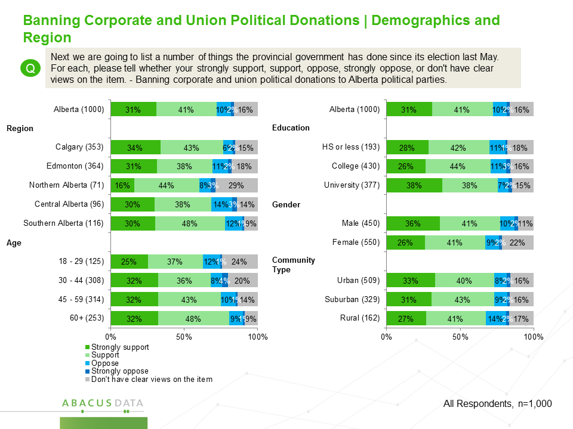

Progressives supported the political finance reforms more intensely than conservatives although overall support was similar across the political spectrum.

88% of past NDP voters and 81% of past Alberta Liberal voters supported the political finance reforms as did a majority of Wildrose and PC voters.

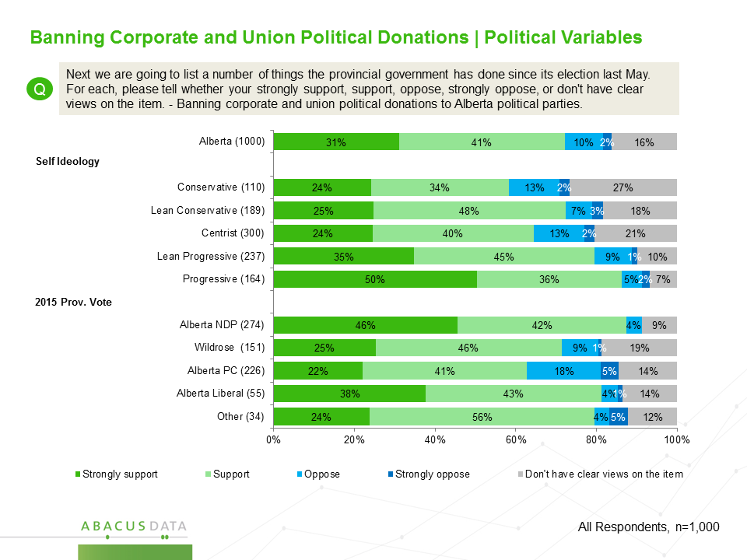

  - Income Tax Increase for High Earners

While banning corporate and union political contributions was generally accepted across political allegiance, income tax increases for high earners was more polarizing.

Although there was only minimal variance across regional and social demographics, there was a nearly linear increase in opposition across the political spectrum. Eighty-five percent of those who self-identified as progressive supported the measure, while 55% of those who self-identified as conservative opposed it.

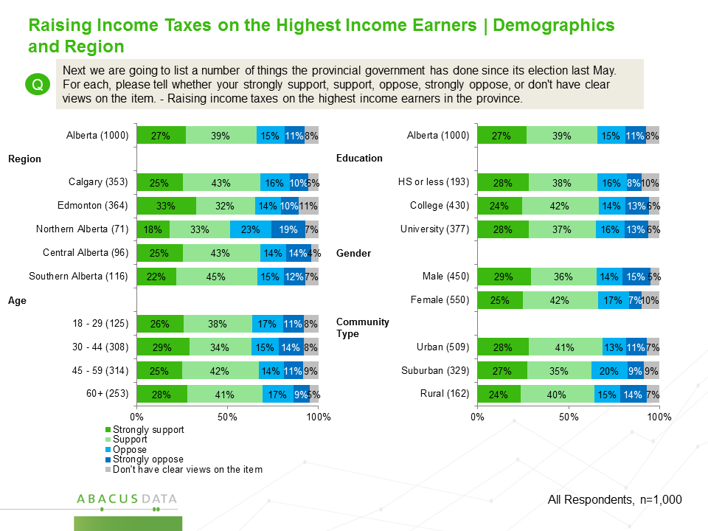

Despite majority opposition from self-identified conservatives, both Wildrose and PC party voters were split nearly in half between support and opposition to the income tax increase on the province’s highest income earners.
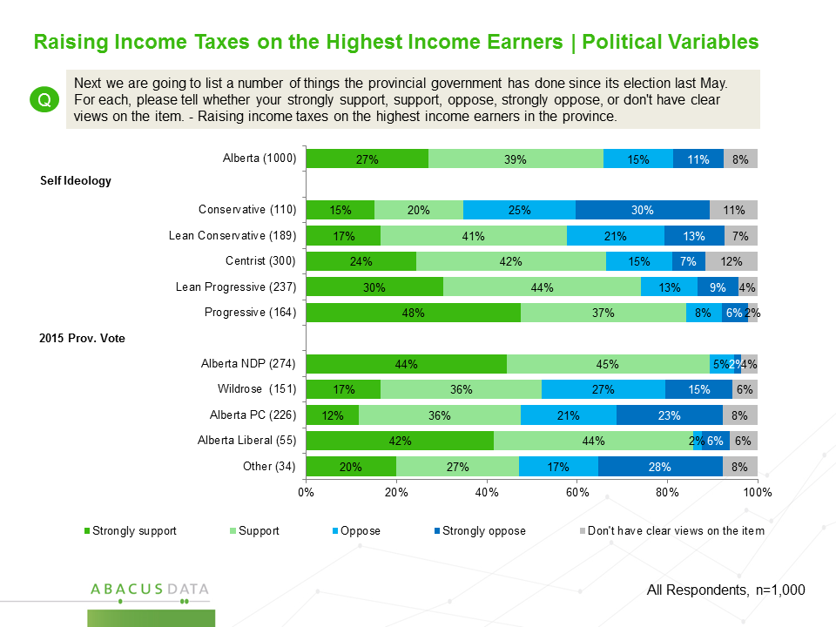

  - Phasing Out Coal Powered Electricity Generation

Overall, 48% of Albertans support the provincial government’s plan to phase out coal-powered electricity generation in the province. Another 36% are opposed while 17% said they do not have clear views on the issue.

Support for phasing out coal power was stronger among those living in urban and suburban communities, and those living in Calgary (52%) and Edmonton (51%). There was also more support for the decision among those with a university degree (59%), and those aged 18 to 29 (58%).
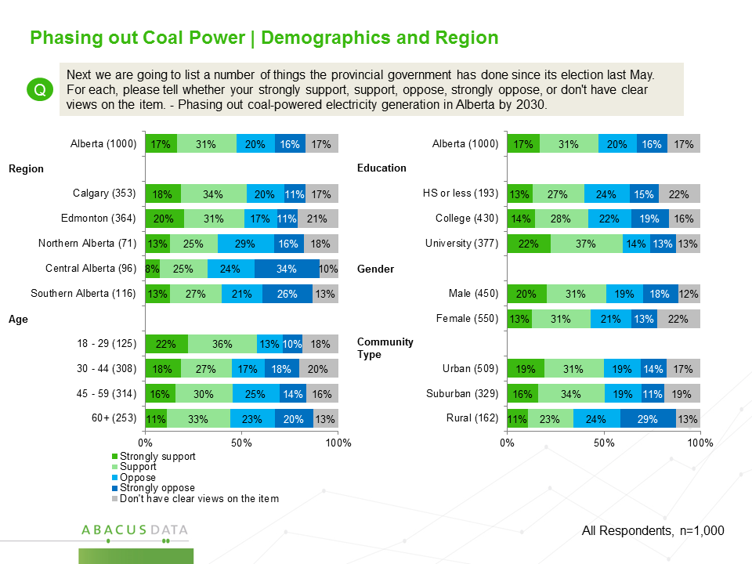

Again there was a clear relationship between self-placement on the political spectrum and support of this initiative. Conservatives were the most likely to oppose phasing out coal power, at 63% while those on the more progressive side of the spectrum were the most likely to support it, at 71%.

Politically, 67% of past NDP voters support the coal power phase out as do 68% of Alberta Liberal voters. Among Wildrose and PC Party voters, a minority support the decision (Wildrose 37%, PC 36%) with a majority of both party supporters opposed.

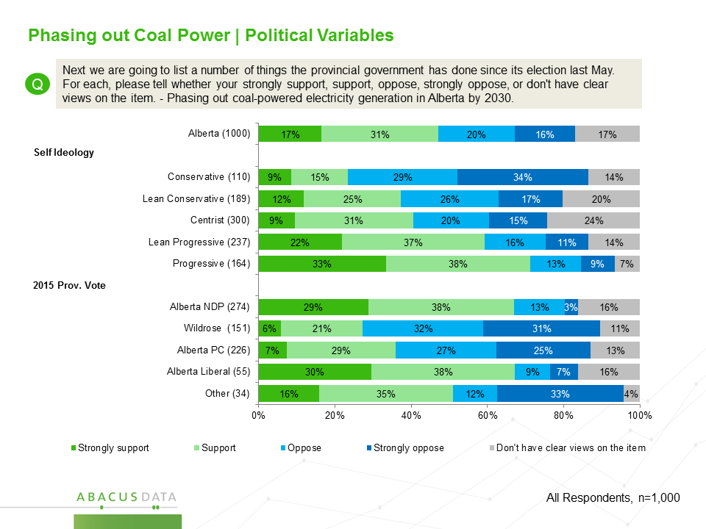

When asked specifically about the impacts and methods for phasing out coal power in Alberta, a majority of respondents felt that the measure would improve air quality (75% support) and accelerate investment in clean energy technologies (66% support).

Simultaneously, 79% of Albertans felt that there should be a government-created community development fund put in place to help communities that are currently dependent upon the coal industry.

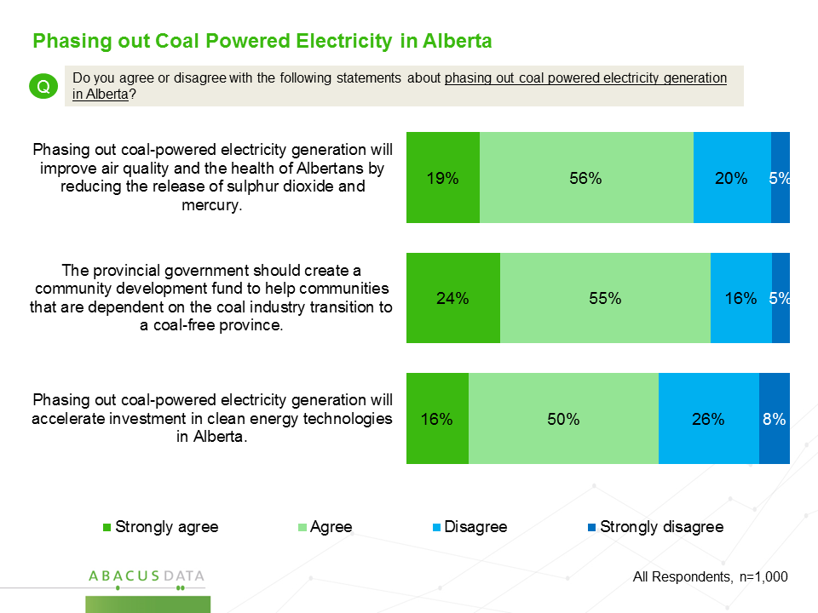

  - Carbon Tax

Overall, 47% of Albertans we surveyed said they support the provincial government’s plan to introduce a carbon tax with revenues being invested in research, public transit, renewable energy, and a rebate to low and middle income Albertans. Forty-two percent were opposed while 12% said they did not have clear views on the issue.

While Albertans overall were split nearly in half over their support of a carbon tax, support for such a measure was strongest among urban residents (52% support), particularly in Edmonton (57% support), and among those aged 18-29 (55% support).

Opposition for the policy was highest among those living in rural communities (51%) and among men (46%).

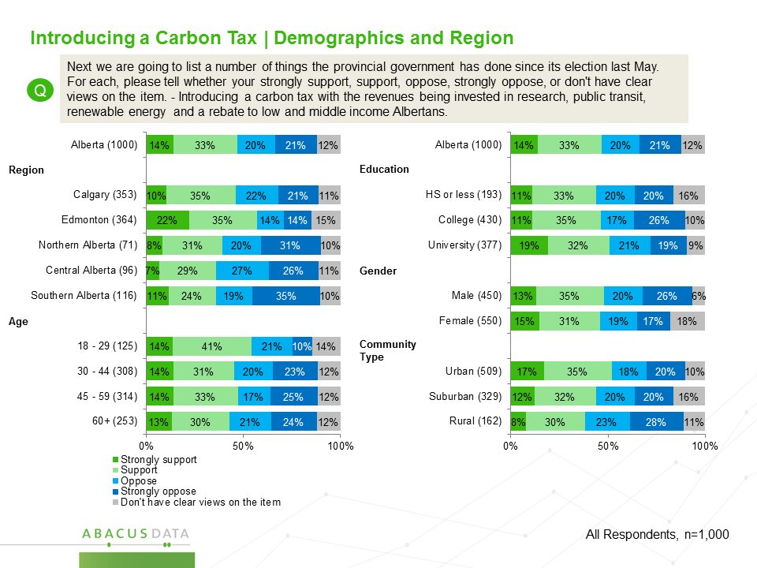

Although support for such a tax was strong among those who self-identified as progressive, over 51% of conservatives strongly opposed the introduction of a carbon tax. Further, although 72% of NDP voters support the tax, a majority of Wildrose and PC voters oppose the idea.

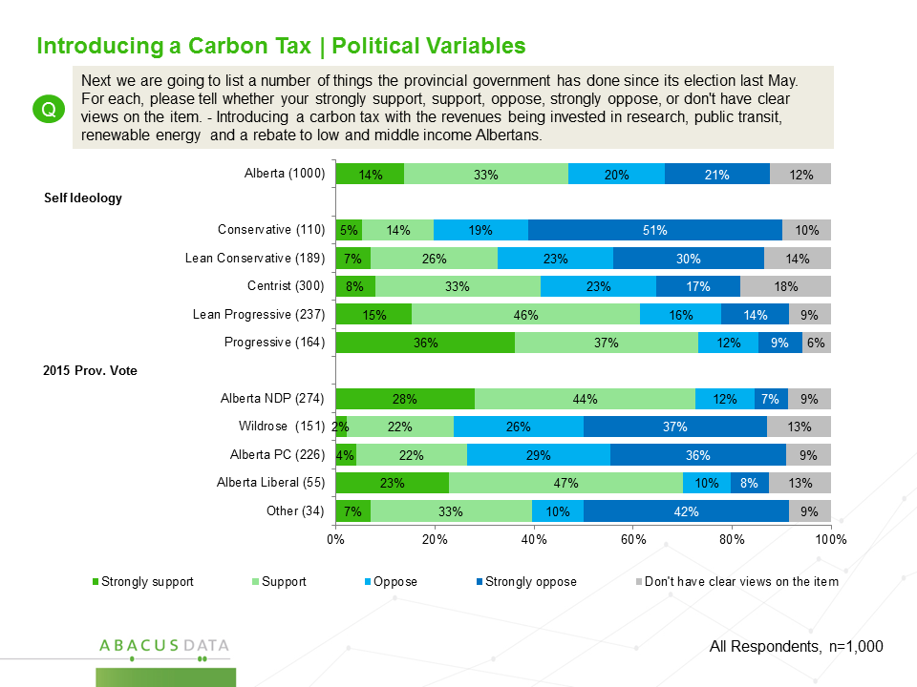

  - Emissions Limit on Oil Sands Producers

When asked about legislating an emissions limit on the oil sands, 47% supported the policy while 37% said they were opposed. Support for an emissions limit was strongest in Calgary and Edmonton, as well as among those with a university education while opposition was highest among those living outside of the two largest cities and among those with less formal education.

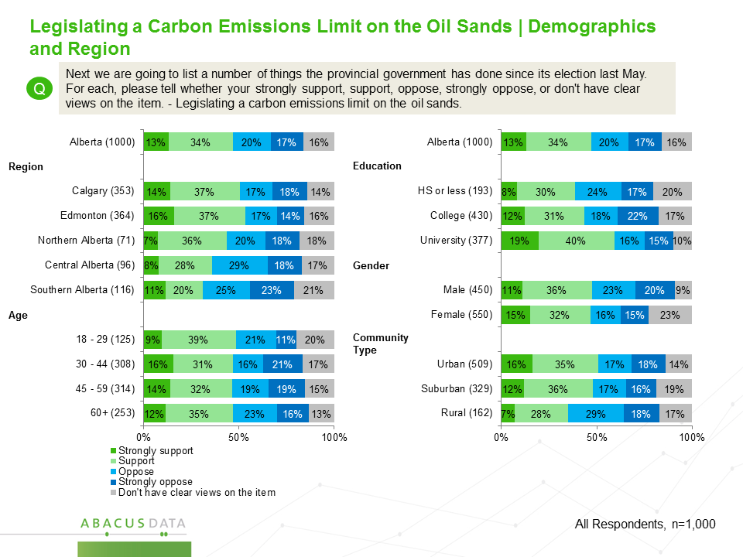

Of most of the policies we tested, opinion was largely determined by one’s political orientation.

Progressives generally support an emissions limit on the oil sands while conservatives are generally opposed. Similarly, 74% of those who voted NDP in 2015 support the emissions limit while a majority of both Wildrose and Alberta PC voters are opposed.

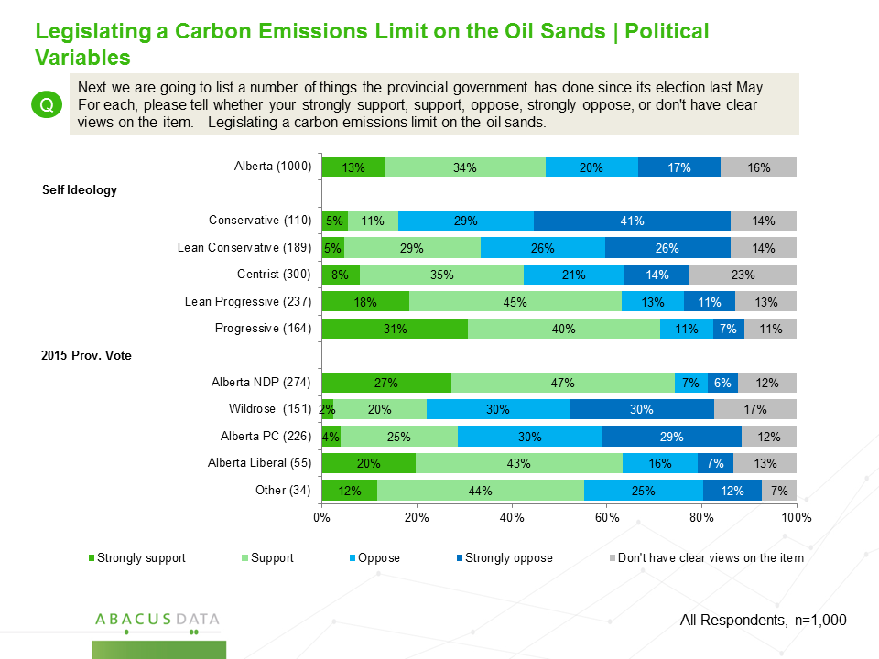

Impressions of Political Leaders in Alberta

Respondents were asked for their overall impression of some of Alberta’s leading political leaders.

Overall, the mayors of Calgary and Edmonton had the most favourable impressions of the five individuals we tested.

Calgary mayor Naheed Nenshi is the most popular political leader we tested with 58% of respondents saying they have a favourable impression of him compared with only 12% who have a negative impression. Edmonton mayor Don Iveson also has a net positive personal image with 34% of Albertans having a positive impression of him compared with only 7% who view him negatively. A large portion of respondents did not know enough about him to have an impression.

When it comes to Alberta Premier Rachel Notley, 32% have a favourable impression of her, eight points higher than Wildrose Party leader Brian Jean and double that of interim PC Leader Ric McIver. Thirty-eight percent of Albertans have a negative impression of Premier Notley while 25% say their impression of her is neutral.

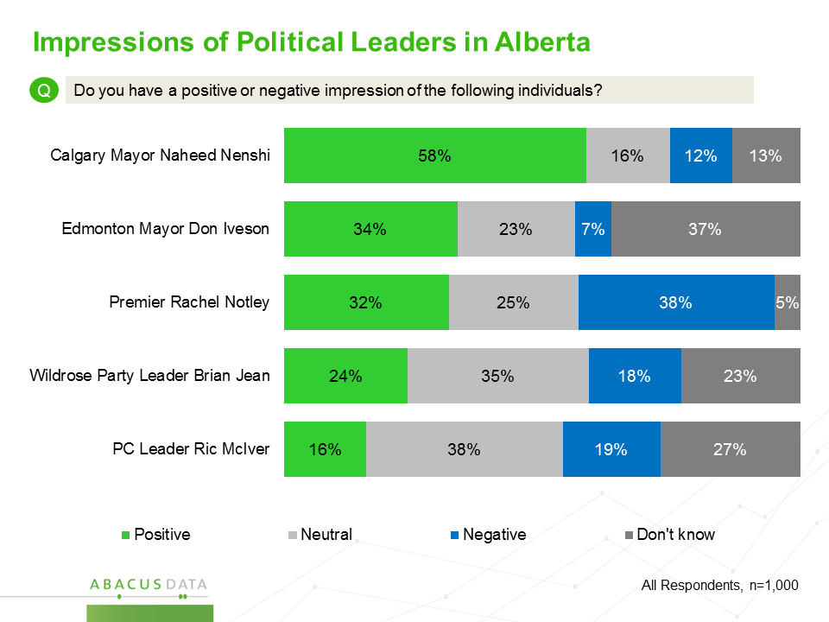

  - Alberta Premier Rachel Notley

Premier Notley is most popular in Edmonton and Calgary, among those living in urban or suburban communities, and among university educated Albertans.

She is viewed less favourably by those in central and southern Alberta, among rural community residents, among men, and among those with less than university education.

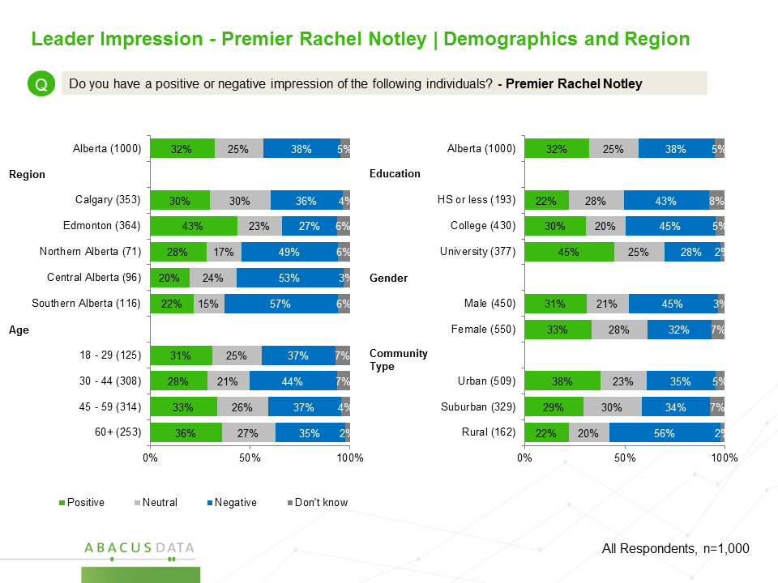

There is a strong correlation between one’s ideology placement and views of the Premier. Among those who self-identify as clearly progressive, 65% have a positive impression of the Premier while 19% have a negative impression. A majority (53%) of those who lean progressive also view the Premier positively.

In contrast, conservative leaning Albertans have a decidedly negative impression of Premier Notley with 74% of clearly conservative respondents and 54% of conservative leaning respondents saying they have an unfavourable impression of her.

Premier Notley remains popular among those who voted NDP in the May 2015 election. 68% of past NDP voters have a positive impression of her while only 11% have a negative impression. Similarly, Alberta Liberal voters are much more likely to view the Premier positively than negatively.

Most Wildrose and PC voters have a negative impression of the Premier.
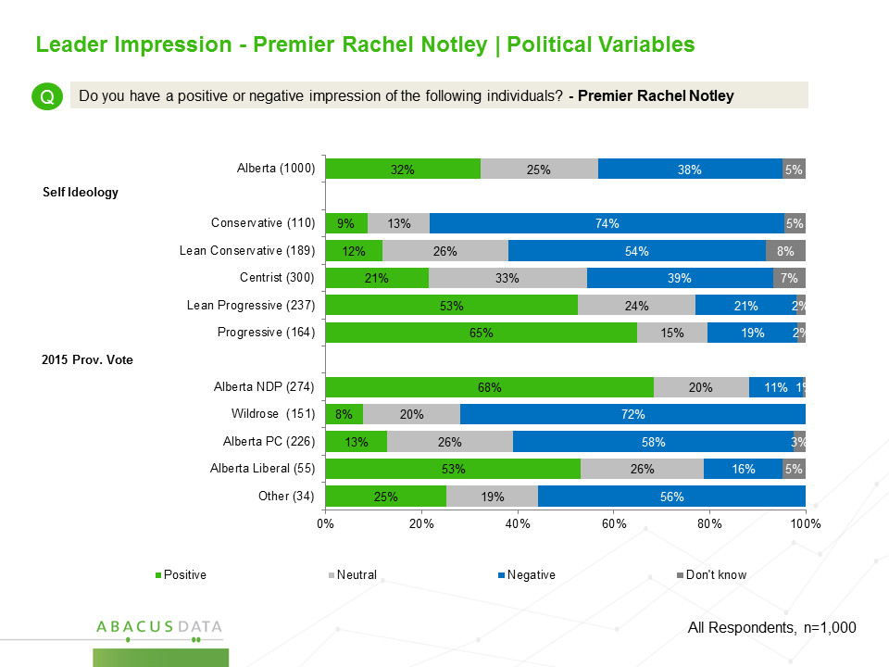

  - Calgary mayor Naheed Nenshi

Mayor Nenshi’s popularity extends across the province and among all demographic subgroups. While he is most popular in Calgary (70% of residents have a positive impression of their mayor), a majority of those living in Edmonton, central Alberta, and southern Alberta have a favourable impression as well.

While he is more popular among urban residents and among those with a university education, a majority of every demographic subgroup has a positive impression of Mayor Nenshi.

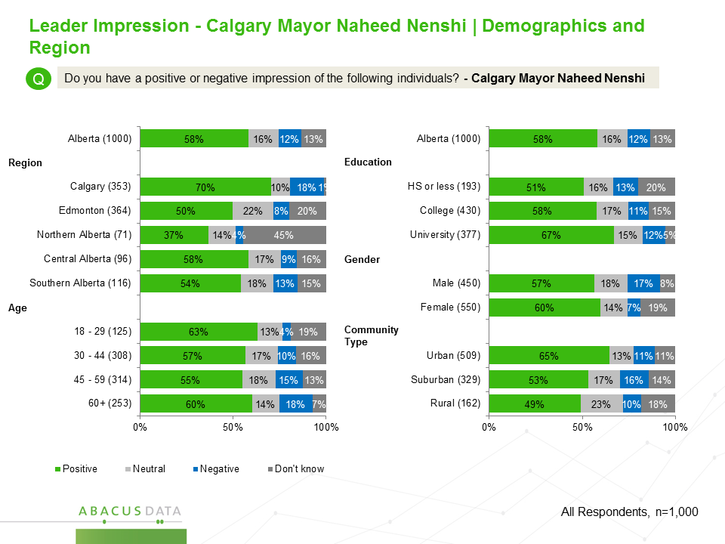

Politically, Mayor Nenshi is most popular among those who voted NDP in the last provincial election (70%) and among those who self-identify as progressives. But he is also viewed positively by a plurality of Wildrose and PC voters and among those who lean conservative on the political spectrum. Only among clear conservative Albertans is there a split of opinion where about equal numbers have a favourable and unfavourable impression of the Mayor Nenshi.

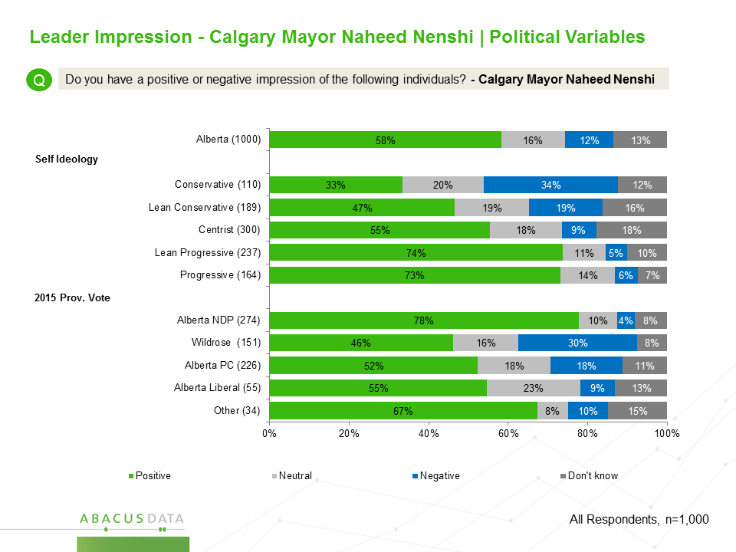

  - Edmonton mayor Don Iveson

Mayor Iveson is very popular in his home city of Edmonton with 63% of Edmonton residents saying they have a positive impression of the mayor. Only 10% have a negative impression. Outside of Edmonton, Mayor Iveson is well known and liked in northern and central Alberta. He is less well known in Calgary and southern Alberta.

Progressives are more likely to have a favourable impression of Mayor Iveson although his personal image is also relatively strong among those who place themselves on the conservative side of the spectrum. NDP and Alberta Liberal voters have the strongest impressions of the Mayor but he is also viewed positively by a third of PC voters.

