**Going to the Rainbow Families Monthly Catch-up**

Most months the Rainbow Families get together in a park for a catch up. This usually happens at the weekend. Sometimes the monthly catch up might happen on a Saturday and sometimes it might happen on a Sunday. If I go to the Rainbow Families monthly catch up I will go with my family.

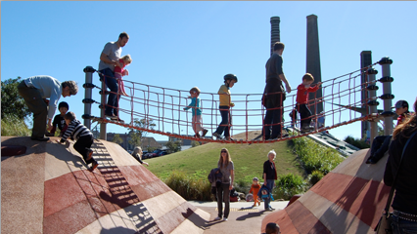

When we get to the monthly catch up there will probably be some other Rainbow families there to play with. There might be some children and adults that I know or there might be some new children and adults that I don’t know. It is good to play with children that I know but it is also good to play with children that I don’t know. When children come to the Rainbow Families catch up for the first time it is good to say “Hello” and ask them “What’s your name?”

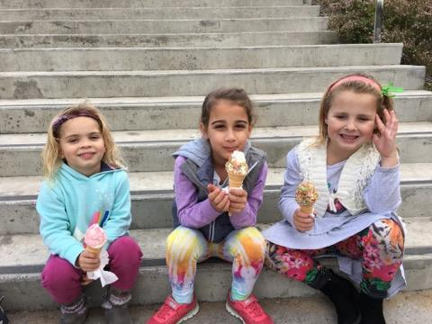

When we go to the Rainbow Families catch up the children usually play on the play equipment. While the children are playing the adults usually like to talk to each other. It’s good for the adults to have time to talk to each other. It’s good for the children to have time to play with each other.

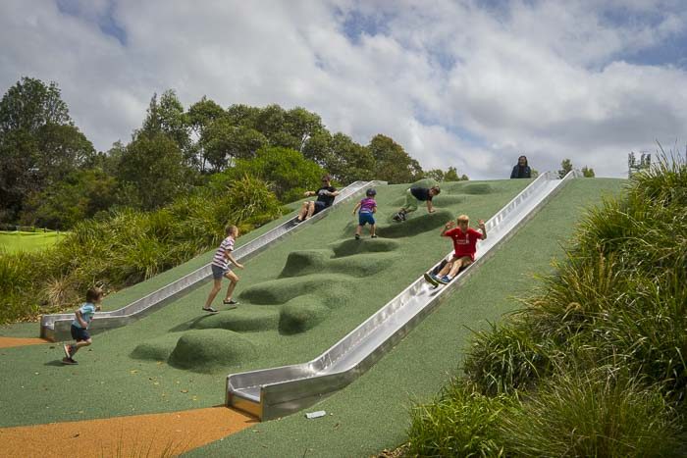

It is good to go to the Rainbow Families catch up to meet lots of different people. It is good to meet families that are like my family. It is also good to meet families that are different to my family. Some families have two mums. Some families have two dads. Some families have one parent. Some families have a mum and a dad. All families are different but that’s ok. I can have fun with lots of different families.

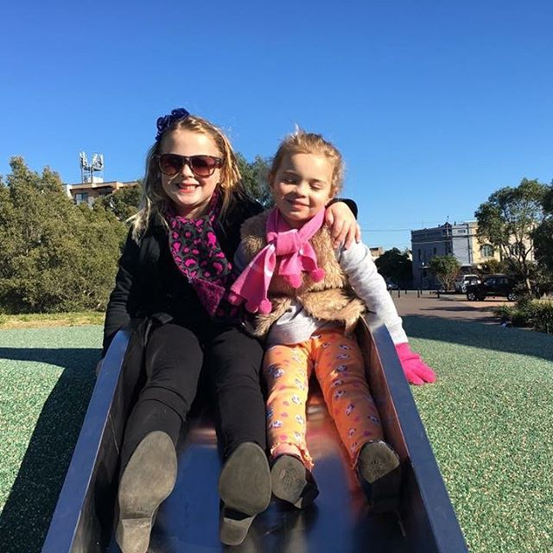

Sometimes it might rain when we are meant to be going to the Rainbow Families Catch up. If it is raining we might go and play somewhere indoors or my parents might find something different to do.