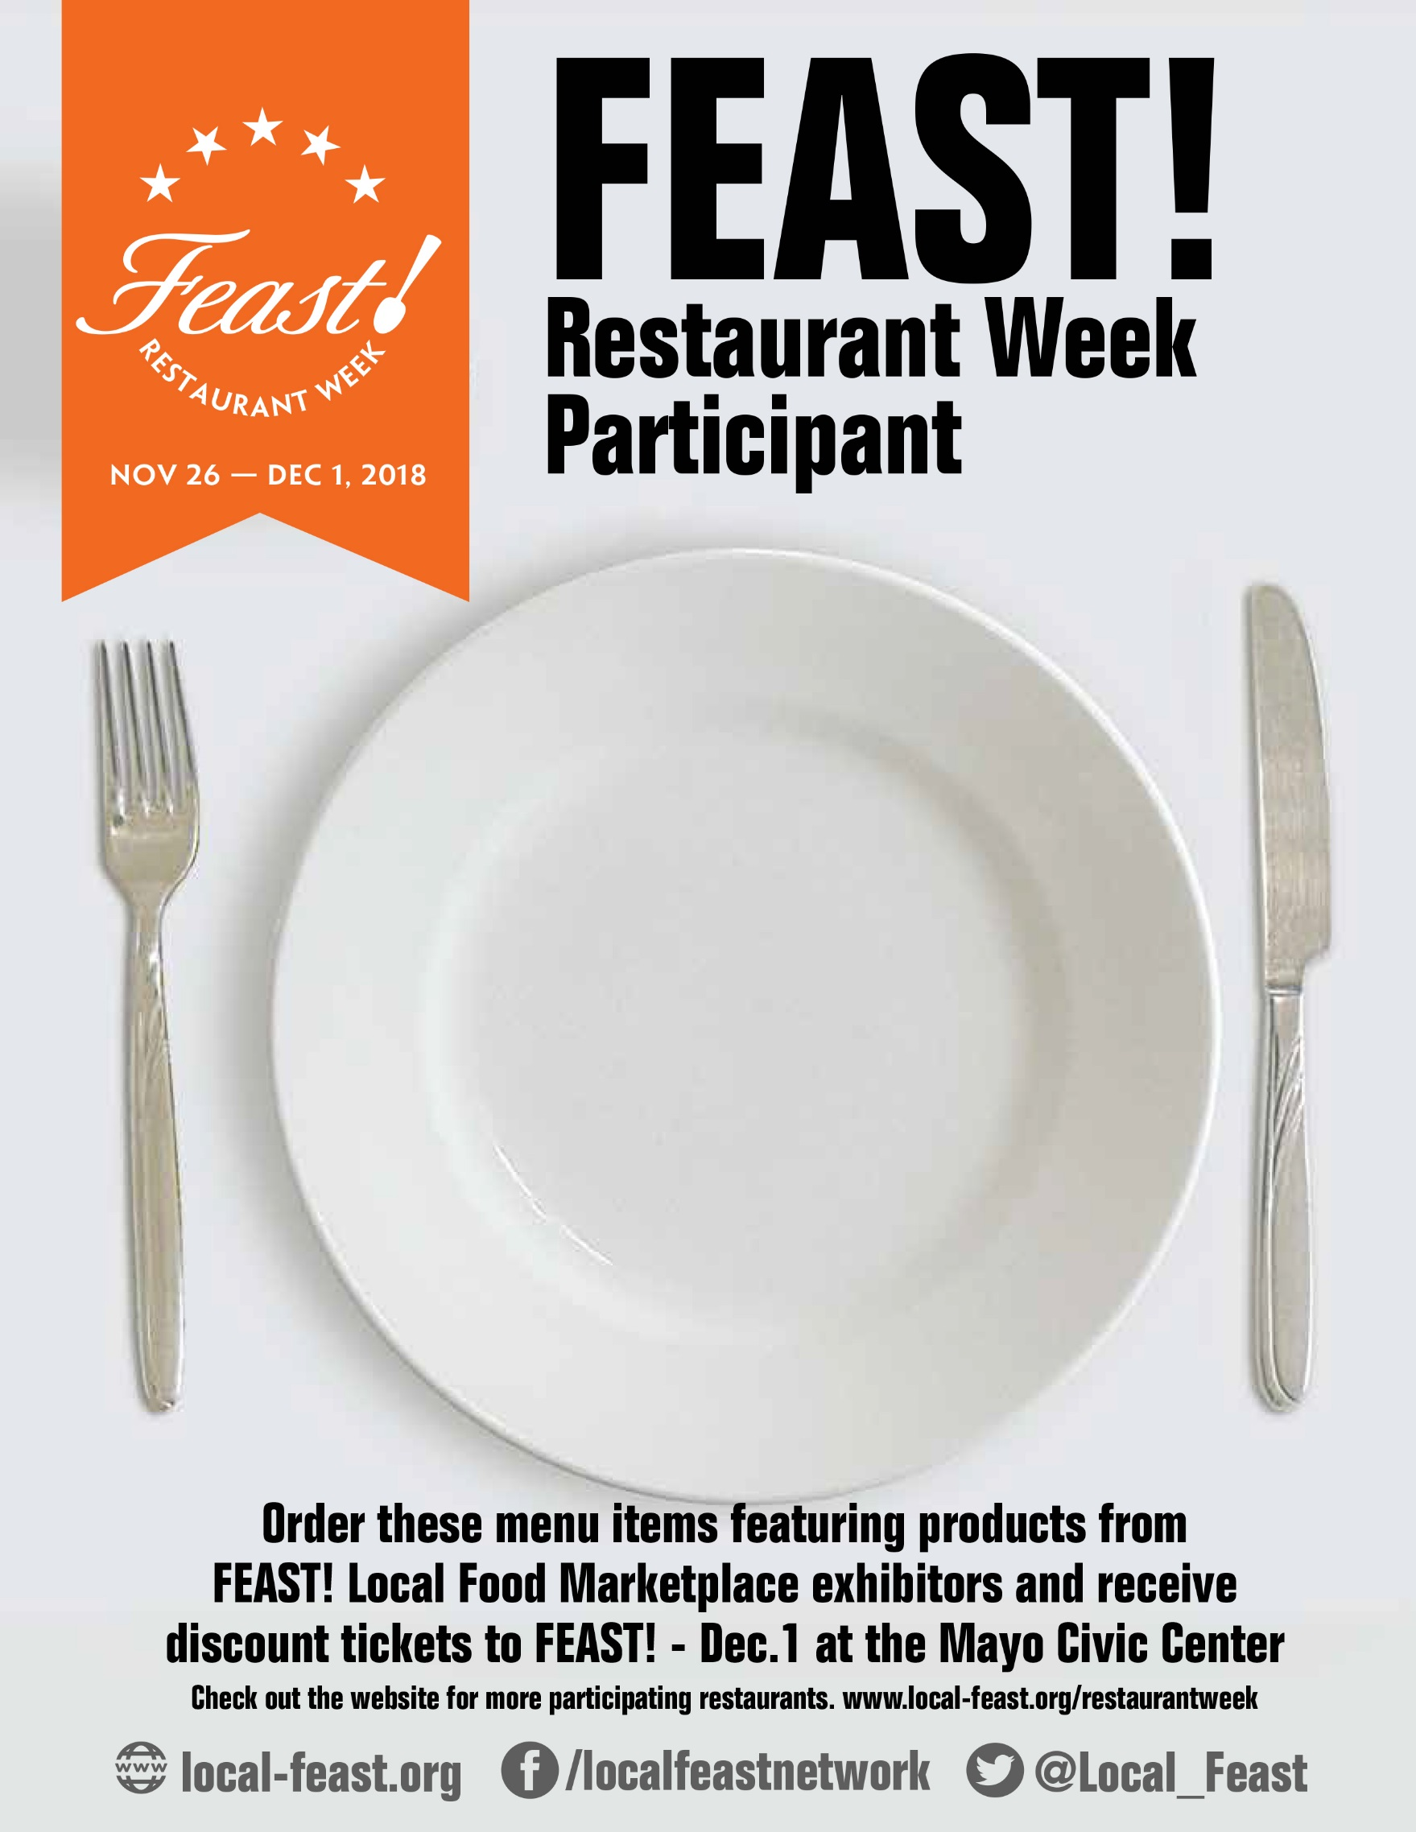

Type menu here

or

delete this text for a blank template