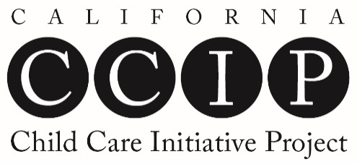
Cumulative List of Participants

REPORTING DATE: _______________________
COUNTY: ________________________________
AGENCY: ________________________________

CCIP PARTICIPANT INFORMATION |  | QUALITY IMPROVEMENT: TRAINING STATUS
 |  | Number of Training Hours Completed in Each Competency Area |  |  |  |  |  |  |  |  |  |  |  | Total Training Hours | Date Trainee Req. met
 | Participant  Name | CDL | CDE | RIG | FCE | DLD | OSAD | SNI | LEC | HSN | LECE | P | AS
1
2
3
4
5
6
7
8
9
10

CDL | Child Development and learning | DLD | Dual-Language Development | HSN | Health, Safety, and Nutrition
CDE | Culture, Diversity, and Equity | OSAD | Observation, Screening, Assessment, and Documentation | LECE | Leadership in Early Childhood Education
RIG | Relationships, Interactions, and Guidance | SNI | Special Needs and Inclusion | P | Professionalism
FCE | Family and Community Engagement | LEC | Learning Environments and Curriculum | AS | Administration and Supervision
California Early Childhood Educator Competency Areas Abbreviation Key

